### **RESUME**

**PAWAN KUMAR ROY PRESENT ADDRESS:**

C/O-Mahavir Roy

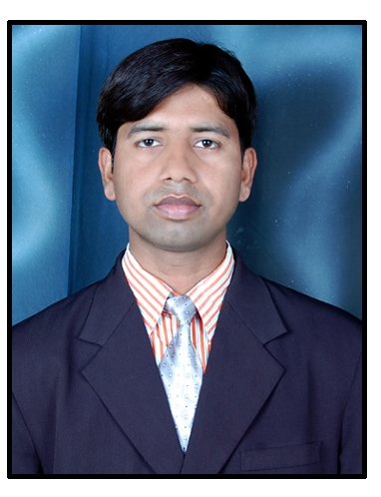

L-192, Mangolpuri

New Delhi-110083

🕿 : +91 9891966748

🖂 : pawan_roy25@yahoo.in

Objective:

To be a part of the dynamic corporate environment and contribute to the organizational growth and in the process acquire knowledge and new skills.

Interpersonal Skills:

* Ability to work in team.
* Easy adaptability to new concepts and ideas.
* Dedication to Continuous Improvement.
* Sincere and committed towards work.
* Current Professional Experience:

Organization : Yes Bank Ltd...

Position held : Business Relationship Partner.

Duration : 12th Aug 2013 to Till Now.

Job Responsibilities & Duties:

* Handling the all liability Products.
* Opening the Current A/C & Trade A/C.
* To Generate & Convert all Assets Products.

Previous Professional Experience(2):

Organization : Kotak Mahindra Bank Ltd.

Position held : Assistant Manager.

Duration : 8th Oct 2010 to 4th Aug 2013.

Job Responsibilities & Duties:

* Handling the all retail liabilities products.
* Opening the current, saving & demat A/C.
* To generate leads for sales in various corporate & SME etc. sectors.
* To generate awareness among people about various new products.

Previous Professional Experience(1):

Organization : Reliance Communication (Anil Dhirubhai Ambani Group).

Positition held : Senior Business Development Executive.

Duration : 27th FEB 2009 to 20 Sept 2010.

Job Responsibilities & Duties:

* Corporate selling of RIM, FWP, DATA CARD.

Professional Qualification :

* M.B.A (Industry Integrated) +Post Graduate Diploma in Business Management from New Delhi Institute of Management Studies (2008-10), New Delhi

Area of Interest: (1) Major…………Sales & Marketing

(2) Minor…………Finance.

Academics:

* M.B.A (Industry Integrated) from Madurai Kamaraj University, Madurai in 2010.
* Graduation (B.Sc.)-[Physics (Hons)] from L.N.M.U. (Dharbhanga) in 2006.
* Senior Secondary Examination (12th) from B.I.E.C., Patna in 2002.
* Higher Secondary Examination (10th) from B.S.E.B., Patna in 2000.

Computer Skills:

* Operating System:-WinXP, Win98, Win2000, Windows Vista, DOS.
* Office Automation: - MS Word, MS Excel, MS Power Point.
* Financial Package: - Tally 7.X.

Extra Curricular Activities:

* Participated in Soft Skill & Industry Relevant Skills from 08-09-08 to 13-09-08 organized by:-NIAM.
* Participated in national seminar of HRD Ministry (Govt. Of India) on the topic

“Effect of American Recession in Indian Economy” from 23-12-08 to 24-12-08

Organized by:-NDIMS, DELHI.

Personal Profile:

Father’s name **:** Narayan Roy

Father’s Occupation : Businessman

Date of Birth **:** 15/02/1985

Sex **:** Male

Marital Status : Married

Nationality **:** Indian

Languages Known **:** English, Hindi, and Maithali

Passport No. : G9598432

Permanent Address **:** Vill- Mirzapur,

Post- Rajnagar

Dist-Madhubani (Bihar)

Pin code-847235

Reading Books, Listening Music &

**Date:**

**Place:** New Delhi **(PAWAN KUMAR ROY)**