RISHI KESH SINGH 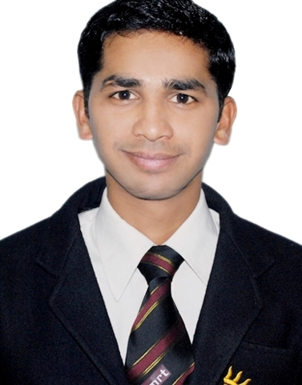

DOB-15/12/1986

**Mobile**: +91 9716474243

**E-Mail**: [rishikesh.singh@ymail.com](mailto:rishikesh.singh@ymail.com)

**Current Address- noida**

CAREER OVERVIEW

* Marketing Management Post Graduate with Total experience of more than 3 year in Relationship Management, current account customer acquisition, New Business Development in the Banking Sector.
* Currently serving as Business relationship partner with YES Bank, Noida.
* Excellent selling skills.

EMPLOYMENT SCAN Total work experience is 3 year and 10 month in Banking sector

**Since October 2013 to present time working with YES Bank as Business Relationship Partner in noida**

Dealing Trade Forex Current account Customers.

* Acquisition of Trade and normal current Account customer of the bank.
* High value current account acqusition.
* Cross Sailing of other Banking Product like Credit card ,Insurance etc.
* Engaging with Corporate team for companies Salary Relationship
* Engaged with business banking team for LAP, OD & CC requirement of customer

**From june 2012 to October 2013 worked with Indusind bank As Associate Relationship Manager- emerging Corporate at Noida Branch**

Dealing Trade Forex Current account Customers.

* Managing the Trade forex and normal current Account customer of the bank.
* Sourcing New Trade and normal Current account Customers.
* Cross Sailing of other Banking Products
* Engaging with Corporate team for companies Salary Relationship

**From October 2010 to may 2012 worked with ICICI Bank, Noida as Relationship officer**

**Key Result Areas:**

* Managing the of Trade forex and normal current Account customer of the bank.
* Sourcing New Current Account Business
* Engaging with business teams in the bank to accomplish the work required to close sales
* Achieving monthly target regularly
* Prepares action plans by individuals as well as by team for effective search of sales leads and prospects.
* Follow up on new leads and referrals resulting from field activity.
* Establish and maintain current client and potential client relationships.

ACHIEVEMENTS IN ICICI BANK

* Got **master performer Award** in icici bank for Quality current account sourcing.in Delhi ncr.
* Categories in **Gold category** for Current Account business acquisition in icici bank.
* Got certificate for best performance (Maximum number of Current Account) in Delhi NCR in the month of September 2011.
* Maintaining good rank in E2E MAB.

SCHOLASTICS

|  |  |  |  |
| --- | --- | --- | --- |
| **Qualification** | **Year** | **Institute** |  |
| MBA (PGDM) | 2010 | IMRT BUSINESS SCHOOL . LUCKNOW |  |
| B.Sc. | 2006 | KANPUR UNIVERSITY |  |
| XII | 2003 | D.S.INTER COLLEGE, LAKHIMPUR |  |
| X | 2001 | L.B.S. COLLEGE, PILIBHIT |  |

ACADEMIC PROJECTS

* **SIP Project on- consumer buying pattern for Xerox Machine of Ricoh India Ltd in Lucknow**
* Conducting research on **TATA NANO**-

**analysis of market potential for Tata nano in lucknow**

(Interviews with experts & Secondary data analysis

* **Business Plan–** A business plan of establishing an **entrepreneur-cell** in Delhi & NCR region.

IT SKILLS

* Sound knowledge in computers and technical skills of information sciences
* Proficient knowledge of MS office

EXTRA CURRICULAR

* **Branding** **&** **Promotional** representative of IMRT College, Lucknow.
* Participate in various cultural activities in IMRT College,
* I participated in 10 days seminar of Mr. Ashok Balaraj Krishnan (Corporate image Consultant/workshop leader)- “**The Finishing Touch” of youth mind.**

**COMPETENCIES**

* Enthusiastic and fast learner.
* Work effectively with diverse groups of people.
* Ambitious and committed to excellence.

HOBBIES

* Bike riding
* Social networking

**Place: noida**

**Date: 03\07\2014 (RISHI KESH SINGH)**