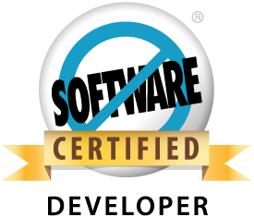 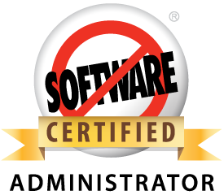 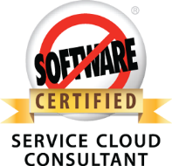

**OMAIR AKRAM**

**E-Mail: akram.omair@gmail.com ~ Contact: +91 9591423138**

**OBJECTIVE**

To pursue a challenging career which helps me to grow continuously and push myself to next level.

**SUMMARY**

* **Salesforce Certifications completed – Service Cloud, ADM 201 ,DEV 401**
* Having 2 years of experience in SFDC development.
* Expertise in Salesforce Customization – Apex , Visual Force
* Have also worked on the CPQ tool – Big Machines.
* Have completed Yellow Belt Certification in Big machines.
* Received award and recognition for my work in multiple projects.
* Team player with strong analytical, communication and interpersonal skills.
* Adaptable and fast learner.

**WORK EXPERIENCE**

Working as a Business Technology Analyst in Customer Solutions service line in **Deloitte Consulting**, Bangalore from June 2012 till date.

**TECHNICAL SKILLS**

Products: Salesforce.com , Big Machines

Languages: Apex , C , JavaScript

Software Tools: Eclipse , Ant, Apex Data Loader, Force.com Explorer

**PROJECTS**

**Project#1**

**Title:** Lonza

**Duration:** 6 Months(Aug 2012 – Dec 2012)

**Tools:** Eclipse , Apex Data Loader

**Team Size:** 7

**Description:**

* The client is a chemicals and a biotechnology firm . The project was a SFDC

CRM implementation to replace their legacy systems.

**Responsibilities:**

* My primary role was in the data migration track . I was involved in loading their legacy data into the Salesforce org using Apex data loader . I was also required to resolve issues related to data before they were loaded.
* I was also involved in work related to customization such as Apex triggers.
* I also worked on preparing test scripts for various requirements.

**Project#2**

**Title:** HP PPS Service Cloud

**Duration:** 1 year(Jan 2013 – Dec 2013)

**Tools:** Eclipse , Ant , Force.com Explorer

**Team Size:** 24

**Description:**

* This was the largest Service Cloud implementation till that point . This was a challenging project involving complex customizations.

**Responsibilities:**

* I worked on several customizations such as Custom Routing for multiple objects.
* I was responsible for handling of the inbound emails functionality and the subsequent routing and actions. This was a very complex piece and I was able to successfully implement it.
* I also worked on multiple functionalities specific to service Cloud console.
* I was also involved in face to face Client Interactions during the Knowledge Transfer sessions.
* I also worked at defect fixing.

**Project#3**

**Title:** Cooper Vision

**Duration:** 2 weeks (July 2013)

**Tools:** Eclipse

**Team Size:** 6

**Description:**

* The client is an optical industry player .This project was a SFDC implementation focused on helping their agents improve their sales.
* I was involved in the project for a short term to help through a critical phase of the project.

**Responsibilities:**

* I was mainly involved in development of VF pages. I was able to get up to speed in a short period of time and was able to deliver.

**Project#4**

**Title:** FOX Entertainment

**Duration:** 2 weeks (Jan 2014)

**Tools:** Eclipse

**Team Size:** 15

**Description:**

* The client is in the Entertainment industry. This project was a SFDC implementation involving development of hundreds of screens with rich UI.

**Responsibilities:**

* I was involved in defect fixing for defects related to VF pages.

**Project#5**

**Title:** Hi-Tech (Internal project)

**Duration:** 6 months (Dec 2013 – May 2014)

**Tools:** Eclipse, Ant

**Team Size:** 4

**Description:**

* This project is an internal firm initiative aimed at developing a package specifically for clients in the Hi- tech sector. This package is used to demo to clients belonging to this sector.

**Responsibilities:**

* I was working on customizations consisting of Apex triggers , VF pages

**Project#6**

**Title:** NOV GP

**Duration:** 5 months (Jan 2014 – May 2014)

**Tools:** Big Machine

**Team Size:** 6

**Description:**

* The client is an Engineering and Construction industry player. The project is for implementing Big machine CPQ solution to replace their legacy system.

**Responsibilities:**

* I am involved in development which consists of mainly writing constraint , hiding , recommendation rules for the application.
* I am also involved in writing test scripts surrounding various functionalities.

**EDUCATION**

* B.E. (Electronics & Communication) from P.E.S Institute of Technology, Bangalore, VTU with 7.70 cgpa in 2012.
* 12th from Jawahar Vidya Mandir, Ranchi(Jharkhand) , CBSE Board with 86.6% marks in 2007.
* 10th from Jawahar Vidya Mandir, Ranchi(Jharkhand) , CBSE Board with 84% marks in 2005.

**EXTRACURRICULAR ACTIVITIES & ACHIEVEMENTS**

* Received excellence award for my work in first project-Lonza.
* Received recognition for outstanding work in HP project.
* Completed a course on “Core Java” from Aptech India.

**PERSONAL DETAILS**

Date of Birth: May 20 , 1989

Languages: English, Hindi

Permanent Address: 25/68-A , Resaldar Nagar , Doranda , Ranchi- 834002 , Jharkhand

Local Address: House #3 , Radha Krishna Niwas , Shamanna reddy Layout , SGR Dental College Rd,

Munekolalu , Marathalli , Bangalore – 560037 , Karnataka