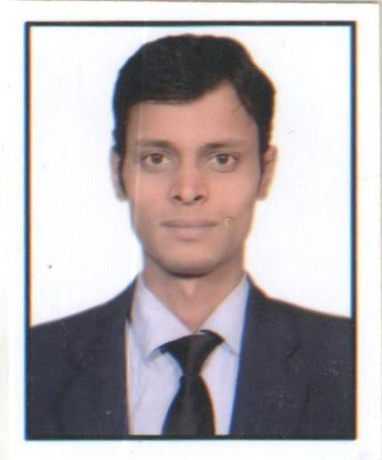

# Mayank Kumar Singh

# Mob No: +91-8010558126, +91-9810316571

# mayanksingh580@gmail.com

**Career Objective:**

To be a part of an organization with a professional work driven environment where I can utilize and apply my knowledge and skills which enable me a fresh graduate to grow while fulfilling the organizational goals

# Educational Qualifications

|  |  |  |  |
| --- | --- | --- | --- |
| **Year of passing** | **Course** | **Name of Board/University/Institute** | **%age** |
| 2015 | **PGDM: (Major)** Marketing  **(Minor)** International Business | Jagan Institute of Management Studies | 67 |
| 2011 | B.B.A | Chatrapati Sahu Ji Maharaj University, Kanpur | 65 |
| 2008 | XII | U.P board | 56 |
| 2006 | X | Bihar board | 71 |

**Projects & Assignments**

* **PGDM: INTERNSHIP**

**Organization:** Amul

**Project:** To increase visibility & develop strategies for increasing penetration of Amul ice-cream

**Duration:** 5th May 2014-28th June 2014

**Responsibilities:**

**First phase**

* Visited retail stores with a sales person.
* Found the problem they were facing and provided solutions for them

**Second phase**

* Amul launched 4 new ice-cream
* Visited a Reliance store daily and tried to convince customers to try those ice-creams

* **PGDM: LIVE PROJECT**

**Company: -** Nielson India, Delhi

**Duration: -** 2 weeks (25nd Nov 2013.-13th Dec. 2013)

**Roles & responsibilities:-**

* + Agent monitoring
  + Getting exit poll data from field interviewer
  + Maintaining the speed of information/data flow

**HOBBIES & INTERESTS**

* Playing and watching cricket games
* Reading news(Sports), Listening Songs

# **PERSONAL DETAILS**

Date of Birth: 15/12/1991

Age as on 7th Feb. 2015: 23 Yrs.

Present Address: C-4 56, sec-5, Rithala, New Delhi

Permanent Address: Village- Maripur ,Post-Fulwaria,Dist-Gopalganj,

Pin code-841425, (BIHAR)

**_______________________________________________________________________________**

**Date: Signature:**

**Name: Mayank Kumar Singh**