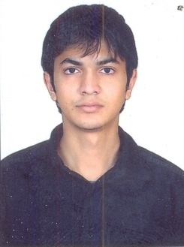



**Curriculum Vitae**

**KESHAV NATANI**

Email id: [keshavnatani64@gmail.com](mailto:keshavnatani64@gmail.com)

Mobile: 09644088805, 09718789765

**PROFESSIONAL EDUCATION ______________________________________________**

|  |  |  |  |  |
| --- | --- | --- | --- | --- |
| **Course** | **Year of Passing** | **Name of Board/University/Institute** | **%age** | **Division** |
| PGDM (2yr Full time) Batch 2013-15  MAJOR (MARKETING)  MINOR  (INTERNATIONAL BUSINESS) | Pursuing(2015) | Jagan Institute of Management Studies, Delhi | 60 | 1 |
| Graduation (B.E.)C.S.E | 2012 | Mahakal Institute of Technology And Management | 65.25 | I |
| XII th | 2008 | Kalidas Montessori Higher Secondary School | 62.6 | I |
| X th | 2006 | St. Mary’s Convent School | 61.2 | I |

**EXPERIENCE ______________________________________________**

**Company Name: Videocon**

**Designation:** Management Trainee (ASM)

**Duration:** 9 Months ( 6 oct 2014 to 31 may 2015)

**Location:** Mumbai

**Roles & Responsibilities:** Channel Sales, Dealer Management and Network Expansion

**SUMMER INTERNSHIP ______________________________________________**

**Company Name: Amul**

**Duration:** 5 Weeks(1st May 2014 to 5th June 2014 )

**Project Title:** “Brand Promotion Of Amul Masti Dahi"

**Role & Responsibility:** Identifying new retail outlets, taking orders and ensuring the supply.

**AWARDS______________________________________________**

* 1st prize in INTER COLLEGE QUIZ competition.
* 1st prize in INTER COLLEGE CRICKET competition.

**EXTRA ACTIVITIES______________________________________________**

* Coordinated many events and done ANCHORING.
* Participated in SPORTS activities {won gold and silver medals}.
* HOUSE CAPTAIN in class X at St. Mary’s Convent School.

**PERSONAL DETAILS**

Date of Birth: 14th December 1989

Present Address: J extension, laxmi nagar, new delhi

Permanent Address: 6, Kshir Sagar , Natani Bhawan , Ujjain (M.P.)

**_____________________**

**Date: Signature:**

**Name: KESHAV NATANI**