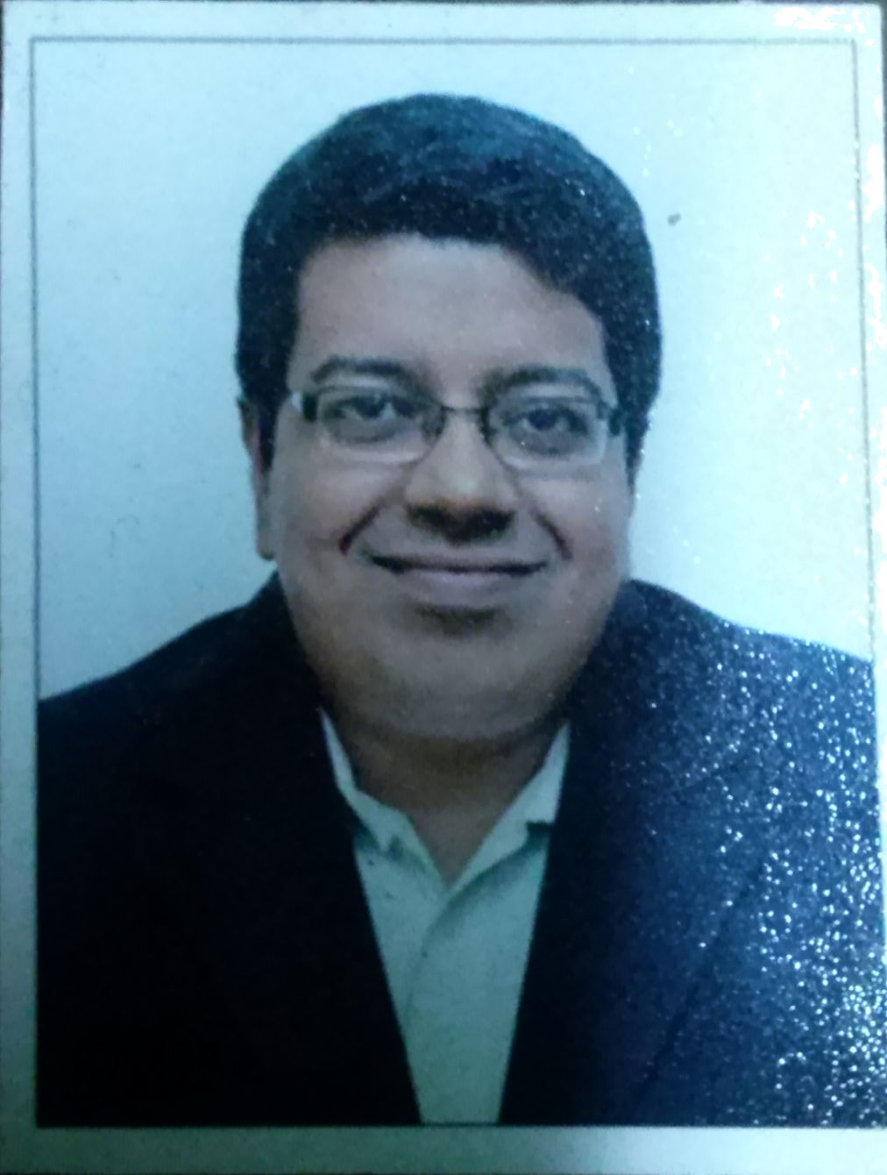
Karthik Iyer
Cell : 98332 60983 Email : cakarthikiyer@gmail.com
iyer_karthik@rediffmail.com

Professional Summary

A Chartered Accountant by qualification with 13 years overall experience in manufacturing, hospitality & media industries. Have passion to understand the dynamics of each organisation to assess the flow of information and identify potential areas for improvement. An able communicator with good analytical and interpersonal skills which helps to work as a team with other team members within the organisation and across geographies in other countries. Areas of functional interest include Management Information Systems (MIS), Systems Review, Process Improvements and Business Analytics.

Organisational Experience

Sr. | Organisation | Designation | From | To | Industry
1 | Entertainment Network (India) Ltd. | Group Head – Finance | Aug-2012 | Till Date | Radio Broadcasting
2 | Time Technoplast Ltd. | Sr.Manager (Finance & MIS) – International Operations | April-2010 | Aug-2012 | Plastic Packaging
3 | Birla Shloka Edutech Ltd. | Manager – Finance & Accounts | Sep-2009 | April-2010 | Education Software
4 | The Lalit, Mumbai | Asst.Manager – Finance | Feb- 2008 | Sep-2009 | Hospitality
5 | Vivanta by Taj President, Mumbai | Asst. Manager – Finance | Oct-2005 | Feb-2008 | Hospitality
6 | Zenstar Impex | Accounts Executive | Feb-2002 | Oct-2005 | Steel Manufacturing

Proficiency Forte:
Analyse the flow of information within the organisation to identify potential areas for improvement by means of automation and training.

- Management Information Systems (MIS)
- Analysing & reporting company & individual branch performance to highlight profitability of individual branches and its effect on company profitability
- Decision Support System document to management on monthly basis highlighting areas for improvement in terms of effective rate, capacity utilisation, debtors outstanding, vendor advance outstanding & settlement, abnormal costs, etc
- Analysis of financial statements (Balance Sheet and Income Statement) for the purpose of benchmarking of key performance metrics
- Presentation to Chief Financial Officer (CFO) on various financial performance metrics for the purpose of quarterly board meeting
- Analysis of production data to analyse production efficiencies, raw material yields and power consumption per unit

- Finalisation of Accounts
- Quarterly submission of financials to auditors for limited review
- Variance analysis
- Cost Audit
- Ensuring compliance of accounts to accounting standards & statutory guidelines issued from time-to-time

- Budgeting & Planning
- Formulation of budgets for Profitability, Balance Sheet and Cashflows for a defined range of future years based on the present trends and anticipated changes in key factors and policies
- Maintaining budgetary controls on branches & group companies for identifying causes of variances, if any and suggesting remedial courses of action

- Credit Rating:
- Submission of information & discussions for obtaining credit rating for various debt instruments

- Inventory Management
- Monitoring inventory levels across production units on a continuous basis to maintain steady state of operations with minimum disruptions
- Report obsolete stocks for timely disposal

Educational Qualifications

- Chartered Accountancy (C.A) – May 2007
- Bachelors of Commerce (B.Com) – April 1999

Other Qualifications:
Working knowledge of MS-Excel, MS-Word, MS-Powerpoint, SAP and Tally (ERP 9 version)

Personal Details

Nationality | : | Indian
Date of Birth | : | 20 November 1978
Marital Status | : | Married
Address | : | B-301, Ashtavinayak Darshan, Old Ayre Road,  Dombivli (E), Thane – 421 201, Maharashtra.
Languages Known | : | English, Hindi, Marathi, Tamil
Passport | : | F 3047689

