RESUME
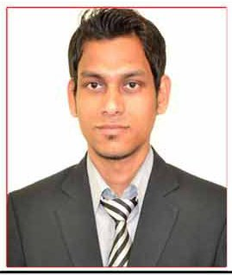


ALOK KUMAR JAISWAL

Email: - alokkumarj544@gmail.com
Address: - AT+PO-Mahagama Dist-Godda, State-Jharkhand.
Mob No: - 08375082423

Career Objective

To contribute towards the growth of the organization as a Marketing person.

Academic Credentials
Course/Degree | Institution &  Board/University | %age of Marks  Obtained | Year of Passing
P.G.D.M | ABS, Noida | ** pursuing ** | 2016
BBA | BITM, Santiniketan (W.B) | 63% | 2014
12th Std (Science) | Aryabhatta Public School,  (CBSE, Board) | 59 % | 2011
10th Std | D.A.V Public School  (CBSE, Board) | 63% | 2009

Work Experience:

Company name: Apex Telecom

Profile: Direct Marketing Executive (DME)

8th March 2014-Till date

Corporate Interface

- Industrial Interference with Parle , ALPS & Yakult

Summer Internship:

- A study on Marketing, Sales And Chargeback Process at Matrix Cellular International Services Ltd.
- Company : Matrix Cellular International Services Ltd
- Period: 4th May to 4th July,2015 (2Months)

Projects:

- A study on Relationship Marketing.
- How corporate relationship is build, keeping in mind the interest of the customers.
- Importance of Relationship marketing in the era of competition.

Achievements :

- Got certified as 1st Runner up by ICICI-Stock mind.
- Got certified as 1st position in Chasse Au Tressor (Treassure Hunt).
- Got certified as 1st position in Confluence.
- Participated in Entrepreneurship E-Week Activity.
- School and college prefect for consecutive years.
- Participated in inter- college competitions.

Technical Skills

- Sound Knowledge of Ms-Word, Ms- Excel, Ms-Power Point.
- Well experienced with use of mailing, internet.

Skill Set:

- Ambitious and hard working.
- Adaptable to change.
- Positive thinking, self-motivated and flexible.
- Optimistic approach to problems.
- Good Communication skills.
- Handle pressure and good team player

Interests

- Playing Cricket, Football.
- Interacting with people.
- Travelling.
- Listening to music.

Personal Profile

Name : Alok Kumar Jaiswal
Father’s Name : Late Madan Jaiswal
D.O.B : 10th Jan 1994
Place of birth : Mahagama (Jharkhand)
Nationality : Indian
Languages Known : English, Hindi, Bengali and French (beginner)

Declaration
I hereby declare that all the information furnished above is true and genuine to the best of my knowledge.

Place:
Date: (Alok Kr. Jaiswal)

