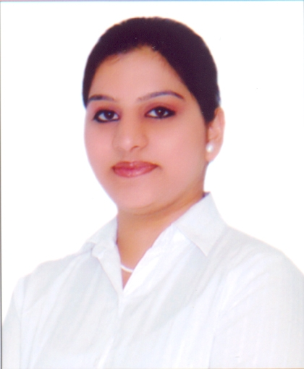

Karuna Sharma Ph: +919999802281 Email1: karuna.sharma150@Gmail.com
Email2: karuna_0301@yahoo.co.in

I am looking forward to be an integral member of a workplace operations team, and can follow
instructions and also have a willingness to learn .
Well presented with exceptional customer service skills, and the ability to provide an effective Front Office and Administrative services. Experienced in working under pressure in a quick paced fast moving environment and able to receive guests on arrival in a friendly, helpful and approachable manner.

AREA OF EXPERience
June’2012 till date working on rolls Randstad India Ltd as Front Office Executive for
Accenture Services Pvt. Ltd (Gurgaon).

KEY RESONSIBILITY
- Handling Front Office and inbound and outbound calls.
- Office Administration works.
- Vendor Management.
- Cafeteria Management.
- Event Management.
- Liaising with internal and external auditors.
- Housekeeping and Pantry Management.
- To prepare reports & MIS(Includes, Travelling Expense, Stationary Expense, Housekeeping & Pantry Maintenance, Office Maintenance, Dispatch, Office Assets, etc.).
- Typing documents and distributing memos.
- Tracking of invoices, Customer relationship management (Handle the quality and complain of the customer).
- Maintaining leaves records.
- Regular supervision on security & housekeeping & conducting various trainings for them.
- Check & reply all e-mails on daily basis, in order to make sure no mail remain non-responded by the end of the business day.
- Planning team day out occasionally.
- Co-ordination with HR Team and IT Team.
- Data entry onto internal systems.

March’2011- June’2012 Worked as CUSTOMER SERVICE AGENT with AIR INDIA SATS.

Responsibilities
- Handling customers enquires and offering assistance to the customers as and when required.
- Exhibiting appropriate communication skills and responding to the customer’s enquiry efficiently and effectively.
- Handling VIP’s, CIP’s, UNM, Physically challenged passenger’s, ministers and celebrities. Following are the duties that includes serving the passengers:
- Issuing boarding pass.
- Providing lounges to the passengers.
- Deplaning and making announcement in the lounge.
- Clearing lounges and escorting the passengers till aircraft.
- Receiving passengers and guiding them at the time of arrival of flight.
- Assisting passengers by clearing security checking and immigration procedure.
- Providing connecting flight information and direction assistance.
- Handling passenger baggage and resolving lost baggage situations.
- Handling unruly, upset and angry passengers.

==================================================================================

February’2010 – March’2011 worked as a Senior Process Associate in Interglobe technologies, Gurgaon.

Responsibilities
- Handling incoming calls and solve passenger’s queries.
- If required, then connects it to the concern department.
- Co-ordination with different departments regarding any queries.
- Planning out the seating chart and organizing the reservations.
- Making reservations as per passenger requirement and also mail their booking details.
- Inform to the passenger if any delay and cancellation in their booking.
- Maintaining a professional appearance at all times.

key skills & COMPETENCIES
- Strong organizational, administrative and analytical skills.
- Ability to multi-task within a demanding and fast paced environment.
- Excellent telephone manner.
- Can offer a warm & friendly greeting to visitor.

PROFESSIONAL SKILLS
MS OFFICE : Word, Excel, and Power Point in 2003 & 2007 version
Internet : good in internet

ACADEMIC CREDENTIALS

- Graduate in Bachelor Degree of Commerce from Delhi University
- 12th passed from C.B.S.E (2006) with aggregate 50% marks.
- 10th passed from C.B.S.E (2004) with aggregate 55% marks.

PROFESSIONAL CREDENTIALS

- Completed 1 year Diploma in AIRLINE AND HOTEL industry from FRANKFINN INSTITUTE OF AIR HOTRESS ACADEMY.
- Completed basic computer course from GATEWAY COMPUTER INSTITUTE, NEW DELHI.

EXTRA CURRICULAR

- Actively participated in dramas and sports competition conducted by our school at REGIONAL LEVEL.

PERSONAL DETAILS

Father and Mother Name | Mr. Brij Mohan Sharma  Mrs. Prem Lata Sharma
Languages Known | English, Hindi, Punjabi
Date of Birth | 03-January-1988
Address for Correspondence | KG-3/165, First Floor, Vikas puri, New Delhi-110018.
Marital Status | Single
Nationality | Indian
Current CTC | Rs. 2,17,080 per annum
Expected CTC | Negotiable
Hobbies | Listening to music, Cooking food, watching cartoon channels, Exploring new things.

I hereby declare that the information given above is true to the best of my knowledge.

Date:
Place:
Karuna Sharma

