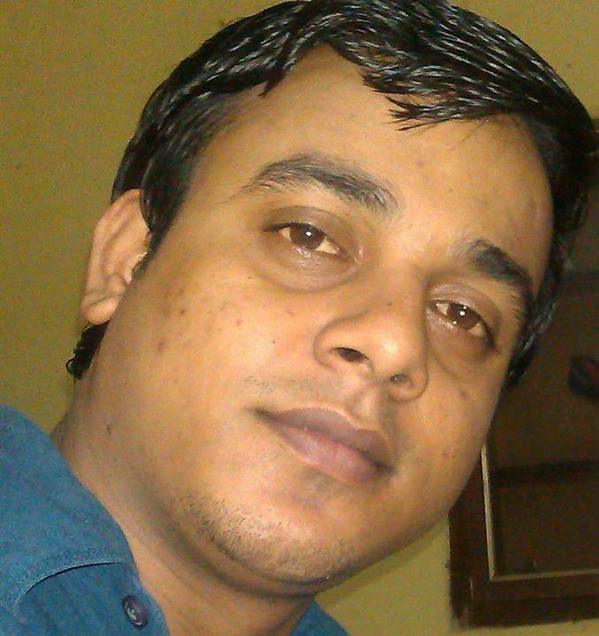
Saurabh Srivastava

H.No 180/1 Miyanwali colony Near Bus stand Gurgaon

Contact No. +918882395252; Email: saurabhsri0@gmail.com

Objective

To be a part of growth-oriented organization wherein I can constantly equip myself with knowledge and skills required to excel in my field, thereby adding value to the organization through continuous learning and innovation.

Synopsis

A result oriented professional with more than 2 years of experience in the areas of Business. Development, Marketing, Sales and Relationship management. Presently working as a Business Associate- Operations with Vertex India Pvt Ltd.

Strategic, self-motivated and creative. Deft in tapping potential accounts analysing their requirements, rendering technical guidance. To the clients and bagging business orders.

Professional Profile/Experience

Total experience more than 20 months in Sales & marketing and Telecom Customer service.
Areas of Expertise

Client Relationship Management:

Ensuring customer satisfaction by achieving delivery & service quality norms.
Maintaining cordial relations with customers to sustain of the profitability of the business. Providing value added customer services by attending customer queries and issues.

Achievements:

Joined Vertex India Pvt Ltd as a Relationship Executive – Operations in Dec 11.
Actively involved in organising post sales training/Client Servicing. Awarded Appreciation Certificate for maintain Best Relationship with Existing Customers
and for Closure value, from Airtel Client.

Training attended:

Training program attended at Vertex for Bharti Airtel Telecom IT Products (ILP, MPLS) From CISCO professionals & Airtel Professionals.

Company
Vertex India Pvt Ltd (Gurgaon)
Role
: Business Associate (Sales Relationship Executive)
Duration
: Dec’11 to till date
Work profile:- Bharti Airtel Networking (For B2B IT Sales)

To ensure the seamless link between top corporate customers of Airtel Telemedia Services. To provide product counselling to achieve maximum output based on client’s current infrastructure. To keep the client updated with the latest product like IPLC, MPLS and to provide them the complete end to end solution.

To visit at customer’s premises along with key account manager, business solution group and product sales specialist team to provide a demo. Certified by Airtel for all data and voice products. Maintain pipeline for leads till its closure. To track leads in ECRM and coordinate with the product team till its implementation.

Able to understand client’s Networking requirement, presentation, networking project
Estimation, Negotiation and proposals & would be responsible for closure also.
Providing data connectivity services like leased line, national long distance (NLD),
Multiple Protocol label switching (MPLS), international protocol label circuit (IPLC), Data Center, Enterprise VPN etc. & voice connectivity like Primary & basic Rate interface (PRI & BRI), audio & video conferencing, DTFS& ITFS, Centrex Solution, routers, hubs, switches etc.

Academic Qualification

Graduate from PurvanchalUniversity Jounpur 2008
Intermediate from UP board sant ravidas nager Bhadohi U P 2005
Matriculation from UP board sants ravidas nager Bhadohi U P 2003

Personal Details

Name : Saurabh Srivastava
Address 180/1 Miyawali colony Near Bus stand Gurgoun
Contact no (+91) 8882395252
Email id saurabhsri0@gmail.com
Date of birth : 20nov87
Gender Male
Marital status Single
Nationality Indian
Languages :English, Hindi
Hobbies Play Cricket .

