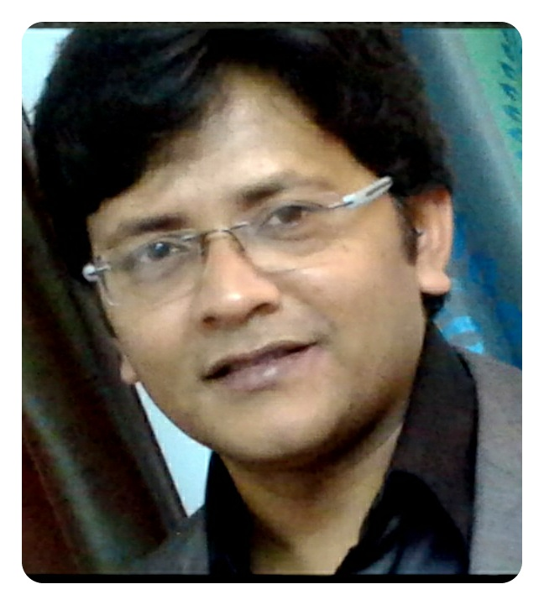SUBHRONIL BHATTACHARYA
CONTACT: +91 9874722946;
ADDRESS: 34/A Huzuri Mull Lane, Kolkata-700014
E MAIL- ID: subhronil_bhattacharya2006@yahoo.co.in

SALES/MARKETING & BUSINESS DEVELOPMENT PROFESSIONAL

Seeking a challenging and rewarding opportunity with an organization of repute which recognizes and utilizes my true potential while nurturing analytical and technical skills

PROFILE

Dynamic and diligent professional with practical exposure in the domain of business development, sales & marketing, Customer Satisfaction & consistently delivering the responsibilities of Revenue Generation, Profitability, Market Share & Customer Satisfaction; determined to carve a niche in field of Marketing and Business Development

- Deft in mapping business dynamics and realigning strategic and operational drivers to combat competitive forces & stay firmly afloat with impeccable track record of delivering superior performances under demanding work environments
- An all rounder intellect blending leadership skills with sound business practices to achieve turn around growth and position organization for long-term profitability; expert in creating sophisticated sales model for consistent business growth
- Self-starter with proven expertise to set up sales operations, establish company brand coupled with excellent track record of driving business operations to profitability in start up, turn around, and high growth situations
- Capable of establishing distribution infrastructure for diverse range of products and developing strong network of channel partners to widen product distribution and deeper market penetration

CORE COMPETENCIES
Relationship Management , Team Management , Key Accounts , Training , Negotiation , Pricing , Business Development , Brand Management , Market Intelligence , Channel Development , Quality Control , Regional Operations

SNAP WORK HISTORY

ABP Pvt. Ltd , Kolkata since Apr 2011

Marketing Executive

- Handling categorywise , Industrial clients which includes TMT bar manufacturers , Genset Manufacturers , Different Pipes , Heavy Engineering equipments .
- Developing new clients from any form of competition which includes news print , radio , digital , hoardings media by keeping regular and vigilant eye on all these media.
- Conceptualizing innovations in Newsprint for clients for better value for money.
- Planning media campaign for some clients at times to help give them maximum OTS ( Opportunity to see ).
- Achievement of 130% of annual target in FY 2012-13.
- Planning and executing special features to meet revenue targets for the month or a quarter.
- Mentoring 2 colleagues , new to this category. Sharing with them the art of planning and projection for a month and what special efforts need to be taken when in crisis.

SPACE AND PEOPLE INDIA PVT LTD, MUMBAI Feb 2010 – Mar2011
Executive - Media Sales

- Deftly exploring and exploiting fresh business opportunities; developing a competitive business development strategy and identifying dynamic & flexible solutions with strict adherence to highest levels of customer service
- Formulate innovative sales and marketing strategies to generate favorable disposition in customers’ minds. Analyzed market intelligence to align business strategy accordingly
- Develop new profitable business partners from main competition vendors analyzing latest marketing trends and tracking competitor’s activities and providing valuable inputs for fine tuning sales & marketing strategies
- Establish healthy business relations with clients & external associates for securing repeat business & long term loyalty and work towards solving their queries and complaints efficiently
- Planning and organizing various promotional campaigns to enhance the brand awareness and market penetration
- Preparing strong and reliable MIS reports for facilitating the decision making process and liaison with Management for extensive market penetration
- Managing customer centric operations & ensuring customer satisfaction by providing quality services
- Handling all corporate clients in Kolkata and suburbs.

THE INCODA, KOLKATA Apr 2009 - Jan 2010
Marketing Executive

- Responsible for overall sales and marketing operations which includes identifying potential customers, market penetration, documentation formalities and competitors moves analysis
- Maintained timely MIS & database reflecting the trends & developments of business for budgetary & strategic review to enhance revenues
- Deftly handled and interacted with various customer base to generate repeat and referral business and deftly managed business development activities
- Effective relationship management through satisfactory customer service & timely resolution of customer queries/ issues. Ensuring that no critical request is to be received from the customer

Summer Internship

STANDARD CHARTERED, STCI CAPITAL MARKETS LTD Feb 2008 - May 2008

PROJECTS UNDERTAKEN
- Projects done on VB.net &ASP.net
- Summer Project done on J2ME at Ardent Collaborations, Salt Lake
- Currently pursuing BI & BA course from Orangetree Global.

EDUCATIONAL CREDENTIALS

MASTER OF BUSINESS ADMINISTRATION IN MARKETING, 2009
ICFAI Business School, ICFAI University

BACHELOR OF TECHNOLOGY, 2006
Institute of Technology and Marine Engg, WBUT

HIGHER SECONDARY CERTIFICATION, 2000
Scottish Church Collegiate School, WBCHSE

SENIOR SECONDARY CERTIFICATION, 1998
Elias Meyer Free School & Talmud Torah, Delhi Board

Computer Skills: Windows, Java, C, SQL, MS Office & Internet Applications

Language Known: English, Hindi & Bengali
Date of Birth: 5th November 1981

