CURRICULUM VITAE_______________

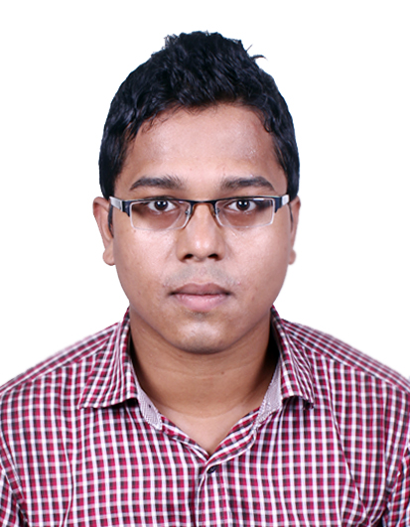
TARIQUE AHMAD

CARRER OBJECTIVE

A challenging & promising career in Sales & Marketing.

WORK EXPERIENCES

Duration: 3 years (from 1st Sep’10 till date)

Sales & Marketing Executive

Selvel Advertising Private Limited
10/1B, Diamond Harbour Road,
Kolkata-700027
India.

Currently posted at Kolkata Head Office as a Sales & Marketing Executive.

CTC: Rs.2,50,000/- P.A.

RESPONSIBILITIES

- Sales, Marketing & Outdoor functions including Project Management.
- Create new business as well as maintaining good relations with the ongoing & old clients.
- Increase volume of business by keeping warm relation with direct clients & big advertisement agencies.
- Maintain liaison & good relations with various Government & Private Landlord authorities to maintain the existing Outdoor Advertising Media on their land as well as putting up new High profile outdoor media like Backlit Hoardings, Unipoles, Tri-Ads, Neon & LED etc.

ACCOMPLISHMENT

Launch & long-term campaign in whole South Bengal & Kolkata.

- Vodafone 3G, Aircel 3G & IDEA 3G (Ongoing campaign)
- Manyavar garments
- Allahabad Bank
- Titan Industries
- Prime Gold Cement & TMT Bar
- Cadbury Oreo biscuit
- M.P.Jewellers
- LG 3D television
- MAKERS (Raymond’s), Pantaloons, Blackberry garments
- Franklin Templeton Investments
- Mahindra Finance
- Camarena, Nikon, Sony, Canon cameras
- Reliance Footprint
- ITC Vivel soap & fairness cream
- Konark Cement
- Tata Safari STORME
- Samsung REX mobile
- NSHM Academy’s [Biggest outdoor campaign ever in whole South Bengal, Midnapur & Kharagpur, Bihar & Jharkhand. (Ongoing campaign)]
- Kisna Diamond Jewellery
- Sprite, Thumbs Up & Limca
- Apollo Gleneagles Hospital
- Axis Bank
- BigBazar
- Local clients like Bengal College of Engineering & Technology, Imperial Solar Solutions, Peerless Hotel (Durgapur), Jewellery Garden, City Gym
- Siddha, Educomp, Medica Superspeciality campaign at Kolkata.

SKILLS

- Ability to work independently, as a leader and as an integral part of a team.
- Committed to deadlines and quality.
- Good written and oral communication skills.
- Ambitious and Hardworking.
- Skilled in English, Bengali and Hindi.
- Understanding the expectations of authority towards me.
- Perform according to the expectations of the authority.
- Increase the quality of my performance.
- Assist other employees as a team man.
- Lead the team.
- I expect satisfaction from both the authority and from the consumer.

SCHOLASTIC RECORD

Year- 2010
Bachelor of Commerce (Pass) 3rd Year,
Vivekananda College, Thakurpukur
University of Calcutta, India

Year- 2009
Bachelor of Commerce (Honors) 2nd Year,
Vivekananda College, Thakurpukur
University of Calcutta, India

Year- 2008
Bachelor of Commerce (Honors) 1st Year,
Vivekananda College, Thakurpukur
University of Calcutta, India

Year- 2007
Higher Secondary (HS)
Behala High School
Board: W.B.C.H.S.E

Year- 2005
Madhyamik
Behala High School
Board: W.B.B.S.E

COMPUTER OPERATION SKILLS

- Software : Microsoft Office.
- Operating systems : Windows 95,98,2000, XP.
- Operation mediums : Microsoft Word, MS Power Point, MS Excel.
- Application : Internet access, browsing and so on.

PERSONAL INFORMATION

Full name : Tarique Ahmad
Nationality : Indian
Present Address : P-505, Parui Paka Road, Behala, Kolkata-700061, India
Permanent Address : 65A, Bonomali Ghoshal Lane, Behala, Kolkata-700034, India
Telephone number : +919775824458, +919831438087 (Res)
Email : tarique1989nov@gmail.com, tariqueahmad.selvelone@gmail.com
Date of birth : 27th November 1989
Marital Status : Unmarried
Passport No. : K7384274, Expiry on: 5th February 2023

The information provided above is true and I will be responsible for any indiscrepancy.
----------------------------------------
TARIQUE AHMAD

