CURRICULUM VITAE
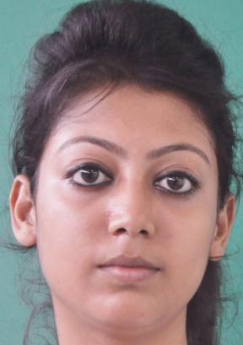

Anuradha Chakraborty,
MASTERS (Mass Communication)

Personal Details:
Date of Birth : 8th September 1989

Contact Details:
Mobile No : +91 9903358720
Email ID : anuradha.chakraborty007@gmail.com

Residence Address:
7A Subhash Pally, Kolkata- 700092

Objective-
Client Servicing position that utilizes my Inter-personal & Negotiation skills and enables me to make a positive contribution to the organization.

Academics:
Degree | University/Board | Class/ Grade
MASTERS(PR & ADVERTISING) | International School of Business & Media Kolkata | Result Awaiting
Communicative English (Major) | Shri Shikshayatan College (CU) | 61.87%
I.S.C | Mahadevi Birla Shishu Vihar | 78.25%
I.C.SE | Holy Home | 66%

Work Experience 6 months

THE PARK HOTELS
Profile: PR Associate

Roles & Responsibilities:
- Organising events at the night clubs and restaurants.
- Coordinating with the team mates.
- Fixing up band performances at Someplace Else, getting big international DJ’s for Tantra and Roxy.
- Creating pre-event buzz, promotion, facebook promotion, print media promotion.
- Vendor management.
- Handling media-net.
- Calling press for the events.
- Sending press releases and pictures to the press.
- Post event follow-ups with the press.
- Newspaper tracking, making Media savings, dossiers

MAHUAA MEDIA PVT LTD. Augest 2013 to March 2014

Profile Client Relations and Ad Sales

Roles and Responsibilities 1.Market coverage and expansion for the entire eastern region

2. Doing Business Development and building perception for the organisation.

3.Finding new prospective clients, giving them brand solutions and pitching
them with different properties according to their brand-fit which aid
them build more awareness and mileage to their brand, hence giving
brands solutions and making revenue for the organisation at the
Same time.

Languages Known

Languages | Write | Read | Speak
English | Yes | Yes | Yes
Hindi | No | Yes | Yes
Bengali | Yes | Yes | Yes

Projects & Live Assignments

- Worked in NSS for 3years.
- Worked with an NGO called Cini Asha in a project called “Each One Teach One.” In this project I had to go to the slum areas and teach the under privileged children.
- Made a TV Commercial on “anti smoking.”
- Did a Documentary Film on “Chandan Nagar, the French Colony in Bengal.”

Awards & Achievements

- Won prizes in Dance Shows.
- Won prizes in Fashion Shows.

EXTRA CURRICULAR ACTIVITIES

- Learned Bhratnatyam for 2 years.
- Member of Corporate Relation Cell, International School Business & Media. (Calling the Corporate from the Industry for Guest Lecture to our Campus and maintaining good relationship with them.)

SKILL:-
- Client relationship building
- Competent in collecting market information to fine tune marketing strategies.
- Excellent communication, interpersonal, and problem solving skills with the ability to work in multi-cultural environments.
- Very enthusiastic and aggressive.
- Team player

ADDITIONAL INFORMATION

Operating Systems: MS Windows XP/Vista/7
Applications: MS Office 2003, MS Office 2007, MS Office 2010

MOTTO IN LIFE

“To be a part of a reputed organization and to deliver the best of my efforts with sincerity and compassion.”

Anuradha Chakraborty.

