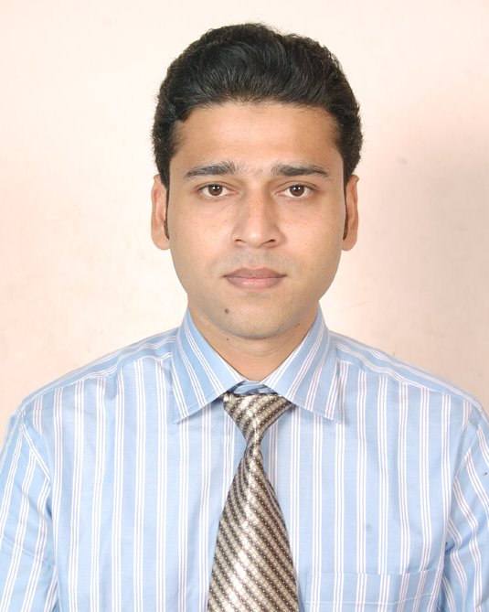
Sabahat Sarwat
Systems Administrator Certification id: 618RG1003005
To work in a dynamic and challenging environment where there is an opportunity of self-improvement in technical, individual and group based work that will ultimately lead to the further development of my career and of the organization.
- Highly motivated systems administrator offering over 6 + Years’ experience in a Windows Administration, IT Procurement, IT Support, and Helpdesk/Desktop & Network support and extensive experience in installations, configurations and troubleshooting of servers 2003, 2008 and OS Win XP, 7
- Experience configuring, monitoring, upgrading and maintaining systems hardware, software and related infrastructure.
- Strong analytical skills; able to work with technicians from various engineering disciplines to troubleshoot complex system-level issues.
- Strong Experience in managing IT infrastructure & Procurement from starting phase needs of organization.
- Strong Presenting Skills to provide & Organizing IT trainings, Presentations & IT workshops program.
- Experience set up IT infrastructure for call center, Hospitals/Healthcare, NGO’s, Education, and IT/ITES.

Education
First Class Executive MBA Information Technology, 2013 from Shridhar University, Pilani, Rajasthan, India.
First Class B.Tech in Computer Science & Engineering, 2007 from Uttar Pradesh Technical University, Lucknow, India.
First Class Diploma in Engineering, 2004 from Aligarh Muslim University, Aligarh, India

Certification: MCSE, CCNA & RHCE

IT Experience
Assistant Manager- IT & Procurement, Nov 2011 to Present
MS International, New Delhi, India
Team Size - 3

To assist in the managing and supporting of the IT infrastructure & IT procurement of the Foundation, including hardware, software, desktop and shared infrastructure, voice and data networks, servers, mobile and fixed telephony.
To ensure all components are maintained and work reliably to meet the Foundation’s needs. To promote the effective use of new and existing technology.

- IT Support (Desktop, Network & Servers).
- Manages activities in the information technology procurement function. Ensures products and services are purchased in the most cost- and time-efficient manner. Evaluates contracts and vendors; makes final decisions regarding suppliers. May serve as a mediator during disputes between vendors and IT staff.
- To support and monitor existing infrastructure, perform preventative maintenance work, backup and perform other regular support activities to ensure effectiveness and to provide cover on such tasks when required.
- To support and monitor the Foundation’s internal networks and links to regional offices, other sites or the Internet, and to ensure they are configured and working correctly.
- To plan, manage and implement infrastructure projects and upgrades to meet Foundation goals.
- To liaise with external suppliers and support agencies for the ongoing support and maintenance of relevant hardware and software.
- To ensure that all work and changes are performed in such a way as to minimize all disruption to existing business use.
- To ensure that technology is used, managed and supported in accordance with Foundation standards, policies and procedures.
- Systems administration, including analyzing, designing, installing, maintaining, repairing hardware, software, peripherals & networks
- Setup call center Infrastructure for MSI, India.
- Create/delete user account in Active Directory.
- IT Helpdesk ticketing System.
- Actively monitoring of network and performing technical troubleshooting which involves checking the link status, routers & switches with Network security Cyberoam.
- Installations and Updating of Antivirus Client-Server.
- Installation and configuration of FTP server and client installation and configuration.
- Provide Technical support on Software’s (MIS, JSMHRIS, Financial Software’s, SUN 5.4, Inflow, and IBM-SPSS.
- Record and maintain hardware and software inventories, licensing/Paper licenses of Software’s.
- Ensure at least 99% uptime of internet, email and other related IT services.

Sr.Technical Support Engineer, Sep 2010 to Nov 2011
IDS InfoTech Limited, Noida, India.
Team Size- 2
- IT Support (Desktop, Network & Servers).
- Installing and configuring new hardware and software.
- IT Ticketing System.
- Daily Reporting.
- Creating & managing users profile (Active Directory).
- Configuring and scheduling Backups for Servers and management. Configuring backup sets, backup scripts using software retrospect.
- Create, modify and repair desktop-to-server connections: physical LAN/WAN. Connections, adding to domain, mail setup, internet access and printer access.
- Handling Antivirus server and clients. Scheduling updating new virus definition from server. Trend Micro.
- Managing the Files Transfer between one locations to another through FileZilla (Server-Client).
- Trouble shooting on hardware failure of Desktops, bringing them up.
- Responsible for IT documentation.
- Maintaining Windows Server 2003 and Windows Server 2008.
- Configuration of Microsoft outlook.
- IT Procurement.
- Coordinate and clear the deals with the external vendors.

IT Manager, Oct 2008 to Sep 2010
ACEM Group, India.
Team Size - 4

- Managed All IT infra of ACEM/ACE.
- IT Support (Desktops, Servers & Network) for more than 900 users.
- Installation and Configuration Desktop.
- Setup of hardware, software and access to network resources.
- Create, modify and repair desktop-to-server connections: physical LAN/CAN. Connections, adding to domain, mail setup, internet
access and printer access.
- Performing backups.(FB Backup)
- Maintaining Windows Server 2003.
- Responsible for IT documentation.
- Design, Installation & Configuration of R&D Labs.
- Antivirus installation & updating.(Kaspersky, Bit defender)
- Creating & managing users/Student profile (Active Directory).
- IT Procurement & Assets Management
- Coordinate and clear the deals with the external vendors.

Project Coordinator, Jun 2007 to Sep 2008
Zapak Digital Entertainment Limited, New Delhi, India

- IT & Desktop Support. (Windows)
- Responsible for IT Procurement & documentation.
- Creating & managing users profile (Active Directory) Supported 525 total users in 5 locations nationwide, as well as corporate office users.
- System & Antivirus Updates.
- Helping users to back up their data.
- Verify and Downloading Steam in New PCs.
- Maintaining Windows Server 2003.
- Maintaining DNS and DHCP servers
- Coordinate and clear the deals with the external vendors.
- Responsible for IT Asset documentation.
- Installed CMS in PCs.
- Antivirus management: Export daily report and get all the affected systems (Symantec server)
- Connected gamers to one location to another.

Systems Admin Skills
Windows Administration, IT Support, Helpdesk/Desktop & Network support, VMware,Citrix,Linux, SW, HW-NW Troubleshooting, Servers Administration, Backup, Antivirus Management, MySQL & IT Asset Management.

Achievements & Trainings
- MSI Provided 2 weeks training on Sun System 5.4.
- Organized Global IT & Finance workshop in The Lalit New Delhi.
- Established server room at MSI, India.
- IT Ticketing System at MSI, India.
- Participated and Presented on IT innovations workshops and presentations.
- Coordinated, established the Computer Labs, R&D Labs and college campus.
- Coordinated, established & presented a demo network in Franchisee Expo2007-08 and Zapak got best franchisee demo award.
- Installed steam, downloading more than 60 games and Test all games in more than 100 PCs in a very short duration.

EF1, Sir Syed ApartmentsSector 110Noida 201301, India 9717688500sabahat.sarwat@gmail.com

