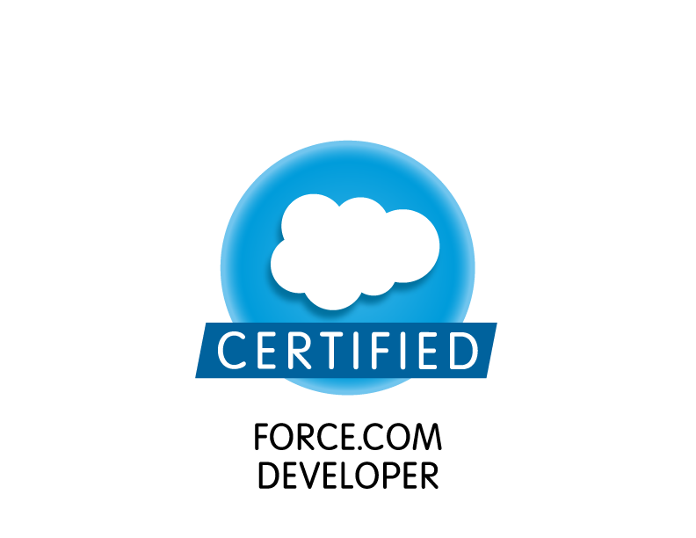

DEVIKA UDUPA K
Contact no: +91 9480764418

Email: udupa.devika@gmail.com
OBJECTIVE: “Looking for a position that will build on my skills and provide me with ample scope for growth and contribution to the organizational goals by effectively using the conceptual skills and knowledge.”

ACADEMIC CREDENTIALS:

SL.NO | DEGREE/  EXAM | PERIOD |  |  | INSTITUTION | MARKS OBTAINED
SL.NO | DEGREE/  EXAM | From |  | To | INSTITUTION | MARKS OBTAINED
1 | 10th std (KSSEB) | 2004 | 2005 |  | PPC Admar  Udupi District | 91.36%  (571/625)
2 | 12th std (Dept. of  PU education) | 2006 | 2007 |  | PPC Admar  Udupi District | 84.83%  (509/600)
3 | B.E. | 2007 | 2011 |  | NMAMIT, nitte | 9.54 (CGPA)

TECHNICAL SKILLS:
- Technology: Salesforce.com(SFDC) certified Developer(DEV401),Salesforce.com certified Administrator (ADM201), Java programming(jsp,servlets,jdbc),Apttus Quote to Cash Certified.
- Database: SQL, SOQL
- Tools: BMC Remedy Ticket Management Tool, Adobe Remedy Lite, Code Collaborator,

Perforce, Business Intelligence Tools (Informatica, Business Objects)

EXPERIENCE: Total IT experience -2 years 10 months and 2 years experience as Salesforce.com Application Developer/Support Analyst in TCS,Bangalore.

KEY SKILLS:
- Loyal and like to work in challenging and creative environment.
- Good skills in developing apex classes, Triggers, Visualforce pages etc.
- Committed, dedicated towards the given task.
- High flexibility to remain agile in a fast changing business and organizational
environment.
- Analyzing work load, determining best practices and implementing changes to improve
productivity.
- Strong team player in leveraging each other’s strengths.
- Good understanding in Incident, change and problem management.
- Strong problem solving skills to quickly narrow down to the root cause of the issue
reported.
- Proactively contributing to improve the team efficiency by sharing knowledge, providing
feedback about best practices, designing tools / utilities etc.
- Formal mentoring for promoting the technical and professional development of others.

PERSONAL ATTRIBUTES:
- Highly motivated and self-driven
- Strong problem solving/analytical/debugging skills
- Strong customer support and relation skills
- Have good experience in communicating to client, Business directly via
emails, Conference calls.
- Have great communication skills especially when working in a remote environment.

About Current Project
I have been working as Application Developer/Support Analyst for Salesforce Sales Application of our U.S Based client who is leading the market in multimedia and creativity software products. We support business users around the global for Sales Application. Hence I have good experience in communicating to client/customer/Business Users/BPMs etc.
My responsibilities are as below.
- Developing apex code to meet enhancement requests coming from Business.
- Understanding/Analyzing the production issues received by Business users.
- Bug fix/minor enhancement requests- this includes configurational/code changes.
- Following the highly structured change management process to deploy code to production via various sandboxes.
- Timely identification of issues in the system & maintain the health of the System
- This also includes creating test cases , preparing IQA-Sheet, capturing the results etc.
- Solving the cases within SLA to prevent breaching, Ageing Calls.
- Handling the ticket management tool- BMC Remedy
- Creating the changelist for deployment in Peforce & Creating the request in Code collaborator to review of code.
- Streamline the process by communicating to customers & setting the right expectations for customers
- Driving the Weekly meeting with Customers to provide update for status of the Cases.
- Mentoring new joiners in the team & taking training for them.
- Handling the System outages & informing the stakeholders accordingly.
- Also playing virtual technical Lead role for SFDC & one more application.

HOBBIES:

Craft working, Sewing, Cycling, Philately and Numismatics.

ACHIEVEMENTS:
- Won “best out going student award” in 10thStd.
- Leader of Udupi taluk “Bharath Seva Dal rally” in 2001.

EXTRA-CURRICULAR ACTIVITIES:
- Won 1st place in interschool high jump and long jump events.
- Actively participated in intra and inter school sports/games meet.
- Played active role in organizing various cultural and technical events at school and college.

ACADEMIC PROJECT WORK:

Mini project on Cell phone detector circuit:

Cell phone detector circuit detects the presence of active cell phones. The circuit can detect both the incoming and outgoing calls, SMS even if the mobile phone is kept in the silent mode. The moment the circuit detects RF transmission signal from an activated mobile phone, we can hear sound in headphones, this continues until the signal transmission ceases.

Final year project on auxiliary switch ZVS PWM DC DC Converter:

A novel auxiliary switch dc–dc converter with coupled inductor circuit achieves loss-less switching for both the main and auxiliary switches without increasing the main device current/voltage rating. A tapping in the pole inductor is added for the purpose of commutation. The circuit is capable of operation at elevated switching frequencies of several hundreds of kHz, in a range of line and load variations. The circuit is applicable to all isolated and non-isolated dc–dc converters. The performance and the design equations of the ZVS are identical for all types of dc–dc converters when the throw voltage and the pole current are properly defined.

INDUSTRIAL TRAINING:
- 2 weeks of in plant training at Mangalore Refinery and Petrochemicals Limited, Mangalore in July 2010.
- 1 week of training at Power mate electronic systems and services, Mangalore in June 2010.
- 3 days of “feel employable” learning and development program in October 2010.

LANGUAGES KNOWN:
- English, Hindi, Kannada, Tulu

PERSONAL DETAILS
NAME : DEVIKA UDUPA K
GENDER : FEMALE
NATIONALITY : INDIAN
FATHER’S NAME : SRIPATHI UDUPA K
DATE OF BIRTH : 10TH AUGUST 1989
ADDRESS : D/O SRIPATHI UDUPA K
LAXMISHA NILAYA, KUNJOOR
TEMPLE ROAD, POST PANIYOOR
YELLUR VILLAGE
UDUPI DISTRICT-574140
KARNATAKA

My assurance,
Sincerity and Diligence

