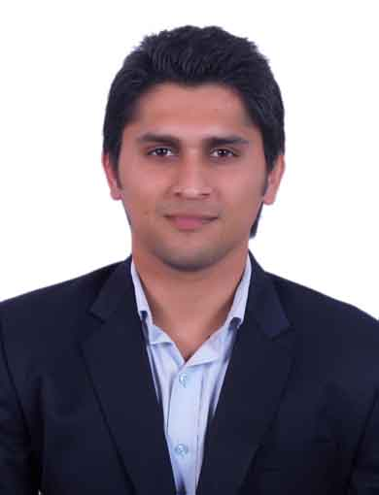

Hatinder Udar

Mob. No. : +91-9971071078
Email ID : hatinderudar@gmail.com Delhi

Skills

- Excellent presentation skills.
- Pleasing and patient personality.
- Aiming efficiency & effectiveness at work.
- Good listener and speaker.

Career Objective

To obtain a position in a reputable organization in the field of sales & marketing that enables me to apply my interpersonal, marketing and analytical skills while enhancing my corporate experience. A middle level managerial position 4 years from now.

Professional Experience & Knowledge Summary

- 1 year + experience in Sales and Marketing/Business Development
- Excellent presentation skills
- Have retained many clients over a year period
- Demonstrated track record of sales success and meeting monthly sales quotas.
- Excellent communication and negotiation skills
- Proven aggressive selling skills, lasting interpersonal relations, strongly analytical & lead by example
- A quick learner and have assertive attitude.
- Generation of Leads through Marketing Activities.
- Recognized as an amiable and effective employee by the entire cross section of the organisation.

Organizational Experience Summary

Current Organization : Vipul Limited

Period : August 2014 to present

Area of Work : Sales and Marketing

Previous Organisation : Raheja Developers Limited

Period : July 2013 to August 2014

Area of Work : Sales and Marketing

Professional Qualification (s) / Certification (S)

MBA (2011 - 13) JIMS – Kalkaji, Delhi
Master of Business Administration
(Marketing)

BSc. (2006 -10) Sri Aurobindo College, Delhi University
B.Com Programme

Major Projects

Project: - Demand for certified emission reduction (CER’s)
Company: - EcoEmission Exchange Pvt Ltd
Duration: - May 2012 – July 2012
Objective:-
To generate data of the buyers and sellers of CER’s in both the developed & developing countries and analyze the demand and supply.

Key Responsibility Areas

Sales and Marketing
- Implementing new sales strategy; handling team of Channel Partners.
- Managing a wide gamut of operations involving prospecting, designing mailers, customer relationship management, building database.
- Holds credit of participating and organizing various National and International property shows/exhibitions, etc.
- Handling new business queries sourced from company website, digital campaigns and International expo.
- Corporate presentation on regular basis for sales closure and branding purpose.
- Corporate tie ups for B2C Sales-Multi National Companies and Public Limited Companies
- Successful in dealing with NRI clients, coordinating with them all the pre and post sales related activities and formalities.
- Regular competitive analysis by visiting competitors and understanding there pre-sales and post-sales strategies.
- Research for new product launch(Pricing, specifications, branding, offers and other practices)
- Event organizing and represent company.
- Assisting clients with property sales and development.
- Analyzing market trends to determine competitive market prices.

Extra Curricular Activities

- Organized various marketing events like Brand war and Ad-film contest

- Won 1st prize in intra-college men’s badminton tournament

- Won 1st prize in intra-Zonal volleyball tournament

- Won 2nd prize in inter-college cricket cup and 1st prize in intra-college cricket tournament

Personnel Vitae

Father’s Name : Ramesh Udar
Date of Birth : 19th June 1989
Marital Status : Single
Languages Known : English, Hindi

References

I can provide references if required.

I hereby declare that the above-furnished details are true with proven records.

Signature

Date: ___/___/2014

