Gobind Singh Bakshi
Email: gobindbakshi89@gmail.com
Mobile No: +91‐7838508499

Seeking assignment in IT consulting domain with a reputed organization involving exposure to diverse technologies and client interactionThe challenges in Business Analysis / Reviewing Requirements / Quality Assurance fields that the organization provides would enable me in imparting value added services to the organization by performing my role to the best of my abilities and sincerity.

Professional Synopsis

- Approx. 4 years of experience as a Business Analyst in IT Services for Retail, Insurance & Shipping Domain, Risk Management.
- Recognized proficiency in IT Governance, Project Management, Rapid Impact Assessment, Requirement Analysis, Designing Technical Solution, Agile Implementation, ITIL v3 Framework and Implementing High/Low level Process Design.
- Experience in Oracle Retail QA, SIM, Returns Management, ORPOS, Mobile POS, CO and BO.
- Proven ability to contribute towards improvement in operations, business growth and profit through achievements in cost reductions and productivity improvement
- Strong Customer Interfacing Experience
- Strong analytical, communication and presentation skills
- Diligent Worker, self-Starter and Consistent Performer, and "can do" approach towards work.
- Product Demonstrations
- Tasks effort Estimation.
- Good exposure to Onsite - Offshore model.
- Finalize requirements in FRS (Functional Requirement Specifications), writing the near-final version with detailed descriptions
- Strong foundation in the area of RETAIL Technologies and a keen learner who tries to handle all the situations with relative ease.
- Hands on experience in various POS payment terminals, Till Reconciliation, etc.
- Model data to create reporting for business process management.
- Create use cases and test cases for business and technical requirements
- Understand customer reported issues and provide timely resolution
- Experience in various types of Testing (Functional / Regression / Integration / Negative / Performance Testing- load testing / Compatibility / UI / configuration). Status reporting, client interfacing skills.

Technical Skills

- Methodologies: ITIL v3 (3 Years of experience in ITIL v3 Implementation Projects), Agile,
Scrum, JIRA, SDLC, Identify Current Business Process and Capabilities.
- IT Tools: HP Quality Centre, MS Visio, MS Project, MS Office(Word,Excel,Macros) HP Caliber
- Database: SQL 2000, MS Access, Microsoft SQL

Experience Summary

- January’2011 to Till Date with Infogain India Pvt. Ltd. Noida,

Name of Client | Limited Brands International 
Name of Project | Victoria Secrets and | Bath and Body Works |Pink
Brief about Project | Limited Brands Inc. (formerly known as Limited Brands Inc and The Limited Inc.) is an American fashion retailer based in Columbus, Ohio; its flagship brands are Victoria's Secret and Bath & Body Works. L Brands posted $10.5 Billion in revenue in 2013, and was listed as #258 in the 2013 Fortune 500 list of top companies. Currently, LBI uses oracle POS 13 version which is being deployed and customized by Infogain team. It’s been more than 5 years of customer satisfaction achieved by Infogain.(since 2010). Some Of the recent enhancements with Oracle point of sales include :  - Swipes stake functionality  - Customer Capture (CCES)  - Email Hygiene  - Multiple discount eligibility  - Coupon discount  - Sales Transaction House Account
Duration of Involvement | July-2014- Till date
Tasks / Role Performed | - Understanding business requirements of the customers and translating them to  Flow Chart and specific software requirements.  - Analyzing Current Business Operations and IT Implementations for the Customer.  - Preparing Functional Enhancement Specification Document.  - Identify complex fuzzy problems, break it down in smaller parts and implement creative, data-driven solutions.  - Handling client calls individually with Stake Holders, Business, and Revenue teams.  - Process Consulting & Streamlining Project Delivery Operations.  - Specs writing, Scoping and Writing Functional / Business Requirements  - Writing Business Requirement Specification Document [BRS], System Requirement Specification Document [SRS] and Screen Mock Ups  - Providing Business Analysis support to the US team by helping them in researching production issues raised by the Client.  - Provide Support for the Development team by helping them in raising issues and concerns regarding the Product Development with the Client.  - Perform system testing, regression testing and exploratory testing.  - Execute the test cases, log and verify the test cases

Name of Client | FedEx 
Name of Project | Future Point of Sale (FPOSR-7)/Ship Site Manager(SSM)/ Web-Fedex.com
Brief about Project | FedEx Express, formerly Federal Express, is a cargo airline based in Memphis, Tennessee, United States. It is the world's largest airline in terms of freight tons flown and the world's fourth largest in terms of fleet size. It is a subsidiary of FedEx Corporation, delivering packages and freight to more than 375 destinations in nearly every country each day. FedEx Express is the world's largest express transportation company. With the aim to redesign and reinvent exiting POS for FedEx, FPOS R is a new effort being made in this direction. This includes migration of all the existing features along with additional enhancements at feature level, for the better customer experience more reliable product from both FedEx as well as customer’s end.
Duration of Involvement | December-2013- July2014
Tasks / Role Performed | - Requirement gathering, business analysis and functional testing of UID Software System  - Hosting/Participation in all fortnightly / monthly project meetings and project review meetings  - Understanding business requirements of the customers and translating them to  Flow Chart and specific software requirements.  - Analyzing Current Business Operations and IT Implementations for the Customer.  - Handling client calls individually with Stake Holders, Business, and Revenue teams.  - Assessing Customer’s IT solutions with Industry Standards and Market Requirements  - Designing Business Requirements in collaboration with the Business users.  - Process Consulting & Streamlining Project Delivery Operations.  - Mentoring the Development and Test Teams on the Product and Project Requirements.  - Specs writing, Scoping and Writing Functional / Business Requirements  - Writing Business Requirement Specification Document [BRS], System Requirement Specification Document [SRS] and Screen Mock Ups  - Preparing mockups, wire frames and navigation flows.  - Providing Business Analysis support to the US team by helping them in researching production issues raised by the Client.  - Preparing mockups, wire frames and navigation flows.  - Provide Support for the Development team by helping them in raising issues and concerns regarding the Product Development with the Client.

Name of Client | FedEx 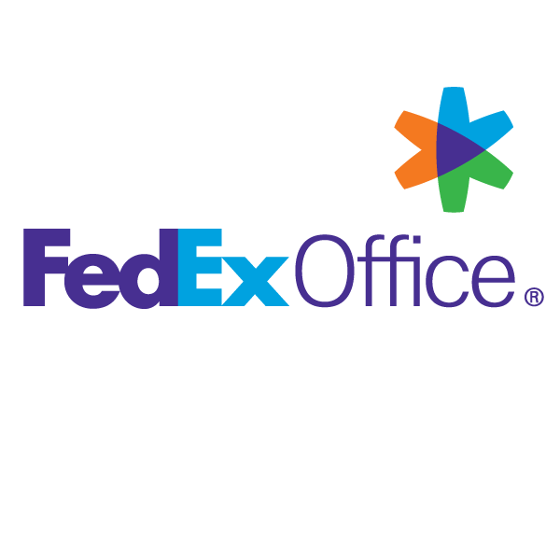
Name of Project | FedEx Retail Alliance –OfficeMax, FedEx Smart Post(FXSP) WOSV
Brief about Project | The goal of this project is to move all relevant FedEx® Ship Site functionality into the FPOS Reinvention platform while minimizing the impact to OfficeMax, improve on cost savings and internal efficiencies. With the objectives in place, Clerk Part 1 is being designed by leveraging the existing SSM experience and bringing in new enhancements.
Duration of Involvement | January 2012-November 2013
Tasks / Role Performed | - Client meetings and feedback sessions to understand and document client requirements, business needs and project objectives.  - Used to create documents related to project process improvement & cost benefit analysis.  - Interaction with various Operations Stakeholder to capture their requirement in the form of Demand Stories  - Decompose the Demand Story into CE Stories in order to make it more understandable for Platform Architects and Designers  - Regular Engagement with various Platform Directors, Architects and Designers for the feasibility study of Demand Stories.  - Preparation of month wise work package for the delivery of solution  - Used to prepare the Transformation Roadmap for each Demand Stories.  - Used to prepare Tool Assessment Report in order to map the requirements of the customer to the capabilities of the tool.  - Preparation of Gap Analysis & Benefit Analysis Report.  - Writing Business Requirement Specification Document [BRS], System Requirement Specification Document [SRS] and Screen Mock Ups  - Prepare Approach and Functional Specification Document  - Testing Of User Interface, client and server end to end validations  - Writing Test Scenarios and Test Cases  - Performing Sanity testing, Running test cases, Build Verification test.  - Understand new Business Requirements of the Client and work on “Product Change Requests” and do Impact Analysis.

Name of Client | Mitchell(Auto Physical Damage/Salvage) 
Name of Project | Claim Solutions Operation And Maintenance (CSOM)
Brief about Project | This project was developed on ASP, VB.Net and C#.Net, and PL-SQL and SQL Server 2005 for maintaining database. This project is for Mitchell, USA, for the insurance sector, in which the customer applies for the claim for damage happened to vehicle. Our Project team provides 24 * 5 maintenance and Support to the application on Production and perform the task to resolves the issue occur on live application and also perform the enhancements and changes to be made in application according to client requirements
Duration of Involvement | January 2011-December 2011
Tasks / Role Performed | - Active involvement in overall project execution & implementation  - Frequent meetings & regular discussion with various partners/vendors involved in the project to meet business requirements, deadlines and client demand.  - Interaction with various Stakeholders involved at client site to pick up and understand Issue Statement (Requirements)  - Used to conduct Brainstorming sessions with Stakeholders to decompose Demand Story into Multiple Customer Experience (CE) stories  - Business analysis, project assessment and feasibility determination for the new Change Orders.  - Involved in coding, testing and bug fixing of the product.  - Involved in Smoke testing of servers.  - Performing the different testing scenarios (Manual Testing) on different applications accordingly and providing the help to development team in creating the defect free application, before delivering it to client, by executing all the possible test cases.  - Defined and introduced the project, team members' roles, and key deliverables. Mapped out timelines, milestones, communication processes, question and answer session.  - To prepare various use cases using MS Visio & explain requirements to CFT (Cross Functional Team) required for CA (Continuous Analysis) phase.  - Used to attend all review meetings at client site on regular basis & expedite concern areas to various cross functional teams.

Education

• B.Tech (CSE): Punjab Technical University in year 2011 with 69% of aggregate
• 12th: Sacred heart Senior Secondary Convent School, Ludhiana (Punjab) in year 2007 with 68% marks.
• 10th: Sacred heart Senior Secondary Convent School, Ludhiana (Punjab) in year 2005 with 82% marks.

Achievements

- Received “Special Recognition Award” for FedEx Client during Client Visit in Town Hall meetings
- Received “Spot Award” for exemplary performance, job commitment and dedication from the Project Manager in Infogain
- Involved in Fire marshal, Infogain cricket team and choreographed dance shows for events.

Personal Detail

- Father’s Name : Mr. H. S. Bakshi
- Languages Known : English, Hindi, Punjabi
- Marital Status : Single
- Date of Birth : 02 September 1989
- Passport Number : J0408924

(Gobind Singh Bakshi)

