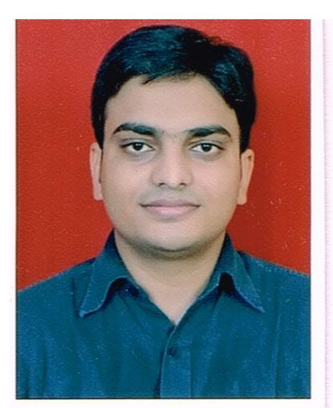 SATISH B JADHAV
A Wing 701, Om Shivam Residency,
Sector 17, Plot no 8A/9, Mansarovar
Kamothe, Navi Mumbai - 400701
Contact Info: +91 7506637004
Email Id: Kevin_l2007@yahoo.com

Personal Statement:
Good interpersonal and communication skill. Good Analytical thinking and Decision Making abilities. Accustomed to long work hours. Believe in WIN- WIN situation.
Career Objective:
To work with a organization where I can apply my leadership skills to meet the company goals and objective. Want to work in an environment where they will make impact on internal and external customers and my ideas are welcome and good leadership is required.

Education:
- Year 2003 Bachelor’s Degree – Commerce -56%
Mumbai University.
Major Subjects: Economics, Accounts and Marketing.

- Year 2000 HSC – Pillai Collage of Chembur - 57%

- Year 1998 SSC – Navi Mumbai High School, Vashi- 67%

Work Experience:
Feb 2006 to 30th August 2014 - 8yrs 6 months Serco Global Services
( Intelenet Global Services).
Work experience in Banking and Financial sector. Worked for Barclays Wealth Account Management UK process. Also worked for Equifax and Trans Union US process. Work experience in both Data as well as Voice process.

Team Manager (Operations)
- SLA Management – Meeting TAT on a daily basis.
- Attrition Management – Ensuring minimum attrition.
- Shrinkage Management – Controlling absenteeism in the process
- Ensuring high ESAT and CSAT.
- Handling daily and weekly client review calls.
- Monthly MBR reporting to AGM and DGM.
- Managing client escalation and risk events.
- Governance of the compliance policies.
- KRO settings for the performance appraisals for Advisors, SME, QA and Team Leader.
- Quality improvement focus.
- Raising RFP for new hire in team.

Team Leader : (Operations)
- Managing the team of 22-25 associates.
- Coaching, Mentoring and providing constructive feedback wherever necessary.
- Managing the absenteeism in the team.
- Performance review on a monthly basis and conducting annual appraisals.
- Ensuring the Performance Management System is followed.
- Auditing the Appraisal data forms filled by the team leaders during appraisal period.
- Ensuring the BOND variation among the top team members is less than 0.20.
- Encouraging and motivating team members to excel in their performance.
- Preparing Weekly, Monthly and Quarterly review reports for the team.
- Ensuring the minimum attrition for the team.
- Ensuring all the SAL’s are met for the process.

Achievement and Rewards:
- Best Team and Team Leader for the month of Dec 2011
- Best Team and Team Leader for the month of Nov 2010
- Process Expert March 2008
- Client appreciation for outstanding customer service for the month of Oct 2008
- Best Voice Associate for the month of Feb 2008
- Best Customer Service Associate for the month of June 2007
- Best Voice Associate for the month of May 2007
- Best Customer Service Associate for the month of May 2007
- Best Customer Service Associate for the month of April 2007
- Best Customer Service Associate for the month of Feb 2007
- Best Voice Associate for the month of Oct 2006

Sept 2005 to Dec 2006 Translink Televentures

Sr. Customer Service Associate:
- Business to Business outbound calls for US Mortgage process.
- Meeting the sales target.

Languages Known: English, Marathi, Hindi.

Hobby: Painting

Date of Birth: 8th June 1982

Marital Status: Married

Name : Satish B. Jadhav
Date : Signature.

