Padmini Sandil
Contact

E-mail: pooja.leo1993@gmail.com

Tel:- +91-9163547972(Kolkata)
/ +91-8092521253(Tata)
OBJECTIVE
Observe .Learn. Initiate .Execute. Succeed …….. Repeat

To work with an esteemed organization where I can utilize my learned knowledge and skills for the fulfillment of the organization’s goal. My academic background and analytical skills along with my ability to work in a group will definitely be an additional advantage.
EDUCATIONA
Institute Period Degree/Level CPI /Percentage

HILL TOP School, Jamshedpur.

HILL TOP School, Jamshedpur.

B.Com Hons.(Marketing) (3rd year), St. Xavier’s College (Kolkata)

2010

2012

2012-2015

I.C.S.E

I.S.C

AUTONOMUS
78.2% [Best Five]

77% [Best Four]

Appearing

INDUSTRIAL TRAINING

- Internship for 4 weeks(1 month) at Mukti World in PR & MARKETING and SALES
- Internship for 4 weeks (1 month) at Mukti world in PR & MARKETING

EXTRA CURRICULAR ACTIVITIES

- 1st Prize in PowerPoint Show, Commerce Fest(Inter-School)
- 1st Prize in Collage Making, Eco Fest, 2008
- 1st Prize in Skipping Race, 2002
- 2nd Prize in 4x100 meter Relay Race, 2003
- 2nd Prize in 4x100 meter Relay Race, 2007
- 2nd in Long Jump, 2004
- 2nd in Short Put, 2008
- 3rd in Short Put, 2004
- Participated in 8th National Cyber Olympiad, 2008
- Participated in English Choral Recitation, 2004

- Good communication and analytical skills.
- Trained in Computer Programming Languages
- Effective Team Leader
STRENGTHS

INTEREST

- Making PowerPoint Presentations and learning more about Computer
- Programming Languages
- Dancing and Athletics

Personal Information

DATE OF BIRTH | 2nd August, 1993
LANGUAGE | English, Hindi
MARITAL STATUS | Unmarried
CURRENT ADDRESS | 93F, Beltala Road,  Near Bhawanipore Thana,  Kolkata- 26
PERMANENT ADDRESS | H.No-124, Zone No.-4, Birsanagar, P.O.- Birsanagar, Jamshedpur- 831019
DECLARATION:

I hereby declare that the information given above is true to the best of my knowledge and I bear the responsibility for the correctness of the above-mentioned particulars.

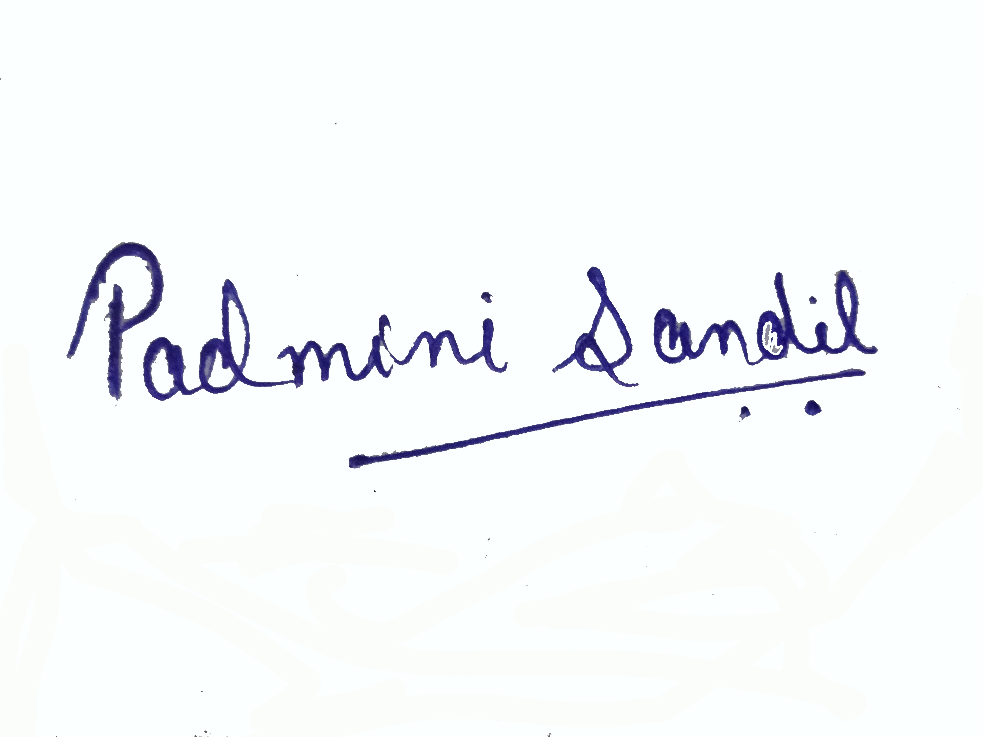
Signature
PADMINI SANDIL

Date-17th October, 2014
Place-Kolkata

