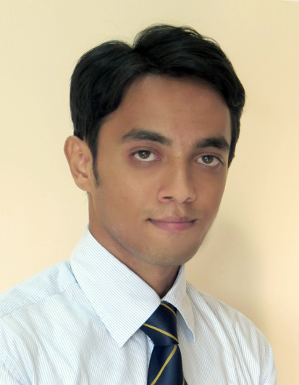
Choudhury Badrur Rahman

Objective: To be a part of an organisation and utilise my skills for the success of the organisation, also gather knowledge and experience through the work.

Academic Background:
School | Location | Graduation Year | Course/ Board/  University | Specialization / Intended Major | CGPA
NSHM Business School | Durgapur | Pursuing MBA | MBA  WBUT | MARKETING | 6.75  (YGPA,till 2nd sem)
Deshbandhu Mahavidyalaya | Chittaranjan | 2012 | B.Com(hons)  Burdwan University | ACCOUNTING | 41%
Santinagar Vidyamandir | Asansol | 2009 | Higher Secoundary  WBCHSC | COMMERCE | 58%
Eastern Railway Boys’ H.S.School | Asansol | 2007 | Madhayamik  WBBSE | BENG, ENG, MATH, PSC, LSC, HIST, GEO, | 47%

Computer Proficiency:
- One year Diploma in Financial Accounting System.
- Office tools: MS Office.Tally7.2

Winter Internship: Complete One month Winter Internship in Rudra Hyundai, Asansol.

SUMMER INTERNSHIP

DURATION: 60 DAYS NAME OF ORGANIZATION: JAYSHREE JCB,DURGAPUR
Project Brief | Brand Image of JCB
Findings | 1. During the Project I learnt that demand of JCB machine in southern west Bengal comparatively higher than the other earth movers company. According to my survey report I analyse that servicing and warranty are well provided by dealer and company respectively.  2. Though this earth mover company holding no.1 position in India, there is a crisis of demand of purchasing machines recently due to lack of work and government policy.
Key Learning | During the internship I have learnt many things. I have obtained the marketing strategies of the company, also learn how to interact with the customers and improve my inter personal skill as well.

Extra Curricular activities:

- CSR Co-ordinator in MBA class.
- Organized various fest and events in School & College.

Hobbies and interest:
- Playing cricket.
- Gardening.
- Listening Music.

Personal Information:
- Date of Birth : 23.02.1991
- Marital Status : Single
- Father’s name : Choudhury Bazlur Rahman
- Father’s occupation : Railway Serviceman in Eastern Railway.
- Permanent address : : Sasthinagar(south)near Huda manzil, Ismile, Asansol
Pin 713301
- Contact number : 09832255539, 07501373205
- Email ID : badrur.rahman91@gmail.com

Declaration: I hereby declare that all the information furnished above is true to the best of my knowledge.

