Curriculum Vitae

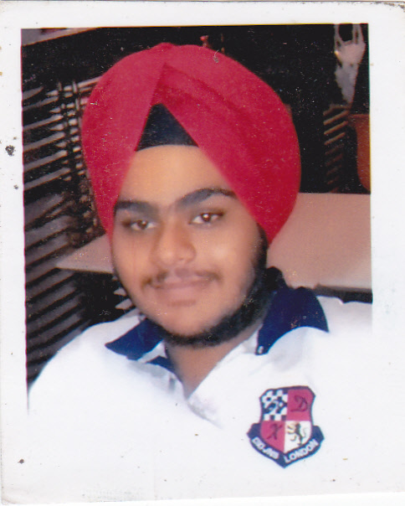

Mashmeet singh
(B.B.A b & i)
Email: mssethi1991@gmail.com
Contact: +91-9953325257

Objective:
I’m seeking a career which provides me an opportunity to grow, learn and utilize my skills for my organization and to further enhance my knowledge and evolvea professional in this field. I’m capable of exploiting my potential to the best and providing my best under trying and difficult circumstances

Personal Information:
Name: | Mashmeet Singh
Father’s Name: | Amarjit Singh
D.O.B: | 26 FEBRUARY 1995
Present Address: | M 40/28 Moti Bagh 1st New Delhi – 110021
Permanent Address: | Same as Above
Martial Status: | Single
Languages known: | English, Hindi, Punjabi

Educational Qualification:
Degree | College/ School |  | %Age, Year of Passing
Class 10 | Guru Harkrishan public school |  | 7.8, 2010
Class 12 | Guru Harkrishan public school |  | 80%, 2012
B.B.A (B&I)(1st year) | Trinity Institute Of Professional Studies (IPU) |  | 84% 2013
B.B.A (B&I)(2nd year) | Trinity Institute Of Professional Studies (IPU) |  | 72% 2014
B.B.A (B&I)(3rd year) |  | Trinity Institute Of Professional Studies (IPU) |  | PURSUING

Experience:
Worked as an intern I.D.B.I. Federal Life Insurance Barakhambha Delhi

Personal Qualities:
Smart, Responsible, Extremely Motivated, Trustworthy, Proactive, Multi-Tasking, Impressive verbal and written communication skills, Self-Driven, Inquisitive, Ability to deal with people diplomatically, Team facilitator, Pleasing Persona and Body Language.

Skill Set:
Languages/Skills: | DATABASE,HTML,Web Browsing
Other Tools | Ms excel, Ms office, tally ERP 9.1

Other Areas of Interests/Hobbies:
- Thorough interest in Physical and outdoor activities like Dancing,Adventure Sports, Travelling, Basketball,and different sports.
- Other interests include Photography, Net Surfing and Social Work.

New Delhi

