Munish Goel
House No. 126, A/6, G FLOOR, SAVITRI NAGAR,
NEAR SHEIKH SARAI – I, NEW DELHI – 10017

Voice: +919911332620 E-mail gmunish2003@gmail.com
Career Objective

To be a part of the challenging team which strives for the better growth of the organization and which explores my potential and provides me with the opportunity to enhance my talent with an intention to be an asset to the company.”

Overview of Present Profile:

Presently working as a Sales Manager in ICICI Prudential Life Insurance Company at team handling profile in Bancassurance vertical since July 2006. I am handling ICICI Bank relationship. I am responsible to manage the life insurance business generation process through my team through assigned bank and scale up the business through Distribution driving skills, Man Management expertise, selling, motivational, communication and analytical skills.

Sep 2010- Till date Sales Manager – Bancassurance -ICICI Bank -Delhi ICICI PRU LIFE

During this Tenure, I have managed the ICICI Bank Ebor relationship (ENTIRE DELHI ZONE with 24 branches) and ICICI bank South Delhi Region. I was managing the EBOR branches (Bank of Rajasthan was merged with ICICI bank called as EBOR) as a Sales Manager with 17 Team members for the period of Sep 2010 – March 201.. Since March 2011, I have been assigned to manage the 9 branches of South Delhi Region of ICICI Bank.

Key Responsibilities-

- To scale up the activisation and productivity of ICICI Bank’s employees and of my team to garner more n more business.
- To provide the Training to ICICI Bank Employee to upgrade their knowledge, to built up the confidence to pitch the plan to customers.
- To train the ICICI Bank employee to manage the customer's query and escalations.
- To train given team members on interpersonal and communication skills.
- To maintain the relationship with Regional Head, Cluster Manager, Bms and other focused ICICI bank staff.
- To discuss and conceptualize the strategy with Regional Head, Cluster Manager and BMs , to drive the Life Insurance Business.
- To review my team members and Bank employee’s performance in co-ordination with the Regional Head, Cluster Manager and Branch Manager of ICICI Bank.
- To Conduct RnR activity in sync with Regional Head -ICICI bank to motivate the employees.
- To coordinate with the underwriting team and operations team for clearing all the bottle necks in issuance.
- To handle and solve the customer’s escalations.
- To Provide Comparative Business MIS with a view to increase competition in different ICICI Bank branches.
- To Close the Super HNI Customer's calls if required.

Achievements-

- Controlled dead business to 2%.
- Scaled up the per employee activisation from 25% to 50%.
- Scale up the per employee productivity from 6,00,000 to 11,00,000
- Scaled up the average ticket size of policy from Rs. 60,000 to Rs.98,000.
- Ranked as Number 1 Sales Manager in Oct 2010 to March 2011, June 2011, July 2011, Sep 2011 and at number 2 in July 2012.
- Promoted as Sales Manager ( 3rd Promotion in ICICI Pru).

July 2006- August 2010 ICICI PRU LIFE FINANCIAL SERVICES MANAGER

Over view: I had Joined ICICI Pru in July 2006, as Bancassurance Officer. Then promoted as Financial Services Consultant in Sep 2007. In March 2008, again promoted as Financial Services Manager. During this tenure, I enriched my experience by managing the South Indian Bank ( our channel partner for selling Life Insurance to their customer) and ICICI Bank-Wealth Management relationship. Working with different verticals of company, help me in sharpening my skills and of course in grooming as well.

Key Responsibilities-
- To have Joint calls with employees of channel partner to increase the business .
- To enhance the productivity and activisation of every bank employee through joint calls with them, training on basic knowledge of Insurance Products, Training on selling the Insurance with need based selling concept.
- To arrange the review in sync with Cluster Branch Manager, Branch Manager & Wealth Manager on regular basis to scale up the business.
- To Coordinate with the underwriting team and operations team for clearing all the bottle necks in issuance.
- To handle and solve the customer’s escalations.
- To Provide Comparative Business MIS with a view to increase competition in different ICICI Bank branches.
- To Close the Super HNI Customer's calls.
Achievements
- Persistency of 90% employee activisation.
- Month on month persistency of being in Top 2 Rank.
- Controlled the dead business to 1%.
- Awarded as Topper for selling Highest Health Policies in OND’09
- Got Certificate of Excellence from “Zonal Manager” for outstanding performance of Oct-Dec 09.
- 2 promotions in 19 months ( in less than 2 years).

Career’s Milestones in ICICI PRU LIFE

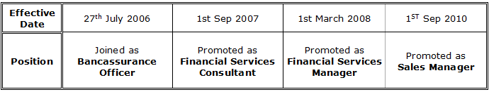

Nov 05- July 06 Axis Bank Ltd Executive-Sales
Branch: Shakti Nagar Location: New Delhi
Key Deliverables-
- To generate business for the bank in retail banking.
- To interact with prospective clients and bring their savings and current accounts.
- To drive promotional campaigns & provide customer service.

Qualification and Personal Profile

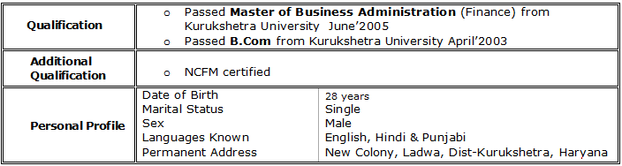

(Munish Goel)

