DBMS
LAB Assignment-2

- Create a table EMP1 with following structure.

ID | Name | Basic | Designation | Age

Column Description:-
ID Number (2)
Name Varchar2 (10)
Basic Number (6, 2)
Designation Varchar2 (10)
Age Number (2)

SQL QUERY:
CREATE TABLE EMP1 (
ID NUMBER(2),
Name VARCHAR2(10),
Basic NUMBER(6,2),
Designation VARCHAR2(10),
Age NUMBER(2)
);
EXPECTED OUTPUT:
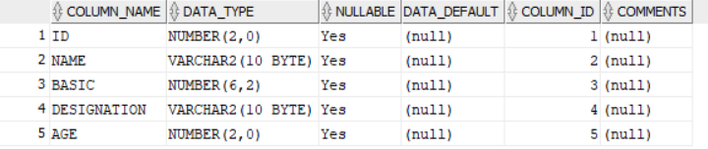

- Change the data type of the field Basic from float to integer with required size of the EMP1 table.
SQL QUERY:
ALTER TABLE EMP1
MODIFY(Basic NUMBER (6));

EXPECTED OUTPUT:
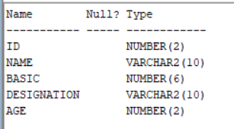

3. Change the field size of Name column of the EMP1 table from 10 to 15.

SQL QUERY:

ALTER TABLE EMP1
MODIFY (Name VARCHAR2(15));
DESC EMP1;

EXPECTED OUTPUT:
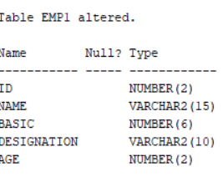

4. Create another table EMP_trainee with the same (changed) structure. The column ID to be renamed as Emp_id in the EMP_trainee table.

SQL QUERY:

CREATE TABLE EMP_TRAINEE AS
SELECT ID AS Emp_id,Name,Basic,Designation,Age
FROM EMP1
where 1=2;

EXPECTED OUTPUT:
TABLE EMP_TRAINEE CREATED
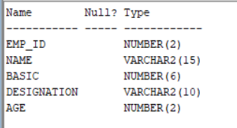

5. Insert following data in EMP1 table:-
(1, Rohit, 6700, Manager, 24)
(2, Sunil, 6200, Engineer, 27)
(3, Payal, 6300, Engineer, 25)
(4, Kunal, 6700, Trainee, 28)
(5, Sunita, 6230, Trainee, 26)
(6, Bimal, 7000, Trainee, 25)

SQL QUERY:
INSERT INTO EMP1 VALUES(1,'Rohit',6700,'Manager',24);
INSERT INTO EMP1 VALUES(2,'Sunil',6200,'Engineer',27);
INSERT INTO EMP1 VALUES(3,'Payal',6300,'Egineer',25);
INSERT INTO EMP1 VALUES(4,'Kunal',6700,'Trainee',28);
INSERT INTO EMP1 VALUES(5,'Sunita',6230,'Trainee',26);
INSERT INTO EMP1 VALUES(6,'Bimal',7000,'Trainee',25);

EXPECTED OUTPUT:
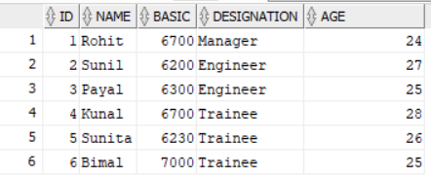
6 ROWS INSERTED.

6. Insert all rows with the designation ‘trainee’ from the EMP1 table to EMP_trainee table.

SQL QUERY:
INSERT INTO EMP_TRAINEE (Emp_id,Name,Basic,Designation,Age)
SELECT ID, Name,Basic,Designation,Age
FROM EMP1
WHERE Designation = 'Trainee';

EXPECTED OUTPUT:
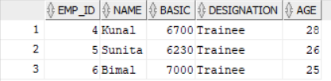

7. Add columns Skills (data type-varchar2 and size-10) and DOJ(data type-date) to the EMP1 table and add data for the Skills and DOJ columns according to your own wish.

SQL QUERY:

ALTER TABLE EMP1
ADD(Skills VARCHAR2(10),DOJ DATE);
UPDATE EMP1
SET Skills ='SQL' , DOJ= TO_DATE('08-JAN-2006','DD-MON-YYYY');

EXPECTED OUTPUT:

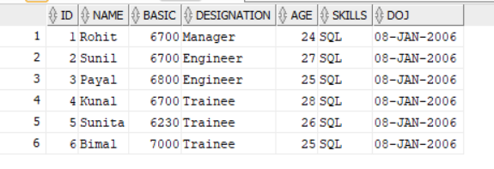
6 ROWS UPDATED.

8. Update more than one row in one query in EMP1 table.

SQL QUERY:

UPDATE EMP1
SET Basic = Basic+500
WHERE Designation = 'Engineer';

EXPECTED OUTPUT:

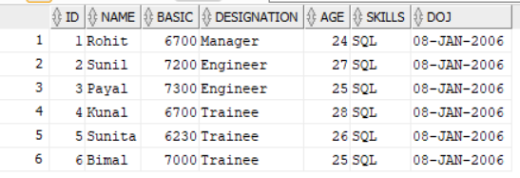

9. Rename the column Age of EMP1 table to Age_in_Years.

SQL QUERY:

ALTER TABLE EMP1
RENAME COLUMN Age TO Age_in_Years;

EXPECTED OUTPUT:

TABLE EMP1 ALTERED.
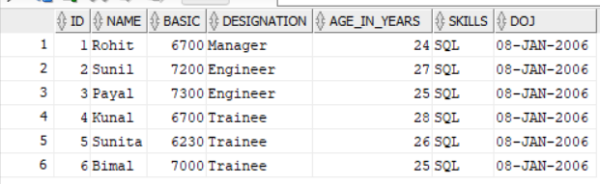

10. Drop the Age column from the EMP_trainee table.

SQL QUERY:

ALTER TABLE EMP_TRAINEE
DROP COLUMN Age;

EXPECTED OUTPUT:
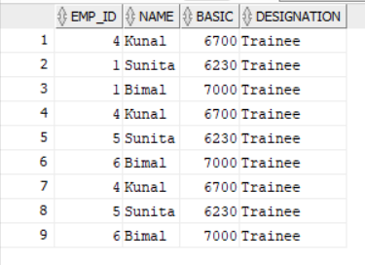

11. Rename the table EMP to EMP_Mgr_Engr.

SQL QUERY:
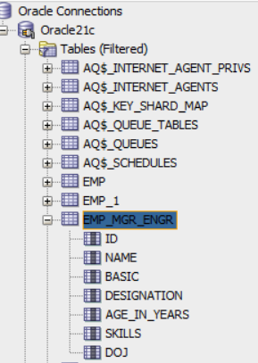
RENAME EMP1 TO EMP_Mgr_Engr;

EXPECTED OUTPUT:
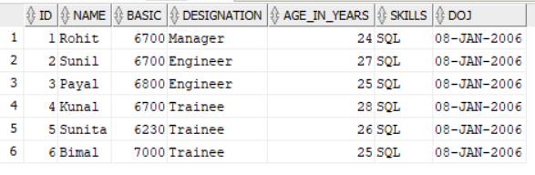

12. Truncate EMP_Mgr_Engr table.

SQL QUERY:

TRUNCATE TABLE EMP_Mgr_Engr;

EXPECTED OUTPUT:

