WATER REPORT
SAMPLE COLLECTION DATE | : | 01-10-2026
SAMPLE ANALYSIS DATE | : | 01-10-2026
CLIENT NAME | : | Shree Prakash Textiles
ADDRESS | : | Aditya Nagar, Near Asarwa Railway Station, Ahmedabad
CONTACT PERSON | : | Mr. Ranjeet Sir
RO FEED WATER & RO 3RD STAGE REJECT WATER WATER ANALYSIS REPORT
PARAMETER | UNIT | RO FEED WATER | RO 3RD STAGE REJECT WATER
pH | - | 7
Chloride as Cl | Mg/L | 1900
Sulphate | Mg/L | 300
Calcium | Mg/L | 900
REMARKS
The water condition is at its worst.
For,
Nirmaan WaterTech Solutions
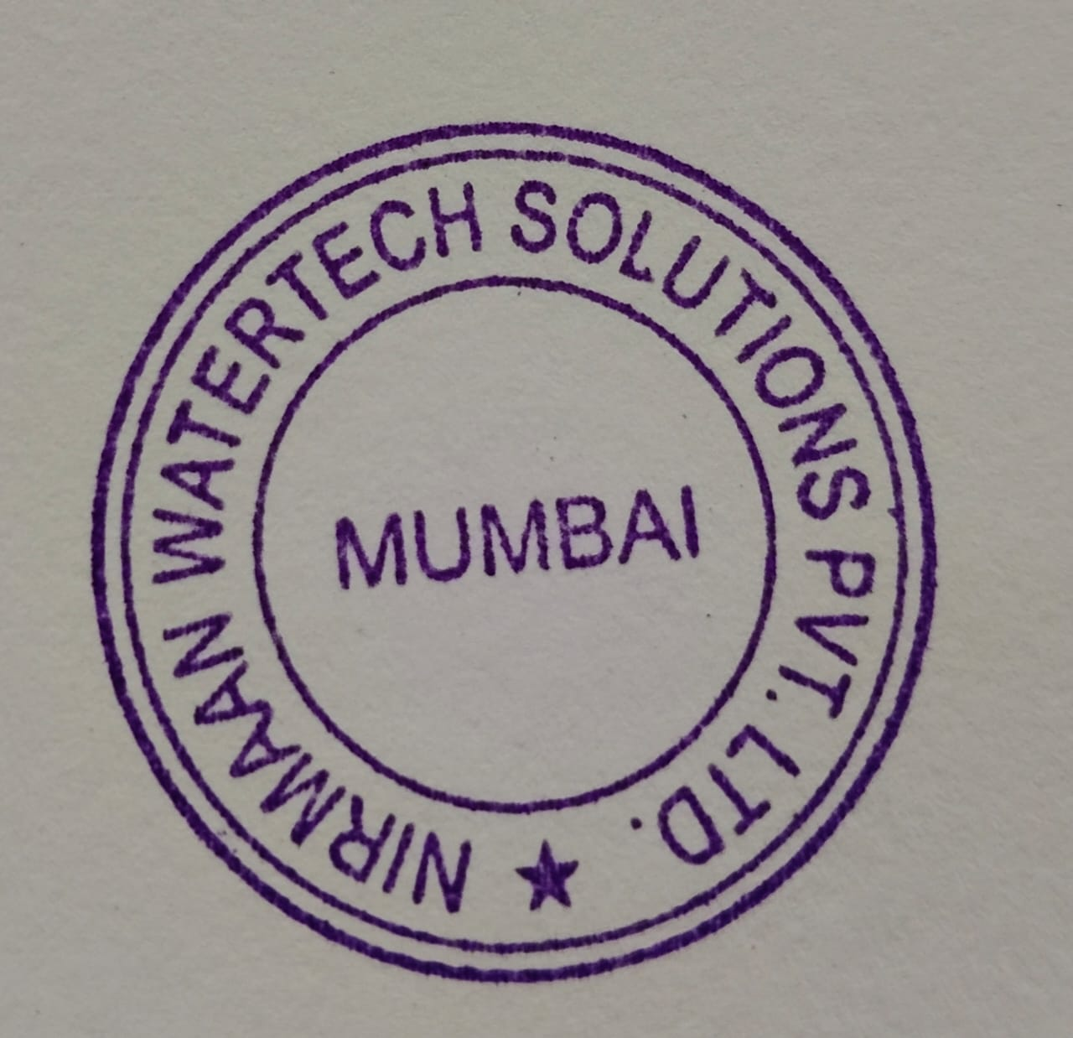
Ritesh Dantani
info@nirmaanwatertech.com
Analysed by: Administrator

