WATER REPORT
SAMPLE COLLECTION DATE | : | 01-10-2026
SAMPLE ANALYSIS DATE | : | 02-10-2026
CLIENT NAME | : | Anandam
ADDRESS | : | Rohinjan Upper Kharghar
CONTACT PERSON | : | Manoj Bagade
RO FEED WATER ANALYSIS REPORT
Dear Sir,
Please find below the water analysis results for Anandam. The measured parameters for the submitted samples are presented for your review.
PARAMETER | UNIT | RO FEED WATER
pH | - | 7
Total Hardness as CaCO3 | Mg/L | 14
T Alkalinity as CaCO3 | Mg/L | 300
Chloride as Cl | Mg/L | 5,200
Phosphate as PO4 | Mg/L | 600
Calcium | Mg/L | 900
Turbidity | NTU | 8,000
REMARKS
• The water container is damaged, and the water quality has been adversely affected.
For,
Nirmaan WaterTech Solutions
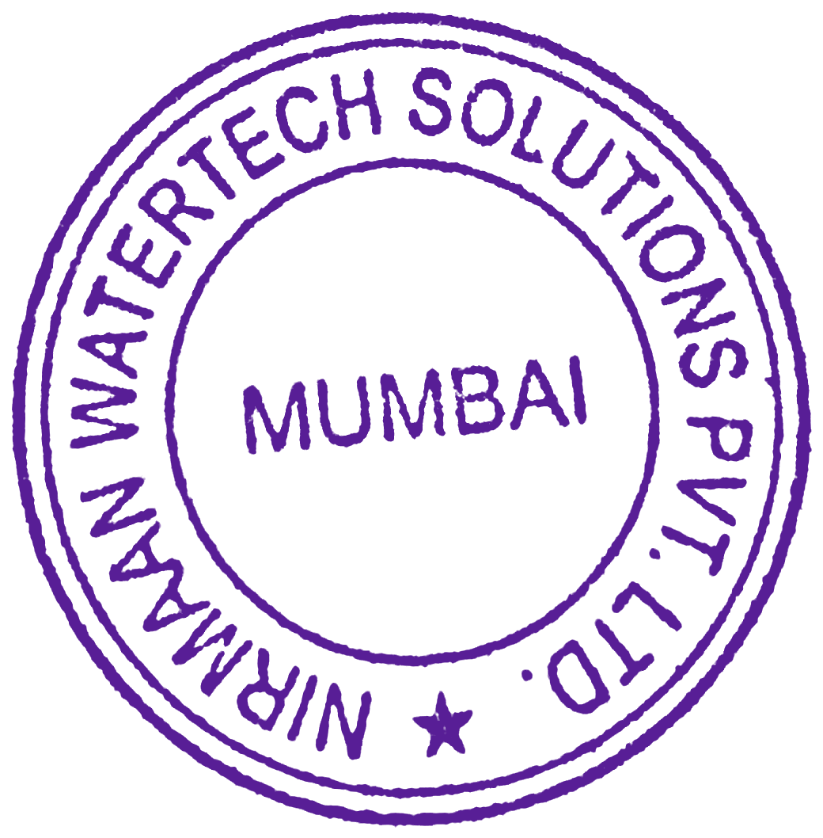
Payal Kadam
payalkadam0430@gmail.com

