WATER ANALYSIS REPORT
SAMPLE COLLECTION DATE: | 09-06-2026
SAMPLE ANALYSIS DATE: | 12-06-2026
CLIENT NAME: | Shree Prakash Textiles
ADDRESS: | Addr
CONTACT PERSON: | Mr. R
RO FEED WATER & RO 3RD STAGE REJECT WATER ANALYSIS REPORT
Dear Sir,
Please find below the water analysis results for Shree Prakash Textiles. The measured parameters for the submitted samples are presented for your review.
PARAMETER | UNIT | RO FEED WATER | RO 3RD STAGE REJECT WATER
pH | Mg/L | 7.2 | 7.6
TDS | Mg/L | 1,250 | 10,000
Total Hardness as CaCO3 | Mg/L | 320 | 1,450.5
Chloride as Cl | Mg/L | BDL | <0.1
Sulphate | Mg/L | 85 | 125,000
REMARKS
• Water sample was clear and free from visible impurities.
• pH value was within the specified range.
• TDS of reject water is high.
For,
Nirmaan WaterTech Solutions
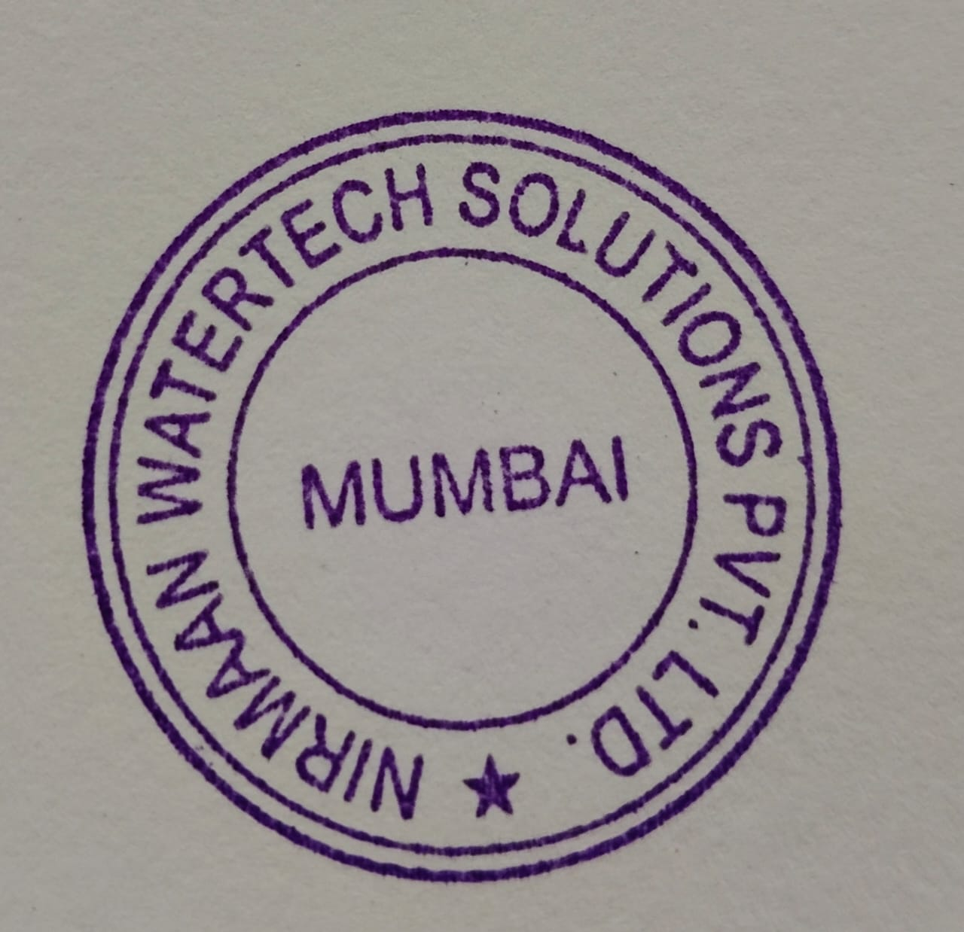
Ritesh Dantani
info@nirmaanwatertech.com

