Request letter to Indian Mission for Foreign Employer (FE) Registration
(For Individual Employers (i.e. Individual person), desiring to employ Indian workers for domestic
works. To be filled by the Employer himself/herself in his/ her own handwriting in English Language
and uploaded online along with the supporting document at the time applying online through
eMigrate System.

1. I {{SPNAME}}
, .
(Name of the Employer)

National of UAE .
(Name of the country, to which Employer belong)
and

.
having residential address at {{SPADD}}
(Complete Address of the Employer & email)

and having Personal Identification No {{CRNONDIDNO}}
(Passport Number/ National Identification No./ Civil Id no.)
.

issued by UNITED ARAB EMIRATES , (a Govt. Authority)
(Name of the Agency who has issued the Personal Identification No.to the Authorized Signatory)
hereby apply for registration of myself as Foreign Employer (FE) in the eMigrate System of Govt. of India, through Indian Mission in
EMBASSY OF INDIA, DUBAI
………………………………………………………………………………………….
(Name of the city and country where Indian Embassy/ Consulate is located)

2.I certify that the information provided in this Request Letter and in online application form is
correct.
3.I undertake that I shall abide by the rules and regulations as required time to time by the
eMigrate System or the Govt. of India.
4.I undertake that in case of any Indian worker employed by my, desires to go back to his/ her
country before completion of employment contract for any reason, I shall give the ‘No objection
Certificate’ or any other document as required, to the Indian Mission officials and to the
government of my country, to facilitate the exit of the Indian employee.
5.I undertake that I shall not withhold/ confiscate the passport, visa or the work permit
belonging to the Indian worker, under any circumstances.
(Contd)
6.I undertake that I shall not falsely implicate any Indian worker and/ or shall not register any false case with any govt. agency or the police against the Indian worker.
7.I undertake that once FE registration application submitted by me is approved, I shall not apply for the registration of the same organization again under any circumstances.

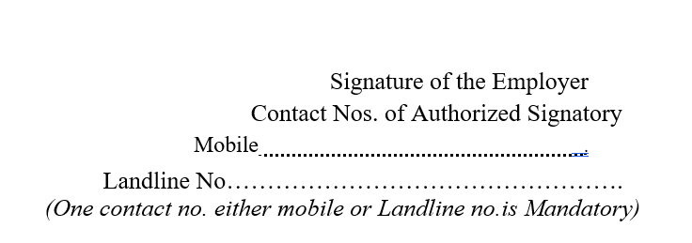
Date {{VISAISSUEDATE}}.

+{{PHONENO}}

Important Notes:
1.This Request letter is required to be downloaded by the Employer from eMigrate website and
filled-in completely with required information and signature etc. before start applying online for
FE Registration on eMigrate.
2.The completely filled in Request Letter is required to be uploaded by the Employer along with the other supporting document, at the time of online application.
3.Employer is required to mention the date and sign both the pages of this Request letter as indicated.
4.This Request Letter must be filled-in completely and in English Language only. In case the
form is not filed completely or filled-in any language other than English, the Indian Mission
officer, processing the FE registration application is directed to summarily reject the application
for FE Registration.
5.The content of this Request Letter shall not be altered or modified under any circumstance.
Application for FE Registration, with altered/ modified Request Letter shall be rejected summarily by the Indian Mission.
List of Documents uploaded on eMigrate System along with FE Registration Application, are as under (Please tick box as applicable):
1.Request Letter for FE Registration duly signed by Authorized Signatory/ individual
Employer.
2.Copy of Passport / Personal Identification Number / Civil Id issued by Govt. Authority in the name of Authorized Signatory.
3.Copy of Address proof.

