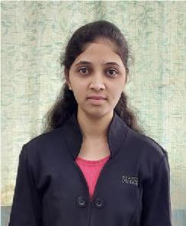

**RESUME**

♦ Harshada Vikram Nikam

♦+91-9890255897

♦ **1997harshadanikam@gmail.com**

♦ Pune, Maharashtra

Career Objectives

I would like to work in an organization which provides positive environment where I can grow personally as well as professionally.

Educational Background

**Degree/Course :** Bachelor of Mechanical Engineering

**Board/Institute :** Shivaji University

**Percentage :** 89.44%

**Year of completion :**2021

**Degree/Course :** Diploma in Mechanical Engineering

**Board/Institute :** Maharastra state board of technical Education

**Percentage :** 61.00%

**Year of completion :**2018

**Degree/Course :**HSC

**Board/Institute :** Kolhapur University

**Percentage :** 52.17%

**Year of completion :**2016

**Degree/Course :**SSC

**Board/Institute :** Kolhapur University

**Percentage :** 76.40%

**Year of completion :**2014

Technical Skills

**SQL :**

* Knowledge of **RDBMS Concept**
* Comfortable in writing **SQL statements** like **DDL, DML, DQL**
* Good understand of **SQL** queries

**Core Java :**

* Knowledge of **OOP's concept**

**Manual Testing :**

* Knowledge of **Black Box Testing** and **White Box Testing**
* Knowledge of **SDLC**
* Knowledge of **STLC**
* Good in writing a **Functional** and **Integration Testing Scenario**

Academic Project

**Diploma Project: Folding Bench**

**Degree** **Project: Automatic Agriculture Sprayer**

**Description:**

The main motive of this project is to reduce the reliance on manual labour and the other hand Increases the efficiency, production yield and the quality.

**Time Period:** 2020-2021

Achievement

I achieved Best Employee award in the quality dept in Piaggio Vehicles private Limited, Baramati**.**

Strength

* Good listener
* Leadership qualities
* Punctual

Personal Details

Date of Birth: 17 November 1997

Nationality : Indian

Languages Known : English, Hindi, Marathi

Hobbies **:** Dancing, Reading book, Travelling , Cooking

Declaration

I hereby declare that the above information given is true to the best of my knowledge.

**Date : Harshada Vikram Nikam**

**Place:**