**1. What is OpenStack & Its Applications**

**OpenStack is an open-source cloud platform that helps you build and manage your own private or hybrid cloud — similar to AWS, but hosted on your own servers.**

**🌐 Main Applications / Use Cases**

| **Use Case** | **Description** | **Example** |
| --- | --- | --- |
| **🏢 Private Cloud** | **Companies use OpenStack to create their own AWS-like cloud in their data center.** | **A bank hosts its own internal cloud to run secure apps.** |
| **🧪 Development & Testing** | **Developers create virtual servers on demand for testing new applications.** | **A DevOps team spins up multiple test environments daily.** |
| **🖥️ Data Center Virtualization** | **Replaces expensive virtualization products like VMware.** | **IT teams manage thousands of VMs using OpenStack.** |
| **☁️ Hybrid Cloud** | **Combines on-prem OpenStack cloud with public clouds like AWS or Azure.** | **An enterprise runs sensitive data in OpenStack and other workloads in AWS.** |
| **🧠 Research & Education** | **Universities use it to teach cloud concepts and run experiments.** | **Students learn cloud provisioning and orchestration.** |
| **🧰 Automation & CI/CD** | **Integrates with tools like Jenkins, Ansible, Terraform for automated deployments.** | **CI/CD pipelines launch VMs for testing builds.** |

**2. Basic Configuration on Ubuntu Server**

You can install OpenStack in different ways.  
For beginners, the easiest is **DevStack** (good for lab / testing).

**🧑‍💻 Minimum Requirements**

* Ubuntu Server 22.04 LTS (or 20.04)
* 8 GB RAM (minimum for DevStack)
* 4 vCPUs
* 50+ GB disk
* Internet connection
* Sudo access

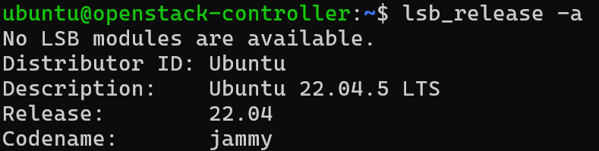





Step-by-Step (DevStack Installation Example)

# 1️⃣ Update your Ubuntu system

sudo apt update && sudo apt upgrade -y

# 2️⃣ Install Git

sudo apt install -y git

# 3️⃣ Clone DevStack repository

git clone https://opendev.org/openstack/devstack

cd devstack

# 4️⃣ Create local.conf file

cat <<EOF > local.conf

[[local|localrc]]

ADMIN_PASSWORD=admin

DATABASE_PASSWORD=admin

RABBIT_PASSWORD=admin

SERVICE_PASSWORD=admin

HOST_IP=157.119.43.47

EOF

# 5️⃣ Start the installation

./stack.sh

**🌍 After Successful Installation**

* Dashboard URL → http://<your_server_ip>/dashboard
* Username → admin
* Password → admin (as per the config)

**4. Check Services Individually**

Run:

systemctl list-units | grep devstack@

or

sudo systemctl status devstack@n-cpu.service

sudo systemctl status devstack@n-api.service

✅ If services show as “active (running)”, it’s good.  
❌ If they show “failed” or “inactive”, some components didn’t install properly.