Assignment Day 3

Q1. WAP to print even numbers till n.

Code:

*package* com.myassignments;  
  
*import* java.util.Scanner;  
  
*public class* Main {  
  
 *public static void* main(String[] args) {  
 Scanner sc = *new* Scanner(System.in);  
 System.out.println("Enter a number to print even number till 'n':");  
 *int* n = sc.nextInt();  
 *for* (*int* i = 2; i <= n; i+=2) {  
 System.out.println(i);  
 }  
 }  
}

Output:

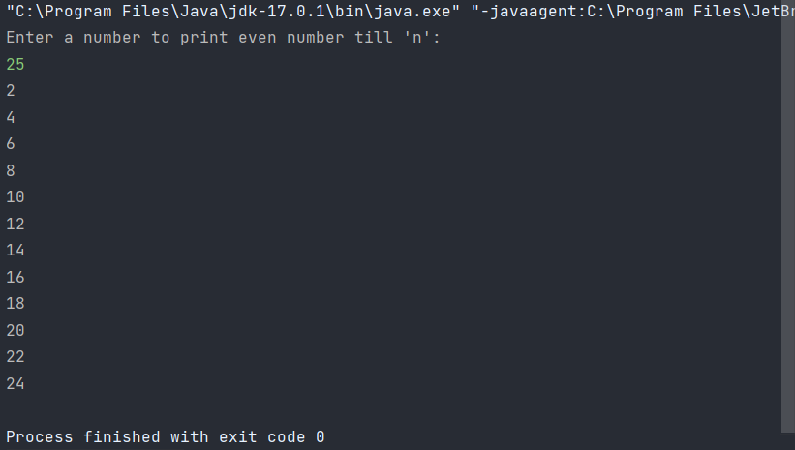

Q2. WAP to print all multiples of 7 till n.

Code:

*package* com.myassignments;  
  
*import* java.util.Scanner;  
  
*public class* Main {  
  
 *public static void* main(String[] args) {  
 Scanner sc = *new* Scanner(System.in);  
 System.out.println("Enter a number to print multiples of 7 till 'n':");  
 *int* n = sc.nextInt();  
 *for* (*int* i = 1; i <= n; i++) {  
 *int* temp = i\*7;  
 *if*(temp <= n){  
 System.out.println(i\*7);  
 }  
 }  
 }  
}

Output:

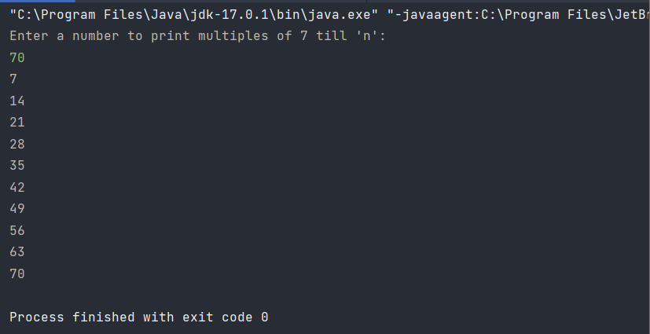

Q3. WAP to count multiples of 3, multiples of 5 and both 3,5 in range 1-n.

Code:

*package* com.myassignments;  
  
*import* java.util.Scanner;  
  
*public class* Main {  
  
 *public static void* main(String[] args) {  
 Scanner sc = *new* Scanner(System.in);  
 System.out.println("Enter a number to print multiples of 7 till 'n':");  
 *int* n = sc.nextInt();  
 *int* count3 = 0;  
 *int* count5 = 0;  
 *int* count35 = 0;  
 *for* (*int* i = 1; i <= n; i++) {  
 *int* temp3 = i\*3;  
 *int* temp5 = i\*5;  
  
 *if*(temp3 <= n){  
 *//System.out.println(i\*3);* count3++;  
 }  
  
 *if*(temp5<= n){  
 *// System.out.println(i\*5);* count5++;  
  
 }*if*(temp5<= n && temp3 <=n){  
 count35++;  
 }  
 }  
 System.out.format("Number of multiples of 3 are %d%n",count3);  
 System.out.format("Number of multiples of 5 are %d%n",count5);  
 System.out.format("Number of multiples of 3 & 5 are %d%n",count35);  
 }  
}

Output:

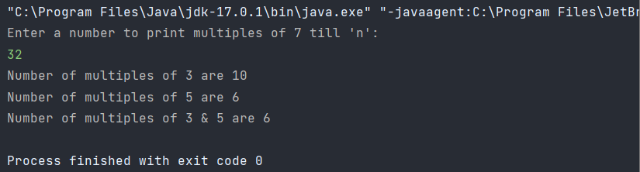

Q4. WAP to input n, loop for n times and input 2 numbers in each iteration, if iteration is even(0th,2nd,4th..) print sum else print multiplication.

Code:

*package* com.myassignments;  
  
*import* java.util.Scanner;  
  
*public class* Main {  
  
 *public static void* main(String[] args) {  
 Scanner sc = *new* Scanner(System.in);  
 System.out.println("Enter a number 'n' to loop 'n' times:");  
 *int* n = sc.nextInt();  
 *for* (*int* i = 0; i <= n; i++) {  
 System.out.println("Enter two numbers to do operations of sum and multiplication-");  
 System.out.println("Enter Enter first number:");  
 *int* a = sc.nextInt();  
 System.out.println("Enter Enter second number:");  
 *int* b = sc.nextInt();  
  
 *if* (i % 2 == 0) {  
 System.out.format("Sum is %d%n:",a + b);  
 } *else* {  
 System.out.format("Product is %d%n:",a \* b);  
 }  
 }  
 }  
}

Output:

