CHAPTER 1: INTRODUCTION

DukaanSetu is a modern multi-vendor e-commerce platform built with the MERN stack (MongoDB, Express, React and Node). Its name, ‘Shop Bridge’, is indicative of its primary role, which is to bring together offline shop owners and the digital-savvy consumer. Today there is a fierce competition in the retail sector and small-scale local retailers do not have the technical resources to stand up against the global e-commerce giants. With a strong digital foundation, DukaanSetu puts shopkeepers on an equal footing, allowing them to easily digitize their inventory, manage orders and track their business growth through a user-friendly dashboard.

It provides customers with a simplified shopping experience, where they can find and buy from local shops using powerful search and multi-criteria filtering. Highlights include role-based authentication and a shopping cart feature that allows you to see the cart even after you close your browser, as well as a single order-level review system that provides trust and transparency. Moreover, there's a centralized Admin panel that makes it easier to ensure platform governance and control, especially when it comes to product taxonomy and real-time sales analytics. At the end of the day, DukaanSetu is an ecosystem that focuses on the community, aiming to bring about a transformation in local economies, support small businesses, and offer convenience to neighborhood shoppers, making it a bridge between physical and digital spaces.

1.1 Abstraction
DukaanSetu is an orchestration platform built using the MERN stack that aims to help offline retail to be digitized to connect offline shopkeepers with online consumers. It also simplifies the real estate of commerce workflows into a role-based ecosystem that enables shopkeepers to track stock through easy to operate dashboards, customers to explore multiple vendors, and admins to oversee platform governance. The integration of a high fidelity real-time UI and backend systems synchronizing in real-time make the system a powerful brick-and-mortar alternative – and a seamless digital marketplace.

1.2 Existing System and Need of System

Existing system
Offline sales methods are traditionally practiced by most of the local shopkeepers. They don't have their
Are unable to use own websites or online systems due to low technical skills and resources. Customers need to physically go to various shops to see whether products are available and the prices.
Shopkeepers also use paper registers for sales and record keeping, which can cause discrepancies. The ease and convenience of online shopping platforms makes it hard for small local vendors to compete with.Online shopping platforms offer better digital services and convenience, making it difficult for small local vendors to compete with.

Need of the system
The need for a platform that enables local vendors to sell online with ease without needing to have technical skills. The system enables the consumer to view the products, compare prices and make purchases for products from local shops at a single location. It also streamlines the sales monitoring, stock control, and order processing, minimizing human effort and mistakes. The site offers an online shopping experience that's comparable to the major e-commerce sites, but also promotes people to shop local.

1.3 Scope of work
    - Implementing three different interfaces (Admin, Shopkeeper, Customer) where each interface has unique authentication and permissions using secure JWT.
    - The ability for the shopkeeper to list and manage products including product descriptions, images and pricing with a complete CRUD (Create, Read, Update, Delete) system.
    - Advanced searching and filtering of products to enables customers to search for products by name, category, price range and specific shop locations.
    - A multi-vendor cart engine where the user can put items of various vendors on one cart and keep the items on the cart even after refreshing the page.
    - A module for doing a post-purchase review, where a customer is able to rate and comment on an entire order at one time.
    - Administration features to handle person accounts and uninstall merchandise to ensure safety and quality of the platform.

1.4 Operating Environment-Hardware and Software

Software:
NodeJS (v18.x), MongoDB (v6.x), npm and any modern browser supporting WebGL (v18.x).
Hardware:
Must have at least 4GB of RAM (8GB recommended) and Dual-core CPU and WebGL compatible GPU for the platform's 3D interactive functionality.

1.5 Technology Used

  - Frontend – Reactjs, Boostrap 5, Css3
  - Backend – Nodejs, Bcrypt.js
  - Database – MongoDB

1.6 Module Specification
- User Authentication & Identity Module
  - Registration: Secure signup for Customers, Shopkeepers, and Admins.
  - Secure Login: JWT (JSON Web Token) based authentication with encrypted password storage using Bcrypt.js.
  - Role-Based Access Control (RBAC): Middleware that restricts or grants access to specific routes and UI components based on whether the user is an Admin, Shopkeeper, or Customer

.

Customer Experience Module
  - Marketplace Engine: Advanced search and multi-criteria filtering by category, price, and shop location.
  - Multi-Vendor Cart: A persistent shopping cart that aggregates items from various shopkeepers into a single checkout flow.
  - Order History: A detailed view for customers to track their previous purchases and current order statuses.
  - Integrated Review System: Allows customers to provide comprehensive feedback and ratings for their entire order experience.

Shopkeeper Inventory & Fulfillment Module
  - Inventory Manager: Full CRUD (Create, Read, Update, Delete) for product listings, linked to Admin-defined categories.
  - Orders Dashboard: Real-time access to incoming customer orders, including delivery addresses and itemized lists.
  - Fulfillment Toggle: Ability to update order status from "Pending" to "Delivered" to track completion.
  - Earnings Tracker: Automatic calculation of total profit and sales performance.

Administrative Governance Module
  - Category Standardization: Managing the global list of product categories available to all shopkeepers.
  - Platform Analytics: High-level monitoring of total system sales, total orders, and active user counts.
  - Market Trends: Tracking "Popular Products" based on purchase frequency.
  - Moderation Tools: Ability to remove unauthorized products or users to ensure platform security.

Backend & Data Orchestration Module
  - RESTful API Services: Clean and documented endpoints for frontend-backend communication.
  - Database Management: Schema definitions for Users, Products, Categories, Orders, and Reviews using MongoDB.
  - Data Population: Deep-linking logic that connects orders to both products and shopkeepers for accurate reporting.

CHAPTER 2: ANALYSIS & DESIGN
  - Entity Relationship Diagram
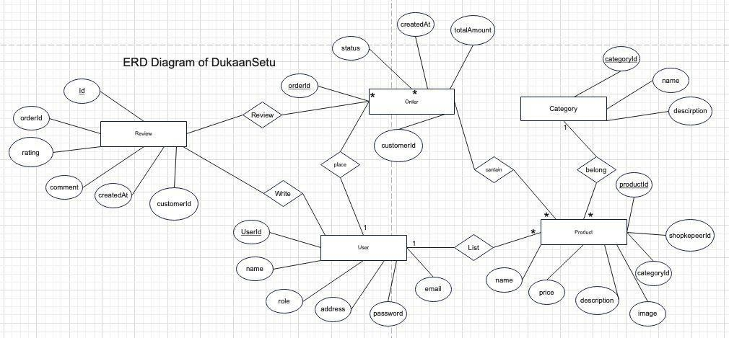

Use Case Diagram

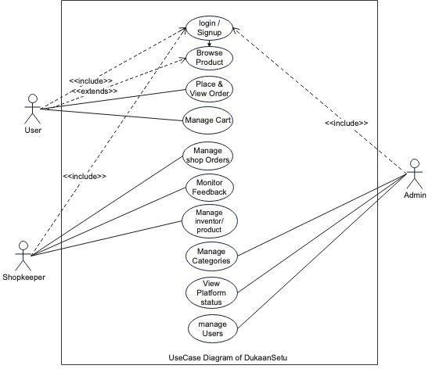

Class Diagram
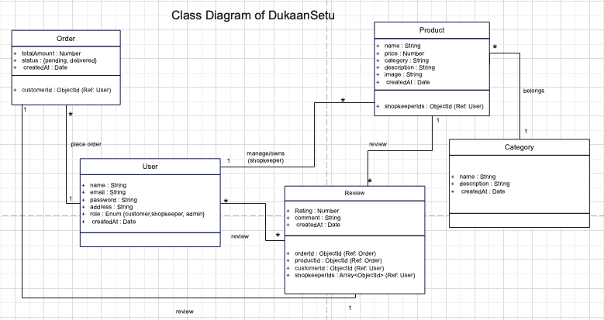

Activity Diagram

- User

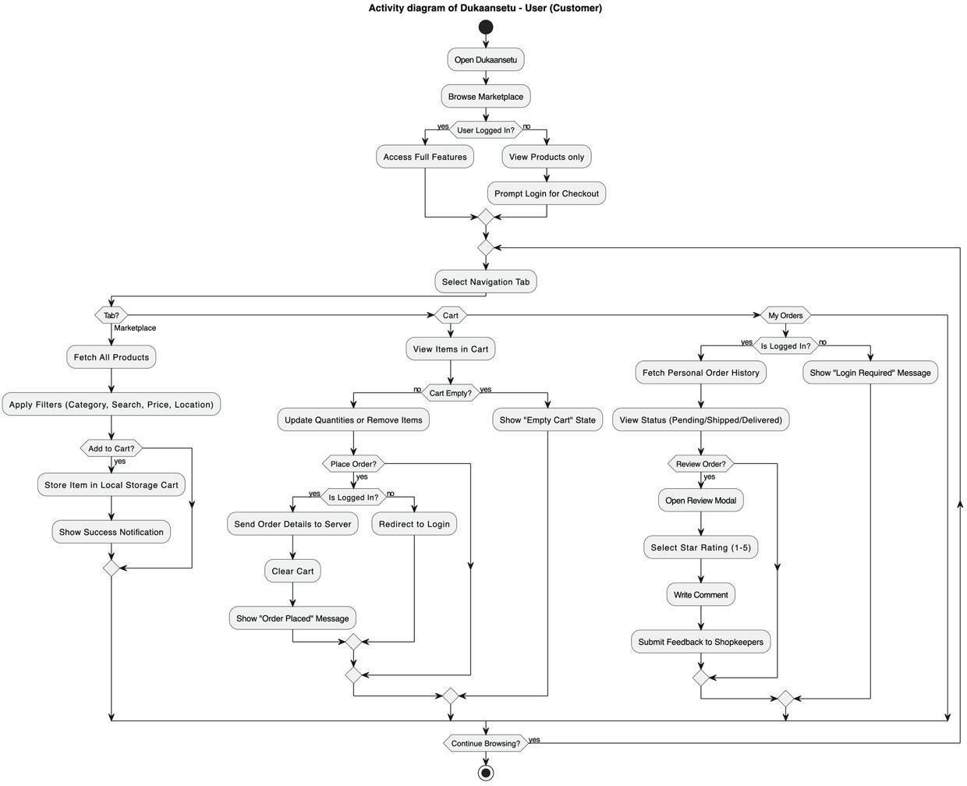

Shopkepper

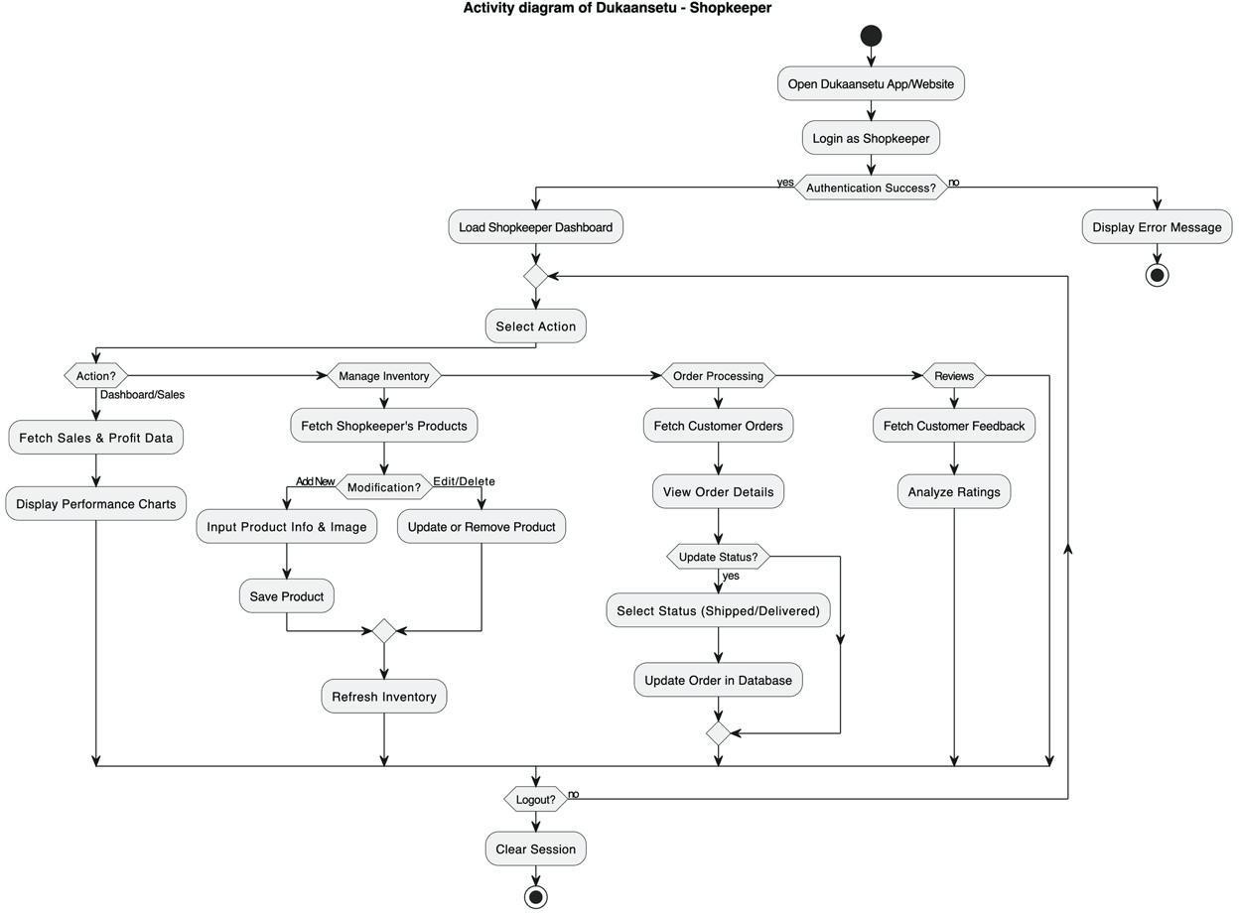

Admin

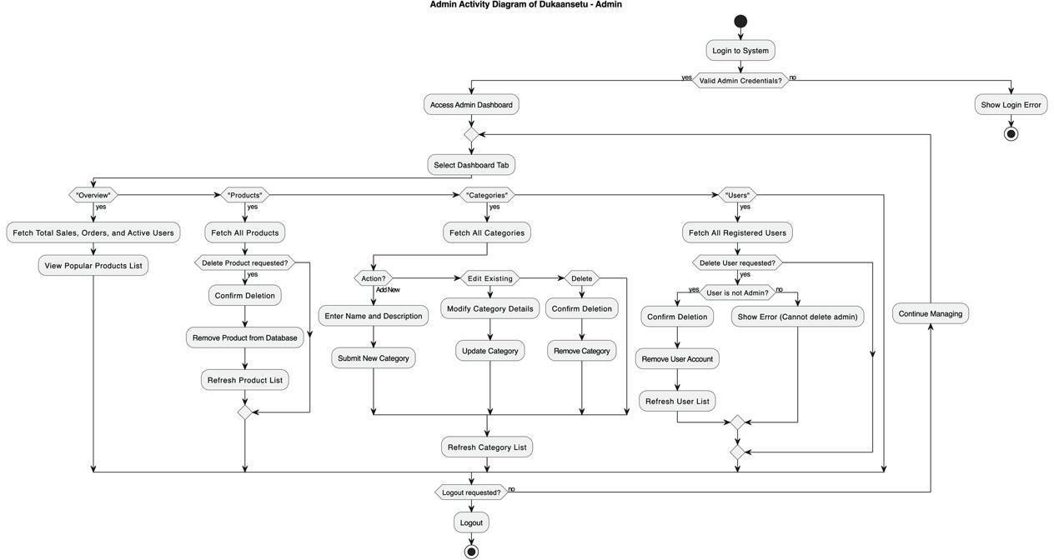

Context Level Data Flow Diagram
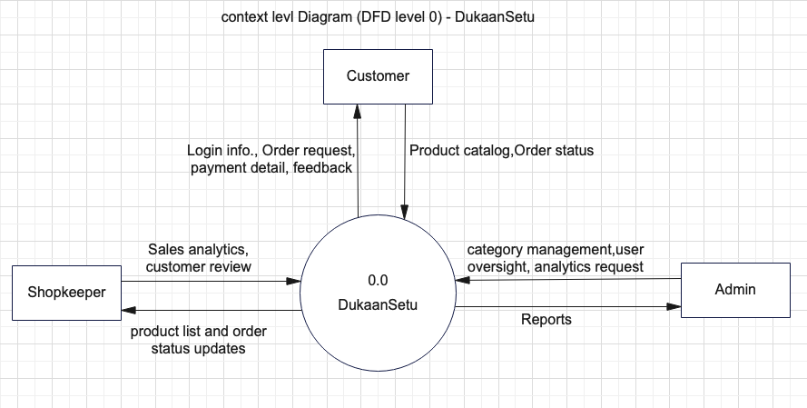

Sequence Diagram
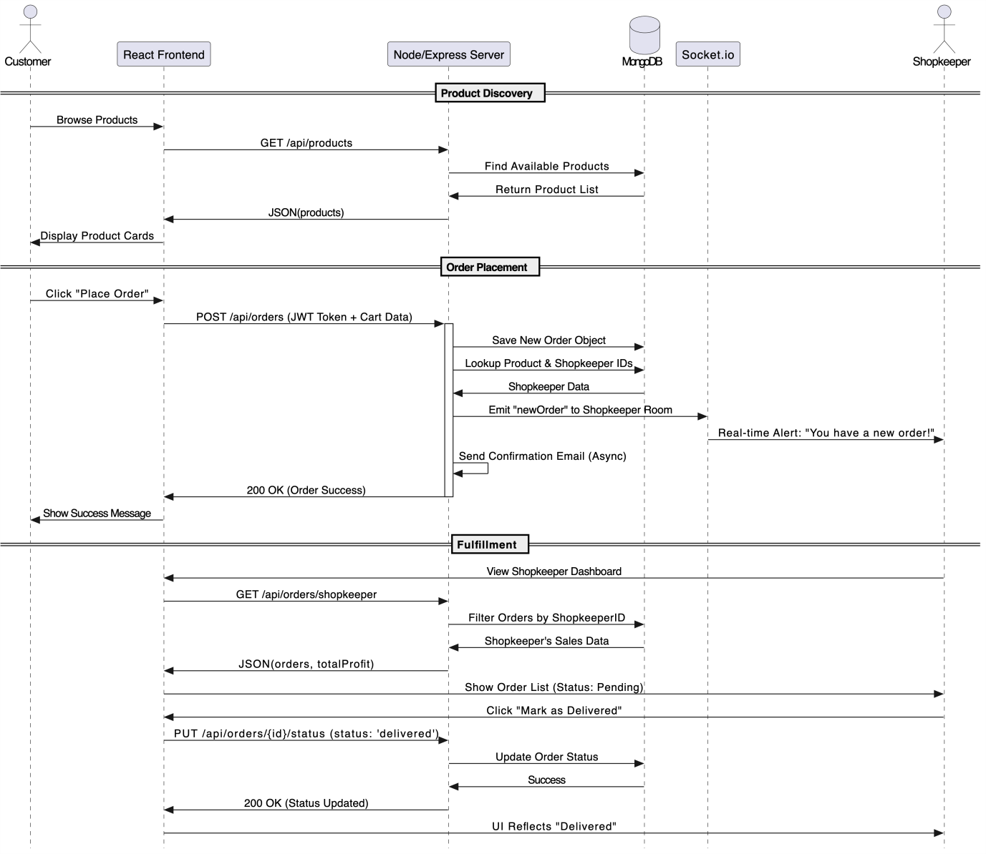

Tabel Structure

- User Collection

Field Name | Data Type | Description | Constraints
_id | ObjectId | Unique identifier for each user | Primary Key, Auto-gen
name | String | Full name of the user | Required
email | String | Email address | Unique, Required
password | String | Bcrypt hashed secure password | Required
address | String | delivery address | Required for Orders
role | String | Defines user access | Enum
createdAt | Date | Timestamp | Default : Date.now

- Product Collection

Field Name | Data Type | Description | Constraints
_id | ObjectId | Unique identifier for each user | Primary Key, Auto-gen
name | String | Title of product | Required
Price | String | Cost per unit | Required
category | String | Category name | Defined by admin
description | String | Detail info. | Required
image | String | url of product | Default placeholder
shopkeeperId | ObjcetId | Reference to the user | Foreign key
createdAt | Date | Timestamp | Default : Date.now

- Category Collection

Field Name | Data Type | Description | Constraints
_id | ObjectId | Unique identifier for each user | Primary Key, Auto-gen
name | String | Unique name of  category | Required
description | String | Detail info. | Required

- Review Collection

Field Name | Data Type | Description | Constraints
_id | ObjectId | Unique identifier for each user | Primary Key, Auto-gen

OrderId | ObjectId | Specific order reviewed | Foreign key
shopkeeperIds | Array | Ids of all shopkeeper involved order | Foreign key
rating | Number | Numeric score | Min:1 Max:5
customerId | ObjectId | User wrote the review | Foreign key
comment | String | Feedback text | required
createdAt | Date | Timestamp | Default : Date.now

- OrderCollection

Field Name | Data Type | Description | Constraints
_id | ObjectId | Unique identifier for each user | Primary Key, Auto-gen
customerId | ObjectId | Reference of buyer | Foreign key
products | Array | List of items | Non-empty
totalAmount | Number | Total cost | Required
status | String | Current stage | Enum: pending,  delivered
createdAt | Date | Timestamp | Default : Date.now

Drawbacks and Limitation
- The system currently does not facilitate real-time financial transactions, requiring payments to be handled externally or upon delivery.

- Product images are managed through external URLs instead of a direct cloud storage integration (like AWS S3), which may lead to broken links if the source image is removed.
- The application lacks an automated notification engine to alert users of new orders, status changes, or feedback via Email or SMS.
- There is no automated "low-stock" alert system, forcing shopkeepers to manually track their inventory levels and update listings.
- The user interface is currently restricted to the English language, which may limit adoption by local shopkeepers in non-English speaking regions.

Proposed Enhancement
  - Future iterations will include the integration of real-time payment processors such as Razorpay,Stripe, or PayPal to facilitate secure online transactions and automated payouts to shopkeepers.
  - Implementing a direct image upload system using services like Cloudinary or AWS S3 will allow shopkeepers to host product images securely on the platform without relying on external URLs.
  - To increase accessibility for diverse local markets, the platform will implement localization (i18n) to support multiple regional languages for both the interface and product details.
  - Enhancing the Shopkeeper Dashboard with graphical data visualization (charts and graphs) to track monthly sales trends, inventory turnover rates, and low-stock alerts.
  - Implementing a real-time chat feature between customers and shopkeepers to allow for pre-purchase inquiries,order customizations, and personalized customer support.

Conclusion

The development of DukaanSetu represents a significant step toward the digital transformation of hyper-local commerce by providing a robust and accessible marketplace for traditional offline shopkeepers. Through the successful implementation of the MERN stack, the platform effectively bridges the gap between neighborhood vendors and modern consumers, offering a seamless and secure transaction experience. By introducing specialized,role-based dashboards for Admins, Shopkeepers, and Customers, the system ensures structured platform governance, transparent order fulfillment, and an intuitive product discovery process. Ultimately, the project fulfills its core mission of digital empowerment—allowing local entrepreneurs to digitize their inventory and scale their reach while providing consumers with the convenience of online shopping combined with the trust of their local community stores. As the platform continues to evolve with future enhancements like integrated payments and real-time logistics, it stands poised to revitalize local economies and redefine the neighborhood shopping experience for the digital age.

Bibliography
ANNEXURE 1 : USER INTERFACE SCREENS

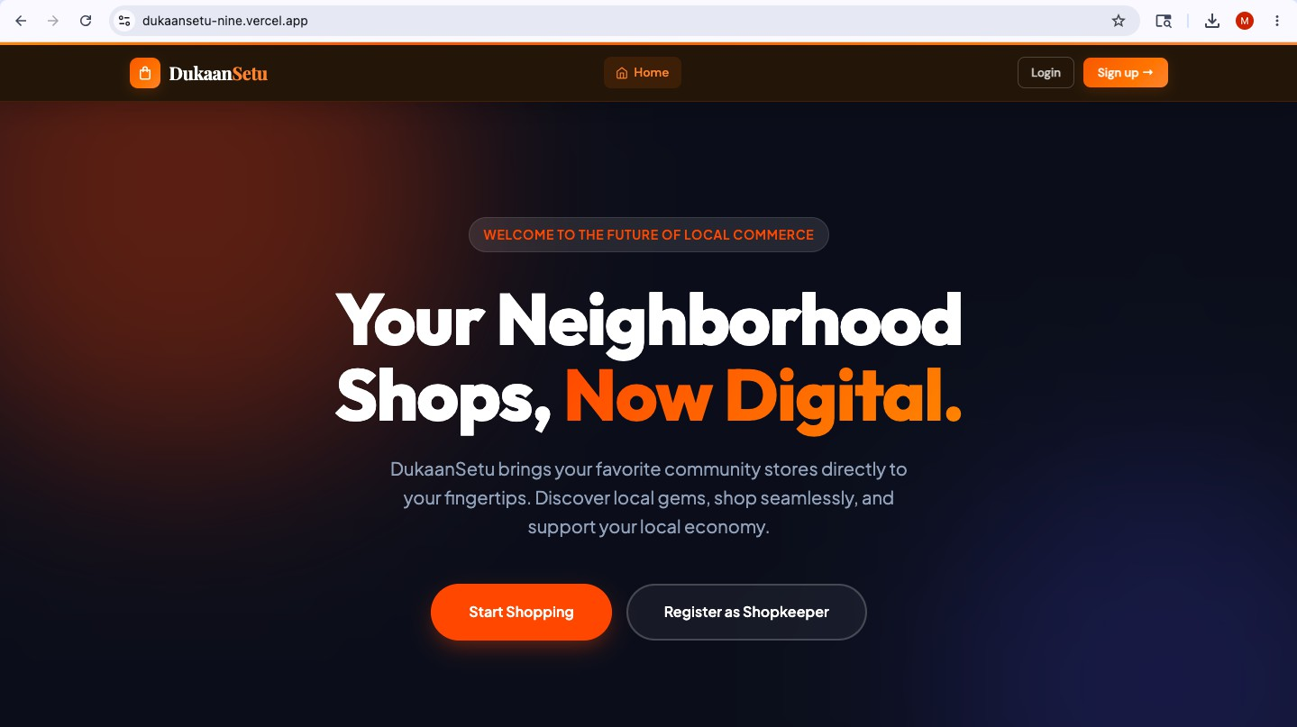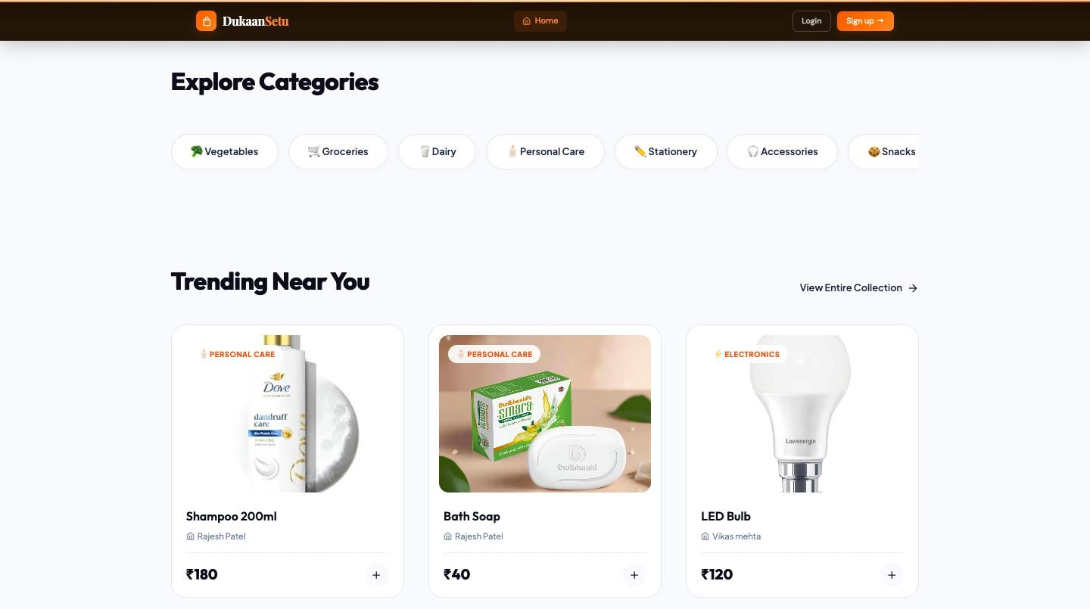
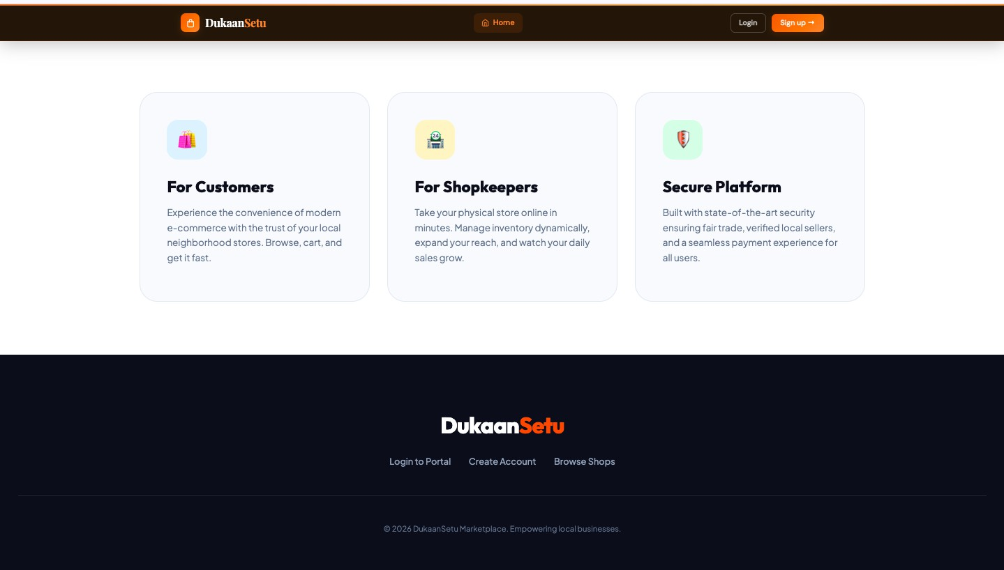
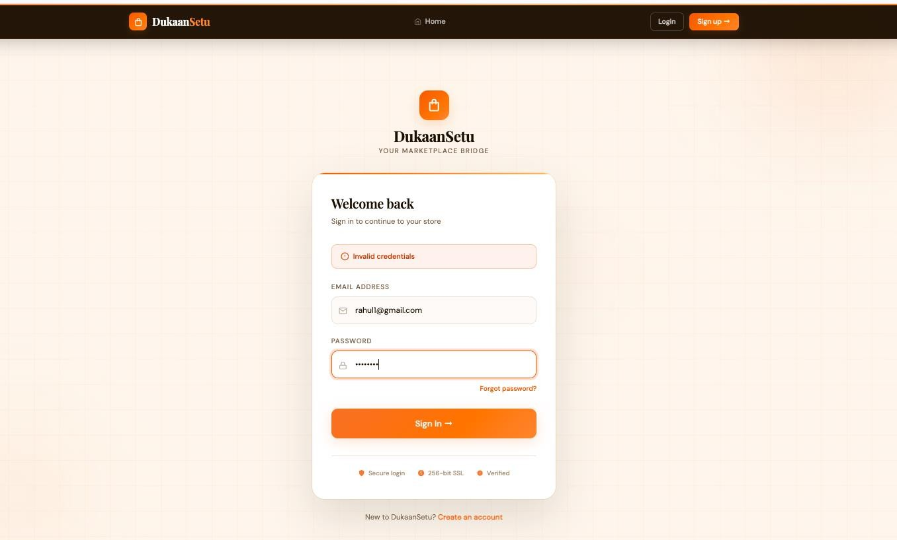
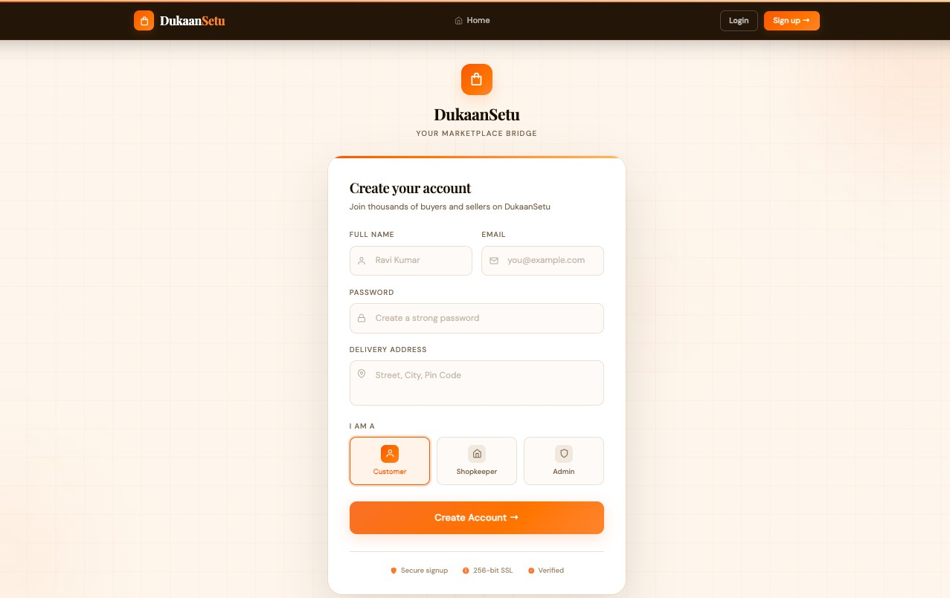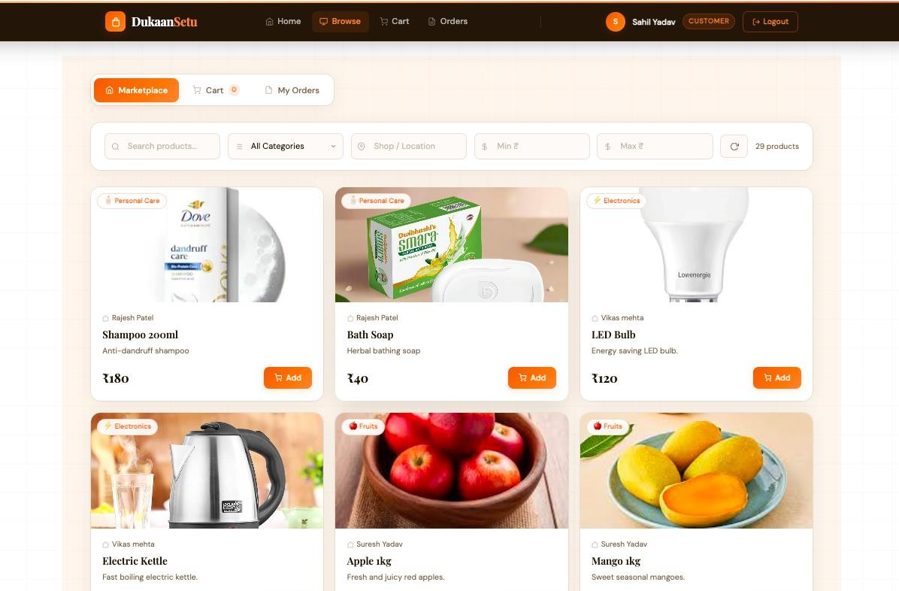
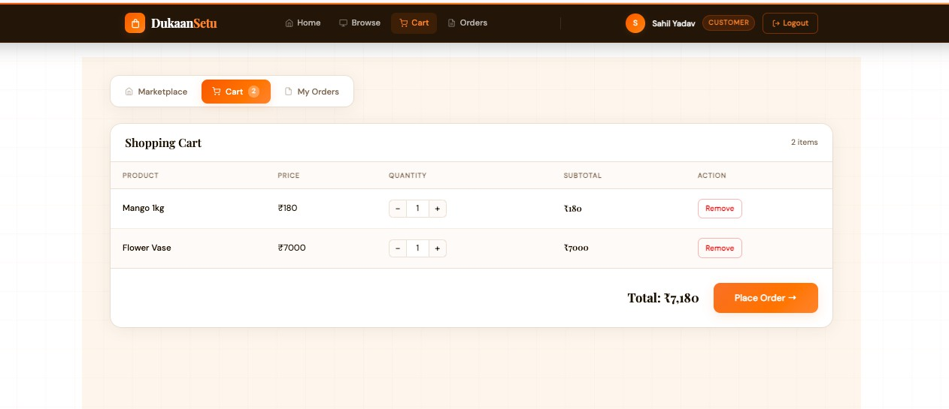

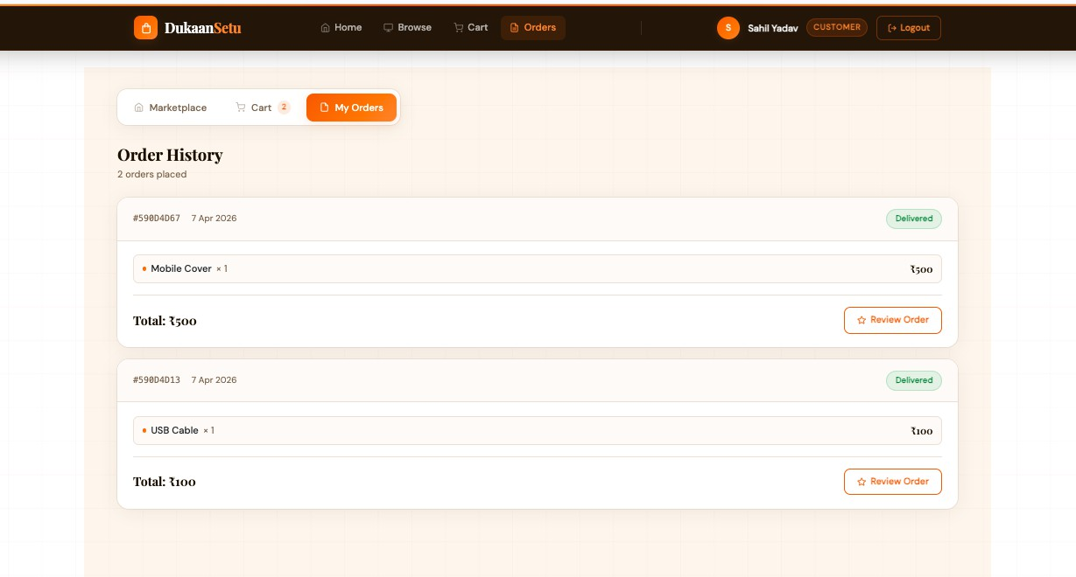
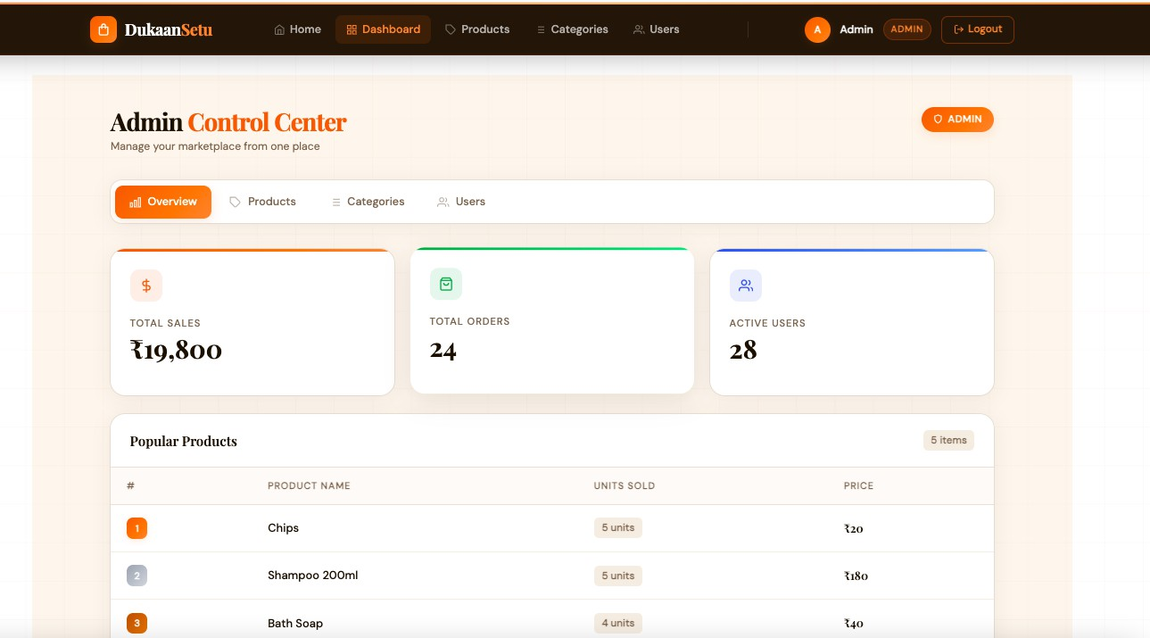

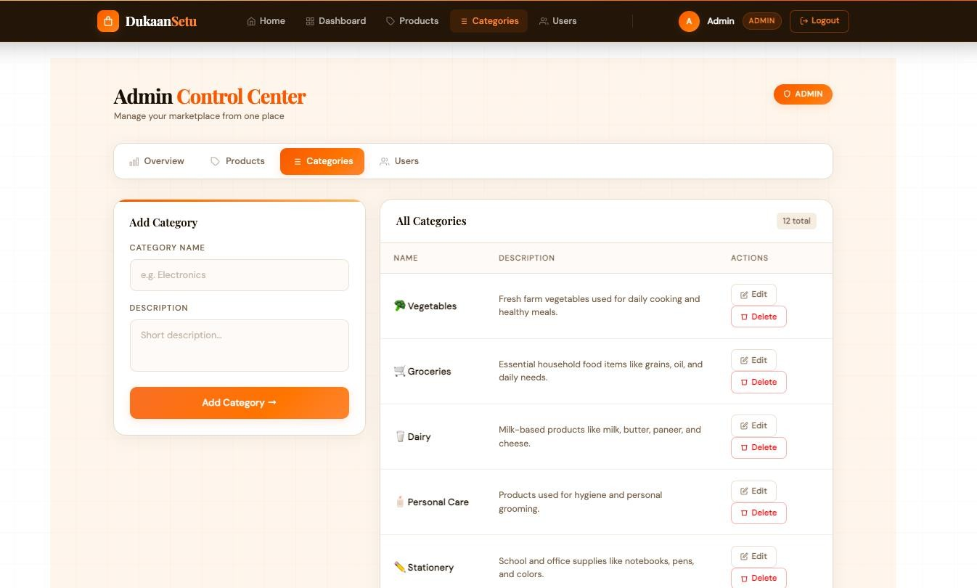
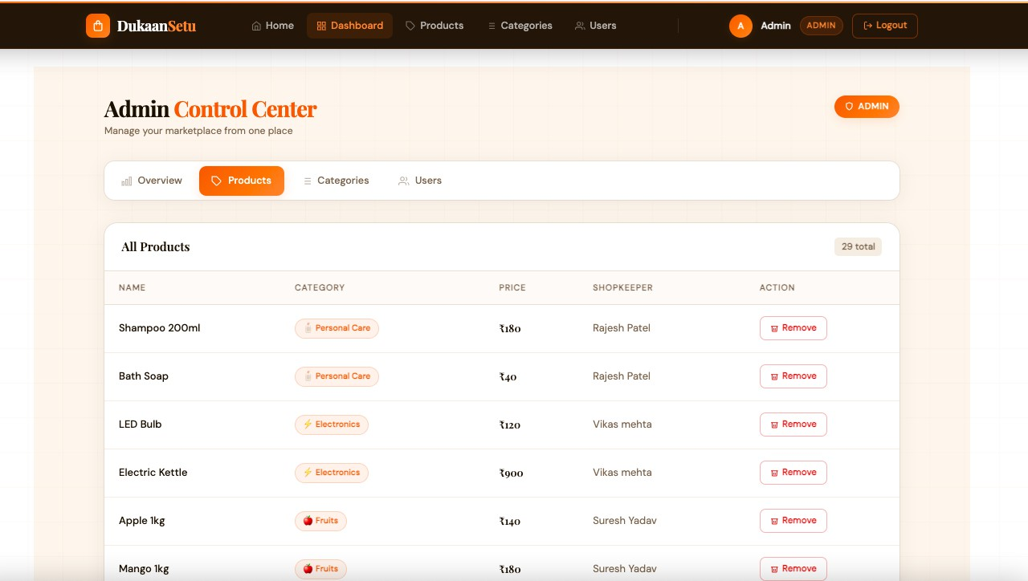

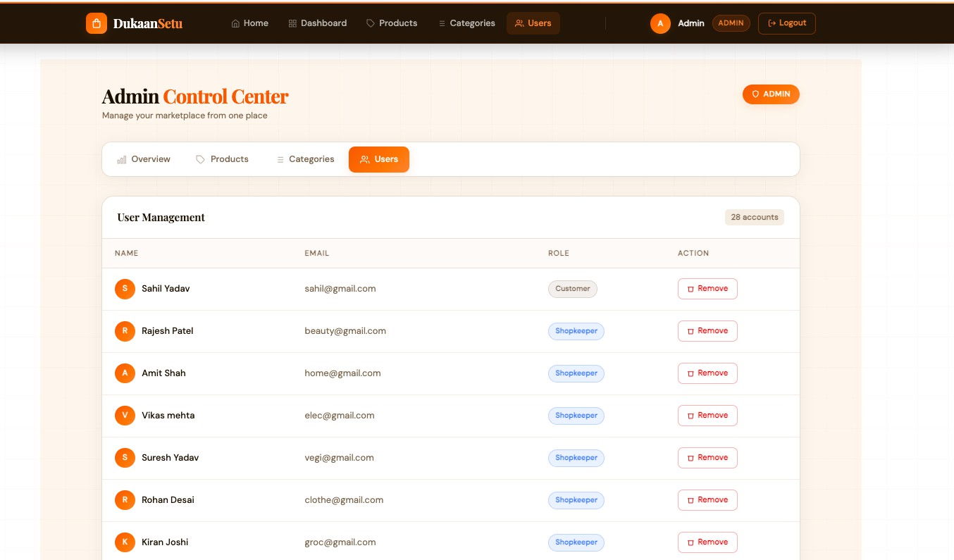
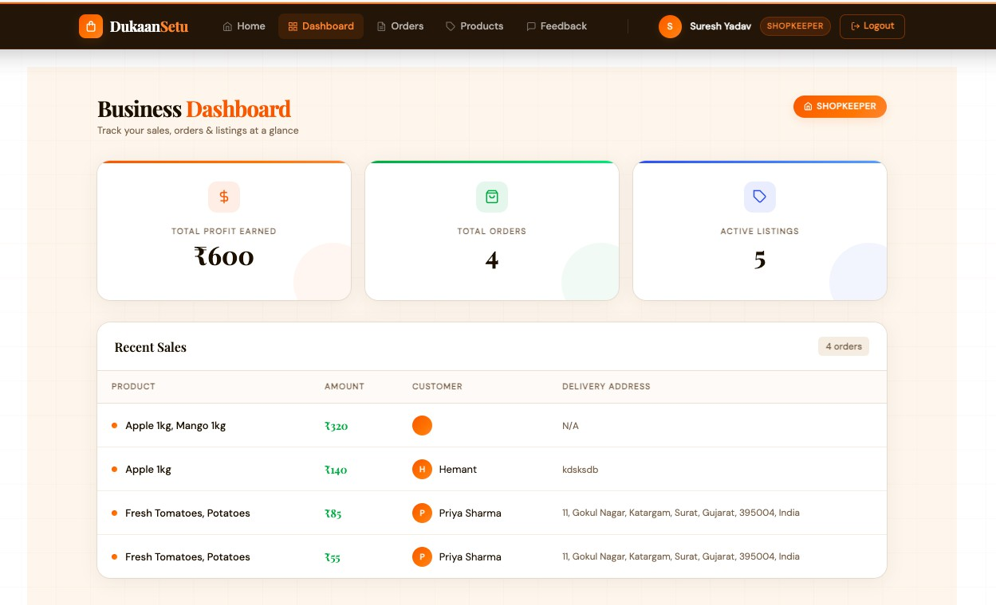
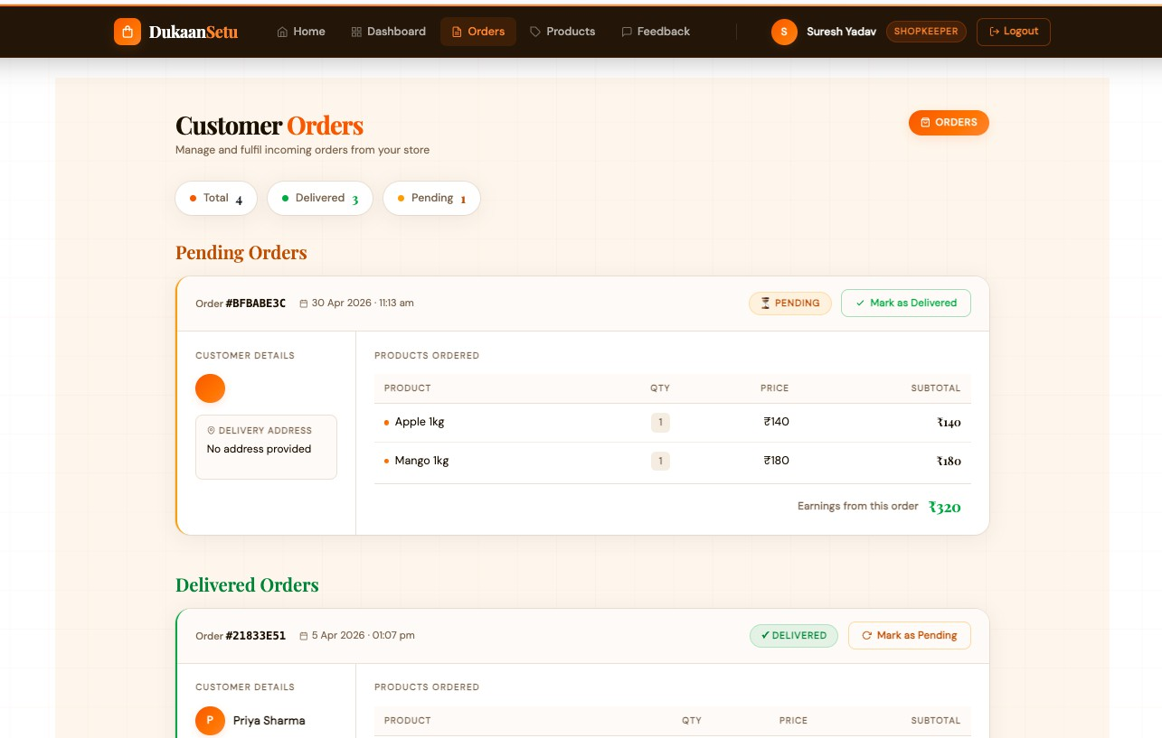
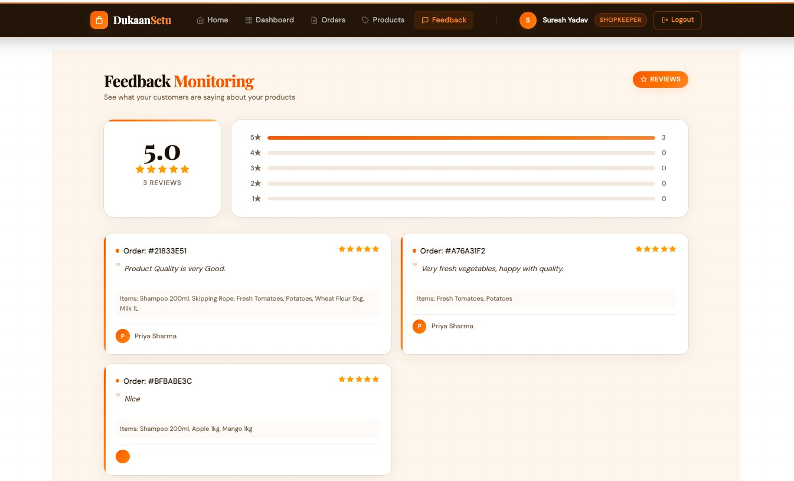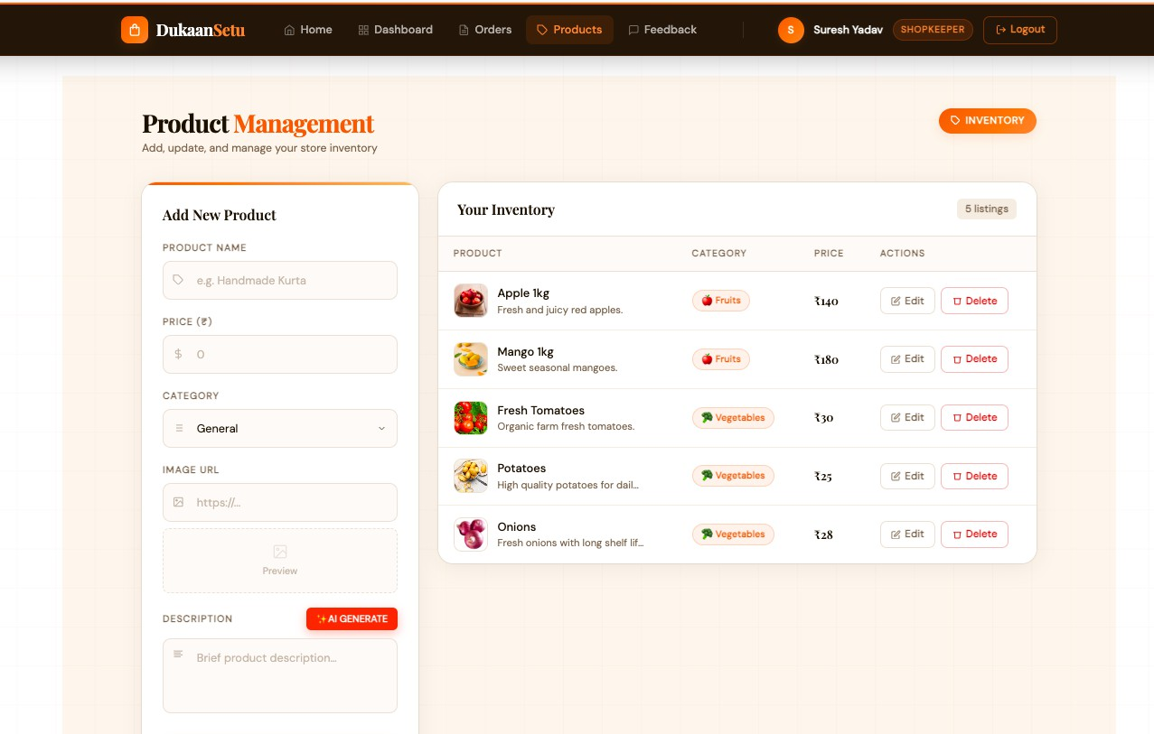
ANNEXURE 2 : SAMPLE PROGRAM CODE

App.jsx

import React, { useState } from 'react'; import { BrowserRouter as Router, Route, Routes, Navigate } from 'react-router-dom'; import Navbar from './components/Navbar'; import Login from './pages/Login'; import Signup from './pages/Signup'; import CustomerView from './pages/CustomerView'; import ShopkeeperDashboard from './pages/ShopkeeperDashboard'; import ProductManagement from './pages/ProductManagement'; import FeedbackMonitoring from './pages/FeedbackMonitoring'; import AdminDashboard from './pages/AdminDashboard'; import EditProduct from './pages/EditProduct'; import ShopkeeperOrders from './pages/ShopkeeperOrders'; import Home from './pages/Home'; import 'bootstrap/dist/css/bootstrap.min.css';
function App() { const [user, setUser] = useState(JSON.parse(localStorage.getItem('user')) || null);
const handleLogin = (userData) => { setUser(userData); localStorage.setItem('user', JSON.stringify(userData)); }; const handleLogout = () => { setUser(null); localStorage.removeItem('user'); localStorage.removeItem('token'); }; const isRole = (role) => user && user.role === role;
return ( <Route path="/" element={} /> <Route path="/login" element={} /> <Route path="/signup" element={}
/>
{/* Customer Routes */}
<Route path="/customer" element={isRole('customer') ? <div className="container mt-4"><CustomerView defaultView="marketplace" /></div> : <Navigate to="/login" />} />
<Route path="/cart" element={isRole('customer') ? <div className="container mt-4 "><CustomerView defaultView="cart" /></div> : <Navigate to="/login" />} />
<Route path="/orders" element={isRole('customer') ? <div className="container mt-4"><CustomerView defaultView="orders" /></div> : <Navigate to="/login" />} />

{/* Shopkeeper Routes */}
<Route path="/shopkeeper" element={isRole('shopkeeper') ? <div className="container mt-4"><ShopkeeperDashboard /></div> : <Navigate to="/login" />} />
<Route path="/shopkeeper-orders" element={isRole('shopkeeper') ? <div className="container mt-4"><ShopkeeperOrders /></div> : <Navigate to="/login" />} />
<Route path="/product-management" element={isRole('shopkeeper') ? <div className="container mt-4"><ProductManagement /></div> : <Navigate to="/login" />} />
<Route path="/feedback" element={isRole('shopkeeper') ? <div className="container mt-4"><FeedbackMonitoring /></div> : <Navigate to="/login" />} />
<Route path="/edit-product/:id" element={isRole('shopkeeper') ? <div className="container mt-4"><EditProduct /></div> : <Navigate to="/login" />} />
{/* Admin Routes */}
<Route path="/admin" element={isRole('admin') ? <div className="container mt-4"><AdminDashboard defaultTab="stats" /></div> : <Navigate to="/login" />} />
<Route path="/admin-products" element={isRole('admin') ? <div className="container mt-4"><AdminDashboard defaultTab="products" /></div> : <Navigate to="/login" />} />
<Route path="/admin-categories" element={isRole('admin') ? <div className="container mt-4"><AdminDashboard defaultTab="categories" /></div> : <Navigate to="/login" />} />
<Route path="/admin-users" element={isRole('admin') ? <div className="container mt-4"><AdminDashboard defaultTab="users" /></div> : <Navigate to="/login" />} />
</Routes>
</Router>
); }
export default App;

Index.js

const express = require('express'); const mongoose = require('mongoose'); const cors = require('cors');
const http = require('http'); // Import http
const { Server } = require('socket.io'); // Import socket.io require('dotenv').config();

const app = express();
const server = http.createServer(app); // Create HTTP server const io = new Server(server, {
cors: {
origin: "http://localhost:5173", // Your frontend URL methods: ["GET", "POST", "PUT", "DELETE"]
}
});

app.use(cors()); app.use(express.json());

const PORT = process.env.PORT || 5000;
const MONGO_URI = process.env.MONGO_URI || 'mongodb://localhost:27017/dukaansetu';

mongoose.connect(MONGO_URI)
.then(() => console.log('MongoDB connected'))
.catch(err => console.log(err));
app.set('socketio', io);

io.on('connection', (socket) => {
// console.log('A user connected:', socket.id); // Silent connection

socket.on('join', (userId) => { socket.join(userId);
// console.log(`User ${userId} joined their room`);
});

socket.on('disconnect', () => {
// console.log('User disconnected');
});
});

app.use('/api/auth', require('./routes/auth')); app.use('/api/products', require('./routes/products')); app.use('/api/orders', require('./routes/orders')); app.use('/api/admin', require('./routes/admin')); app.use('/api/reviews', require('./routes/reviews'));

server.listen(PORT, () => console.log(`Server running on port ${PORT}`));

