IPL BALL-BY-BALL
DATA ANALYSIS
Interactive Python Dashboard & Project Report
IBM Internship Data Analytics Project
Python • Pandas • NumPy • Plotly • Streamlit
Dataset: Ball_by_Ball.csv
Professional project documentation with the exact dashboard screenshots supplied for submission.
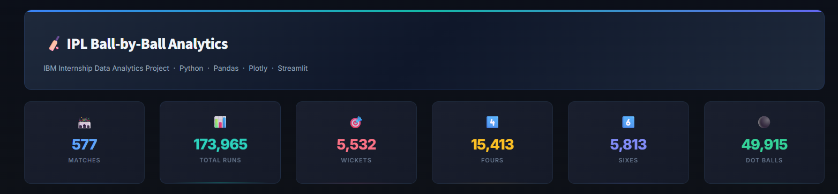
Figure 1. Exact dashboard header and KPI-card screenshot.

1. Executive Summary
This project presents an end-to-end IPL ball-by-ball data analytics solution developed using Python. The workflow transforms delivery-level cricket data into meaningful performance metrics and an interactive Streamlit dashboard. The dashboard provides team, batting, bowling, scoring, extras, dismissal and innings-level analysis.
The dashboard screenshots included in this report are the exact screenshots supplied by the project author. They are embedded without recreating or redesigning the visual content.

2. Project Objectives
- Load and clean the IPL ball-by-ball dataset.
- Create analytical features such as total runs, dot balls, fours, sixes and wickets.
- Analyze team-level batting performance and run rate.
- Identify top batting performers using striker IDs.
- Analyze bowling performance using wickets and economy.
- Study scoring trends across over numbers.
- Analyze extras and dismissal types.
- Provide innings score distribution and filtered ball-level data.
- Build a professional interactive dashboard using Python and Streamlit.

3. Dashboard KPI Summary
KPI | Value | KPI | Value
Matches | 577 | Total Runs | 173,965
Wickets | 5,532 | Fours | 15,413
Sixes | 5,813 | Dot Balls | 49,915
The KPI values above are transcribed directly from the supplied dashboard screenshot.

4. Dataset and Analytical Methodology
The source dataset is a ball-by-ball IPL dataset in CSV format. Each record represents a delivery and contains match, innings, over, ball, team, player, scoring, extras and dismissal information.
Stage | Implementation
Data ingestion | Read the CSV dataset using Pandas.
Data cleaning | Standardize column names, convert numeric fields and handle missing categorical values.
Feature engineering | Create total runs and binary indicators for dot balls, fours, sixes and wickets.
Aggregation | Group records by teams, striker IDs, bowler IDs, overs, extras and dismissal types.
Visualization | Present analytical results through interactive Plotly charts in Streamlit.
Dashboard | Combine KPIs, charts, filters and a detailed data table into one user-facing application.

5. Exact Dashboard Screenshots
The following pages contain the exact dashboard screenshots provided for the project. The screenshots are included as submitted and are not replaced by generated approximations.

5.1 Team Performance Overview
The team overview compares total runs and run rate across batting team IDs.
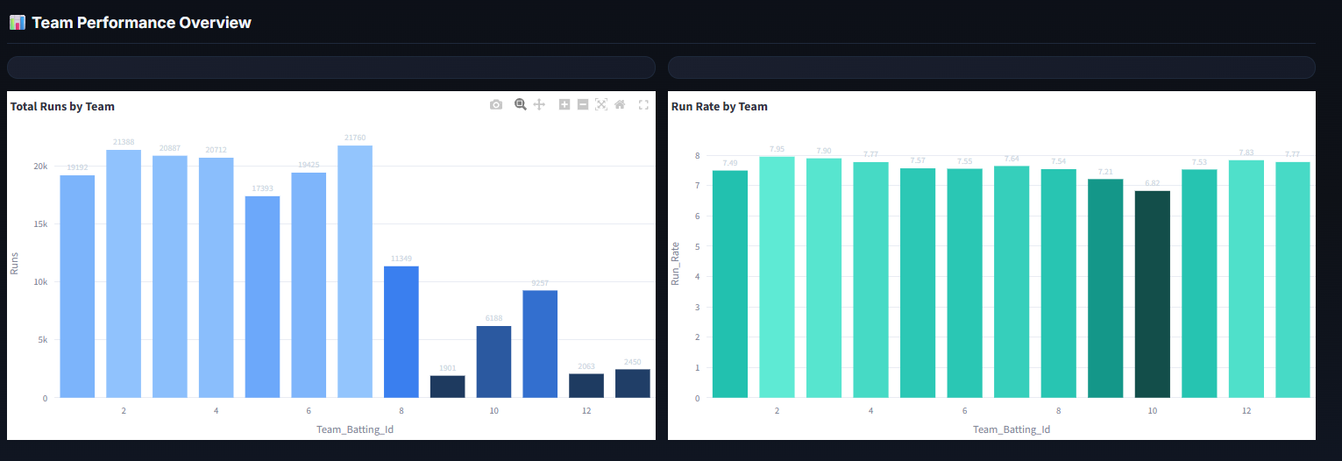
Figure 2. Exact screenshot supplied for the dashboard.

5.2 Dashboard Header and KPI Cards
The dashboard header presents the project identity and six high-level KPIs.
Figure 3. Exact screenshot supplied for the dashboard.

5.3 Top Batting Performers
This view presents the top 15 striker IDs by runs scored.
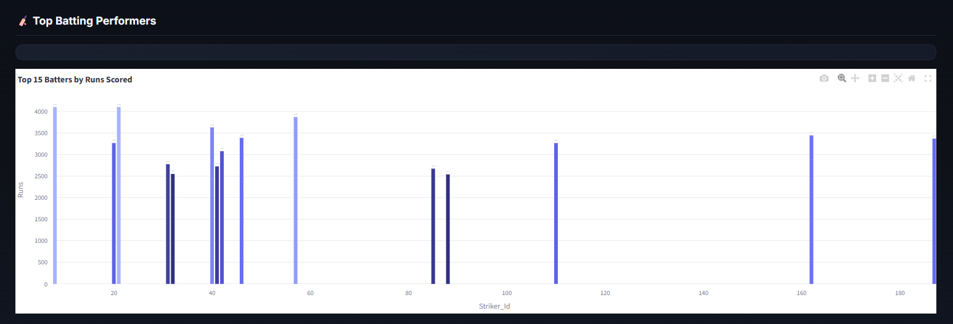
Figure 4. Exact screenshot supplied for the dashboard.

5.4 Bowling Performance
This view compares bowlers by recorded wickets and economy among bowlers meeting the dashboard threshold.
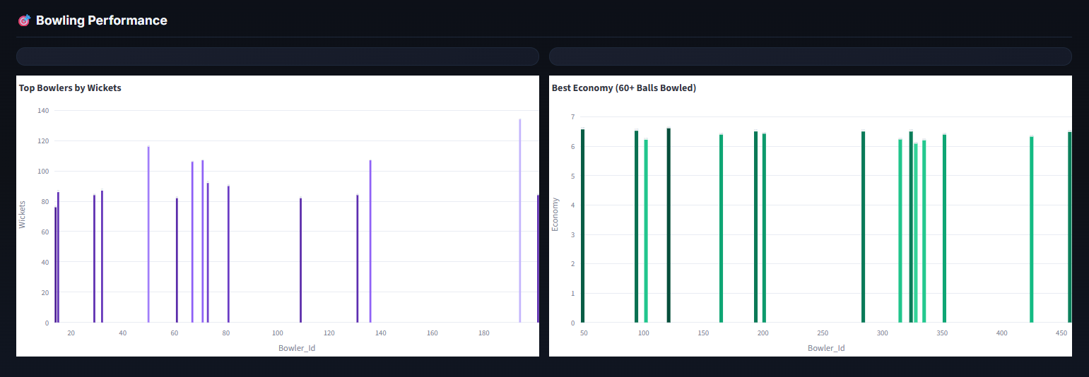
Figure 5. Exact screenshot supplied for the dashboard.

5.5 Scoring Trends by Over
The line chart shows the progression of run rate across over numbers.
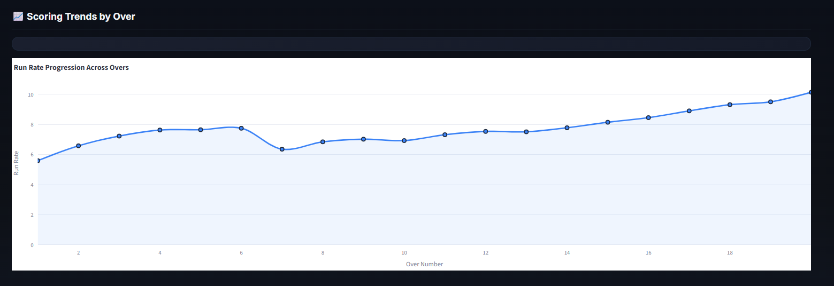
Figure 6. Exact screenshot supplied for the dashboard.

5.6 Extras and Dismissals Breakdown
The dashboard separates extra-run categories and displays dismissal-type counts.
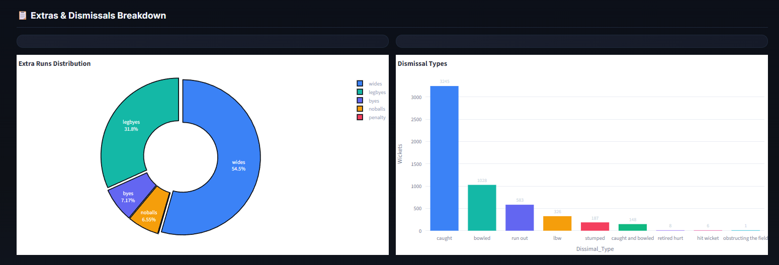
Figure 7. Exact screenshot supplied for the dashboard.

5.7 Innings Score Distribution
The histogram shows the distribution of innings totals.
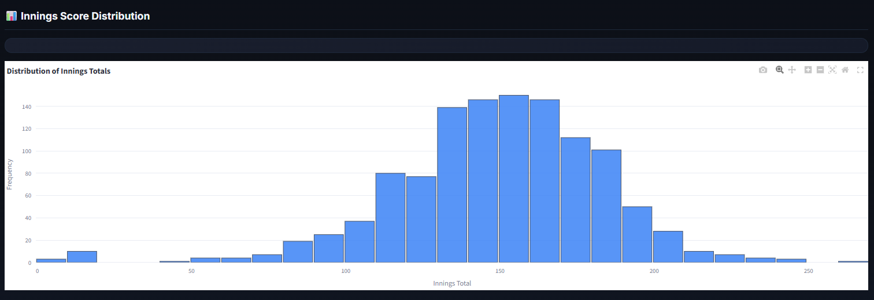
Figure 8. Exact screenshot supplied for the dashboard.

5.8 Filtered Ball-by-Ball Data
The detailed table provides delivery-level records including match, innings, over, teams, players, runs, extras and dismissal information.
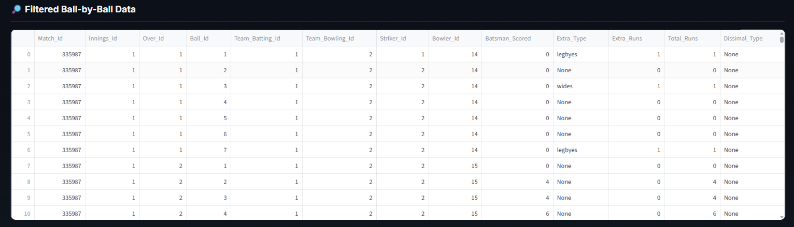
Figure 9. Exact screenshot supplied for the dashboard.

6. Key Analytical Findings
- The dashboard reports 577 matches and 173,965 total runs.
- The dashboard records 5,532 wickets, 15,413 fours and 5,813 sixes.
- There are 49,915 dot balls in the displayed dataset.
- Team performance varies substantially across batting team IDs, with the dashboard showing both aggregate runs and run-rate comparisons.
- The batting-performance view highlights substantial differences in aggregate runs among striker IDs.
- The bowling view provides two complementary measures: recorded wickets and economy for bowlers with at least 60 balls.
- The run-rate trend increases toward the later overs in the displayed aggregate view, with a noticeable dip around the middle overs.
- Wides and leg byes form the largest portions of the displayed extra-run distribution.
- Caught dismissals are the most frequently displayed dismissal category, followed by bowled and run out.
- The innings-score histogram shows most innings totals concentrated around the middle scoring range, with fewer very low and very high totals.

7. Technical Stack
- Python — primary programming language
- Pandas — data cleaning and analysis
- NumPy — numerical transformations
- Plotly — interactive visualization
- Streamlit — dashboard development
- Jupyter Notebook — reproducible analysis workflow

8. Dashboard Features
Dashboard Component | Purpose
KPI Cards | Matches, total runs, wickets, fours, sixes and dot balls.
Team Analysis | Total runs and run rate by batting team ID.
Batting Analysis | Top 15 striker IDs by runs.
Bowling Analysis | Wickets and economy for qualified bowlers.
Scoring Trends | Run-rate progression across overs.
Extras Analysis | Distribution of wides, leg byes, byes, no-balls and penalties.
Dismissal Analysis | Counts by dismissal type.
Innings Distribution | Frequency distribution of innings totals.
Data Explorer | Detailed filtered ball-by-ball records.

9. Limitations and Future Scope
- The supplied dashboard uses numeric team and player IDs rather than readable names.
- A verified team/player master table could be added to improve dashboard readability.
- Season, venue and match-result dimensions could be incorporated if available.
- Future versions could include phase-wise analysis, player ranking models, predictive analytics and win-probability modeling.

10. Conclusion
The IPL Ball-by-Ball Analytics project demonstrates a complete Python-based data analytics workflow, from raw delivery-level data to an interactive dashboard. The solution combines data preparation, feature engineering, aggregation, visualization and dashboard development into a practical internship-ready project.

11. Project Deliverables
- Ball_by_Ball.csv — source dataset
- IPL_Ball_by_Ball_IBM_Project.ipynb — complete Python analysis notebook
- app.py — Streamlit dashboard application
- IPL_IBM_Project_Report_Exact_Dashboard_Screenshots.docx — final project report with exact dashboard screenshots
IBM Internship Data Analytics Project

