Dear Aspirer,
The project report is an inherent component of your Industry Project. We are enclosing a reference table of contents for the project report. Depending on the Industry project, you may choose to include, exclude, or rename sections from the Table of Contents listed below. You can also showcase your creativity to present the report. The key objective of this report is to comprehensively document the project work completed.
Industry Project Title | Personal Finance Tracker
Name of the Company | TCS ion
Name of the Institute | MP Online

Start Date | End Date | Total Effort (hrs.) | Project Environment | Tools used
25/10/2025 | 09/11/2025 | 90 | Java | VS Code

TABLE OF CONTENTS
- Acknowledgements
- Objective and Scope
- Problem Statement
- Existing Approaches
- Approach / Methodology - Tools and Technologies used
- Workflow
- Assumptions
- Implementation - Data collection, Processing Steps, Diagrams - Charts, Table
- Solution Design
- Challenges & Opportunities
- Reflections on the project
- Recommendations
- Outcome / Conclusion
- Enhancement Scope
- Link to code and executable file
- Research questions and responses
- References

Acknowledgements

I would like to express my sincere gratitude to TCS iON PSP for providing me with the opportunity to work on this comprehensive and enriching project. The Industry Project has played a pivotal role in enhancing my technical skills and offering valuable exposure to real-world software development challenges.

I am especially thankful to Atul Kumar Gupta, whose invaluable guidance, constant support, and expert insights have been crucial throughout the entire project lifecycle. His patience in explaining complex concepts, providing constructive feedback, and sharing industry best practices has significantly enriched my learning experience and contributed to the successful completion of this project.

I would also like to extend my heartfelt thanks to Sumanpreet Hora and Ifra Shareef for their continuous support and encouragement throughout this journey. Their inputs, mentorship, and collaboration have been instrumental in shaping the outcome of this project.

The mentorship and resources provided by TCS iON PSP have not only enabled me to develop a robust Event Booking Management System but have also instilled in me the confidence to tackle future challenges in software development. I am truly grateful for the knowledge, experience, and professional growth I have gained through this opportunity.

DATE : 09/11/2025
PLACE: BHOPAL

Objective and Scope

The objective of this project is to build a Personal Finance Tracker using object-oriented programming in JAVA.
This application allows users to record income & expenses and generates a financial summary report showing savings trend.

The scope of this project is limited to console-based personal finance management for a single user.

Problem Statement

Managing finances manually becomes difficult. Most people forget where their money is going. Tracking income and expenses needs a systematic and structured record. This project solves this problem by providing a simple automated system to enter transactions and compute the savings report.

Existing Approaches

There are several apps and tools available for expense tracking; however:

Many require internet connectivity and account setup.

Some are complex for casual users.

Most are not open-source or customizable.

This project provides a lightweight, console-based alternative that can be extended as needed.

Approach / Methodology - Tools and Technologies used
Component | Technology
Programming Language | Java
Concepts Used | Object Oriented Programming (Polymorphism, Inheritance, Abstraction)
IDE Used | VS Code
Memory Management | Smart Pointers (unique )
Output Medium | Console Application

Workflow

User selects Add Income / Add Expense

User inputs amount + category + date

The system applies the transaction and updates the balance

System stores the transaction list in memory

The user can generate a financial report anytime

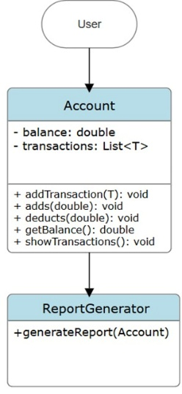
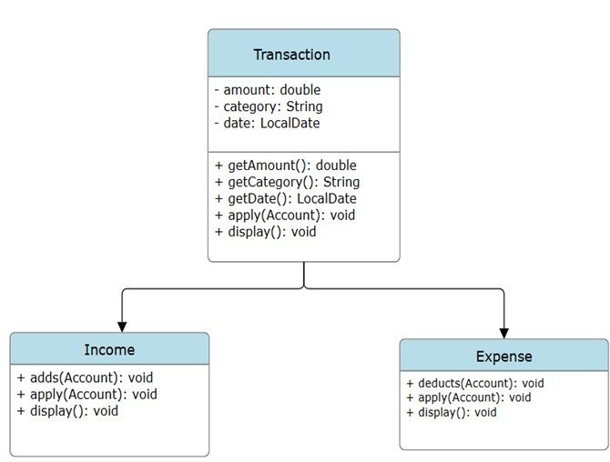

Assumptions

One user only

Date input format is correct (DD-MM-YYYY)

Data is stored in runtime memory (not persisted permanently)

Implementation

Data Collection:

Input received from the user during runtime via the console

Processing Steps:

Validate user input

Polymorphism-based transaction applies

Balance Updation through unified addBalance() method
- FT01 - Transaction Entry
- 4 iteration
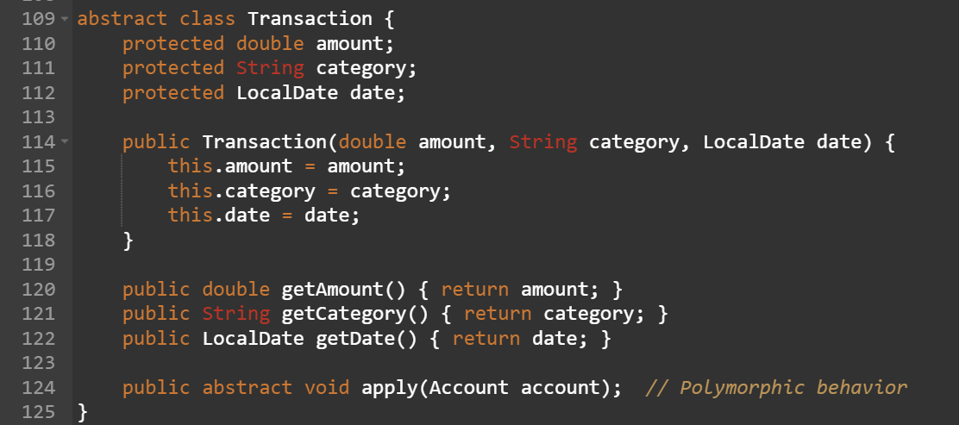
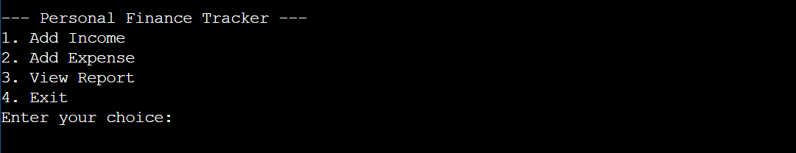

- FT02 - Verify income addition
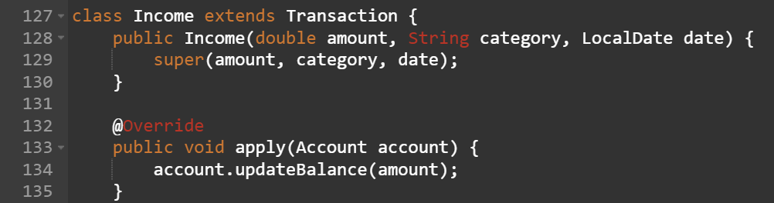
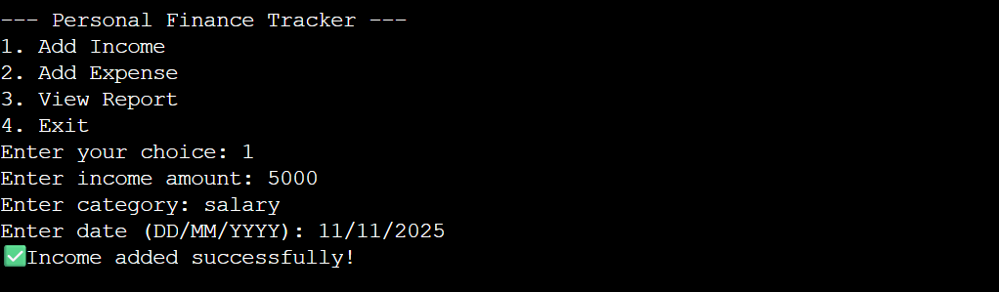
2.1. Balance should increase .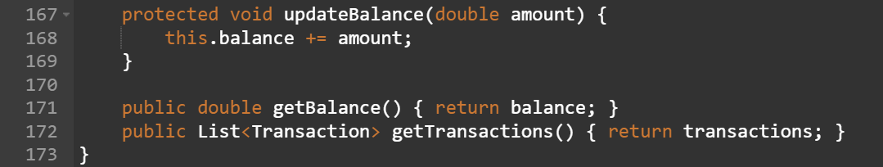
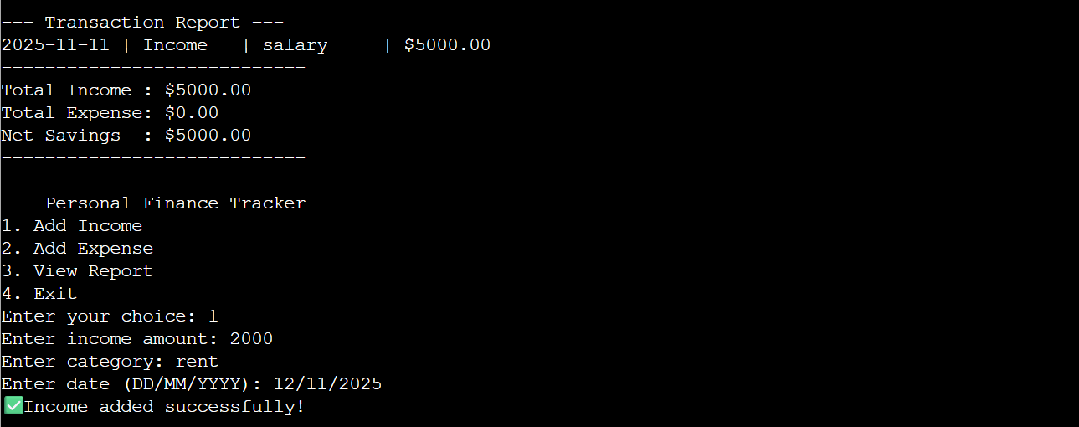
2.2. Code running - Yes
2.3. Income adding = 5000
  - 3 iteration
  - Manual check -Yes
  - Balance updated
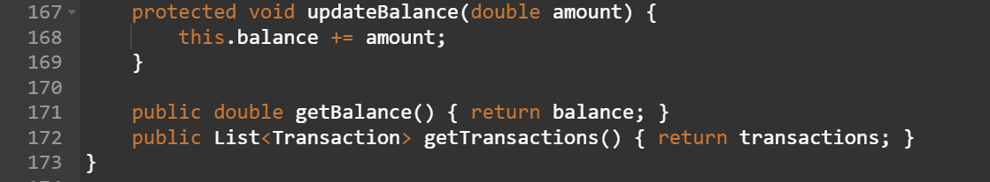
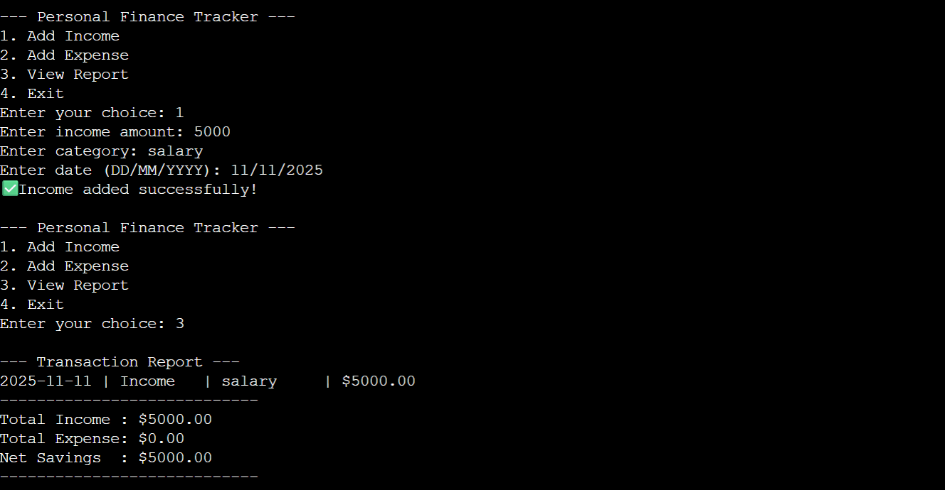
  - NA

- Test Case template :
- FT02
- Check expense deduction
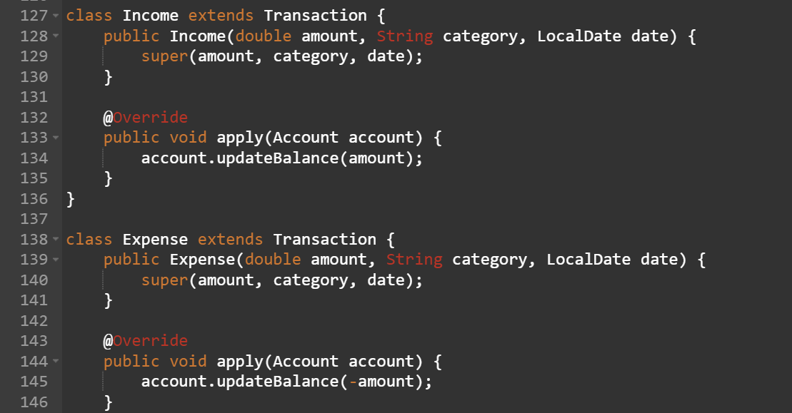
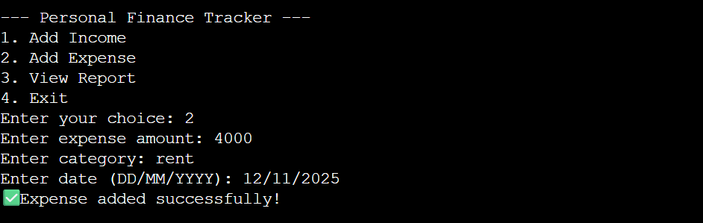

- Account Transaction report
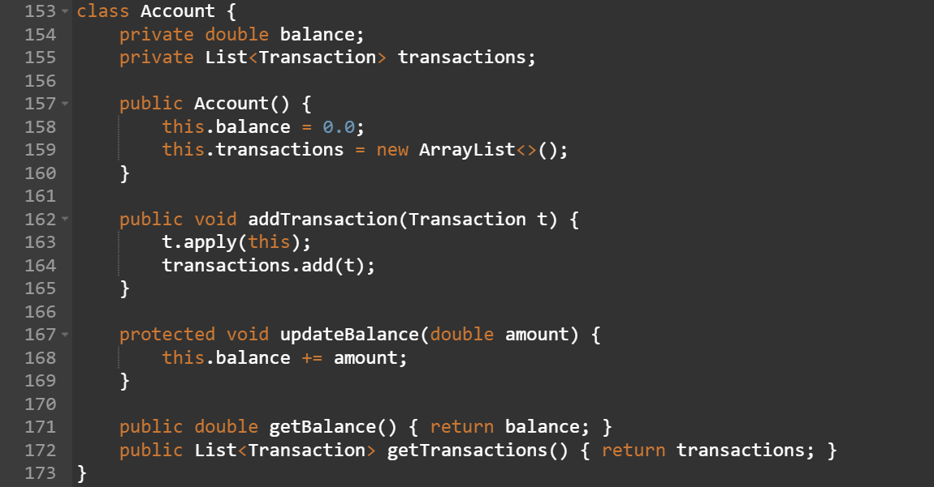
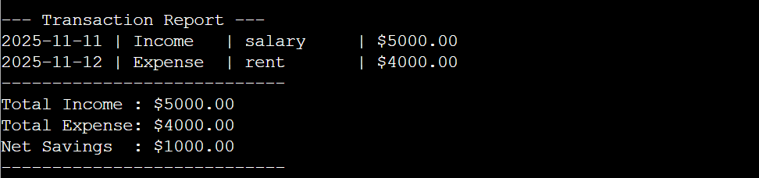
- Add expense of 2000
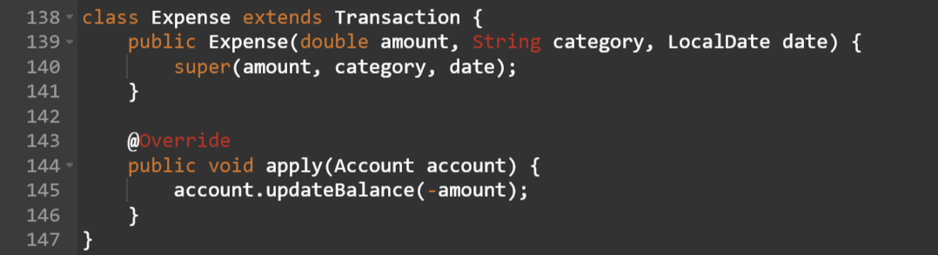
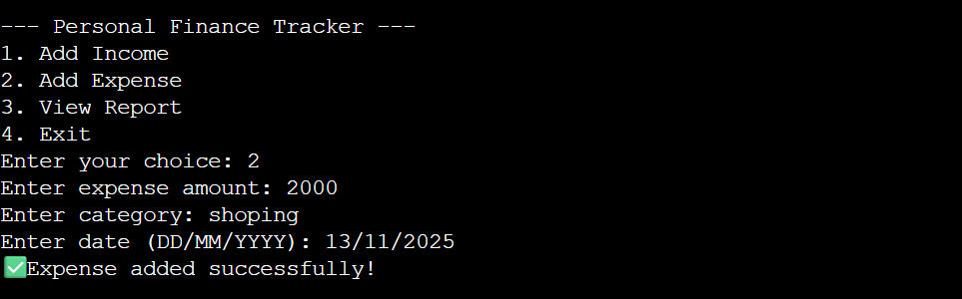
- Balance should decrease
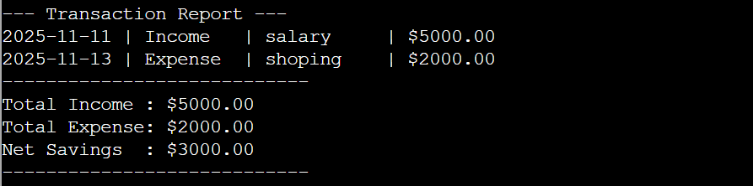
- Code running – Yes
- Expense = 2000

- Test Scenario Template :
- REQ01
- TS01
- Report Generator
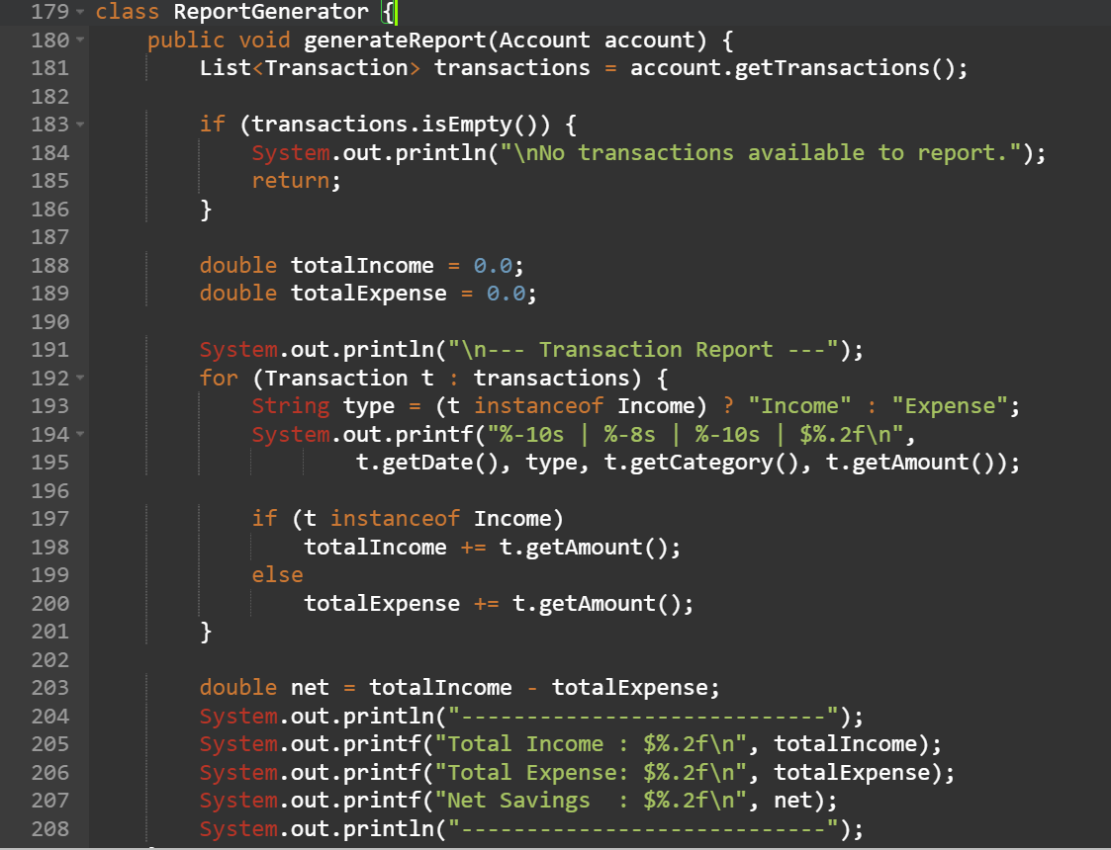
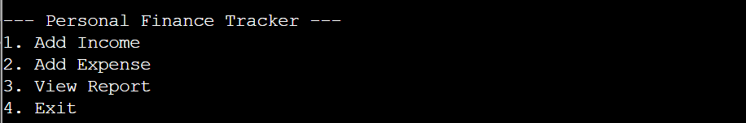

- Generate monthly report
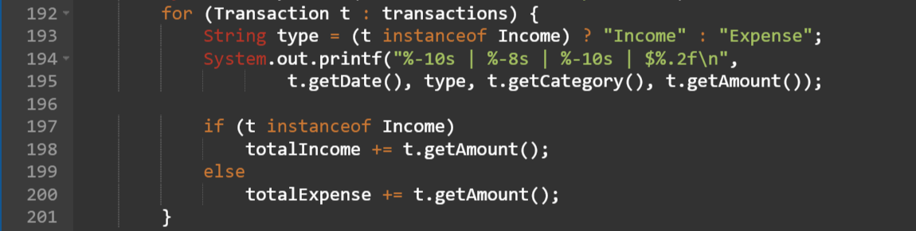
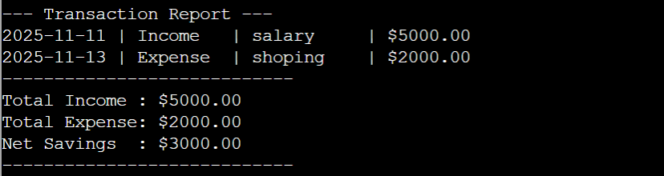
- Income, Expenses, Saving
- High

Solution Design

Classes Used:

Transaction (Base)

Income (Derived)

Expense (Derived)

Account (Manages all transactions + balance)

Report Generator

Inheritance + dynamic polymorphism allows runtime linking of Income/Expense apply.

Challenges & Opportunities
Challenges | Opportunities
Date validation | Use the chrono library date validation.
No database persistence | Add MySQL / SQLite storage.
No chart visual representation | Add web UI / dashboard.

Reflections

This project improved my understanding of OOP, smart pointers, abstractions and file handling. It helped me think modularly and design reusable class structures.

Recommendations

Add category-wise charting

Add search /

filter (month-wise, category-wise)

Export report file (PDF / CSV)

Add login / multi-user support

Outcome / Conclusion

A functional personal finance tracker was developed using JAVA OOP, which successfully records transactions and generates a financial summary. It simplifies financial record-keeping and promotes better money management.

Enhancement Scope

Cloud sync option

Mobile app UI

Graph-based analytics

ML-based expense prediction

Link to code and executable file

GitHub:

Research Questions & Answers
Research Question | Response
Why OOP instead of procedural Java ? | Scalability & reusability increase.
Why smart pointers? | Prevent memory leaks without manual deletion.
Which design pattern was used? | Polymorphic command-based transaction apply pattern.

References

JAVA Documentation

geeksforgeeks.org

ISO JAVA Standard Library tutorials

