**Introduction to Request Dispatcher**

**RequestDispatcher** is an interface, implementation of which defines an object which can dispatch request to any resources(such as HTML, Image, JSP, Servlet) on the server.

**Methods of RequestDispatcher**

**RequestDispatcher** interface provides two important methods

|  |  |
| --- | --- |
| **Methods** | **Description** |
| void forward(ServletRequest request, ServletResponse response) | forwards a request from a servlet to another resource (servlet, JSP file, or HTML file) on the server |
| void include(ServletRequest request, ServletResponse response) | includes the content of a resource (servlet, JSP page, HTML file) in the response |

**How to get an Object of RequestDispatcher**

getRequestDispatcher() method of **ServletRequest** returns the object of **RequestDispatcher**.

RequestDispatcher *rs* = request.**getRequestDispatcher**("hello.html");

rs.**forward**(request,response);

**OR**

RequestDispatcher *rs* = request.**getRequestDispatcher**("hello.html");

rs.**include**(request,response);

**Example demonstrating usage of RequestDispatcher**

In this example, we will show you how RequestDispatcher is used to **forward** or **include** response of a resource in a Servlet. Here we are using **index.html** to get username and password from the user, **Validate** Servlet will validate the password entered by the user, if the user has entered "studytonight" as password, then he will be forwarded to **Welcome** Servlet else the user will stay on the index.html page and an error message will be displayed.

**Files to be created :**

* **index.html** will have form fields to get user information.
* **Validate.java** will validate the data entered by the user.
* **Welcome.java** will be the welcome page.
* **web.xml** , the deployment descriptor.

**index.html**

<form method="**post**" action="**Validate**">

Name:<input type="text" name="user" /><br/>

Password:<input type="password" name="pass" ><br/>

<input type="submit" value="submit">

</form>

**Validate.java**

import java.io.*;

import javax.servlet.*;

import javax.servlet.http.*;

public class *Validate* **extends** HttpServlet {

protected void **doPost**(HttpServletRequest request, HttpServletResponse response)

throws ServletException, IOException {

response.setContentType("text/html;charset=UTF-8");

PrintWriter out = response.getWriter();

try {

String **name** = request.getParameter("user");

String **password** = request.getParameter("pass");

if(**password**.equals("studytonight"))

{

RequestDispatcher *rd* = request.**getRequestDispatcher**("Welcome");

rd.**forward**(request, response);

}

else

{

out.println("<font color='red'><b>You have entered incorrect password</b></font>");

RequestDispatcher *rd* = request.**getRequestDispatcher**("index.html");

rd.**include**(request, response);

}

}finally {

out.close();

}

}

}

**Welcome.java**

import java.io.*;

import javax.servlet.*;

import javax.servlet.http.*;

public class *Welcome* **extends** HttpServlet {

protected void **doPost**(HttpServletRequest request, HttpServletResponse response)

throws ServletException, IOException {

response.setContentType("text/html;charset=UTF-8");

PrintWriter **out** = response.getWriter();

try {

out.println("<h2>Welcome user</h2>");

} finally {

out.close();

}

}

}

**web.xml**

<web-app>

<servlet>

<servlet-name>Validate</servlet-name>

<servlet-class>Validate</servlet-class>

</servlet>

<servlet>

<servlet-name>Welcome</servlet-name>

<servlet-class>Welcome</servlet-class>

</servlet>

<servlet-mapping>

<servlet-name>Validate</servlet-name>

<url-pattern>/Validate</url-pattern>

</servlet-mapping>

<servlet-mapping>

<servlet-name>Welcome</servlet-name>

<url-pattern>/Welcome</url-pattern>

</servlet-mapping>

<welcome-file-list>

<welcome-file>index.html</welcome-file>

</welcome-file-list>

</web-app>

This will be the first screen. You can enter your Username and Password here.

When you click on Submit, Password will be validated, if it is not 'studytonight' , error message will be displayed.

Enter any Username, but enter 'studytonight' as password.

Password will be successfully validated and you will be directed to the Welcome Servlet.

# Life Cycle of a Servlet (Servlet Life Cycle)

1. [Life Cycle of a Servlet](http://www.javatpoint.com/life-cycle-of-a-servlet)
   1. [Servlet class is loaded](http://www.javatpoint.com/life-cycle-of-a-servlet#servletlifecycle1)
   2. [Servlet instance is created](http://www.javatpoint.com/life-cycle-of-a-servlet#servletlifecycle2)
   3. [init method is invoked](http://www.javatpoint.com/life-cycle-of-a-servlet#servletlifecycle3)
   4. [service method is invoked](http://www.javatpoint.com/life-cycle-of-a-servlet#servletlifecycle4)
   5. [destroy method is invoked](http://www.javatpoint.com/life-cycle-of-a-servlet#servletlifecycle5)

The web container maintains the life cycle of a servlet instance. Let's see the life cycle of the servlet:

1. Servlet class is loaded.
2. Servlet instance is created.
3. init method is invoked.
4. service method is invoked.
5. destroy method is invoked.

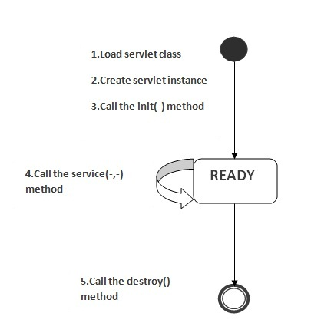

As displayed in the above diagram, there are three states of a servlet: new, ready and end. The servlet is in new state if servlet instance is created. After invoking the init() method, Servlet comes in the ready state. In the ready state, servlet performs all the tasks. When the web container invokes the destroy() method, it shifts to the end state.

### 1) Servlet class is loaded

The classloader is responsible to load the servlet class. The servlet class is loaded when the first request for the servlet is received by the web container.

### 2) Servlet instance is created

The web container creates the instance of a servlet after loading the servlet class. The servlet instance is created only once in the servlet life cycle.

### 3) init method is invoked

|  |
| --- |
| The web container calls the init method only once after creating the servlet instance. The init method is used to initialize the servlet. It is the life cycle method of the javax.servlet.Servlet interface. Syntax of the init method is given below: |

[copy to clipboard](http://www.javatpoint.com/life-cycle-of-a-servlet)

1. public void init(ServletConfig config) throws ServletException



### 4) service method is invoked

The web container calls the service method each time when request for the servlet is received. If servlet is not initialized, it follows the first three steps as described above then calls the service method. If servlet is initialized, it calls the service method. Notice that servlet is initialized only once. The syntax of the service method of the Servlet interface is given below:

[copy to clipboard](http://www.javatpoint.com/life-cycle-of-a-servlet)

1. public void service(ServletRequest request, ServletResponse response)
2. throws ServletException, IOException



### 5) destroy method is invoked

The web container calls the destroy method before removing the servlet instance from the service. It gives the servlet an opportunity to clean up any resource for example memory, thread etc. The syntax of the destroy method of the Servlet interface is given below:

[copy to clipboard](http://www.javatpoint.com/life-cycle-of-a-servlet)

1. public void destroy()

# Steps to create a servlet example

1. [Steps to create the servlet using Tomcat server](http://www.javatpoint.com/steps-to-create-a-servlet-using-tomcat-server)
   1. [Create a directory structure](http://www.javatpoint.com/steps-to-create-a-servlet-using-tomcat-server#servletstep1)
   2. [Create a Servlet](http://www.javatpoint.com/steps-to-create-a-servlet-using-tomcat-server#servletstep2)
   3. [Compile the Servlet](http://www.javatpoint.com/steps-to-create-a-servlet-using-tomcat-server#servletstep3)
   4. [Create a deployment descriptor](http://www.javatpoint.com/steps-to-create-a-servlet-using-tomcat-server#servletstep4)
   5. [Start the server and deploy the application](http://www.javatpoint.com/steps-to-create-a-servlet-using-tomcat-server#servletstep5)

There are given 6 steps to create a **servlet example**. These steps are required for all the servers.

The servlet example can be created by three ways:

1. By implementing Servlet interface,
2. By inheriting GenericServlet class, (or)
3. By inheriting HttpServlet class

The mostly used approach is by extending HttpServlet because it provides http request specific method such as doGet(), doPost(), doHead() etc.

Here, we are going to use **apache tomcat server** in this example. The steps are as follows:

1. Create a directory structure
2. Create a Servlet
3. Compile the Servlet
4. Create a deployment descriptor
5. Start the server and deploy the project
6. Access the servlet

[download this example of servlet](http://www.javatpoint.com/src/servlet/firstservlet.zip)  
[download example of servlet by extending GenericServlet](http://www.javatpoint.com/src/servlet/genericexample.zip)  
[download example of servlet by implementing Servlet interface](http://www.javatpoint.com/src/servlet/servletexample.zip)

### 1)Create a directory structures

The **directory structure** defines that where to put the different types of files so that web container may get the information and respond to the client.

The Sun Microsystem defines a unique standard to be followed by all the server vendors. Let's see the directory structure that must be followed to create the servlet.

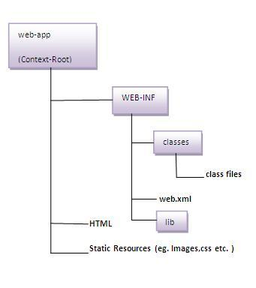

As you can see that the servlet class file must be in the classes folder. The web.xml file must be under the WEB-INF folder.

### 2)Create a Servlet

|  |
| --- |
| There are three ways to create the servlet.   1. By implementing the Servlet interface 2. By inheriting the GenericServlet class 3. By inheriting the HttpServlet class   The HttpServlet class is widely used to create the servlet because it provides methods to handle http requests such as doGet(), doPost, doHead() etc. |
| In this example we are going to create a servlet that extends the HttpServlet class. In this example, we are inheriting the HttpServlet class and providing the implementation of the doGet() method. Notice that get request is the default request. |

**DemoServlet.java**

[copy to clipboard](http://www.javatpoint.com/steps-to-create-a-servlet-using-tomcat-server)

1. import javax.servlet.http.*;
2. import javax.servlet.*;
3. import java.io.*;
4. public class DemoServlet extends HttpServlet{
5. public void doGet(HttpServletRequest req,HttpServletResponse res)
6. throws ServletException,IOException
7. {
8. res.setContentType("text/html");//setting the content type
9. PrintWriter pw=res.getWriter();//get the stream to write the data
11. //writing html in the stream
12. pw.println("<html><body>");
13. pw.println("Welcome to servlet");
14. pw.println("</body></html>");
16. pw.close();//closing the stream
17. }}



### 3)Compile the servlet

For compiling the Servlet, jar file is required to be loaded. Different Servers provide different jar files:

|  |  |
| --- | --- |
| **Jar file** | **Server** |
| 1) servlet-api.jar | Apache Tomcat |
| 2) weblogic.jar | Weblogic |
| 3) javaee.jar | Glassfish |
| 4) javaee.jar | JBoss |

### Two ways to load the jar file

1. set classpath
2. paste the jar file in JRE/lib/ext folder

Put the java file in any folder. After compiling the java file, paste the class file of servlet in **WEB-INF/classes** directory.

### 4)Create the deployment descriptor (web.xml file)

The **deployment descriptor** is an xml file, from which Web Container gets the information about the servet to be invoked.

The web container uses the Parser to get the information from the web.xml file. There are many xml parsers such as SAX, DOM and Pull.

There are many elements in the web.xml file. Here is given some necessary elements to run the simple servlet program.

**web.xml file**

[copy to clipboard](http://www.javatpoint.com/steps-to-create-a-servlet-using-tomcat-server)

1. <web-app>
3. <servlet>
4. <servlet-name>sonoojaiswal</servlet-name>
5. <servlet-class>DemoServlet</servlet-class>
6. </servlet>
8. <servlet-mapping>
9. <servlet-name>sonoojaiswal</servlet-name>
10. <url-pattern>/welcome</url-pattern>
11. </servlet-mapping>
13. </web-app>



### Description of the elements of web.xml file

There are too many elements in the web.xml file. Here is the illustration of some elements that is used in the above web.xml file. The elements are as follows:

|  |
| --- |
| **<web-app>** represents the whole application. |
| **<servlet>** is sub element of <web-app> and represents the servlet. |
| **<servlet-name>** is sub element of <servlet> represents the name of the servlet. |
| **<servlet-class>** is sub element of <servlet> represents the class of the servlet. |
| **<servlet-mapping>** is sub element of <web-app>. It is used to map the servlet. |
| **<url-pattern>** is sub element of <servlet-mapping>. This pattern is used at client side to invoke the servlet. |

### 5)Start the Server and deploy the project

To start Apache Tomcat server, double click on the startup.bat file under apache-tomcat/bin directory.

### One Time Configuration for Apache Tomcat Server

You need to perform 2 tasks:

1. set JAVA_HOME or JRE_HOME in environment variable (It is required to start server).
2. Change the port number of tomcat (optional). It is required if another server is running on same port (8080).

#### 1) How to set JAVA_HOME in environment variable?

To start Apache Tomcat server JAVA_HOME and JRE_HOME must be set in Environment variables.

Go to My Computer properties -> Click on advanced tab then environment variables -> Click on the new tab of user variable -> Write JAVA_HOME in variable name and paste the path of jdk folder in variable value -> ok -> ok -> ok.

Go to My Computer properties:



Click on advanced system settings tab then environment variables:

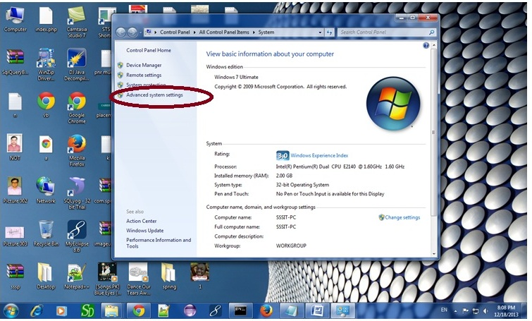

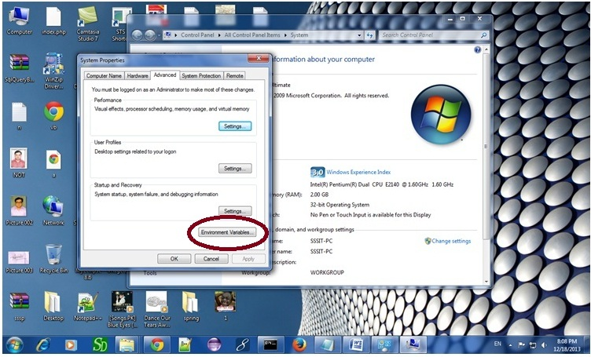

Click on the new tab of user variable or system variable:

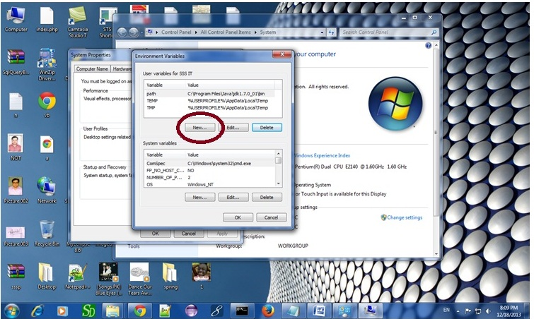

Write JAVA_HOME in variable name and paste the path of jdk folder in variable value:

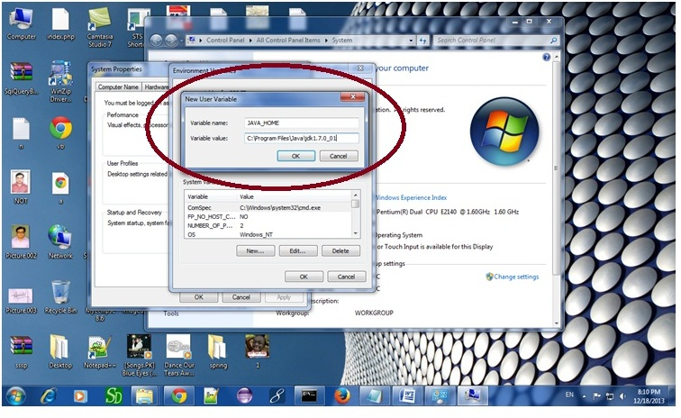

There must not be semicolon (;) at the end of the path.

|  |
| --- |
| After setting the JAVA_HOME double click on the startup.bat file in apache tomcat/bin. |
| Note: There are two types of tomcat available:   1. Apache tomcat that needs to extract only (no need to install) 2. Apache tomcat that needs to install |
| It is the example of apache tomcat that needs to extract only. |

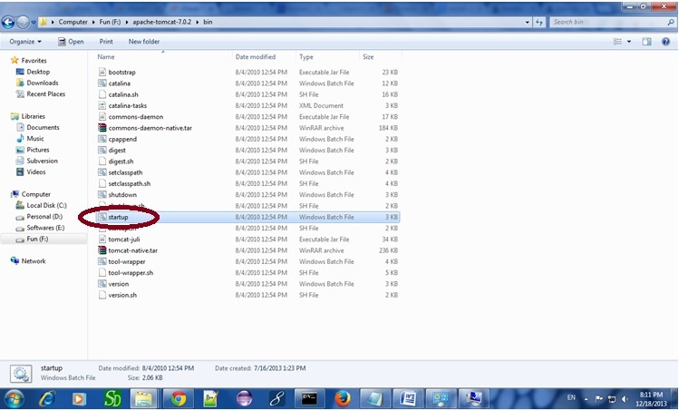

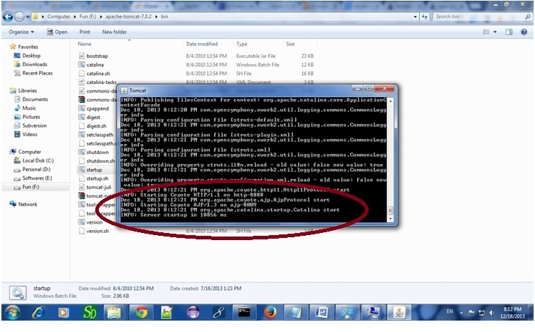

Now server is started successfully.

### 2) How to change port number of apache tomcat

Changing the port number is required if there is another server running on the same system with same port number.Suppose you have installed oracle, you need to change the port number of apache tomcat because both have the default port number 8080.

Open **server.xml file** in notepad. It is located inside the **apache-tomcat/conf** directory . Change the Connector port = 8080 and replace 8080 by any four digit number instead of 8080. Let us replace it by 9999 and save this file.

### 5) How to deploy the servlet project

Copy the project and paste it in the webapps folder under apache tomcat.

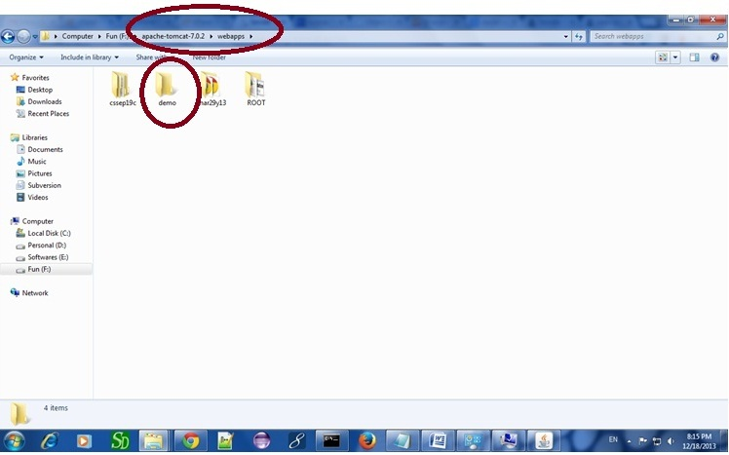

But there are several ways to deploy the project. They are as follows:

* By copying the context(project) folder into the webapps directory
* By copying the war folder into the webapps directory
* By selecting the folder path from the server
* By selecting the war file from the server

Here, we are using the first approach.

You can also create war file, and paste it inside the webapps directory. To do so, you need to use jar tool to create the war file. Go inside the project directory (before the WEB-INF), then write:

[copy to clipboard](http://www.javatpoint.com/steps-to-create-a-servlet-using-tomcat-server)

1. projectfolder> jar cvf myproject.war *



Creating war file has an advantage that moving the project from one location to another takes less time.

### 6) How to access the servlet

Open broser and write http://hostname:portno/contextroot/urlpatternofservlet. For example:

[copy to clipboard](http://www.javatpoint.com/steps-to-create-a-servlet-using-tomcat-server)

1. http://localhost:9999/demo/welcome



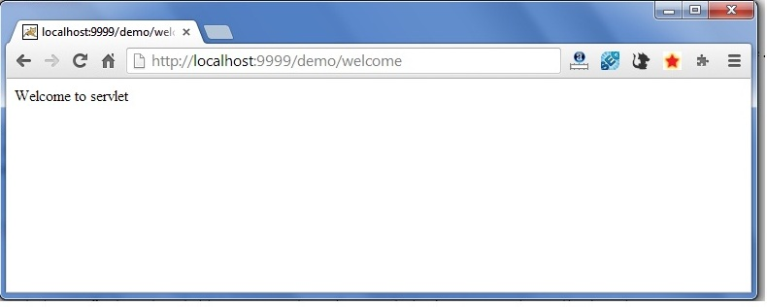

[download this example of servlet (using notepad)](http://www.javatpoint.com/src/servlet/firstservlet.zip)  
[download example of servlet by extending GenericServlet](http://www.javatpoint.com/src/servlet/genericexample.zip)  
[download example of servlet by implementing Servlet interface](http://www.javatpoint.com/src/servlet/servletexample.zip)

# How Servlet works?

It is important to learn how servlet works for understanding the servlet well. Here, we are going to get the internal detail about the first servlet program.

The server checks if the servlet is requested **for the first time**.

**If yes,** web container does the following tasks:

* loads the servlet class.
* instantiates the servlet class.
* calls the init method passing the ServletConfig object

**else**

* calls the service method passing request and response objects

The web container calls the destroy method when it needs to remove the servlet such as at time of stopping server or undeploying the project.

### How web container handles the servlet request?

The web container is responsible to handle the request. Let's see how it handles the request.

* maps the request with the servlet in the web.xml file.
* creates request and response objects for this request
* calls the service method on the thread
* The public service method internally calls the protected service method
* The protected service method calls the doGet method depending on the type of request.
* The doGet method generates the response and it is passed to the client.
* After sending the response, the web container deletes the request and response objects. The thread is contained in the thread pool or deleted depends on the server implementation.

### What is written inside the public service method?

The public service method converts the ServletRequest object into the HttpServletRequest type and ServletResponse object into the HttpServletResponse type. Then, calls the service method passing these objects. Let's see the internal code:

[copy to clipboard](http://www.javatpoint.com/how-servlet-works)

1. public void service(ServletRequest req, ServletResponse res)
2. throws ServletException, IOException
3. {
4. HttpServletRequest request;
5. HttpServletResponse response;
6. try
7. {
8. request = (HttpServletRequest)req;
9. response = (HttpServletResponse)res;
10. }
11. catch(ClassCastException e)
12. {
13. throw new ServletException("non-HTTP request or response");
14. }
15. service(request, response);
16. }



### What is written inside the protected service method?

The protected service method checks the type of request, if request type is get, it calls doGet method, if request type is post, it calls doPost method, so on. Let's see the internal code:

[copy to clipboard](http://www.javatpoint.com/how-servlet-works)

1. protected void service(HttpServletRequest req, HttpServletResponse resp)
2. throws ServletException, IOException
3. {
4. String method = req.getMethod();
5. if(method.equals("GET"))
6. {
7. long lastModified = getLastModified(req);
8. if(lastModified == -1L)
9. {
10. doGet(req, resp);
11. }
12. ....
13. //rest of the code
14. }
15. }

# War File

A **war (web archive) File** contains files of a web project. It may have servlet, xml, jsp, image, html, css, js etc. files.

Here, we will discuss what is war file, how to create war file, how to deploy war file and how to extract war file.

## What is war file?

web archive (war) file contains all the contents of a web application. It reduces the time duration for transferring file.

## Advantage of war file

**saves time**: The war file combines all the files into a single unit. So it takes less time while transferring file from client to server.

## How to create war file?

To create war file, you need to use **jar tool** of JDK. You need to use **-c** switch of jar, to create the war file.

Go inside the project directory of your project (outside the WEB-INF), then write the following command:

[copy to clipboard](http://www.javatpoint.com/war-file)

1. jar -cvf projectname.war *



Here, **-c** is used to create file, **-v** to generate the verbose output and **-f** to specify the arhive file name.

The **\* (asterisk) symbol** signifies that all the files of this directory (including sub directory).

## How to deploy the war file?

There are two ways to deploy the war file.

1. By server console panel
2. By manually having the war file in specific folder of server.

If you want to deploy the war file in **apache tomcat** server manually, go to the **webapps** directory of apache tomcat and paste the war file here.

Now, you are able to access the web project through browser.

#### *Note: server will extract the war file internally.*

## How to extract war file manually?

To extract the war file, you need to use **-x switch** of **jar tool** of JDK. Let's see the command to extract the war file.

[copy to clipboard](http://www.javatpoint.com/war-file)

1. jar -xvf projectname.war

# welcome-file-list in web.xml

The **welcome-file-list** element of **web-app**, is used to define a list of welcome files. Its sub element is **welcome-file** that is used to define the welcome file.

A **welcome file** is the file that is invoked automatically by the server, if you don't specify any file name.

By default server looks for the welcome file in following order:

1. welcome-file-list in web.xml
2. index.html
3. index.htm
4. index.jsp

If none of these files are found, server renders 404 error.

If you have specified welcome-file in web.xml, and all the files index.html, index.htm and index.jsp exists, priority goes to welcome-file.

If welcome-file-list entry doesn't exist in web.xml file, priority goes to index.html file then index.htm and at last index.jsp file.

Let's see the web.xml file that defines the welcome files.

*web.xml*

[copy to clipboard](http://www.javatpoint.com/welcome-file-list)

1. <web-app>
2. ....
4. <welcome-file-list>
5. <welcome-file>home.html</welcome-file>
6. <welcome-file>default.html</welcome-file>
7. </welcome-file-list>
8. </web-app>



Now, home.html and default.html will be the welcome files.

If you have the welcome file, you can directory invoke the project as given below:

[copy to clipboard](http://www.javatpoint.com/welcome-file-list)

1. http://localhost:8888/myproject



As you can see, we have not specified any file name after the project.

# load on startup in web.xml

The **load-on-startup** element of **web-app** loads the servlet at the time of deployment or server start if value is positive. It is also known as **pre initialization of servlet**.

You can pass positive and negative value for the servlet.

#### Advantage of load-on-startup element

As you know well, servlet is loaded at first request. That means it consumes more time at first request. If you specify the load-on-startup in web.xml, servlet will be loaded at project deployment time or server start. So, it will take **less time** for responding to first request.

#### Passing positive value

If you pass the positive value, the lower integer value servlet will be loaded before the higher integer value servlet. In other words, container loads the servlets in ascending integer value. The 0 value will be loaded first then 1, 2, 3 and so on.

Let's try to understand it by the example given below:

*web.xml*

[copy to clipboard](http://www.javatpoint.com/load-on-startup)

1. <web-app>
2. ....
4. <servlet>
5. <servlet-name>servlet1</servlet-name>
6. <servlet-class>com.javatpoint.FirstServlet</servlet-class>
7. <load-on-startup>0</load-on-startup>
8. </servlet>
10. <servlet>
11. <servlet-name>servlet2</servlet-name>
12. <servlet-class>com.javatpoint.SecondServlet</servlet-class>
13. <load-on-startup>1</load-on-startup>
14. </servlet>
16. ...
17. </web-app>



There are defined 2 servlets, both servlets will be loaded at the time of project deployment or server start. But, servlet1 will be loaded first then servlet2.

#### Passing negative value

If you pass the negative value, servlet will be loaded at request time, at first request.

# RequestDispatcher in Servlet

1. [RequestDispatcher Interface](http://www.javatpoint.com/requestdispatcher-in-servlet)
2. [Methods of RequestDispatcher interface](http://www.javatpoint.com/requestdispatcher-in-servlet#rdmethod)
   1. [forward method](http://www.javatpoint.com/requestdispatcher-in-servlet#rdforward)
   2. [include method](http://www.javatpoint.com/requestdispatcher-in-servlet#rdinclude)
3. [How to get the object of RequestDispatcher](http://www.javatpoint.com/requestdispatcher-in-servlet#rdhow)
4. [Example of RequestDispatcher interface](http://www.javatpoint.com/requestdispatcher-in-servlet#rdex)

The RequestDispatcher interface provides the facility of dispatching the request to another resource it may be html, servlet or jsp. This interface can also be used to include the content of another resource also. It is one of the way of servlet collaboration.

There are two methods defined in the RequestDispatcher interface.

### Methods of RequestDispatcher interface

The RequestDispatcher interface provides two methods. They are:

1. **public void forward(ServletRequest request,ServletResponse response)throws ServletException,java.io.IOException:**Forwards a request from a servlet to another resource (servlet, JSP file, or HTML file) on the server.
2. **public void include(ServletRequest request,ServletResponse response)throws ServletException,java.io.IOException:**Includes the content of a resource (servlet, JSP page, or HTML file) in the response.

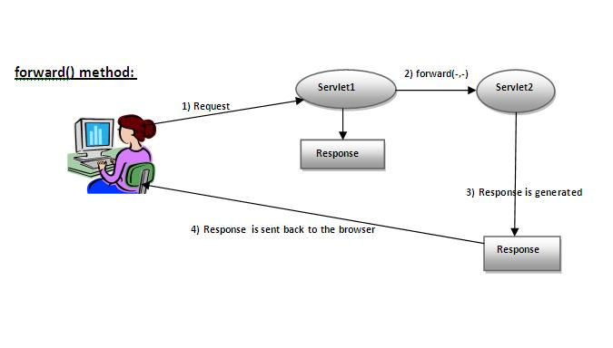

As you see in the above figure, response of second servlet is sent to the client. Response of the first servlet is not displayed to the user.

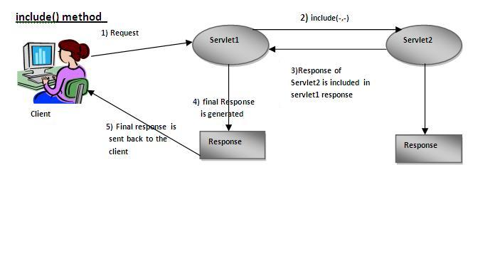

|  |
| --- |
| As you can see in the above figure, response of second servlet is included in the response of the first servlet that is being sent to the client. |

### How to get the object of RequestDispatcher

The getRequestDispatcher() method of ServletRequest interface returns the object of RequestDispatcher. Syntax:

#### Syntax of getRequestDispatcher method

[copy to clipboard](http://www.javatpoint.com/requestdispatcher-in-servlet)

1. public RequestDispatcher getRequestDispatcher(String resource);



#### Example of using getRequestDispatcher method

[copy to clipboard](http://www.javatpoint.com/requestdispatcher-in-servlet)

1. RequestDispatcher rd=request.getRequestDispatcher("servlet2");
2. //servlet2 is the url-pattern of the second servlet
4. rd.forward(request, response);//method may be include or forward



### Example of RequestDispatcher interface

In this example, we are validating the password entered by the user. If password is servlet, it will forward the request to the WelcomeServlet, otherwise will show an error message: sorry username or password error!. In this program, we are cheking for hardcoded information. But you can check it to the database also that we will see in the development chapter. In this example, we have created following files:

* **index.html file:** for getting input from the user.
* **Login.java file:** a servlet class for processing the response. If password is servet, it will forward the request to the welcome servlet.
* **WelcomeServlet.java file:** a servlet class for displaying the welcome message.
* **web.xml file:** a deployment descriptor file that contains the information about the servlet.

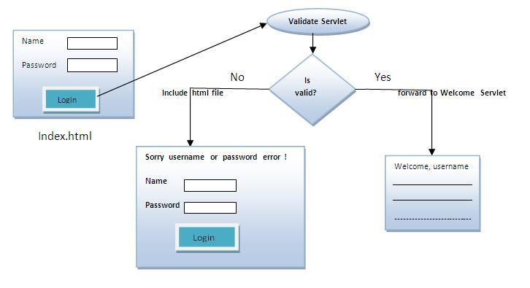

**index.html**

[copy to clipboard](http://www.javatpoint.com/requestdispatcher-in-servlet)

1. <form action="servlet1" method="post">
2. Name:<input type="text" name="userName"/><br/>
3. Password:<input type="password" name="userPass"/><br/>
4. <input type="submit" value="login"/>
5. </form>



**Login.java**

[copy to clipboard](http://www.javatpoint.com/requestdispatcher-in-servlet)

1. import java.io.*;
2. import javax.servlet.*;
3. import javax.servlet.http.*;

6. public class Login extends HttpServlet {
8. public void doPost(HttpServletRequest request, HttpServletResponse response)
9. throws ServletException, IOException {
11. response.setContentType("text/html");
12. PrintWriter out = response.getWriter();
14. String n=request.getParameter("userName");
15. String p=request.getParameter("userPass");
17. if(p.equals("servlet"){
18. RequestDispatcher rd=request.getRequestDispatcher("servlet2");
19. rd.forward(request, response);
20. }
21. else{
22. out.print("Sorry UserName or Password Error!");
23. RequestDispatcher rd=request.getRequestDispatcher("/index.html");
24. rd.include(request, response);
26. }
27. }
29. }



**WelcomeServlet.java**

[copy to clipboard](http://www.javatpoint.com/requestdispatcher-in-servlet)

1. import java.io.*;
2. import javax.servlet.*;
3. import javax.servlet.http.*;
5. public class WelcomeServlet extends HttpServlet {
7. public void doPost(HttpServletRequest request, HttpServletResponse response)
8. throws ServletException, IOException {
10. response.setContentType("text/html");
11. PrintWriter out = response.getWriter();
13. String n=request.getParameter("userName");
14. out.print("Welcome "+n);
15. }
17. }



**web.xml**

[copy to clipboard](http://www.javatpoint.com/requestdispatcher-in-servlet)

1. <web-app>
2. <servlet>
3. <servlet-name>Login</servlet-name>
4. <servlet-class>Login</servlet-class>
5. </servlet>
6. <servlet>
7. <servlet-name>WelcomeServlet</servlet-name>
8. <servlet-class>WelcomeServlet</servlet-class>
9. </servlet>

12. <servlet-mapping>
13. <servlet-name>Login</servlet-name>
14. <url-pattern>/servlet1</url-pattern>
15. </servlet-mapping>
16. <servlet-mapping>
17. <servlet-name>WelcomeServlet</servlet-name>
18. <url-pattern>/servlet2</url-pattern>
19. </servlet-mapping>
21. <welcome-file-list>
22. <welcome-file>index.html</welcome-file>
23. </welcome-file-list>
24. </web-app>



[download this example](http://www.javatpoint.com/src/servlet/requestdispatcher.zip)  
[download this example (developed in Myeclipse IDE)](http://www.javatpoint.com/src/servlet/requestdispatcherm.zip)  
[download this example (developed in eclipse IDE)](http://www.javatpoint.com/src/servlet/eclipse/requestdispatcher.zip)  
[download this example (developed in netbeans IDE)](http://www.javatpoint.com/src/servlet/netbeans/requestdispatcher.zip)

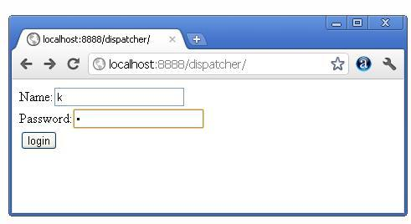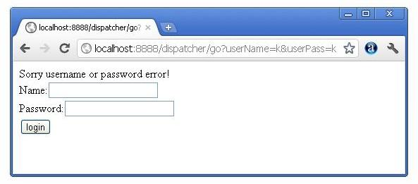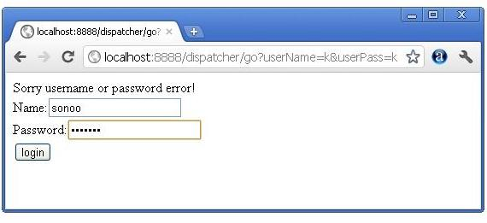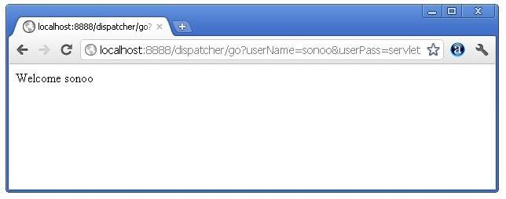

Next Topic[SendRedirect() Method](http://www.javatpoint.com/sendRedirect()-method)

# SendRedirect in servlet

1. [sendRedirect method](http://www.javatpoint.com/sendRedirect()-method)
2. [Syntax of sendRedirect() method](http://www.javatpoint.com/sendRedirect()-method#redirectsyn)
3. [Example of RequestDispatcher interface](http://www.javatpoint.com/sendRedirect()-method#redirectex)

The **sendRedirect()** method of **HttpServletResponse** interface can be used to redirect response to another resource, it may be servlet, jsp or html file.

It accepts relative as well as absolute URL.

It works at client side because it uses the url bar of the browser to make another request. So, it can work inside and outside the server.

## Difference between forward() and sendRedirect() method

There are many differences between the forward() method of RequestDispatcher and sendRedirect() method of HttpServletResponse interface. They are given below:

|  |  |
| --- | --- |
| **forward() method** | **sendRedirect() method** |
| The forward() method works at server side. | The sendRedirect() method works at client side. |
| It sends the same request and response objects to another servlet. | It always sends a new request. |
| It can work within the server only. | It can be used within and outside the server. |
| Example: request.getRequestDispacher("servlet2").forward(request,response); | Example: response.sendRedirect("servlet2"); |

### Syntax of sendRedirect() method

[copy to clipboard](http://www.javatpoint.com/sendRedirect()-method)

1. public void sendRedirect(String URL)throws IOException;



### Example of sendRedirect() method

[copy to clipboard](http://www.javatpoint.com/sendRedirect()-method)

1. response.sendRedirect("http://www.javatpoint.com");



### Full example of sendRedirect method in servlet

|  |
| --- |
| In this example, we are redirecting the request to the google server. Notice that sendRedirect method works at client side, that is why we can our request to anywhere. We can send our request within and outside the server. |

*DemoServlet.java*

[copy to clipboard](http://www.javatpoint.com/sendRedirect()-method)

1. import java.io.*;
2. import javax.servlet.*;
3. import javax.servlet.http.*;
5. public class DemoServlet extends HttpServlet{
6. public void doGet(HttpServletRequest req,HttpServletResponse res)
7. throws ServletException,IOException
8. {
9. res.setContentType("text/html");
10. PrintWriter pw=res.getWriter();
12. response.sendRedirect("http://www.google.com");
14. pw.close();
15. }}



### Creating custom google search using sendRedirect

In this example, we are using sendRedirect method to send request to google server with the request data.

*index.html*

[copy to clipboard](http://www.javatpoint.com/sendRedirect()-method)

1. <!DOCTYPE html>
2. <html>
3. <head>
4. <meta charset="ISO-8859-1">
5. <title>sendRedirect example</title>
6. </head>
7. <body>

10. <form action="MySearcher">
11. <input type="text" name="name">
12. <input type="submit" value="Google Search">
13. </form>
15. </body>
16. </html>



*MySearcher.java*

[copy to clipboard](http://www.javatpoint.com/sendRedirect()-method)

1. import java.io.IOException;
2. import javax.servlet.ServletException;
3. import javax.servlet.http.HttpServlet;
4. import javax.servlet.http.HttpServletRequest;
5. import javax.servlet.http.HttpServletResponse;
7. public class MySearcher extends HttpServlet {
8. protected void doGet(HttpServletRequest request, HttpServletResponse response)
9. throws ServletException, IOException {
11. String name=request.getParameter("name");
12. response.sendRedirect("https://www.google.co.in/#q="+name);
13. }
14. }



[download this example (developed in Eclipse)](http://www.javatpoint.com/src/servlet/eclipse/GoogleSearcher.zip)

#### Output

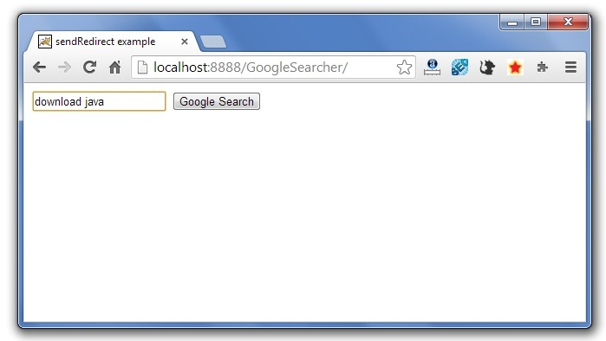  
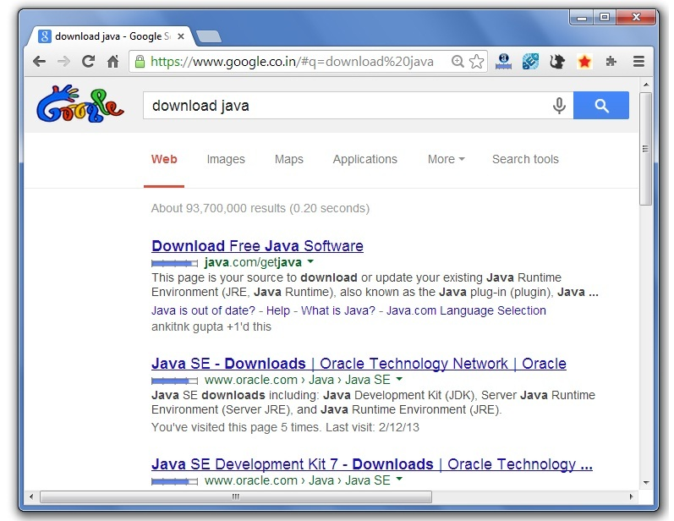

Next Topic[Servletconfig Example](http://www.javatpoint.com/servletconfig)

# ServletConfig Interface

1. [ServletConfig Interface](http://www.javatpoint.com/servletconfig)
2. [Methods of ServletConfig interface](http://www.javatpoint.com/servletconfig#configmethod)
3. [How to get the object of ServletConfig](http://www.javatpoint.com/servletconfig#configobject)
4. [Syntax to provide the initialization parameter for a servlet](http://www.javatpoint.com/servletconfig#configsyntax)
5. [Example of ServletConfig to get initialization parameter](http://www.javatpoint.com/servletconfig#configex1)
6. [Example of ServletConfig to get all the initialization parameter](http://www.javatpoint.com/servletconfig#configex2)

An object of ServletConfig is created by the web container for each servlet. This object can be used to get configuration information from web.xml file.

If the configuration information is modified from the web.xml file, we don't need to change the servlet. So it is easier to manage the web application if any specific content is modified from time to time.

### Advantage of ServletConfig

The core advantage of ServletConfig is that you don't need to edit the servlet file if information is modified from the web.xml file.

### Methods of ServletConfig interface

1. **public String getInitParameter(String name):**Returns the parameter value for the specified parameter name.
2. **public Enumeration getInitParameterNames():**Returns an enumeration of all the initialization parameter names.
3. **public String getServletName():**Returns the name of the servlet.
4. **public ServletContext getServletContext():**Returns an object of ServletContext.

### How to get the object of ServletConfig

1. **getServletConfig() method** of Servlet interface returns the object of ServletConfig.

#### Syntax of getServletConfig() method

[copy to clipboard](http://www.javatpoint.com/servletconfig)

1. public ServletConfig getServletConfig();



#### Example of getServletConfig() method

[copy to clipboard](http://www.javatpoint.com/servletconfig)

1. ServletConfig config=getServletConfig();
2. //Now we can call the methods of ServletConfig interface



### Syntax to provide the initialization parameter for a servlet

The init-param sub-element of servlet is used to specify the initialization parameter for a servlet.

[copy to clipboard](http://www.javatpoint.com/servletconfig)

1. <web-app>
2. <servlet>
3. ......
5. <init-param>
6. <param-name>parametername</param-name>
7. <param-value>parametervalue</param-value>
8. </init-param>
9. ......
10. </servlet>
11. </web-app>



### Example of ServletConfig to get initialization parameter

In this example, we are getting the one initialization parameter from the web.xml file and printing this information in the servlet.

**DemoServlet.java**

[copy to clipboard](http://www.javatpoint.com/servletconfig)

1. import java.io.*;
2. import javax.servlet.*;
3. import javax.servlet.http.*;
5. public class DemoServlet extends HttpServlet {
6. public void doGet(HttpServletRequest request, HttpServletResponse response)
7. throws ServletException, IOException {
9. response.setContentType("text/html");
10. PrintWriter out = response.getWriter();
12. ServletConfig config=getServletConfig();
13. String driver=config.getInitParameter("driver");
14. out.print("Driver is: "+driver);
16. out.close();
17. }
19. }



**web.xml**

[copy to clipboard](http://www.javatpoint.com/servletconfig)

1. <web-app>
3. <servlet>
4. <servlet-name>DemoServlet</servlet-name>
5. <servlet-class>DemoServlet</servlet-class>
7. <init-param>
8. <param-name>driver</param-name>
9. <param-value>sun.jdbc.odbc.JdbcOdbcDriver</param-value>
10. </init-param>
12. </servlet>
14. <servlet-mapping>
15. <servlet-name>DemoServlet</servlet-name>
16. <url-pattern>/servlet1</url-pattern>
17. </servlet-mapping>
19. </web-app>



[download this example (developed in Myeclipse IDE)](http://www.javatpoint.com/src/servlet/config1.zip)  
[download this example(developed in Eclipse IDE)](http://www.javatpoint.com/src/servlet/eclipse/config1.zip)  
[download this example(developed in Netbeans IDE)](http://www.javatpoint.com/src/servlet/netbeans/config4.zip)

### Example of ServletConfig to get all the initialization parameters

In this example, we are getting all the initialization parameter from the web.xml file and printing this information in the servlet.

**DemoServlet.java**

[copy to clipboard](http://www.javatpoint.com/servletconfig)

1. import java.io.IOException;
2. import java.io.PrintWriter;
3. import java.util.Enumeration;
5. import javax.servlet.ServletConfig;
6. import javax.servlet.ServletException;
7. import javax.servlet.http.HttpServlet;
8. import javax.servlet.http.HttpServletRequest;
9. import javax.servlet.http.HttpServletResponse;

12. public class DemoServlet extends HttpServlet {
13. public void doGet(HttpServletRequest request, HttpServletResponse response)
14. throws ServletException, IOException {
16. response.setContentType("text/html");
17. PrintWriter out = response.getWriter();
19. ServletConfig config=getServletConfig();
20. Enumeration<String> e=config.getInitParameterNames();
22. String str="";
23. while(e.hasMoreElements()){
24. str=e.nextElement();
25. out.print("<br>Name: "+str);
26. out.print(" value: "+config.getInitParameter(str));
27. }
29. out.close();
30. }
32. }



**web.xml**

[copy to clipboard](http://www.javatpoint.com/servletconfig)

1. <web-app>
3. <servlet>
4. <servlet-name>DemoServlet</servlet-name>
5. <servlet-class>DemoServlet</servlet-class>
7. <init-param>
8. <param-name>username</param-name>
9. <param-value>system</param-value>
10. </init-param>
12. <init-param>
13. <param-name>password</param-name>
14. <param-value>oracle</param-value>
15. </init-param>
17. </servlet>
19. <servlet-mapping>
20. <servlet-name>DemoServlet</servlet-name>
21. <url-pattern>/servlet1</url-pattern>
22. </servlet-mapping>
24. </web-app>



[download this example (developed in Myeclipse IDE)](http://www.javatpoint.com/src/servlet/config2.zip)  
[download this example(developed in Eclipse IDE)](http://www.javatpoint.com/src/servlet/eclipse/config2.zip)  
[download this example(developed in Netbeans IDE)](http://www.javatpoint.com/src/servlet/netbeans/config5.zip)

# ServletContext Interface

1. [ServletContext Interface](http://www.javatpoint.com/servletcontext)
2. [Usage of ServletContext Interface](http://www.javatpoint.com/servletcontext#contextusage)
3. [Methods of ServletContext interface](http://www.javatpoint.com/servletcontext#contextmethods)
4. [How to get the object of ServletContext](http://www.javatpoint.com/servletcontext#contextobject)
5. [Syntax to provide the initialization parameter in Context scope](http://www.javatpoint.com/servletcontext#contextsyn)
6. [Example of ServletContext to get initialization parameter](http://www.javatpoint.com/servletcontext#contextex1)
7. [Example of ServletContext to get all the initialization parameter](http://www.javatpoint.com/servletcontext#contextex2)

An object of ServletContext is created by the web container at time of deploying the project. This object can be used to get configuration information from web.xml file. There is only one ServletContext object per web application.

If any information is shared to many servlet, it is better to provide it from the web.xml file using the **<context-param>** element.

### Advantage of ServletContext

**Easy to maintain** if any information is shared to all the servlet, it is better to make it available for all the servlet. We provide this information from the web.xml file, so if the information is changed, we don't need to modify the servlet. Thus it removes maintenance problem.

### Usage of ServletContext Interface

There can be a lot of usage of ServletContext object. Some of them are as follows:

1. The object of ServletContext provides an interface between the container and servlet.
2. The ServletContext object can be used to get configuration information from the web.xml file.
3. The ServletContext object can be used to set, get or remove attribute from the web.xml file.
4. The ServletContext object can be used to provide inter-application communication.

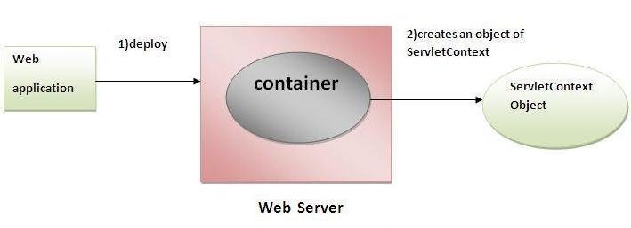

### Commonly used methods of ServletContext interface

|  |
| --- |
| There is given some commonly used methods of ServletContext interface.   1. **public String getInitParameter(String name):**Returns the parameter value for the specified parameter name. 2. **public Enumeration getInitParameterNames():**Returns the names of the context's initialization parameters. 3. **public void setAttribute(String name,Object object):**sets the given object in the application scope. 4. **public Object getAttribute(String name):**Returns the attribute for the specified name. 5. **public Enumeration getInitParameterNames():**Returns the names of the context's initialization parameters as an Enumeration of String objects. 6. **public void removeAttribute(String name):**Removes the attribute with the given name from the servlet context. |

### How to get the object of ServletContext interface

1. **getServletContext() method** of ServletConfig interface returns the object of ServletContext.
2. **getServletContext() method** of GenericServlet class returns the object of ServletContext.

#### Syntax of getServletContext() method

[copy to clipboard](http://www.javatpoint.com/servletcontext)

1. public ServletContext getServletContext()



#### Example of getServletContext() method

[copy to clipboard](http://www.javatpoint.com/servletcontext)

1. //We can get the ServletContext object from ServletConfig object
2. ServletContext application=getServletConfig().getServletContext();
4. //Another convenient way to get the ServletContext object
5. ServletContext application=getServletContext();



### Syntax to provide the initialization parameter in Context scope

|  |
| --- |
| The **context-param** element, subelement of web-app, is used to define the initialization parameter in the application scope. The param-name and param-value are the sub-elements of the context-param. The param-name element defines parameter name and and param-value defines its value. |

[copy to clipboard](http://www.javatpoint.com/servletcontext)

1. <web-app>
2. ......
4. <context-param>
5. <param-name>parametername</param-name>
6. <param-value>parametervalue</param-value>
7. </context-param>
8. ......
9. </web-app>



### Example of ServletContext to get the initialization parameter

|  |
| --- |
| In this example, we are getting the initialization parameter from the web.xml file and printing the value of the initialization parameter. Notice that the object of ServletContext represents the application scope. So if we change the value of the parameter from the web.xml file, all the servlet classes will get the changed value. So we don't need to modify the servlet. So it is better to have the common information for most of the servlets in the web.xml file by context-param element. Let's see the simple example: |

**DemoServlet.java**

[copy to clipboard](http://www.javatpoint.com/servletcontext)

1. import java.io.*;
2. import javax.servlet.*;
3. import javax.servlet.http.*;

6. public class DemoServlet extends HttpServlet{
7. public void doGet(HttpServletRequest req,HttpServletResponse res)
8. throws ServletException,IOException
9. {
10. res.setContentType("text/html");
11. PrintWriter pw=res.getWriter();
13. //creating ServletContext object
14. ServletContext context=getServletContext();
16. //Getting the value of the initialization parameter and printing it
17. String driverName=context.getInitParameter("dname");
18. pw.println("driver name is="+driverName);
20. pw.close();
22. }}



**web.xml**

[copy to clipboard](http://www.javatpoint.com/servletcontext)

1. <web-app>
3. <servlet>
4. <servlet-name>sonoojaiswal</servlet-name>
5. <servlet-class>DemoServlet</servlet-class>
6. </servlet>
8. <context-param>
9. <param-name>dname</param-name>
10. <param-value>sun.jdbc.odbc.JdbcOdbcDriver</param-value>
11. </context-param>
13. <servlet-mapping>
14. <servlet-name>sonoojaiswal</servlet-name>
15. <url-pattern>/context</url-pattern>
16. </servlet-mapping>
18. </web-app>



### Example of ServletContext to get all the initialization parameters

|  |
| --- |
| In this example, we are getting all the initialization parameter from the web.xml file. For getting all the parameters, we have used the getInitParameterNames() method in the servlet class. |

**DemoServlet.java**

[copy to clipboard](http://www.javatpoint.com/servletcontext)

1. import java.io.*;
2. import javax.servlet.*;
3. import javax.servlet.http.*;

6. public class DemoServlet extends HttpServlet{
7. public void doGet(HttpServletRequest req,HttpServletResponse res)
8. throws ServletException,IOException
9. {
10. res.setContentType("text/html");
11. PrintWriter out=res.getWriter();
13. ServletContext context=getServletContext();
14. Enumeration<String> e=context.getInitParameterNames();
16. String str="";
17. while(e.hasMoreElements()){
18. str=e.nextElement();
19. out.print("<br> "+context.getInitParameter(str));
20. }
21. }}



**web.xml**

[copy to clipboard](http://www.javatpoint.com/servletcontext)

1. <web-app>
3. <servlet>
4. <servlet-name>sonoojaiswal</servlet-name>
5. <servlet-class>DemoServlet</servlet-class>
6. </servlet>
8. <context-param>
9. <param-name>dname</param-name>
10. <param-value>sun.jdbc.odbc.JdbcOdbcDriver</param-value>
11. </context-param>
13. <context-param>
14. <param-name>username</param-name>
15. <param-value>system</param-value>
16. </context-param>
18. <context-param>
19. <param-name>password</param-name>
20. <param-value>oracle</param-value>
21. </context-param>
23. <servlet-mapping>
24. <servlet-name>sonoojaiswal</servlet-name>
25. <url-pattern>/context</url-pattern>
26. </servlet-mapping>
28. </web-app>

# Attribute in Servlet

1. [Attribute in Servlet](http://www.javatpoint.com/attribute)
2. [Attribute specific methods](http://www.javatpoint.com/attribute#attributemethod)
3. [Example of ServletContext to set and get attribute](http://www.javatpoint.com/attribute#attributeex)
4. [Difference between ServletConfig and ServletContext](http://www.javatpoint.com/attribute#diffcontext)

An **attribute in servlet** is an object that can be set, get or removed from one of the following scopes:

1. request scope
2. session scope
3. application scope

The servlet programmer can pass informations from one servlet to another using attributes. It is just like passing object from one class to another so that we can reuse the same object again and again.

### Attribute specific methods of ServletRequest, HttpSession and ServletContext interface

|  |
| --- |
| There are following 4 attribute specific methods. They are as follows:   1. **public void setAttribute(String name,Object object):**sets the given object in the application scope. 2. **public Object getAttribute(String name):**Returns the attribute for the specified name. 3. **public Enumeration getInitParameterNames():**Returns the names of the context's initialization parameters as an Enumeration of String objects. 4. **public void removeAttribute(String name):**Removes the attribute with the given name from the servlet context. |

### Example of ServletContext to set and get attribute

|  |
| --- |
| In this example, we are setting the attribute in the application scope and getting that value from another servlet. |

### DemoServlet1.java

[copy to clipboard](http://www.javatpoint.com/attribute)

1. import java.io.*;
2. import javax.servlet.*;
3. import javax.servlet.http.*;

6. public class DemoServlet1 extends HttpServlet{
7. public void doGet(HttpServletRequest req,HttpServletResponse res)
8. {
9. try{
11. res.setContentType("text/html");
12. PrintWriter out=res.getWriter();
14. ServletContext context=getServletContext();
15. context.setAttribute("company","IBM");
17. out.println("Welcome to first servlet");
18. out.println("<a href='servlet2'>visit</a>");
19. out.close();
21. }catch(Exception e){out.println(e);}
23. }}

import java.io.*;

import javax.servlet.*;

import javax.servlet.http.*;

public class DemoServlet1 extends HttpServlet{

public void doGet(HttpServletRequest req,HttpServletResponse res)

{

try{

res.setContentType("text/html");

PrintWriter out=res.getWriter();

ServletContext context=getServletContext();

context.setAttribute("company","IBM");

out.println("Welcome to first servlet");

out.println("<a href='servlet2'>visit</a>");

out.close();

}catch(Exception e){out.println(e);}

}}

### DemoServlet2.java

[copy to clipboard](http://www.javatpoint.com/attribute)

1. import java.io.*;
2. import javax.servlet.*;
3. import javax.servlet.http.*;

6. public class DemoServlet2 extends HttpServlet{
7. public void doGet(HttpServletRequest req,HttpServletResponse res)
8. {
9. try{
11. res.setContentType("text/html");
12. PrintWriter out=res.getWriter();
14. ServletContext context=getServletContext();
15. String n=(String)context.getAttribute("company");
17. out.println("Welcome to "+n);
18. out.close();
20. }catch(Exception e){out.println(e);}
22. }}

import java.io.*;

import javax.servlet.*;

import javax.servlet.http.*;

public class DemoServlet2 extends HttpServlet{

public void doGet(HttpServletRequest req,HttpServletResponse res)

{

try{

res.setContentType("text/html");

PrintWriter out=res.getWriter();

ServletContext context=getServletContext();

String n=(String)context.getAttribute("company");

out.println("Welcome to "+n);

out.close();

}catch(Exception e){out.println(e);}

}}

### web.xml

[copy to clipboard](http://www.javatpoint.com/attribute)

1. <web-app>
3. <servlet>
4. <servlet-name>s1</servlet-name>
5. <servlet-class>DemoServlet1</servlet-class>
6. </servlet>
8. <servlet-mapping>
9. <servlet-name>s1</servlet-name>
10. <url-pattern>/servlet1</url-pattern>
11. </servlet-mapping>
13. <servlet>
14. <servlet-name>s2</servlet-name>
15. <servlet-class>DemoServlet2</servlet-class>
16. </servlet>
18. <servlet-mapping>
19. <servlet-name>s2</servlet-name>
20. <url-pattern>/servlet2</url-pattern>
21. </servlet-mapping>
23. </web-app>

<web-app>

<servlet>

<servlet-name>s1</servlet-name>

<servlet-class>DemoServlet1</servlet-class>

</servlet>

<servlet-mapping>

<servlet-name>s1</servlet-name>

<url-pattern>/servlet1</url-pattern>

</servlet-mapping>

<servlet>

<servlet-name>s2</servlet-name>

<servlet-class>DemoServlet2</servlet-class>

</servlet>

<servlet-mapping>

<servlet-name>s2</servlet-name>

<url-pattern>/servlet2</url-pattern>

</servlet-mapping>

</web-app>

### Difference between ServletConfig and ServletContext

|  |
| --- |
| The servletconfig object refers to the single servlet whereas servletcontext object refers to the whole web application. |

Next Topic[Session Tracking in Servlets](http://www.javatpoint.com/session-tracking-in-servlets)

# Session Tracking in Servlets

1. [Session Tracking](http://www.javatpoint.com/session-tracking-in-servlets#session1)
2. [Session Tracking Techniques](http://www.javatpoint.com/session-tracking-in-servlets#session1tech)

**Session** simply means a particular interval of time.

**Session Tracking** is a way to maintain state (data) of an user. It is also known as **session management** in servlet.

Http protocol is a stateless so we need to maintain state using session tracking techniques. Each time user requests to the server, server treats the request as the new request. So we need to maintain the state of an user to recognize to particular user.

HTTP is stateless that means each request is considered as the new request. It is shown in the figure given below:

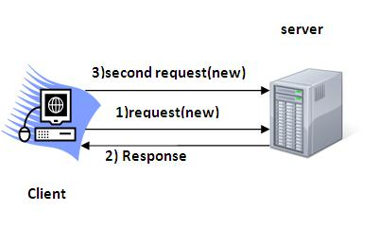

### Why use Session Tracking?

**To recognize the user** It is used to recognize the particular user.

### Session Tracking Techniques

There are four techniques used in Session tracking:

1. **Cookies**
2. **Hidden Form Field**
3. **URL Rewriting**
4. **HttpSession**

# Cookies in Servlet

A **cookie** is a small piece of information that is persisted between the multiple client requests.

A cookie has a name, a single value, and optional attributes such as a comment, path and domain qualifiers, a maximum age, and a version number.

### How Cookie works

By default, each request is considered as a new request. In cookies technique, we add cookie with response from the servlet. So cookie is stored in the cache of the browser. After that if request is sent by the user, cookie is added with request by default. Thus, we recognize the user as the old user.

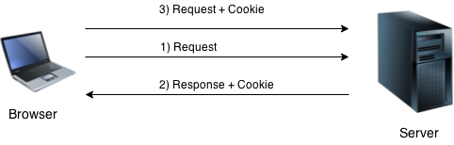

### Types of Cookie

There are 2 types of cookies in servlets.

1. Non-persistent cookie
2. Persistent cookie

### Non-persistent cookie

It is **valid for single session** only. It is removed each time when user closes the browser.

### Persistent cookie

It is **valid for multiple session** . It is not removed each time when user closes the browser. It is removed only if user logout or signout.

### Advantage of Cookies

1. Simplest technique of maintaining the state.
2. Cookies are maintained at client side.

### Disadvantage of Cookies

1. It will not work if cookie is disabled from the browser.
2. Only textual information can be set in Cookie object.

#### *Note: Gmail uses cookie technique for login. If you disable the cookie, gmail won't work.*

### Cookie class

**javax.servlet.http.Cookie** class provides the functionality of using cookies. It provides a lot of useful methods for cookies.

### Constructor of Cookie class

|  |  |
| --- | --- |
| **Constructor** | **Description** |
| Cookie() | constructs a cookie. |
| Cookie(String name, String value) | constructs a cookie with a specified name and value. |

### Useful Methods of Cookie class

There are given some commonly used methods of the Cookie class.

|  |  |
| --- | --- |
| **Method** | **Description** |
| public void setMaxAge(int expiry) | Sets the maximum age of the cookie in seconds. |
| public String getName() | Returns the name of the cookie. The name cannot be changed after creation. |
| public String getValue() | Returns the value of the cookie. |
| public void setName(String name) | changes the name of the cookie. |
| public void setValue(String value) | changes the value of the cookie. |

### Other methods required for using Cookies

|  |
| --- |
| For adding cookie or getting the value from the cookie, we need some methods provided by other interfaces. They are:   1. **public void addCookie(Cookie ck):**method of HttpServletResponse interface is used to add cookie in response object. 2. **public Cookie[] getCookies():**method of HttpServletRequest interface is used to return all the cookies from the browser. |

### How to create Cookie?

Let's see the simple code to create cookie.

[copy to clipboard](http://www.javatpoint.com/cookies-in-servlet)

1. Cookie ck=new Cookie("user","sonoo jaiswal");//creating cookie object
2. response.addCookie(ck);//adding cookie in the response



### How to delete Cookie?

Let's see the simple code to delete cookie. It is mainly used to logout or signout the user.

[copy to clipboard](http://www.javatpoint.com/cookies-in-servlet)

1. Cookie ck=new Cookie("user","");//deleting value of cookie
2. ck.setMaxAge(0);//changing the maximum age to 0 seconds
3. response.addCookie(ck);//adding cookie in the response



### How to get Cookies?

Let's see the simple code to get all the cookies.

[copy to clipboard](http://www.javatpoint.com/cookies-in-servlet)

1. Cookie ck[]=request.getCookies();
2. for(int i=0;i<ck.length;i++){
3. out.print("<br>"+ck[i].getName()+" "+ck[i].getValue());//printing name and value of cookie
4. }



### Simple example of Servlet Cookies

In this example, we are storing the name of the user in the cookie object and accessing it in another servlet. As we know well that session corresponds to the particular user. So if you access it from too many browsers with different values, you will get the different value.

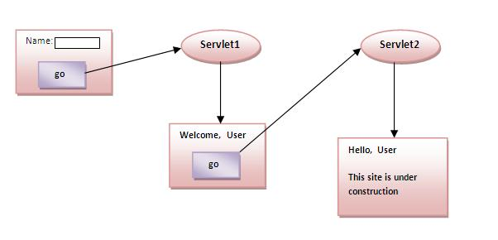

### index.html

[copy to clipboard](http://www.javatpoint.com/cookies-in-servlet)

1. <form action="servlet1" method="post">
2. Name:<input type="text" name="userName"/><br/>
3. <input type="submit" value="go"/>
4. </form>



### FirstServlet.java

[copy to clipboard](http://www.javatpoint.com/cookies-in-servlet)

1. import java.io.*;
2. import javax.servlet.*;
3. import javax.servlet.http.*;

6. public class FirstServlet extends HttpServlet {
8. public void doPost(HttpServletRequest request, HttpServletResponse response){
9. try{
11. response.setContentType("text/html");
12. PrintWriter out = response.getWriter();
14. String n=request.getParameter("userName");
15. out.print("Welcome "+n);
17. Cookie ck=new Cookie("uname",n);//creating cookie object
18. response.addCookie(ck);//adding cookie in the response
20. //creating submit button
21. out.print("<form action='servlet2'>");
22. out.print("<input type='submit' value='go'>");
23. out.print("</form>");
25. out.close();
27. }catch(Exception e){System.out.println(e);}
28. }
29. }



### SecondServlet.java

[copy to clipboard](http://www.javatpoint.com/cookies-in-servlet)

1. import java.io.*;
2. import javax.servlet.*;
3. import javax.servlet.http.*;
5. public class SecondServlet extends HttpServlet {
7. public void doPost(HttpServletRequest request, HttpServletResponse response){
8. try{
10. response.setContentType("text/html");
11. PrintWriter out = response.getWriter();
13. Cookie ck[]=request.getCookies();
14. out.print("Hello "+ck[0].getValue());
16. out.close();
18. }catch(Exception e){System.out.println(e);}
19. }

22. }



### web.xml

[copy to clipboard](http://www.javatpoint.com/cookies-in-servlet)

1. <web-app>
3. <servlet>
4. <servlet-name>s1</servlet-name>
5. <servlet-class>FirstServlet</servlet-class>
6. </servlet>
8. <servlet-mapping>
9. <servlet-name>s1</servlet-name>
10. <url-pattern>/servlet1</url-pattern>
11. </servlet-mapping>
13. <servlet>
14. <servlet-name>s2</servlet-name>
15. <servlet-class>SecondServlet</servlet-class>
16. </servlet>
18. <servlet-mapping>
19. <servlet-name>s2</servlet-name>
20. <url-pattern>/servlet2</url-pattern>
21. </servlet-mapping>
23. </web-app>



[download this example (developed using Myeclipse IDE)](http://www.javatpoint.com/src/servlet/myeclipse/cookies.zip)  
[download this example (developed using Eclipse IDE)](http://www.javatpoint.com/src/servlet/eclipse/cookies.zip)  
[download this example (developed using Netbeans IDE)](http://www.javatpoint.com/src/servlet/netbeans/cookies.zip)

#### Output

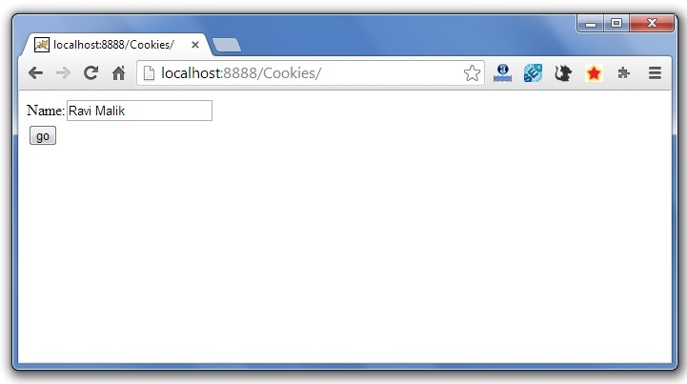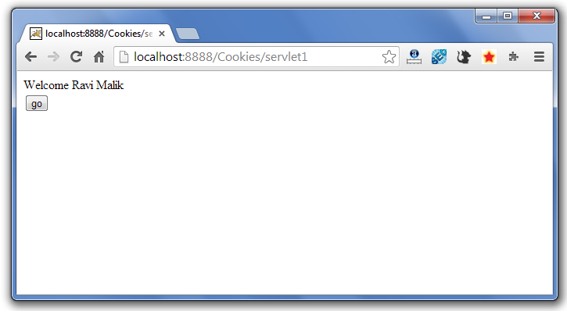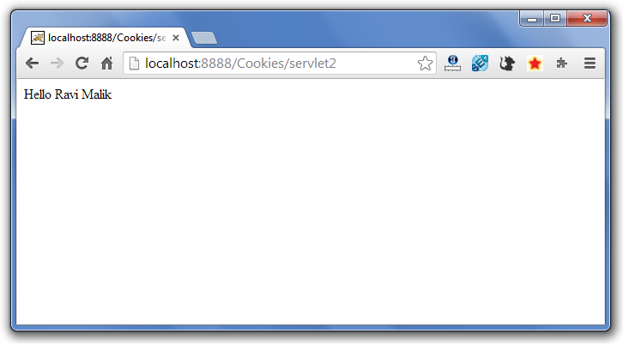

Next Topic[servlet login and logout example using cookies (Real Login App)](http://www.javatpoint.com/servlet-login-and-logout-example-using-cookies)

# Servlet Login and Logout Example using Cookies

A **cookie** is a kind of information that is stored at client side.

In the previous page, we learned a lot about cookie e.g. how to create cookie, how to delete cookie, how to get cookie etc.

Here, we are going to create a login and logout example using servlet cookies.

In this example, we are creating 3 links: login, logout and profile. User can't go to profile page until he/she is logged in. If user is logged out, he need to login again to visit profile.

In this application, we have created following files.

1. index.html
2. link.html
3. login.html
4. LoginServlet.java
5. LogoutServlet.java
6. ProfileServlet.java
7. web.xml

File: index.html

[copy to clipboard](http://www.javatpoint.com/servlet-login-and-logout-example-using-cookies)

1. <!DOCTYPE html>
2. <html>
3. <head>
4. <meta charset="ISO-8859-1">
5. <title>Servlet Login Example</title>
6. </head>
7. <body>
9. <h1>Welcome to Login App by Cookie</h1>
10. <a href="login.html">Login</a>|
11. <a href="LogoutServlet">Logout</a>|
12. <a href="ProfileServlet">Profile</a>
14. </body>
15. </html>



File: link.html

[copy to clipboard](http://www.javatpoint.com/servlet-login-and-logout-example-using-cookies)

1. <a href="login.html">Login</a> |
2. <a href="LogoutServlet">Logout</a> |
3. <a href="ProfileServlet">Profile</a>
4. <hr>



File: login.html

[copy to clipboard](http://www.javatpoint.com/servlet-login-and-logout-example-using-cookies)

1. <form action="LoginServlet" method="post">
2. Name:<input type="text" name="name"><br>
3. Password:<input type="password" name="password"><br>
4. <input type="submit" value="login">
5. </form>



File: LoginServlet.java

[copy to clipboard](http://www.javatpoint.com/servlet-login-and-logout-example-using-cookies)

1. package com.javatpoint;
3. import java.io.IOException;
4. import java.io.PrintWriter;
5. import javax.servlet.ServletException;
6. import javax.servlet.http.Cookie;
7. import javax.servlet.http.HttpServlet;
8. import javax.servlet.http.HttpServletRequest;
9. import javax.servlet.http.HttpServletResponse;
10. public class LoginServlet extends HttpServlet {
11. protected void doPost(HttpServletRequest request, HttpServletResponse response)
12. throws ServletException, IOException {
13. response.setContentType("text/html");
14. PrintWriter out=response.getWriter();
16. request.getRequestDispatcher("link.html").include(request, response);
18. String name=request.getParameter("name");
19. String password=request.getParameter("password");
21. if(password.equals("admin123")){
22. out.print("You are successfully logged in!");
23. out.print("<br>Welcome, "+name);
25. Cookie ck=new Cookie("name",name);
26. response.addCookie(ck);
27. }else{
28. out.print("sorry, username or password error!");
29. request.getRequestDispatcher("login.html").include(request, response);
30. }
32. out.close();
33. }
35. }



File: LogoutServlet.java

[copy to clipboard](http://www.javatpoint.com/servlet-login-and-logout-example-using-cookies)

1. package com.javatpoint;
3. import java.io.IOException;
4. import java.io.PrintWriter;
5. import javax.servlet.ServletException;
6. import javax.servlet.http.Cookie;
7. import javax.servlet.http.HttpServlet;
8. import javax.servlet.http.HttpServletRequest;
9. import javax.servlet.http.HttpServletResponse;
10. public class LogoutServlet extends HttpServlet {
11. protected void doGet(HttpServletRequest request, HttpServletResponse response)
12. throws ServletException, IOException {
13. response.setContentType("text/html");
14. PrintWriter out=response.getWriter();

17. request.getRequestDispatcher("link.html").include(request, response);
19. Cookie ck=new Cookie("name","");
20. ck.setMaxAge(0);
21. response.addCookie(ck);
23. out.print("you are successfully logged out!");
24. }
25. }



File: ProfileServlet.java

[copy to clipboard](http://www.javatpoint.com/servlet-login-and-logout-example-using-cookies)

1. package com.javatpoint;
3. import java.io.IOException;
4. import java.io.PrintWriter;
5. import javax.servlet.ServletException;
6. import javax.servlet.http.Cookie;
7. import javax.servlet.http.HttpServlet;
8. import javax.servlet.http.HttpServletRequest;
9. import javax.servlet.http.HttpServletResponse;
10. public class ProfileServlet extends HttpServlet {
11. protected void doGet(HttpServletRequest request, HttpServletResponse response)
12. throws ServletException, IOException {
13. response.setContentType("text/html");
14. PrintWriter out=response.getWriter();
16. request.getRequestDispatcher("link.html").include(request, response);
18. Cookie ck[]=request.getCookies();
19. if(ck!=null){
20. String name=ck[0].getValue();
21. if(!name.equals("")||name!=null){
22. out.print("<b>Welcome to Profile</b>");
23. out.print("<br>Welcome, "+name);
24. }
25. }else{
26. out.print("Please login first");
27. request.getRequestDispatcher("login.html").include(request, response);
28. }
29. out.close();
30. }
31. }



File: web.xml

[copy to clipboard](http://www.javatpoint.com/servlet-login-and-logout-example-using-cookies)

1. <?xml version="1.0" encoding="UTF-8"?>
2. <web-app xmlns:xsi="http://www.w3.org/2001/XMLSchema-instance"
3. xmlns="http://java.sun.com/xml/ns/javaee" xsi:schemaLocation="http://java.sun.com/xml/ns/javaee
4. http://java.sun.com/xml/ns/javaee/web-app_2_5.xsd" id="WebApp_ID" version="2.5">
6. <servlet>
7. <description></description>
8. <display-name>LoginServlet</display-name>
9. <servlet-name>LoginServlet</servlet-name>
10. <servlet-class>com.javatpoint.LoginServlet</servlet-class>
11. </servlet>
12. <servlet-mapping>
13. <servlet-name>LoginServlet</servlet-name>
14. <url-pattern>/LoginServlet</url-pattern>
15. </servlet-mapping>
16. <servlet>
17. <description></description>
18. <display-name>ProfileServlet</display-name>
19. <servlet-name>ProfileServlet</servlet-name>
20. <servlet-class>com.javatpoint.ProfileServlet</servlet-class>
21. </servlet>
22. <servlet-mapping>
23. <servlet-name>ProfileServlet</servlet-name>
24. <url-pattern>/ProfileServlet</url-pattern>
25. </servlet-mapping>
26. <servlet>
27. <description></description>
28. <display-name>LogoutServlet</display-name>
29. <servlet-name>LogoutServlet</servlet-name>
30. <servlet-class>com.javatpoint.LogoutServlet</servlet-class>
31. </servlet>
32. <servlet-mapping>
33. <servlet-name>LogoutServlet</servlet-name>
34. <url-pattern>/LogoutServlet</url-pattern>
35. </servlet-mapping>
36. </web-app>



[download this example (developed using Eclipse IDE)](http://www.javatpoint.com/src/servlet/eclipse/loginappcookie.zip)

#### Output

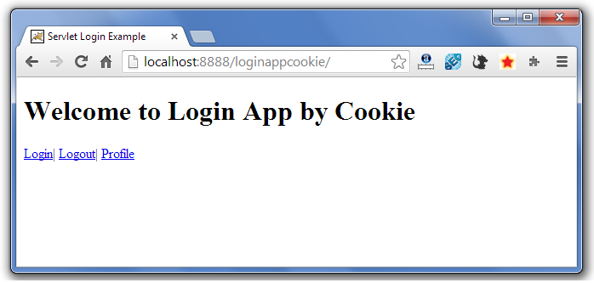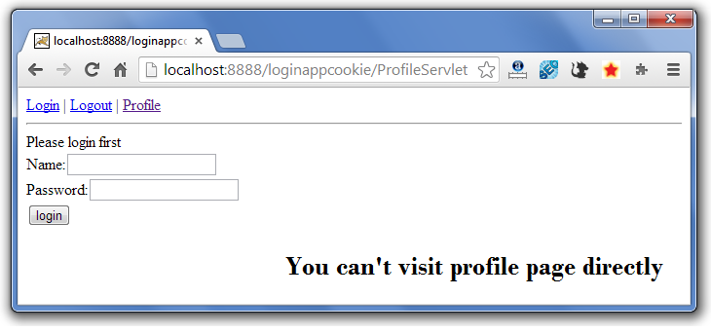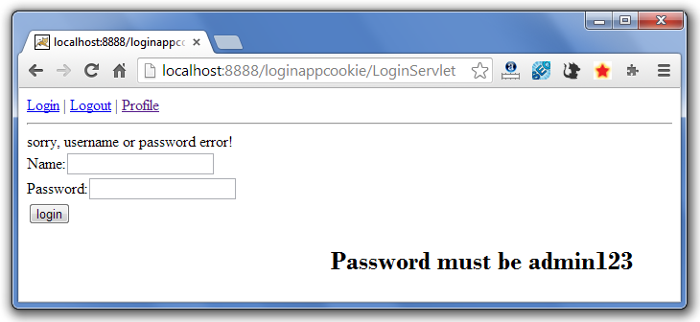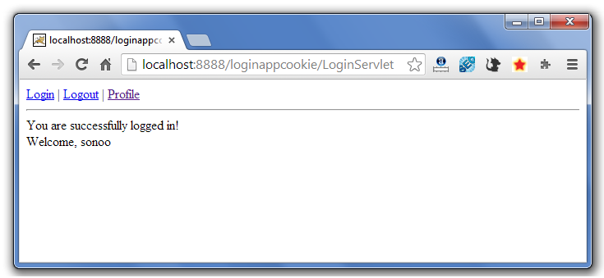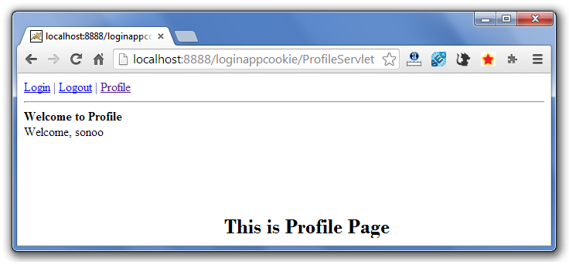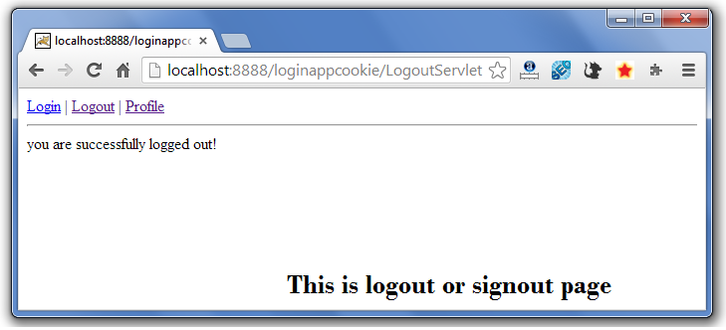

If again you click on the profile link, you need to login first.

Next Topic[Hidden Form Field In Session Tracking](http://www.javatpoint.com/hidden-form-field-in-session-tracking)

# 2) Hidden Form Field

1. [Hidden Form Field](http://www.javatpoint.com/hidden-form-field-in-session-tracking)
2. [Example of Hidden Form Field](http://www.javatpoint.com/hidden-form-field-in-session-tracking#session2ex)

In case of Hidden Form Field **a hidden (invisible) textfield** is used for maintaining the state of an user.

In such case, we store the information in the hidden field and get it from another servlet. This approach is better if we have to submit form in all the pages and we don't want to depend on the browser.

Let's see the code to store value in hidden field.

[copy to clipboard](http://www.javatpoint.com/hidden-form-field-in-session-tracking)

1. <input type="hidden" name="uname" value="Vimal Jaiswal">



Here, uname is the hidden field name and Vimal Jaiswal is the hidden field value.

### Real application of hidden form field

It is widely used in comment form of a website. In such case, we store page id or page name in the hidden field so that each page can be uniquely identified.

### Advantage of Hidden Form Field

1. It will always work whether cookie is disabled or not.

### Disadvantage of Hidden Form Field:

1. It is maintained at server side.
2. Extra form submission is required on each pages.
3. Only textual information can be used.

### Example of using Hidden Form Field

In this example, we are storing the name of the user in a hidden textfield and getting that value from another servlet.

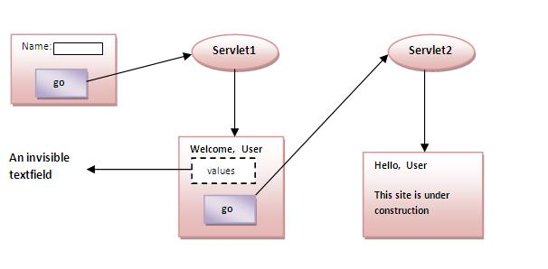

### index.html

[copy to clipboard](http://www.javatpoint.com/hidden-form-field-in-session-tracking)

1. <form action="servlet1">
2. Name:<input type="text" name="userName"/><br/>
3. <input type="submit" value="go"/>
4. </form>



### FirstServlet.java

[copy to clipboard](http://www.javatpoint.com/hidden-form-field-in-session-tracking)

1. import java.io.*;
2. import javax.servlet.*;
3. import javax.servlet.http.*;
5. public class FirstServlet extends HttpServlet {
6. public void doGet(HttpServletRequest request, HttpServletResponse response){
7. try{
9. response.setContentType("text/html");
10. PrintWriter out = response.getWriter();
12. String n=request.getParameter("userName");
13. out.print("Welcome "+n);
15. //creating form that have invisible textfield
16. out.print("<form action='servlet2'>");
17. out.print("<input type='hidden' name='uname' value='"+n+"'>");
18. out.print("<input type='submit' value='go'>");
19. out.print("</form>");
20. out.close();
22. }catch(Exception e){System.out.println(e);}
23. }
25. }



### SecondServlet.java

[copy to clipboard](http://www.javatpoint.com/hidden-form-field-in-session-tracking)

1. import java.io.*;
2. import javax.servlet.*;
3. import javax.servlet.http.*;
4. public class SecondServlet extends HttpServlet {
5. public void doGet(HttpServletRequest request, HttpServletResponse response)
6. try{
7. response.setContentType("text/html");
8. PrintWriter out = response.getWriter();
10. //Getting the value from the hidden field
11. String n=request.getParameter("uname");
12. out.print("Hello "+n);
14. out.close();
15. }catch(Exception e){System.out.println(e);}
16. }
17. }



### web.xml

[copy to clipboard](http://www.javatpoint.com/hidden-form-field-in-session-tracking)

1. <web-app>
3. <servlet>
4. <servlet-name>s1</servlet-name>
5. <servlet-class>FirstServlet</servlet-class>
6. </servlet>
8. <servlet-mapping>
9. <servlet-name>s1</servlet-name>
10. <url-pattern>/servlet1</url-pattern>
11. </servlet-mapping>
13. <servlet>
14. <servlet-name>s2</servlet-name>
15. <servlet-class>SecondServlet</servlet-class>
16. </servlet>
18. <servlet-mapping>
19. <servlet-name>s2</servlet-name>
20. <url-pattern>/servlet2</url-pattern>
21. </servlet-mapping>
23. </web-app>



[download this example (developed using Myeclipse IDE)](http://www.javatpoint.com/src/servlet/myeclipse/hiddenformfield.zip)  
[download this example (developed using Eclipse IDE)](http://www.javatpoint.com/src/servlet/eclipse/hiddenformfield.zip)  
[download this example (developed using Netbeans IDE)](http://www.javatpoint.com/src/servlet/netbeans/hiddenformfield.zip)

Next Topic[Url Rewriting In Session Tracking](http://www.javatpoint.com/url-rewriting-in-session-tracking)

# 3)URL Rewriting

1. [URL Rewriting](http://www.javatpoint.com/url-rewriting-in-session-tracking)
2. [Advantage of URL Rewriting](http://www.javatpoint.com/url-rewriting-in-session-tracking#urladv)
3. [Disadvantage of URL Rewriting](http://www.javatpoint.com/url-rewriting-in-session-tracking#urldisadv)
4. [Example of URL Rewriting](http://www.javatpoint.com/url-rewriting-in-session-tracking#urlex)

In URL rewriting, we append a token or identifier to the URL of the next Servlet or the next resource. We can send parameter name/value pairs using the following format:

url?name1=value1&name2=value2&??

A name and a value is separated using an equal = sign, a parameter name/value pair is separated from another parameter using the ampersand(&). When the user clicks the hyperlink, the parameter name/value pairs will be passed to the server. From a Servlet, we can use getParameter() method to obtain a parameter value.

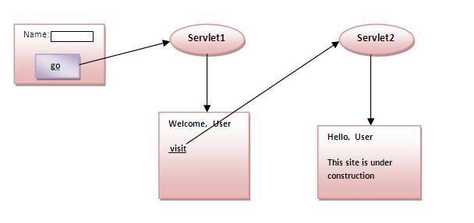

### Advantage of URL Rewriting

1. It will always work whether cookie is disabled or not (browser independent).
2. Extra form submission is not required on each pages.

### Disadvantage of URL Rewriting

1. It will work only with links.
2. It can send Only textual information.

### Example of using URL Rewriting

In this example, we are maintaning the state of the user using link. For this purpose, we are appending the name of the user in the query string and getting the value from the query string in another page.

### index.html

[copy to clipboard](http://www.javatpoint.com/url-rewriting-in-session-tracking)

1. <form action="servlet1">
2. Name:<input type="text" name="userName"/><br/>
3. <input type="submit" value="go"/>
4. </form>



### FirstServlet.java

[copy to clipboard](http://www.javatpoint.com/url-rewriting-in-session-tracking)

1. import java.io.*;
2. import javax.servlet.*;
3. import javax.servlet.http.*;

6. public class FirstServlet extends HttpServlet {
8. public void doGet(HttpServletRequest request, HttpServletResponse response){
9. try{
11. response.setContentType("text/html");
12. PrintWriter out = response.getWriter();
14. String n=request.getParameter("userName");
15. out.print("Welcome "+n);
17. //appending the username in the query string
18. out.print("<a href='servlet2?uname="+n+"'>visit</a>");
20. out.close();
22. }catch(Exception e){System.out.println(e);}
23. }
25. }



### SecondServlet.java

[copy to clipboard](http://www.javatpoint.com/url-rewriting-in-session-tracking)

1. import java.io.*;
2. import javax.servlet.*;
3. import javax.servlet.http.*;
5. public class SecondServlet extends HttpServlet {
7. public void doGet(HttpServletRequest request, HttpServletResponse response)
8. try{
10. response.setContentType("text/html");
11. PrintWriter out = response.getWriter();
13. //getting value from the query string
14. String n=request.getParameter("uname");
15. out.print("Hello "+n);
17. out.close();
19. }catch(Exception e){System.out.println(e);}
20. }

23. }



### web.xml

[copy to clipboard](http://www.javatpoint.com/url-rewriting-in-session-tracking)

1. <web-app>
3. <servlet>
4. <servlet-name>s1</servlet-name>
5. <servlet-class>FirstServlet</servlet-class>
6. </servlet>
8. <servlet-mapping>
9. <servlet-name>s1</servlet-name>
10. <url-pattern>/servlet1</url-pattern>
11. </servlet-mapping>
13. <servlet>
14. <servlet-name>s2</servlet-name>
15. <servlet-class>SecondServlet</servlet-class>
16. </servlet>
18. <servlet-mapping>
19. <servlet-name>s2</servlet-name>
20. <url-pattern>/servlet2</url-pattern>
21. </servlet-mapping>
23. </web-app>



[download this example (developed using Myeclipse IDE)](http://www.javatpoint.com/src/servlet/myeclipse/urlrewriting.zip)  
[download this example (developed using Eclipse IDE)](http://www.javatpoint.com/src/servlet/eclipse/urlrewriting.zip)  
[download this example (developed using Netbeans IDE)](http://www.javatpoint.com/src/servlet/netbeans/urlrewriting.zip)

Next Topic[Http Session In Session Tracking](http://www.javatpoint.com/http-session-in-session-tracking)

# ) HttpSession interface

1. [HttpSession interface](http://www.javatpoint.com/http-session-in-session-tracking)
2. [How to get the HttpSession object](http://www.javatpoint.com/http-session-in-session-tracking#httpsessionhow)
3. [Commonly used methods of HttpSession interface](http://www.javatpoint.com/http-session-in-session-tracking#httpsessionmethod)
4. [Example of using HttpSession](http://www.javatpoint.com/http-session-in-session-tracking#httpsessionex)

In such case, container creates a session id for each user.The container uses this id to identify the particular user.An object of HttpSession can be used to perform two tasks:

1. bind objects
2. view and manipulate information about a session, such as the session identifier, creation time, and last accessed time.

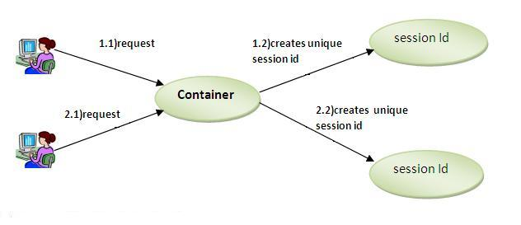

### How to get the HttpSession object ?

The HttpServletRequest interface provides two methods to get the object of HttpSession:

1. **public HttpSession getSession():**Returns the current session associated with this request, or if the request does not have a session, creates one.
2. **public HttpSession getSession(boolean create):**Returns the current HttpSession associated with this request or, if there is no current session and create is true, returns a new session.

### Commonly used methods of HttpSession interface

1. **public String getId():**Returns a string containing the unique identifier value.
2. **public long getCreationTime():**Returns the time when this session was created, measured in milliseconds since midnight January 1, 1970 GMT.
3. **public long getLastAccessedTime():**Returns the last time the client sent a request associated with this session, as the number of milliseconds since midnight January 1, 1970 GMT.
4. **public void invalidate():**Invalidates this session then unbinds any objects bound to it.

### Example of using HttpSession

In this example, we are setting the attribute in the session scope in one servlet and getting that value from the session scope in another servlet. To set the attribute in the session scope, we have used the setAttribute() method of HttpSession interface and to get the attribute, we have used the getAttribute method.

### index.html

[copy to clipboard](http://www.javatpoint.com/http-session-in-session-tracking)

1. <form action="servlet1">
2. Name:<input type="text" name="userName"/><br/>
3. <input type="submit" value="go"/>
4. </form>



### FirstServlet.java

[copy to clipboard](http://www.javatpoint.com/http-session-in-session-tracking)

1. import java.io.*;
2. import javax.servlet.*;
3. import javax.servlet.http.*;

6. public class FirstServlet extends HttpServlet {
8. public void doGet(HttpServletRequest request, HttpServletResponse response){
9. try{
11. response.setContentType("text/html");
12. PrintWriter out = response.getWriter();
14. String n=request.getParameter("userName");
15. out.print("Welcome "+n);
17. HttpSession session=request.getSession();
18. session.setAttribute("uname",n);
20. out.print("<a href='servlet2'>visit</a>");
22. out.close();
24. }catch(Exception e){System.out.println(e);}
25. }
27. }



### SecondServlet.java

[copy to clipboard](http://www.javatpoint.com/http-session-in-session-tracking)

1. import java.io.*;
2. import javax.servlet.*;
3. import javax.servlet.http.*;
5. public class SecondServlet extends HttpServlet {
7. public void doGet(HttpServletRequest request, HttpServletResponse response)
8. try{
10. response.setContentType("text/html");
11. PrintWriter out = response.getWriter();
13. HttpSession session=request.getSession(false);
14. String n=(String)session.getAttribute("uname");
15. out.print("Hello "+n);
17. out.close();
19. }catch(Exception e){System.out.println(e);}
20. }

23. }



### web.xml

[copy to clipboard](http://www.javatpoint.com/http-session-in-session-tracking)

1. <web-app>
3. <servlet>
4. <servlet-name>s1</servlet-name>
5. <servlet-class>FirstServlet</servlet-class>
6. </servlet>
8. <servlet-mapping>
9. <servlet-name>s1</servlet-name>
10. <url-pattern>/servlet1</url-pattern>
11. </servlet-mapping>
13. <servlet>
14. <servlet-name>s2</servlet-name>
15. <servlet-class>SecondServlet</servlet-class>
16. </servlet>
18. <servlet-mapping>
19. <servlet-name>s2</servlet-name>
20. <url-pattern>/servlet2</url-pattern>
21. </servlet-mapping>
23. </web-app>



[download this example (developed using Myeclipse IDE)](http://www.javatpoint.com/src/servlet/myeclipse/HttpSession.zip)  
[download this example (developed using Eclipse IDE)](http://www.javatpoint.com/src/servlet/eclipse/HttpSession.zip)  
[download this example (developed using Netbeans IDE)](http://www.javatpoint.com/src/servlet/netbeans/HttpSession.zip)

Next Topic[Servlet HttpSession login and logout example](http://www.javatpoint.com/servlet-http-session-login-and-logout-example)

# Servlet HttpSession Login and Logout Example

We can bind the objects on HttpSession instance and get the objects by using setAttribute and getAttribute methods.

In the previous page, we have learnt about what is HttpSession, How to store and get data from session object etc.

Here, we are going to create a real world login and logout application without using database code. We are assuming that password is admin123.

Visit here for login and logout application using cookies only [servlet login and logout example using cookies](http://www.javatpoint.com/servlet-login-and-logout-example-using-cookies)

In this example, we are creating 3 links: login, logout and profile. User can't go to profile page until he/she is logged in. If user is logged out, he need to login again to visit profile.

In this application, we have created following files.

1. index.html
2. link.html
3. login.html
4. LoginServlet.java
5. LogoutServlet.java
6. ProfileServlet.java
7. web.xml

File: index.html

[copy to clipboard](http://www.javatpoint.com/servlet-http-session-login-and-logout-example)

1. <!DOCTYPE html>
2. <html>
3. <head>
4. <meta charset="ISO-8859-1">
5. <title>Servlet Login Example</title>
6. </head>
7. <body>
9. <h1>Login App using HttpSession</h1>
10. <a href="login.html">Login</a>|
11. <a href="LogoutServlet">Logout</a>|
12. <a href="ProfileServlet">Profile</a>
14. </body>
15. </html>



File: link.html

[copy to clipboard](http://www.javatpoint.com/servlet-http-session-login-and-logout-example)

1. <a href="login.html">Login</a> |
2. <a href="LogoutServlet">Logout</a> |
3. <a href="ProfileServlet">Profile</a>
4. <hr>



File: login.html

[copy to clipboard](http://www.javatpoint.com/servlet-http-session-login-and-logout-example)

1. <form action="LoginServlet" method="post">
2. Name:<input type="text" name="name"><br>
3. Password:<input type="password" name="password"><br>
4. <input type="submit" value="login">
5. </form>



File: LoginServlet.java

[copy to clipboard](http://www.javatpoint.com/servlet-http-session-login-and-logout-example)

1. import java.io.IOException;
2. import java.io.PrintWriter;
4. import javax.servlet.ServletException;
5. import javax.servlet.http.HttpServlet;
6. import javax.servlet.http.HttpServletRequest;
7. import javax.servlet.http.HttpServletResponse;
8. import javax.servlet.http.HttpSession;
9. public class LoginServlet extends HttpServlet {
10. protected void doPost(HttpServletRequest request, HttpServletResponse response)
11. throws ServletException, IOException {
12. response.setContentType("text/html");
13. PrintWriter out=response.getWriter();
14. request.getRequestDispatcher("link.html").include(request, response);
16. String name=request.getParameter("name");
17. String password=request.getParameter("password");
19. if(password.equals("admin123")){
20. out.print("Welcome, "+name);
21. HttpSession session=request.getSession();
22. session.setAttribute("name",name);
23. }
24. else{
25. out.print("Sorry, username or password error!");
26. request.getRequestDispatcher("login.html").include(request, response);
27. }
28. out.close();
29. }
30. }



File: LogoutServlet.java

[copy to clipboard](http://www.javatpoint.com/servlet-http-session-login-and-logout-example)

1. import java.io.IOException;
2. import java.io.PrintWriter;
4. import javax.servlet.ServletException;
5. import javax.servlet.http.HttpServlet;
6. import javax.servlet.http.HttpServletRequest;
7. import javax.servlet.http.HttpServletResponse;
8. import javax.servlet.http.HttpSession;
9. public class LogoutServlet extends HttpServlet {
10. protected void doGet(HttpServletRequest request, HttpServletResponse response)
11. throws ServletException, IOException {
12. response.setContentType("text/html");
13. PrintWriter out=response.getWriter();
15. request.getRequestDispatcher("link.html").include(request, response);
17. HttpSession session=request.getSession();
18. session.invalidate();
20. out.print("You are successfully logged out!");
22. out.close();
23. }
24. }



File: ProfileServlet.java

[copy to clipboard](http://www.javatpoint.com/servlet-http-session-login-and-logout-example)

1. import java.io.IOException;
2. import java.io.PrintWriter;
3. import javax.servlet.ServletException;
4. import javax.servlet.http.HttpServlet;
5. import javax.servlet.http.HttpServletRequest;
6. import javax.servlet.http.HttpServletResponse;
7. import javax.servlet.http.HttpSession;
8. public class ProfileServlet extends HttpServlet {
9. protected void doGet(HttpServletRequest request, HttpServletResponse response)
10. throws ServletException, IOException {
11. response.setContentType("text/html");
12. PrintWriter out=response.getWriter();
13. request.getRequestDispatcher("link.html").include(request, response);
15. HttpSession session=request.getSession(false);
16. if(session!=null){
17. String name=(String)session.getAttribute("name");
19. out.print("Hello, "+name+" Welcome to Profile");
20. }
21. else{
22. out.print("Please login first");
23. request.getRequestDispatcher("login.html").include(request, response);
24. }
25. out.close();
26. }
27. }



File: web.xml

[copy to clipboard](http://www.javatpoint.com/servlet-http-session-login-and-logout-example)

1. <?xml version="1.0" encoding="UTF-8"?>
2. <web-app xmlns:xsi="http://www.w3.org/2001/XMLSchema-instance"
3. xmlns="http://java.sun.com/xml/ns/javaee" xsi:schemaLocation="http://java.sun.com/xml/ns/javaee
4. http://java.sun.com/xml/ns/javaee/web-app_2_5.xsd" id="WebApp_ID" version="2.5">
6. <servlet>
7. <description></description>
8. <display-name>LoginServlet</display-name>
9. <servlet-name>LoginServlet</servlet-name>
10. <servlet-class>LoginServlet</servlet-class>
11. </servlet>
12. <servlet-mapping>
13. <servlet-name>LoginServlet</servlet-name>
14. <url-pattern>/LoginServlet</url-pattern>
15. </servlet-mapping>
16. <servlet>
17. <description></description>
18. <display-name>ProfileServlet</display-name>
19. <servlet-name>ProfileServlet</servlet-name>
20. <servlet-class>ProfileServlet</servlet-class>
21. </servlet>
22. <servlet-mapping>
23. <servlet-name>ProfileServlet</servlet-name>
24. <url-pattern>/ProfileServlet</url-pattern>
25. </servlet-mapping>
26. <servlet>
27. <description></description>
28. <display-name>LogoutServlet</display-name>
29. <servlet-name>LogoutServlet</servlet-name>
30. <servlet-class>LogoutServlet</servlet-class>
31. </servlet>
32. <servlet-mapping>
33. <servlet-name>LogoutServlet</servlet-name>
34. <url-pattern>/LogoutServlet</url-pattern>
35. </servlet-mapping>
36. </web-app>



[download this example (developed using Eclipse IDE)](http://www.javatpoint.com/src/servlet/eclipse/httpsessionlogin.zip)

#### Output

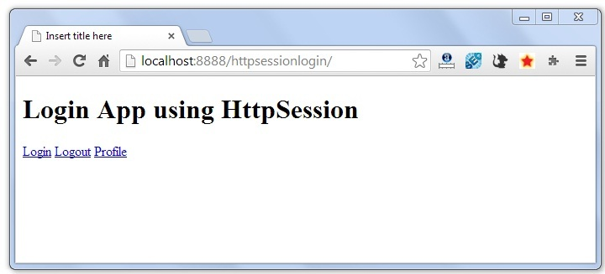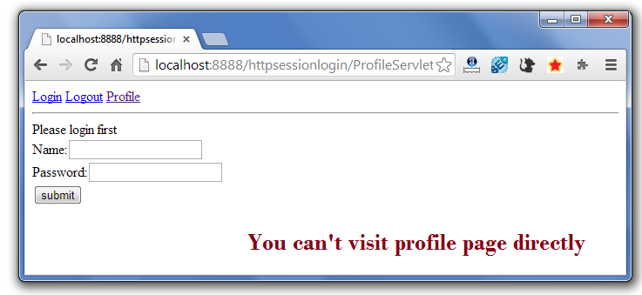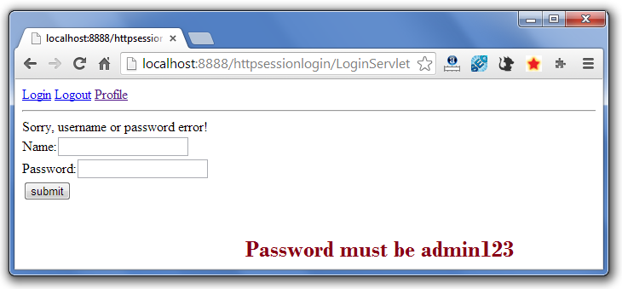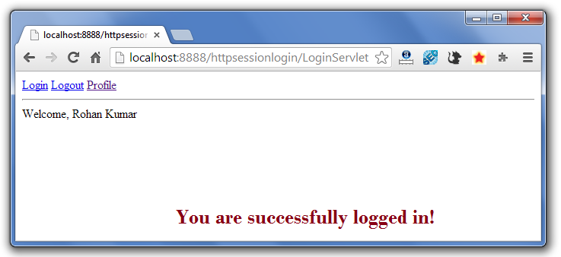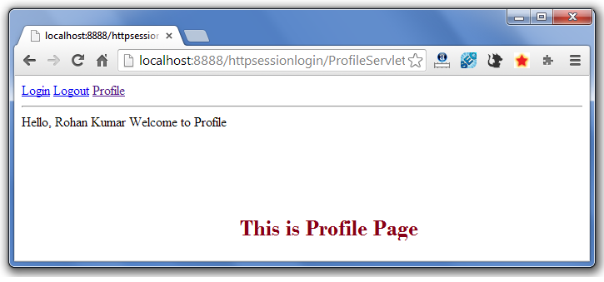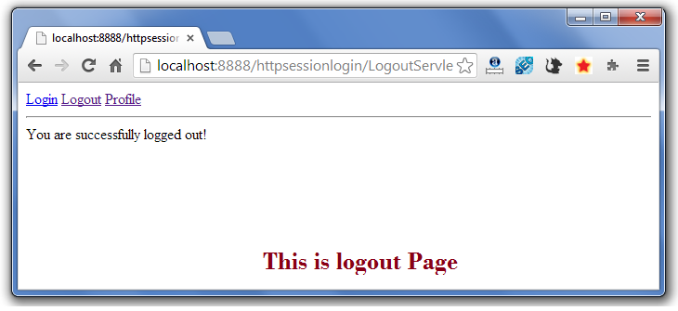

If again you click on the profile link, you need to login first.

Next Topic[Event and Listener in Servlet](http://www.javatpoint.com/Event-and-Listener-in-Servlet)

# Event and Listener in Servlet

1. [Event and Listener in Servlet](http://www.javatpoint.com/Event-and-Listener-in-Servlet)
2. [Event classes](http://www.javatpoint.com/Event-and-Listener-in-Servlet#eventclasses)
3. [Event interfaces](http://www.javatpoint.com/Event-and-Listener-in-Servlet#eventinterfaces)

|  |
| --- |
| Events are basically occurrence of something. Changing the state of an object is known as an event. |
| We can perform some important tasks at the occurrence of these exceptions, such as counting total and current logged-in users, creating tables of the database at time of deploying the project, creating database connection object etc. |
| There are many Event classes and Listener interfaces in the javax.servlet and javax.servlet.http packages. |

### Event classes

The event classes are as follows:

1. ServletRequestEvent
2. ServletContextEvent
3. ServletRequestAttributeEvent
4. ServletContextAttributeEvent
5. HttpSessionEvent
6. HttpSessionBindingEvent

### Event interfaces

The event interfaces are as follows:

1. ServletRequestListener
2. ServletRequestAttributeListener
3. ServletContextListener
4. ServletContextAttributeListener
5. HttpSessionListener
6. HttpSessionAttributeListener
7. HttpSessionBindingListener
8. HttpSessionActivationListener

### Upcoming topics in Servlet Events and Listeners

[ServletContextEvent](http://www.javatpoint.com/ServletContextEvent)

Let's see the simple example of ServletContextEvent and ServletContextListener

[HttpSessionEvent](http://www.javatpoint.com/HttpSessionEvent)

Let's see the simple example of HttpSessionEvent and HttpSessionListener

[ServletRequestEvent](http://www.javatpoint.com/ServletRequestEvent)

Let's see the simple example of ServletRequestEvent and ServletRequestListener

[ServletContext AttributeEvent](http://www.javatpoint.com/ServletContextAttributeEvent)

Let's see the simple example of ServletContextAttributeEvent and ServletContextAttributeListener

[HttpSessionBindingEvent](http://www.javatpoint.com/HttpSessionBindingEvent)

Let's see the simple example of HttpSessionBindingEvent and HttpSessionAttributeListener

[ServletRequestAttributeEvent](http://www.javatpoint.com/ServletRequestAttributeEvent)

Let's see the simple example of ServletRequestAttributeEvent and ServletRequestAttributeEvent

Next Topic[Filter](http://www.javatpoint.com/filter)

# Servlet Filter

1. [Filter](http://www.javatpoint.com/servlet-filter)
2. [Usage of Filter](http://www.javatpoint.com/servlet-filter#filterusage)
3. [Advantage of Filter](http://www.javatpoint.com/servlet-filter#filteradvantage)
4. [Filter API](http://www.javatpoint.com/servlet-filter#filterapi)
   1. [Filter interface](http://www.javatpoint.com/servlet-filter#filterinterface)
   2. [FilterChain interface](http://www.javatpoint.com/servlet-filter#filterchain)
   3. [FilterConfig interface](http://www.javatpoint.com/servlet-filter#filterconfig)
5. [Simple Example of Filter](http://www.javatpoint.com/servlet-filter#filterex)

A **filter** is an object that is invoked at the preprocessing and postprocessing of a request.

It is mainly used to perform filtering tasks such as conversion, logging, compression, encryption and decryption, input validation etc.

The **servlet filter is pluggable**, i.e. its entry is defined in the web.xml file, if we remove the entry of filter from the web.xml file, filter will be removed automatically and we don't need to change the servlet.

So maintenance cost will be less.

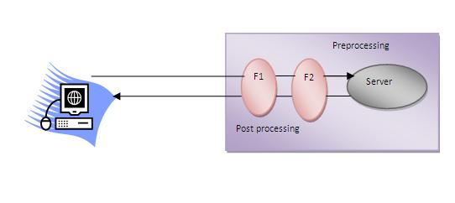

#### *Note: Unlike Servlet, One filter doesn't have dependency on another filter.*

### Usage of Filter

* recording all incoming requests
* logs the IP addresses of the computers from which the requests originate
* conversion
* data compression
* encryption and decryption
* input validation etc.

### Advantage of Filter

1. Filter is pluggable.
2. One filter don't have dependency onto another resource.
3. Less Maintenance

### Filter API

Like servlet filter have its own API. The javax.servlet package contains the three interfaces of Filter API.

1. Filter
2. FilterChain
3. FilterConfig

### 1) Filter interface

For creating any filter, you must implement the Filter interface. Filter interface provides the life cycle methods for a filter.

|  |  |
| --- | --- |
| **Method** | **Description** |
| public void init(FilterConfig config) | init() method is invoked only once. It is used to initialize the filter. |
| public void doFilter(HttpServletRequest request,HttpServletResponse response, FilterChain chain) | doFilter() method is invoked every time when user request to any resource, to which the filter is mapped.It is used to perform filtering tasks. |
| public void destroy() | This is invoked only once when filter is taken out of the service. |

### 2) FilterChain interface

The object of FilterChain is responsible to invoke the next filter or resource in the chain.This object is passed in the doFilter method of Filter interface.The FilterChain interface contains only one method:

1. **public void doFilter(HttpServletRequest request, HttpServletResponse response):** it passes the control to the next filter or resource.

### How to define Filter

We can define filter same as servlet. Let's see the elements of filter and filter-mapping.

[copy to clipboard](http://www.javatpoint.com/servlet-filter)

1. <web-app>
3. <filter>
4. <filter-name>...</filter-name>
5. <filter-class>...</filter-class>
6. </filter>
8. <filter-mapping>
9. <filter-name>...</filter-name>
10. <url-pattern>...</url-pattern>
11. </filter-mapping>
13. </web-app>



For mapping filter we can use, either url-pattern or servlet-name. The url-pattern elements has an advantage over servlet-name element i.e. it can be applied on servlet, JSP or HTML.

### Simple Example of Filter

In this example, we are simply displaying information that filter is invoked automatically after the post processing of the request.

### index.html

[copy to clipboard](http://www.javatpoint.com/servlet-filter)

1. <a href="servlet1">click here</a>



### MyFilter.java

[copy to clipboard](http://www.javatpoint.com/servlet-filter)

1. import java.io.IOException;
2. import java.io.PrintWriter;
4. import javax.servlet.*;
6. public class MyFilter implements Filter{
8. public void init(FilterConfig arg0) throws ServletException {}
10. public void doFilter(ServletRequest req, ServletResponse resp,
11. FilterChain chain) throws IOException, ServletException {
13. PrintWriter out=resp.getWriter();
14. out.print("filter is invoked before");
16. chain.doFilter(req, resp);//sends request to next resource
18. out.print("filter is invoked after");
19. }
20. public void destroy() {}
21. }



### HelloServlet.java

[copy to clipboard](http://www.javatpoint.com/servlet-filter)

1. import java.io.IOException;
2. import java.io.PrintWriter;
4. import javax.servlet.ServletException;
5. import javax.servlet.http.*;
7. public class HelloServlet extends HttpServlet {
8. public void doGet(HttpServletRequest request, HttpServletResponse response)
9. throws ServletException, IOException {
11. response.setContentType("text/html");
12. PrintWriter out = response.getWriter();
14. out.print("<br>welcome to servlet<br>");
16. }
18. }



**web.xml**

|  |
| --- |
| For defining the filter, filter element of web-app must be defined just like servlet. |

[copy to clipboard](http://www.javatpoint.com/servlet-filter)

1. <web-app>
3. <servlet>
4. <servlet-name>s1</servlet-name>
5. <servlet-class>HelloServlet</servlet-class>
6. </servlet>
8. <servlet-mapping>
9. <servlet-name>s1</servlet-name>
10. <url-pattern>/servlet1</url-pattern>
11. </servlet-mapping>
13. <filter>
14. <filter-name>f1</filter-name>
15. <filter-class>MyFilter</filter-class>
16. </filter>
18. <filter-mapping>
19. <filter-name>f1</filter-name>
20. <url-pattern>/servlet1</url-pattern>
21. </filter-mapping>

24. </web-app>



[download this example (developed using Myeclipse IDE)](http://www.javatpoint.com/src/servlet/filter1.zip)  
[download this example (developed using Eclipse IDE)](http://www.javatpoint.com/src/servlet/eclipse/filter1.zip)  
[download this example (developed using Netbeans IDE)](http://www.javatpoint.com/src/servlet/netbeans/filter1.zip)

Next Topic[Authentication Filter](http://www.javatpoint.com/authentication-filter)

# Authentication Filter

We can perform authentication in filter. Here, we are going to check to password given by the user in filter class, if given password is admin, it will forward the request to the WelcomeAdmin servlet otherwise it will display error message.

### Example of authenticating user using filter

Let's see the simple example of authenticating user using filter.

Here, we have created 4 files:

* index.html
* MyFilter.java
* AdminServlet.java
* web.xml

**index.html**

[copy to clipboard](http://www.javatpoint.com/authentication-filter)

1. <form action="servlet1">
2. Name:<input type="text" name="name"/><br/>
3. Password:<input type="password" name="password"/><br/>
5. <input type="submit" value="login">
7. </form>



**MyFilter.java**

[copy to clipboard](http://www.javatpoint.com/authentication-filter)

1. import java.io.IOException;
2. import java.io.PrintWriter;
3. import javax.servlet.*;
5. public class MyFilter implements Filter{
7. public void init(FilterConfig arg0) throws ServletException {}
9. public void doFilter(ServletRequest req, ServletResponse resp,
10. FilterChain chain) throws IOException, ServletException {
12. PrintWriter out=resp.getWriter();
14. String password=req.getParameter("password");
15. if(password.equals("admin")){
16. chain.doFilter(req, resp);//sends request to next resource
17. }
18. else{
19. out.print("username or password error!");
20. RequestDispatcher rd=req.getRequestDispatcher("index.html");
21. rd.include(req, resp);
22. }
24. }
25. public void destroy() {}
27. }



**AdminServlet.java**

[copy to clipboard](http://www.javatpoint.com/authentication-filter)

1. import java.io.IOException;
2. import java.io.PrintWriter;
4. import javax.servlet.ServletException;
5. import javax.servlet.http.*;
7. public class AdminServlet extends HttpServlet {
8. public void doGet(HttpServletRequest request, HttpServletResponse response)
9. throws ServletException, IOException {
11. response.setContentType("text/html");
12. PrintWriter out = response.getWriter();
14. out.print("welcome ADMIN");
15. out.close();
16. }
17. }



**web.xml**

[copy to clipboard](http://www.javatpoint.com/authentication-filter)

1. <web-app>
2. <servlet>
3. <servlet-name>AdminServlet</servlet-name>
4. <servlet-class>AdminServlet</servlet-class>
5. </servlet>
7. <servlet-mapping>
8. <servlet-name>AdminServlet</servlet-name>
9. <url-pattern>/servlet1</url-pattern>
10. </servlet-mapping>
12. <filter>
13. <filter-name>f1</filter-name>
14. <filter-class>MyFilter</filter-class>
15. </filter>
16. <filter-mapping>
17. <filter-name>f1</filter-name>
18. <url-pattern>/servlet1</url-pattern>
19. </filter-mapping>
21. </web-app>



[download this example (developed using Myeclipse IDE)](http://www.javatpoint.com/src/servlet/filterauth.zip)  
[download this example (developed using Eclipse IDE)](http://www.javatpoint.com/src/servlet/eclipse/filterauth.zip)  
[download this example (developed using Netbeans IDE)](http://www.javatpoint.com/src/servlet/netbeans/filterauth.zip)

Next Topic[Filter Config](http://www.javatpoint.com/filter-config)

# FilterConfig

An object of FilterConfig is created by the web container. This object can be used to get the configuration information from the web.xml file.

## Methods of FilterConfig interface

There are following 4 methods in the FilterConfig interface.

1. **public void init(FilterConfig config):** init() method is invoked only once it is used to initialize the filter.
2. **public String getInitParameter(String parameterName):** Returns the parameter value for the specified parameter name.
3. **public java.util.Enumeration getInitParameterNames():** Returns an enumeration containing all the parameter names.
4. **public ServletContext getServletContext():** Returns the ServletContext object.

### Example of FilterConfig

In this example, if you change the param-value to no, request will be forwarded to the servlet otherwise filter will create the response with the message: this page is underprocessing. Let's see the simple example of FilterConfig. Here, we have created 4 files:

* index.html
* MyFilter.java
* HelloServlet.java
* web.xml

**index.html**

[copy to clipboard](http://www.javatpoint.com/filter-config)

1. <a href="servlet1">click here</a>



**MyFilter.java**

[copy to clipboard](http://www.javatpoint.com/filter-config)

1. import java.io.IOException;
2. import java.io.PrintWriter;
4. import javax.servlet.*;
6. public class MyFilter implements Filter{
7. FilterConfig config;
9. public void init(FilterConfig config) throws ServletException {
10. this.config=config;
11. }
13. public void doFilter(ServletRequest req, ServletResponse resp,
14. FilterChain chain) throws IOException, ServletException {
16. PrintWriter out=resp.getWriter();
18. String s=config.getInitParameter("construction");
20. if(s.equals("yes")){
21. out.print("This page is under construction");
22. }
23. else{
24. chain.doFilter(req, resp);//sends request to next resource
25. }
27. }
28. public void destroy() {}
29. }



**HelloServlet.java**

[copy to clipboard](http://www.javatpoint.com/filter-config)

1. import java.io.IOException;
2. import java.io.PrintWriter;
4. import javax.servlet.ServletException;
5. import javax.servlet.http.*;
7. public class HelloServlet extends HttpServlet {
8. public void doGet(HttpServletRequest request, HttpServletResponse response)
9. throws ServletException, IOException {
11. response.setContentType("text/html");
12. PrintWriter out = response.getWriter();
14. out.print("<br>welcome to servlet<br>");
16. }
18. }



**web.xml**

[copy to clipboard](http://www.javatpoint.com/filter-config)

1. <web-app>
3. <servlet>
4. <servlet-name>HelloServlet</servlet-name>
5. <servlet-class>HelloServlet</servlet-class>
6. </servlet>
8. <servlet-mapping>
9. <servlet-name>HelloServlet</servlet-name>
10. <url-pattern>/servlet1</url-pattern>
11. </servlet-mapping>
13. <filter>
14. <filter-name>f1</filter-name>
15. <filter-class>MyFilter</filter-class>
16. <init-param>
17. <param-name>construction</param-name>
18. <param-value>no</param-value>
19. </init-param>
20. </filter>
21. <filter-mapping>
22. <filter-name>f1</filter-name>
23. <url-pattern>/servlet1</url-pattern>
24. </filter-mapping>

27. </web-app>



[download this example (developed using Myeclipse IDE)](http://www.javatpoint.com/src/servlet/filterconfig.zip)  
[download this example (developed using Eclipse IDE)](http://www.javatpoint.com/src/servlet/eclipse/filterconfig.zip)  
[download this example (developed using Netbeans IDE)](http://www.javatpoint.com/src/servlet/netbeans/filterconfig.zip)

Next Topic[Useful Example Of Filter](http://www.javatpoint.com/filter2)

# Useful Filter Examples

There is given some useful examples of filter.

### Example of sending response by filter only

**MyFilter.java**

[copy to clipboard](http://www.javatpoint.com/filter2)

1. import java.io.*;
2. import javax.servlet.*;
4. public class MyFilter implements Filter{
5. public void init(FilterConfig arg0) throws ServletException {}
7. public void doFilter(ServletRequest req, ServletResponse res,
8. FilterChain chain) throws IOException, ServletException {
10. PrintWriter out=res.getWriter();
12. out.print("<br/>this site is underconstruction..");
13. out.close();
15. }
16. public void destroy() {}
17. }



### Example of counting number of visitors for a single page

**MyFilter.java**

[copy to clipboard](http://www.javatpoint.com/filter2)

1. import java.io.*;
2. import javax.servlet.*;
4. public class MyFilter implements Filter{
5. static int count=0;
6. public void init(FilterConfig arg0) throws ServletException {}
8. public void doFilter(ServletRequest req, ServletResponse res,
9. FilterChain chain) throws IOException, ServletException {
11. PrintWriter out=res.getWriter();
12. chain.doFilter(request,response);
14. out.print("<br/>Total visitors "+(++count));
15. out.close();
17. }
18. public void destroy() {}
19. }



### Example of checking total response time in filter

**MyFilter.java**

[copy to clipboard](http://www.javatpoint.com/filter2)

1. import java.io.*;
2. import javax.servlet.*;
4. public class MyFilter implements Filter{
5. static int count=0;
6. public void init(FilterConfig arg0) throws ServletException {}
8. public void doFilter(ServletRequest req, ServletResponse res,
9. FilterChain chain) throws IOException, ServletException {
11. PrintWriter out=res.getWriter();
12. long before=System.currentTimeMillis();
14. chain.doFilter(request,response);
16. long after=System.currentTimeMillis();
17. out.print("<br/>Total response time "+(after-before)+" miliseconds");
18. out.close();
20. }
21. public void destroy() {}
22. }



Next Topic[ServletInputStream Class](http://www.javatpoint.com/ServletInputStream-class)

# ServletInputStream class

1. [ServletInputStream class](http://www.javatpoint.com/ServletInputStream-class)
2. [Method of ServletInputStream class](http://www.javatpoint.com/ServletInputStream-class)

**ServletInputStream** class provides stream to read binary data such as image etc. from the request object. It is an abstract class.

The **getInputStream()** method of **ServletRequest** interface returns the instance of ServletInputStream class. So can be get as:

[copy to clipboard](http://www.javatpoint.com/ServletInputStream-class)

1. ServletInputStream sin=request.getInputStream();



### Method of ServletInputStream class

There are only one method defined in the ServletInputStream class.

1. **int readLine(byte[] b, int off, int len)** it reads the input stream.

Next Topic[ServletOutputStream Class](http://www.javatpoint.com/ServletOutputStream-class)

# ServletOutputStream class

1. [ServletOutputStream class](http://www.javatpoint.com/ServletOutputStream-class)
2. [Methods of ServletOutputStream class](http://www.javatpoint.com/ServletOutputStream-class#method)
3. [Example of ServletOutputStream class](http://www.javatpoint.com/ServletOutputStream-class)

**ServletOutputStream** class provides a stream to write binary data into the response. It is an abstract class.

The **getOutputStream()** method of **ServletResponse** interface returns the instance of ServletOutputStream class. It may be get as:

[copy to clipboard](http://www.javatpoint.com/ServletOutputStream-class)

1. ServletOutputStream out=response.getOutputStream();



### Methods of ServletOutputStream class

The ServletOutputStream class provides print() and println() methods that are overloaded.

1. void print(boolean b){}
2. void print(char c){}
3. void print(int i){}
4. void print(long l){}
5. void print(float f){}
6. void print(double d){}
7. void print(String s){}
8. void println{}
9. void println(boolean b){}
10. void println(char c){}
11. void println(int i){}
12. void println(long l){}
13. void println(float f){}
14. void println(double d){}
15. void println(String s){}

### Example of ServletOutputStream class

[**Example of ServletOutputStream class to write image**](http://www.javatpoint.com/example-to-display-image-using-servlet)

Next Topic[Servlet With Annotation](http://www.javatpoint.com/servlet-with-annotation)

# Servlet with Annotation (feature of servlet3):

1. [Servlet with Annotation](http://www.javatpoint.com/servlet-with-annotation)
2. [Example of simple servlet by annotation](http://www.javatpoint.com/servlet-with-annotation#ex)

Annotation represents the metadata. If you use annotation, deployment descriptor (web.xml file) is not required. But you should have tomcat7 as it will not run in the previous versions of tomcat. @WebServlet annotation is used to map the servlet with the specified name.

### Example of simple servlet by annotation

There is given the simple example of servlet with annotation.

### Simple.java

[copy to clipboard](http://www.javatpoint.com/servlet-with-annotation)

1. import java.io.IOException;
2. import java.io.PrintWriter;
4. import javax.servlet.ServletException;
5. import javax.servlet.annotation.WebServlet;
6. import javax.servlet.http.HttpServlet;
7. import javax.servlet.http.HttpServletRequest;
8. import javax.servlet.http.HttpServletResponse;
10. @WebServlet("/Simple")
11. public class Simple extends HttpServlet {
12. private static final long serialVersionUID = 1L;
14. protected void doGet(HttpServletRequest request, HttpServletResponse response)
15. throws ServletException, IOException {

18. response.setContentType("text/html");
19. PrintWriter out=response.getWriter();
21. out.print("<html><body>");
22. out.print("<h3>Hello Servlet</h3>");
23. out.print("</body></html>");
24. }
25. }



[download this example (developed without IDE)](http://www.javatpoint.com/src/servlet/servletannotation.zip)  
[download this example (developed using Eclipse IDE)](http://www.javatpoint.com/src/servlet/eclipse/servletannotation.zip)  
[download this example (developed using Netbeans IDE)](http://www.javatpoint.com/src/servlet/netbeans/servletannotation.zip)

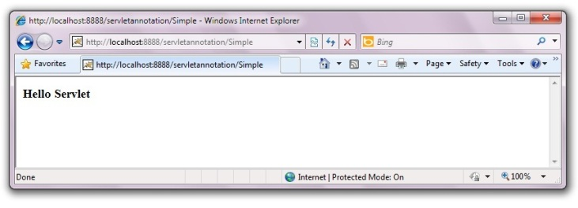

Next Topic[SingleThreadModel Interface](http://www.javatpoint.com/SingleThreadModel-interface)

# SingleThreadModel interface

1. [SingleThreadModel interface](http://www.javatpoint.com/SingleThreadModel-interface)
2. [Example of SingleThreadModel interface](http://www.javatpoint.com/SingleThreadModel-interface#ex)

The servlet programmer should implement SingleThreadModel interface to ensure that servlet can handle only one request at a time. It is a marker interface, means have no methods.

This interface is currently deprecated since Servlet API 2.4 because it doesn't solves all the thread-safety issues such as static variable and session attributes can be accessed by multiple threads at the same time even if we have implemented the SingleThreadModel interface. So it is recommended to use other means to resolve these thread safety issues such as synchronized block etc.

### Example of SingleThreadModel interface

Let's see the simple example of implementing the SingleThreadModel interface.

[copy to clipboard](http://www.javatpoint.com/SingleThreadModel-interface)

1. import java.io.IOException;
2. import java.io.PrintWriter;
3. import javax.servlet.ServletException;
4. import javax.servlet.SingleThreadModel;
5. import javax.servlet.http.HttpServlet;
6. import javax.servlet.http.HttpServletRequest;
7. import javax.servlet.http.HttpServletResponse;

10. public class MyServlet extends HttpServlet implements SingleThreadModel{
12. public void doGet(HttpServletRequest request, HttpServletResponse response)
13. throws ServletException, IOException {
15. response.setContentType("text/html");
16. PrintWriter out = response.getWriter();
18. out.print("welcome");
19. try{Thread.sleep(10000);}catch(Exception e){e.printStackTrace();}
20. out.print(" to servlet");

23. out.close();
24. }
26. }



[download this example (developed using Myeclipse IDE)](http://www.javatpoint.com/src/servlet/stm.zip)  
[download this example (developed usingEclipse IDE)](http://www.javatpoint.com/src/servlet/eclipse/stm.zip)  
[download this example (developed using Netbeans IDE)](http://www.javatpoint.com/src/servlet/netbeans/stm.zip)

Next Topic[Server Side Include](http://www.javatpoint.com/server-side-include)

# Server Side Include (SSI)

Thanks for your visit. This page is currently under processing....

Next Topic[Example Of Registration Form In Servlet](http://www.javatpoint.com/example-of-registration-form-in-servlet)

# Example of Registration form in servlet

Here, you will learn that how to create simple registration form in servlet. We are using oracle10g database. So you need to create a table first as given below:

[copy to clipboard](http://www.javatpoint.com/example-of-registration-form-in-servlet)

1. CREATE TABLE  "REGISTERUSER"
2. (    "NAME" VARCHAR2(4000),
3. "PASS" VARCHAR2(4000),
4. "EMAIL" VARCHAR2(4000),
5. "COUNTRY" VARCHAR2(4000)
6. )
7. /



To create the registration page in servlet, we can separate the database logic from the servlet. But here, we are mixing the database logic in the servlet only for simplicity of the program. We will develop this page in JSP following DAO, DTO and Singleton design pattern later.

### Example of Registration form in servlet

In this example, we have created the three pages.

* register.html
* Register.java
* web.xml

**register.html**

In this page, we have getting input from the user using text fields and combobox. The information entered by the user is forwarded to Register servlet, which is responsible to store the data into the database.

[copy to clipboard](http://www.javatpoint.com/example-of-registration-form-in-servlet)

1. <html>
2. <body>
3. <form action="servlet/Register" method="post">
5. Name:<input type="text" name="userName"/><br/><br/>
6. Password:<input type="password" name="userPass"/><br/><br/>
7. Email Id:<input type="text" name="userEmail"/><br/><br/>
8. Country:
9. <select name="userCountry">
10. <option>India</option>
11. <option>Pakistan</option>
12. <option>other</option>
13. </select>
15. <br/><br/>
16. <input type="submit" value="register"/>
18. </form>
19. </body>
20. </html>



**Register.java**

This servlet class receives all the data entered by user and stores it into the database. Here, we are performing the database logic. But you may separate it, which will be better for the web application.

[copy to clipboard](http://www.javatpoint.com/example-of-registration-form-in-servlet)

1. import java.io.*;
2. import java.sql.*;
3. import javax.servlet.ServletException;
4. import javax.servlet.http.*;
6. public class Register extends HttpServlet {
7. public void doPost(HttpServletRequest request, HttpServletResponse response)
8. throws ServletException, IOException {
10. response.setContentType("text/html");
11. PrintWriter out = response.getWriter();
13. String n=request.getParameter("userName");
14. String p=request.getParameter("userPass");
15. String e=request.getParameter("userEmail");
16. String c=request.getParameter("userCountry");
18. try{
19. Class.forName("oracle.jdbc.driver.OracleDriver");
20. Connection con=DriverManager.getConnection(
21. "jdbc:oracle:thin:@localhost:1521:xe","system","oracle");
23. PreparedStatement ps=con.prepareStatement(
24. "insert into registeruser values(?,?,?,?)");
26. ps.setString(1,n);
27. ps.setString(2,p);
28. ps.setString(3,e);
29. ps.setString(4,c);
31. int i=ps.executeUpdate();
32. if(i>0)
33. out.print("You are successfully registered...");

36. }catch (Exception e2) {System.out.println(e2);}
38. out.close();
39. }
41. }



**web.xml file**

The is the configuration file, providing information about the servlet.

[copy to clipboard](http://www.javatpoint.com/example-of-registration-form-in-servlet)

1. <web-app>
3. <servlet>
4. <servlet-name>Register</servlet-name>
5. <servlet-class>Register</servlet-class>
6. </servlet>
8. <servlet-mapping>
9. <servlet-name>Register</servlet-name>
10. <url-pattern>/servlet/Register</url-pattern>
11. </servlet-mapping>
13. <welcome-file-list>
14. <welcome-file>register.html</welcome-file>
15. </welcome-file-list>
17. </web-app>



[download this example](http://www.javatpoint.com/src/servlet/registeruser1.zip)  
[download the war file](http://www.javatpoint.com/src/servlet/registeruser.war)  
[download this example (developed using Myeclipse IDE)](http://www.javatpoint.com/src/servlet/mregisteruser.zip)  
[download this example (developed using Eclipse IDE)](http://www.javatpoint.com/src/servlet/eclipse/registeruser.zip)  
[download this example (developed using Netbeans IDE)](http://www.javatpoint.com/src/servlet/netbeans/registeruser.zip)

To connect java application with the Oracle database ojdbc14.jar file is required to be loaded. Put this jar file in WEB-INF/lib folder.

[download the jar file ojdbc14.jar](http://www.javatpoint.com/src/jdbc/ojdbc14.jar)

Next Topic[Example Of Fetching Result For The Given Rollno In Servlet](http://www.javatpoint.com/example-of-fetching-result-for-the-given-rollno-in-servlet)

# Example of Fetching Result for the given rollno

Here, you will learn that how to fetch result for the given rollno. I am assuming that there is a table as given below:

[copy to clipboard](http://www.javatpoint.com/example-of-fetching-result-for-the-given-rollno-in-servlet)

1. CREATE TABLE  "RESULT"
2. (    "ROLLNO" NUMBER,
3. "NAME" VARCHAR2(40),
4. "RESULT" VARCHAR2(40),
5. "GRADE" VARCHAR2(40),
6. CONSTRAINT "RESULT_PK" PRIMARY KEY ("ROLLNO") ENABLE
7. )
8. /



We are assuming there are many records in this table. In this example, we are getting the data from the database in servlet and printing it. We are doing all the database logic in servlet for simplicity of the program. But it will be better to separate it from the servlet file.

### Example of Fetching Result for the given rollno

In this example, we have create three files

* index.html
* Search.java
* web.xml

**index.html**

This page gets rollno from the user and forwards this data to servlet which is responsible to show the records based on the given rollno.

[copy to clipboard](http://www.javatpoint.com/example-of-fetching-result-for-the-given-rollno-in-servlet)

1. <html>
2. <body>
3. <form action="servlet/Search">
4. Enter your Rollno:<input type="text" name="roll"/><br/>
6. <input type="submit" value="search"/>
7. </form>
8. </body>
9. </html>



**Search.java**

This is the servlet file which gets the input from the user and maps this data with the database and prints the record for the matched data. In this page, we are displaying the column name of the database along with data, so we are using ResultSetMetaData interface.

[copy to clipboard](http://www.javatpoint.com/example-of-fetching-result-for-the-given-rollno-in-servlet)

1. import java.io.*;
2. import java.sql.*;
3. import javax.servlet.ServletException;
4. import javax.servlet.http.*;
6. public class Search extends HttpServlet {
8. public void doGet(HttpServletRequest request, HttpServletResponse response)
9. throws ServletException, IOException {
11. response.setContentType("text/html");
12. PrintWriter out = response.getWriter();
14. String rollno=request.getParameter("roll");
15. int roll=Integer.valueOf(rollno);
17. try{
18. Class.forName("oracle.jdbc.driver.OracleDriver");
19. Connection con=DriverManager.getConnection(
20. "jdbc:oracle:thin:@localhost:1521:xe","system","oracle");
22. PreparedStatement ps=con.prepareStatement("select * from result where rollno=?");
23. ps.setInt(1,roll);
25. out.print("<table width=50% border=1>");
26. out.print("<caption>Result:</caption>");
28. ResultSet rs=ps.executeQuery();
30. /* Printing column names */
31. ResultSetMetaData rsmd=rs.getMetaData();
32. int total=rsmd.getColumnCount();
33. out.print("<tr>");
34. for(int i=1;i<=total;i++)
35. {
36. out.print("<th>"+rsmd.getColumnName(i)+"</th>");
37. }
39. out.print("</tr>");
41. /* Printing result */
43. while(rs.next())
44. {
45. out.print("<tr><td>"+rs.getInt(1)+"</td><td>"+rs.getString(2)+"
46. </td><td>"+rs.getString(3)+"</td><td>"+rs.getString(4)+"</td></tr>");
48. }
50. out.print("</table>");
52. }catch (Exception e2) {e2.printStackTrace();}
54. finally{out.close();}
56. }
57. }



**web.xml file**

This is the configuration file which provides information of the servlet to the container.

[copy to clipboard](http://www.javatpoint.com/example-of-fetching-result-for-the-given-rollno-in-servlet)

1. <web-app>
3. <servlet>
4. <servlet-name>Search</servlet-name>
5. <servlet-class>Search</servlet-class>
6. </servlet>
8. <servlet-mapping>
9. <servlet-name>Search</servlet-name>
10. <url-pattern>/servlet/Search</url-pattern>
11. </servlet-mapping>
13. </web-app>



[download this example (developed without IDE)](http://www.javatpoint.com/src/servlet/getResult.zip)  
[download this example (developed using Myeclipse IDE)](http://www.javatpoint.com/src/servlet/getResultforgivenrollno.zip)  
[download this example (developed using Eclipse IDE)](http://www.javatpoint.com/src/servlet/getResult.zip)  
[download this example (developed using Netbeans IDE)](http://www.javatpoint.com/src/servlet/getResult.zip)

To connect java application with the Oracle database ojdbc14.jar file is required to be loaded. Put this jar file in WEB-INF/lib folder.

[download the jar file ojdbc14.jar](http://www.javatpoint.com/src/jdbc/ojdbc14.jar)

Next Topic[improving Servlet Performance To Fetch Records](http://www.javatpoint.com/improving-servlet-performance-to-fetch-records)

# Improving Servlet performance to fetch records from database

In this example, we are going to improve the performance of web application to fetch records from the database. To serve this, we are storing the data of the table in a collection, and reusing this collection in our servlet. So, we are not directly hitting the database again and again. By this, we are improving the performance.

To run this application, you need to create following table with some records.

[copy to clipboard](http://www.javatpoint.com/improving-servlet-performance-to-fetch-records)

1. CREATE TABLE  "CSUSER"
2. (    "USERID" NUMBER,
3. "USERNAME" VARCHAR2(4000),
4. "USERPASS" VARCHAR2(4000),
5. "USEREMAIL" VARCHAR2(4000),
6. "USERCOUNTRY" VARCHAR2(4000),
7. "CONTACT" NUMBER,
8. CONSTRAINT "CSUSER_PK" PRIMARY KEY ("USERID") ENABLE
9. )
10. /



### Example to Improve the performance of servlet to fetch records from database

In this example, we have created 6 pages.

1. **index.html**
2. **User.java**
3. **MyListener.java**
4. **MyServlet1.java**
5. **MyServlet2.java**
6. **web.xml**

**1) index.html**

This html file contains two links that sends request to the servlet.

[copy to clipboard](http://www.javatpoint.com/improving-servlet-performance-to-fetch-records)

1. <a href="servlet1">first servlet</a>|
2. <a href="servlet2">second servlet</a>



**2) User.java**

This is simple bean class containing 3 properties with its getters and setters. This class represents the table of the database.

[copy to clipboard](http://www.javatpoint.com/improving-servlet-performance-to-fetch-records)

1. public class User {
2. private int id;
3. private String name,password;
5. public int getId() {
6. return id;
7. }
8. public void setId(int id) {
9. this.id = id;
10. }
11. public String getName() {
12. return name;
13. }
14. public void setName(String name) {
15. this.name = name;
16. }
17. public String getPassword() {
18. return password;
19. }
20. public void setPassword(String password) {
21. this.password = password;
22. }

25. }



**3) MyListener.java**

It is the listener class. When the project will be deployed, contextInitialized method of ServletContextListener is invoked by default. Here, we are getting the records of the table and storing it in the User class object which is added in the ArrayList class object. At last, all the records of the table will be stored in the ArrayList class object (collection). Finally, we are storing the ArrayList object in the ServletConext object as an attribute so that we can get it in the servlet and use it.

[copy to clipboard](http://www.javatpoint.com/improving-servlet-performance-to-fetch-records)

1. import javax.servlet.ServletContext;
2. import javax.servlet.ServletContextEvent;
3. import javax.servlet.ServletContextListener;
4. import java.sql.*;
5. import java.util.ArrayList;
7. public class MyListener implements ServletContextListener{
9. public void contextInitialized(ServletContextEvent e) {
11. ArrayList list=new ArrayList();
12. try{
13. Class.forName("oracle.jdbc.driver.OracleDriver");
14. Connection con=DriverManager.getConnection(
15. "jdbc:oracle:thin:@localhost:1521:xe","system","oracle");
17. PreparedStatement ps=con.prepareStatement("select * from csuser");
18. ResultSet rs=ps.executeQuery();
19. while(rs.next()){
20. User u=new User();
21. u.setId(rs.getInt(1));
22. u.setName(rs.getString(2));
23. u.setPassword(rs.getString(3));
24. list.add(u);
25. }
26. con.close();
28. }catch(Exception ex){System.out.print(ex);}
30. //storing the ArrayList object in ServletContext
31. ServletContext context=e.getServletContext();
32. context.setAttribute("data",list);
34. }
35. public void contextDestroyed(ServletContextEvent arg0) {
36. System.out.println("project undeployed...");
37. }
39. }



**4) MyServlet1.java**

This servlet gets the information from the servlet context object and prints it.

[copy to clipboard](http://www.javatpoint.com/improving-servlet-performance-to-fetch-records)

1. import java.io.IOException;
2. import java.io.PrintWriter;
3. import java.sql.Connection;
4. import java.sql.DriverManager;
5. import java.sql.PreparedStatement;
6. import java.sql.ResultSet;
7. import java.util.Iterator;
8. import java.util.List;
10. import javax.servlet.ServletContext;
11. import javax.servlet.ServletException;
12. import javax.servlet.http.HttpServlet;
13. import javax.servlet.http.HttpServletRequest;
14. import javax.servlet.http.HttpServletResponse;

17. public class MyServlet1 extends HttpServlet {
18. public void doGet(HttpServletRequest request, HttpServletResponse
19. response)throws ServletException, IOException {
21. response.setContentType("text/html");
22. PrintWriter out = response.getWriter();
24. long before=System.currentTimeMillis();
26. ServletContext context=getServletContext();
27. List list=(List)context.getAttribute("data");
29. Iterator itr=list.iterator();
30. while(itr.hasNext()){
31. User u=(User)itr.next();
32. out.print("<br>"+u.getId()+" "+u.getName()+" "+u.getPassword());
33. }
35. long after=System.currentTimeMillis();
36. out.print("<br>total time :"+(after-before));
38. out.close();
39. }
41. }



**5) MyServlet2.java**

It is same as MyServlet1. This servlet gets the information from the servlet context object and prints it.

[copy to clipboard](http://www.javatpoint.com/improving-servlet-performance-to-fetch-records)

1. import java.io.IOException;
2. import java.io.PrintWriter;
3. import java.sql.Connection;
4. import java.sql.DriverManager;
5. import java.sql.PreparedStatement;
6. import java.sql.ResultSet;
7. import java.util.Iterator;
8. import java.util.List;
10. import javax.servlet.ServletContext;
11. import javax.servlet.ServletException;
12. import javax.servlet.http.HttpServlet;
13. import javax.servlet.http.HttpServletRequest;
14. import javax.servlet.http.HttpServletResponse;

17. public class MyServlet2 extends HttpServlet {
18. public void doGet(HttpServletRequest request, HttpServletResponse
19. response)throws ServletException, IOException {
21. response.setContentType("text/html");
22. PrintWriter out = response.getWriter();
24. long before=System.currentTimeMillis();
26. ServletContext context=getServletContext();
27. List list=(List)context.getAttribute("data");
29. Iterator itr=list.iterator();
30. while(itr.hasNext()){
31. User u=(User)itr.next();
32. out.print("<br>"+u.getId()+" "+u.getName()+" "+u.getPassword());
33. }
35. long after=System.currentTimeMillis();
36. out.print("<br>total time :"+(after-before));
38. out.close();
39. }
41. }



**6) web.xml**

Here we are containing the information about servlets and listener.

[copy to clipboard](http://www.javatpoint.com/improving-servlet-performance-to-fetch-records)

1. <?xml version="1.0" encoding="UTF-8"?>
2. <web-app version="2.5"
3. xmlns="http://java.sun.com/xml/ns/javaee"
4. xmlns:xsi="http://www.w3.org/2001/XMLSchema-instance"
5. xsi:schemaLocation="http://java.sun.com/xml/ns/javaee
6. http://java.sun.com/xml/ns/javaee/web-app_2_5.xsd">
8. <listener>
9. <listener-class>MyListener</listener-class>
10. </listener>
12. <servlet>
13. <servlet-name>MyServlet1</servlet-name>
14. <servlet-class>MyServlet1</servlet-class>
16. </servlet>
17. <servlet>
18. <servlet-name>MyServlet2</servlet-name>
19. <servlet-class>MyServlet2</servlet-class>
21. </servlet>
23. <servlet-mapping>
24. <servlet-name>MyServlet1</servlet-name>
25. <url-pattern>/servlet1</url-pattern>
26. </servlet-mapping>
27. <servlet-mapping>
28. <servlet-name>MyServlet2</servlet-name>
29. <url-pattern>/servlet2</url-pattern>
30. </servlet-mapping>
32. </web-app>



[download this example (developed using Myeclipse IDE)](http://www.javatpoint.com/src/servlet/fetchperformance.zip)  
[download this example (developed using Eclipse IDE)](http://www.javatpoint.com/src/servlet/eclipse/fetchperformance.zip)  
[download this example (developed using Netbeans IDE)](http://www.javatpoint.com/src/servlet/netbeans/fetchperformance.zip)

Next Topic[Example Of Uploading File To The Server In Servlet](http://www.javatpoint.com/example-of-uploading-file-to-the-server-in-servlet)

# Example of uploading file to the server in servlet

Here, we will learn how to upload file to the server. For uploading a file to the server, method must be post and enctype must be multipart/form-data in html file. For Example:

**index.html**

[copy to clipboard](http://www.javatpoint.com/example-of-uploading-file-to-the-server-in-servlet)

1. <html>
2. <body>
3. <form action="go" method="post" enctype="multipart/form-data">
4. Select File:<input type="file" name="fname"/><br/>
5. <input type="submit" value="upload"/>
6. </form>
7. </body>
8. </html>



### Example of uploading file to the server in servlet

Now, for uploading a file to the server, there can be various ways. But, I am going to use MultipartRequest class provided by oreilly. For using this class you must have cos.jar file. If you will download this example, we will the cos.jar file alongwith code.

**UploadServlet.java**

[copy to clipboard](http://www.javatpoint.com/example-of-uploading-file-to-the-server-in-servlet)

1. import java.io.*;
2. import javax.servlet.ServletException;
3. import javax.servlet.http.*;
4. import com.oreilly.servlet.MultipartRequest;
6. public class UploadServlet extends HttpServlet {
8. public void doPost(HttpServletRequest request, HttpServletResponse response)
9. throws ServletException, IOException {
11. response.setContentType("text/html");
12. PrintWriter out = response.getWriter();
14. MultipartRequest m=new MultipartRequest(request,"d:/new");
15. out.print("successfully uploaded");
16. }
17. }



There are two arguments passed in MultipartRequest class constructor, first one is HttpServletRequest object and second one is String object (for location). Here I am supposing that you have new folder in D driver.

**web.xml file**

This configuration file provides information about the servlet.

[copy to clipboard](http://www.javatpoint.com/example-of-uploading-file-to-the-server-in-servlet)

1. <web-app>
3. <servlet>
4. <servlet-name>UploadServlet</servlet-name>
5. <servlet-class>UploadServlet</servlet-class>
6. </servlet>
8. <servlet-mapping>
9. <servlet-name>UploadServlet</servlet-name>
10. <url-pattern>/go</url-pattern>
11. </servlet-mapping>
13. </web-app>



[download this example (developed without IDE)](http://www.javatpoint.com/src/servlet/fileupload.zip)  
[download this example (developed using Myeclipse IDE)](http://www.javatpoint.com/src/servlet/mfileupload.zip)  
[download this example (developed using Netbeans IDE)](http://www.javatpoint.com/src/servlet/netbeans/fileupload.zip)

Next Topic[Example Of Downloading File From The Server In Servlet](http://www.javatpoint.com/example-of-downloading-file-from-the-server-in-servlet)

# Example of downloading file from the server in servlet

For downloading a file from the server, here is the simple example. I am supposing you have home.jsp file in E drive that you want to download. If there is any jar or zip file, you can direct provide a link to that file. So there is no need to write the program to download. But if there is any java file or jsp file etc, you need to create a program to download that file.

### Example of downloading file from the server in servlet

In this example, we are creating three files:

* index.html
* DownloadServlet.java
* web.xml

**index.html**

This file provides a link to download the file.

[copy to clipboard](http://www.javatpoint.com/example-of-downloading-file-from-the-server-in-servlet)

1. <a href="servlet/DownloadServlet">download the jsp file</a>



**DownloadServlet.java**

This is the servlet file that reads the content of the file and writes it into the stream to send as a response. For this purpose, we need to inform the server, so we are setting the content type as APPLICATION/OCTET-STREAM .

[copy to clipboard](http://www.javatpoint.com/example-of-downloading-file-from-the-server-in-servlet)

1. import java.io.*;
2. import javax.servlet.ServletException;
3. import javax.servlet.http.*;
5. public class DownloadServlet extends HttpServlet {
7. public void doGet(HttpServletRequest request, HttpServletResponse response)
8. throws ServletException, IOException {
10. response.setContentType("text/html");
11. PrintWriter out = response.getWriter();
12. String filename = "home.jsp";
13. String filepath = "e:\\";
14. response.setContentType("APPLICATION/OCTET-STREAM");
15. response.setHeader("Content-Disposition","attachment; filename=\"" + filename + "\"");
17. FileInputStream fileInputStream = new FileInputStream(filepath + filename);
19. int i;
20. while ((i=fileInputStream.read()) != -1) {
21. out.write(i);
22. }
23. fileInputStream.close();
24. out.close();
25. }
27. }



**web.xml file**

This configuration file provides informations to the server about the servlet.

[copy to clipboard](http://www.javatpoint.com/example-of-downloading-file-from-the-server-in-servlet)

1. <web-app>
3. <servlet>
4. <servlet-name>DownloadServlet</servlet-name>
5. <servlet-class>DownloadServlet</servlet-class>
6. </servlet>
8. <servlet-mapping>
9. <servlet-name>DownloadServlet</servlet-name>
10. <url-pattern>/servlet/DownloadServlet</url-pattern>
11. </servlet-mapping>
13. </web-app>



[download this example (developed without IDE)](http://www.javatpoint.com/src/servlet/filedownload.zip)  
[download this example (developed using Myeclipse IDE)](http://www.javatpoint.com/src/servlet/mfiledownload.zip)  
[download this example (developed using Eclipse IDE)](http://www.javatpoint.com/src/servlet/eclipse/downservlet.zip)  
[download this example (developed using Netbeans IDE)](http://www.javatpoint.com/src/servlet/netbeans/downservlet.zip)

Next Topic[Sending Email Through Java Mail Api In Servlet](http://www.javatpoint.com/sending-email-through-java-mail-api-in-servlet)

# Sending email through JavaMail API in Servlet

The JavaMail API provides many classes that can be used to send email from java. The javax.mail and javax.mail.internet packages contains all the classes required for sending and receiving emails.

For better understanding of this example click [steps for sending email from javamail api](http://www.javatpoint.com/example-of-sending-email-using-java-mail-api)

For sending the email using JavaMail API, you need to load the two jar files:

* **mail.jar**
* **activation.jar**

[download these jar files](http://www.javatpoint.com/src/mail/mailactivation.zip) or go to the Oracle site to download the latest version.

### Example of Sending email through JavaMail API in Servlet

Here is the simple example of sending email from servlet. For this example we are creating 3 files:

* index.html file for input
* SendMail.java , a servlet file for handling the request and providing the response to the user. It uses the send method of Mailer class to send the email.
* Mailer.java , a java class that contains send method to send the emails to the mentioned recipient.

**index.html**

[copy to clipboard](http://www.javatpoint.com/sending-email-through-java-mail-api-in-servlet)

1. <form action="servlet/SendMail">
2. To:<input type="text" name="to"/><br/>
3. Subject:<input type="text" name="subject"><br/>
4. Text:<textarea rows="10" cols="70" name="msg"></textarea><br/>
5. <input type="submit" value="send"/>
6. </form>



**SendMail.java**

[copy to clipboard](http://www.javatpoint.com/sending-email-through-java-mail-api-in-servlet)

1. import java.io.IOException;
2. import java.io.PrintWriter;
4. import javax.servlet.ServletException;
5. import javax.servlet.http.HttpServlet;
6. import javax.servlet.http.HttpServletRequest;
7. import javax.servlet.http.HttpServletResponse;

10. public class SendMail extends HttpServlet {
11. public void doGet(HttpServletRequest request,
12. HttpServletResponse response)
13. throws ServletException, IOException {
15. response.setContentType("text/html");
16. PrintWriter out = response.getWriter();
18. String to=request.getParameter("to");
19. String subject=request.getParameter("subject");
20. String msg=request.getParameter("msg");
22. Mailer.send(to, subject, msg);
23. out.print("message has been sent successfully");
24. out.close();
25. }
27. }



**Mailer.java**

[copy to clipboard](http://www.javatpoint.com/sending-email-through-java-mail-api-in-servlet)

1. import java.util.Properties;
3. import javax.mail.*;
4. import javax.mail.internet.InternetAddress;
5. import javax.mail.internet.MimeMessage;
7. public class Mailer {
8. public static void send(String to,String subject,String msg){
10. final String user="sonoojaiswal@javatpoint.com";//change accordingly
11. final String pass="xxxxx";
13. //1st step) Get the session object
14. Properties props = new Properties();
15. props.put("mail.smtp.host", "mail.javatpoint.com");//change accordingly
16. props.put("mail.smtp.auth", "true");
18. Session session = Session.getDefaultInstance(props,
19. new javax.mail.Authenticator() {
20. protected PasswordAuthentication getPasswordAuthentication() {
21. return new PasswordAuthentication(user,pass);
22. }
23. });
24. //2nd step)compose message
25. try {
26. MimeMessage message = new MimeMessage(session);
27. message.setFrom(new InternetAddress(user));
28. message.addRecipient(Message.RecipientType.TO,new InternetAddress(to));
29. message.setSubject(subject);
30. message.setText(msg);
32. //3rd step)send message
33. Transport.send(message);
35. System.out.println("Done");
37. } catch (MessagingException e) {
38. throw new RuntimeException(e);
39. }
41. }
42. }



[download this example (developed without IDE)](http://www.javatpoint.com/src/servlet/sendmailservlet.zip)  
[download this example (developed using Eclipse IDE)](http://www.javatpoint.com/src/servlet/eclipse/sendmailservlet.zip)  
[download this example (developed using Netbeans IDE)](http://www.javatpoint.com/src/servlet/netbeans/sendmailservlet.zip)

Next Topic[How To Write Data Into PDF Using Servlet](http://www.javatpoint.com/how-to-write-data-into-PDF-using-servlet)

# How to write data into PDF using Servlet

Here, we are going to see how we can write data into PDF using servlet technology. We are simply writing some data using servlet and it will get displayed in the PDF.

To create such application, you need to have the spdf.jar file. If you download this example, you will get the example with jar file.

### Example to write data into PDF using servlet

Let's see the simple example of writing data into PDF using servlet. In this example, we have mentioned the content type application/pdf that must be specified to display data in the PDF format.

**ServletPDF.java**

[copy to clipboard](http://www.javatpoint.com/how-to-write-data-into-PDF-using-servlet)

1. package com.javatpoint;
2. import java.io.*;
3. import java.util.*;
4. import javax.servlet.*;
5. import javax.servlet.http.*;
6. import com.darwinsys.spdf.PDF;
7. import com.darwinsys.spdf.Page;
8. import com.darwinsys.spdf.Text;
9. import com.darwinsys.spdf.MoveTo;
11. public class ServletPDF extends HttpServlet {
13. public void doGet(HttpServletRequest request,
14. HttpServletResponse response) throws IOException {
16. PrintWriter out = response.getWriter();
17. response.setContentType("application/pdf");
19. response.setHeader("Content-disposition","inline; filename='javatpoint.pdf'");
21. PDF p = new PDF(out);
22. Page p1 = new Page(p);
23. p1.add(new MoveTo(p, 200, 700));
24. p1.add(new Text(p, "www.javatpoint.com"));
25. p1.add(new Text(p, "by Sonoo Jaiswal"));
27. p.add(p1);
28. p.setAuthor("Ian F. Darwin");
30. p.writePDF();
32. }
33. }



[download this example (developed using Myeclipse IDE)](http://www.javatpoint.com/src/servlet/pdfservlet.zip)  
[download this example (developed using Eclipse IDE)](http://www.javatpoint.com/src/servlet/eclipse/pdfservlet.zip)  
[download this example (developed using Netbeans IDE)](http://www.javatpoint.com/src/servlet/netbeans/pdfservlet.zip)

Next Topic[Example Of Login Form In Servlet](http://www.javatpoint.com/example-of-login-form-in-servlet)

# Example of Login Form in Servlet Tutorial

Here, we are going to create the simple example to create the login form using servlet. We have used oracle10g as the database. There are 5 files required for this application.

* index.html
* FirstServlet.java
* LoginDao.java
* SecondServlet.java
* web.xml

You must need to create a table userreg with name and pass fields. Moreover, it must have contained some data. The table should be as:

[copy to clipboard](http://www.javatpoint.com/example-of-login-form-in-servlet)

1. create table userreg(name varchar2(40),pass varchar2(40));



**index.html**

[copy to clipboard](http://www.javatpoint.com/example-of-login-form-in-servlet)

1. <form action="servlet1" method="post">
2. Name:<input type="text" name="username"/><br/><br/>
3. Password:<input type="password" name="userpass"/><br/><br/>
4. <input type="submit" value="login"/>
5. </form>



**FirstServlet.java**

[copy to clipboard](http://www.javatpoint.com/example-of-login-form-in-servlet)

1. import java.io.IOException;
2. import java.io.PrintWriter;
4. import javax.servlet.RequestDispatcher;
5. import javax.servlet.ServletException;
6. import javax.servlet.http.HttpServlet;
7. import javax.servlet.http.HttpServletRequest;
8. import javax.servlet.http.HttpServletResponse;

11. public class FirstServlet extends HttpServlet {
12. public void doPost(HttpServletRequest request, HttpServletResponse response)
13. throws ServletException, IOException {
15. response.setContentType("text/html");
16. PrintWriter out = response.getWriter();
18. String n=request.getParameter("username");
19. String p=request.getParameter("userpass");
21. if(LoginDao.validate(n, p)){
22. RequestDispatcher rd=request.getRequestDispatcher("servlet2");
23. rd.forward(request,response);
24. }
25. else{
26. out.print("Sorry username or password error");
27. RequestDispatcher rd=request.getRequestDispatcher("index.html");
28. rd.include(request,response);
29. }
31. out.close();
32. }
33. }



**LoginDao.java**

[copy to clipboard](http://www.javatpoint.com/example-of-login-form-in-servlet)

1. import java.sql.*;
3. public class LoginDao {
4. public static boolean validate(String name,String pass){
5. boolean status=false;
6. try{
7. Class.forName("oracle.jdbc.driver.OracleDriver");
8. Connection con=DriverManager.getConnection(
9. "jdbc:oracle:thin:@localhost:1521:xe","system","oracle");
11. PreparedStatement ps=con.prepareStatement(
12. "select * from userreg where name=? and pass=?");
13. ps.setString(1,name);
14. ps.setString(2,pass);
16. ResultSet rs=ps.executeQuery();
17. status=rs.next();
19. }catch(Exception e){System.out.println(e);}
20. return status;
21. }
22. }



**WelcomeServlet.java**

[copy to clipboard](http://www.javatpoint.com/example-of-login-form-in-servlet)

1. import java.io.IOException;
2. import java.io.PrintWriter;
4. import javax.servlet.ServletException;
5. import javax.servlet.http.HttpServlet;
6. import javax.servlet.http.HttpServletRequest;
7. import javax.servlet.http.HttpServletResponse;
9. public class WelcomeServlet extends HttpServlet {
10. public void doPost(HttpServletRequest request, HttpServletResponse response)
11. throws ServletException, IOException {
13. response.setContentType("text/html");
14. PrintWriter out = response.getWriter();
16. String n=request.getParameter("username");
17. out.print("Welcome "+n);
19. out.close();
20. }
22. }



[download this example](http://www.javatpoint.com/src/servlet/loginservlet.zip)

Next Topic[Example To Display Image Using Servlet](http://www.javatpoint.com/example-to-display-image-using-servlet)

# Example to display image using Servlet

In this example, we are using **FileInputStream** class to read image and **ServletOutputStream** class for writing this image content as a response. To make the performance faster, we have used BufferedInputStream and BufferedOutputStream class.

You need to use the content type **image/jpeg**.

In this example, we are assuming that you have java.jpg image inside the c:\test directory. You may change the location accordingly.

To create this application, we have created three files:

1. index.html
2. DisplayImage.java
3. web.xml

**index.html**

This file creates a link that invokes the servlet. The url-pattern of the servlet is servlet1.

[copy to clipboard](http://www.javatpoint.com/example-to-display-image-using-servlet)

1. <a href="servlet1">click for photo</a>



**DisplayImage.java**

This servlet class reads the image from the mentioned directory and writes the content in the response object using ServletOutputStream and BufferedOutputStream classes.

[copy to clipboard](http://www.javatpoint.com/example-to-display-image-using-servlet)

1. package com.javatpoint;
2. import java.io.*;
3. import javax.servlet.*;
4. import javax.servlet.http.*;
5. public class DisplayImage extends HttpServlet {
7. public void doGet(HttpServletRequest request,HttpServletResponse response)
8. throws IOException
9. {
10. response.setContentType("image/jpeg");
11. ServletOutputStream out;
12. out = response.getOutputStream();
13. FileInputStream fin = new FileInputStream("c:\\test\\java.jpg");
15. BufferedInputStream bin = new BufferedInputStream(fin);
16. BufferedOutputStream bout = new BufferedOutputStream(out);
17. int ch =0; ;
18. while((ch=bin.read())!=-1)
19. {
20. bout.write(ch);
21. }
23. bin.close();
24. fin.close();
25. bout.close();
26. out.close();
27. }
28. }



[download this example (developed using Myeclipse IDE)](http://www.javatpoint.com/src/servlet/imageinservlet.zip)  
[download this example (developed using Eclipse IDE)](http://www.javatpoint.com/src/servlet/eclipse/imageinservlet.zip)  
[download this example (developed using Netbeans IDE)](http://www.javatpoint.com/src/servlet/netbeans/imageinservlet.zip)

Next Topic[Servlet Quiz](http://www.javatpoint.com/servlet-quiz)

# Servlet Quiz | Servlet Online Test

There are a list of Servlet quizzes that will clear your Servlet concepts. Our servlet quiz covers servlet fundamentals, request, response, session, cookies, filter and listener topics.

We have categorized the Servlet quiz in core, advance and miscellaneous.

## Servlet Basics Quiz

[Servlet Basics Quiz-1](http://www.javatpoint.com/directload.jsp?val=198)  
[Servlet Basics Quiz-2](http://www.javatpoint.com/directload.jsp?val=199)  
[Servlet Basics Quiz-3](http://www.javatpoint.com/directload.jsp?val=200)  
[Servlet Basics Quiz-4](http://www.javatpoint.com/directload.jsp?val=201)  
[Servlet Basics Quiz-5](http://www.javatpoint.com/directload.jsp?val=202)

## Servlet Advance Quiz

[Servlet Advance Quiz-1](http://www.javatpoint.com/directload.jsp?val=203)  
[Servlet Advance Quiz-2](http://www.javatpoint.com/directload.jsp?val=204)  
[Servlet Advance Quiz-3](http://www.javatpoint.com/directload.jsp?val=205)  
[Servlet Advance Quiz-4](http://www.javatpoint.com/directload.jsp?val=206)

## Servlet Misc. Quiz

[Servlet Misc. Quiz-1](http://www.javatpoint.com/directload.jsp?val=12)  
[Servlet Misc. Quiz-2](http://www.javatpoint.com/directload.jsp?val=16)  
[Servlet Misc. Quiz-3](http://www.javatpoint.com/directload.jsp?val=28)

# Cookies in Servlet

A **cookie** is a small piece of information that is persisted between the multiple client requests.

A cookie has a name, a single value, and optional attributes such as a comment, path and domain qualifiers, a maximum age, and a version number.

### How Cookie works

By default, each request is considered as a new request. In cookies technique, we add cookie with response from the servlet. So cookie is stored in the cache of the browser. After that if request is sent by the user, cookie is added with request by default. Thus, we recognize the user as the old user.



### Types of Cookie

There are 2 types of cookies in servlets.

1. Non-persistent cookie
2. Persistent cookie

### Non-persistent cookie

It is **valid for single session** only. It is removed each time when user closes the browser.

### Persistent cookie

It is **valid for multiple session** . It is not removed each time when user closes the browser. It is removed only if user logout or signout.

### Advantage of Cookies

1. Simplest technique of maintaining the state.
2. Cookies are maintained at client side.

### Disadvantage of Cookies

1. It will not work if cookie is disabled from the browser.
2. Only textual information can be set in Cookie object.

#### *Note: Gmail uses cookie technique for login. If you disable the cookie, gmail won't work.*

### Cookie class

**javax.servlet.http.Cookie** class provides the functionality of using cookies. It provides a lot of useful methods for cookies.

### Constructor of Cookie class

|  |  |
| --- | --- |
| **Constructor** | **Description** |
| Cookie() | constructs a cookie. |
| Cookie(String name, String value) | constructs a cookie with a specified name and value. |

### Useful Methods of Cookie class

There are given some commonly used methods of the Cookie class.

|  |  |
| --- | --- |
| **Method** | **Description** |
| public void setMaxAge(int expiry) | Sets the maximum age of the cookie in seconds. |
| public String getName() | Returns the name of the cookie. The name cannot be changed after creation. |
| public String getValue() | Returns the value of the cookie. |
| public void setName(String name) | changes the name of the cookie. |
| public void setValue(String value) | changes the value of the cookie. |

### Other methods required for using Cookies

|  |
| --- |
| For adding cookie or getting the value from the cookie, we need some methods provided by other interfaces. They are:   1. **public void addCookie(Cookie ck):**method of HttpServletResponse interface is used to add cookie in response object. 2. **public Cookie[] getCookies():**method of HttpServletRequest interface is used to return all the cookies from the browser. |

### How to create Cookie?

Let's see the simple code to create cookie.

[copy to clipboard](http://www.javatpoint.com/cookies-in-servlet)

1. Cookie ck=new Cookie("user","sonoo jaiswal");//creating cookie object
2. response.addCookie(ck);//adding cookie in the response



### How to delete Cookie?

Let's see the simple code to delete cookie. It is mainly used to logout or signout the user.

[copy to clipboard](http://www.javatpoint.com/cookies-in-servlet)

1. Cookie ck=new Cookie("user","");//deleting value of cookie
2. ck.setMaxAge(0);//changing the maximum age to 0 seconds
3. response.addCookie(ck);//adding cookie in the response



### How to get Cookies?

Let's see the simple code to get all the cookies.

[copy to clipboard](http://www.javatpoint.com/cookies-in-servlet)

1. Cookie ck[]=request.getCookies();
2. for(int i=0;i<ck.length;i++){
3. out.print("<br>"+ck[i].getName()+" "+ck[i].getValue());//printing name and value of cookie
4. }



### Simple example of Servlet Cookies

In this example, we are storing the name of the user in the cookie object and accessing it in another servlet. As we know well that session corresponds to the particular user. So if you access it from too many browsers with different values, you will get the different value.



### index.html

[copy to clipboard](http://www.javatpoint.com/cookies-in-servlet)

1. <form action="servlet1" method="post">
2. Name:<input type="text" name="userName"/><br/>
3. <input type="submit" value="go"/>
4. </form>



### FirstServlet.java

[copy to clipboard](http://www.javatpoint.com/cookies-in-servlet)

1. import java.io.*;
2. import javax.servlet.*;
3. import javax.servlet.http.*;

6. public class FirstServlet extends HttpServlet {
8. public void doPost(HttpServletRequest request, HttpServletResponse response){
9. try{
11. response.setContentType("text/html");
12. PrintWriter out = response.getWriter();
14. String n=request.getParameter("userName");
15. out.print("Welcome "+n);
17. Cookie ck=new Cookie("uname",n);//creating cookie object
18. response.addCookie(ck);//adding cookie in the response
20. //creating submit button
21. out.print("<form action='servlet2'>");
22. out.print("<input type='submit' value='go'>");
23. out.print("</form>");
25. out.close();
27. }catch(Exception e){System.out.println(e);}
28. }
29. }



### SecondServlet.java

[copy to clipboard](http://www.javatpoint.com/cookies-in-servlet)

1. import java.io.*;
2. import javax.servlet.*;
3. import javax.servlet.http.*;
5. public class SecondServlet extends HttpServlet {
7. public void doPost(HttpServletRequest request, HttpServletResponse response){
8. try{
10. response.setContentType("text/html");
11. PrintWriter out = response.getWriter();
13. Cookie ck[]=request.getCookies();
14. out.print("Hello "+ck[0].getValue());
16. out.close();
18. }catch(Exception e){System.out.println(e);}
19. }

22. }



### web.xml

[copy to clipboard](http://www.javatpoint.com/cookies-in-servlet)

1. <web-app>
3. <servlet>
4. <servlet-name>s1</servlet-name>
5. <servlet-class>FirstServlet</servlet-class>
6. </servlet>
8. <servlet-mapping>
9. <servlet-name>s1</servlet-name>
10. <url-pattern>/servlet1</url-pattern>
11. </servlet-mapping>
13. <servlet>
14. <servlet-name>s2</servlet-name>
15. <servlet-class>SecondServlet</servlet-class>
16. </servlet>
18. <servlet-mapping>
19. <servlet-name>s2</servlet-name>
20. <url-pattern>/servlet2</url-pattern>
21. </servlet-mapping>
23. </web-app>



[download this example (developed using Myeclipse IDE)](http://www.javatpoint.com/src/servlet/myeclipse/cookies.zip)  
[download this example (developed using Eclipse IDE)](http://www.javatpoint.com/src/servlet/eclipse/cookies.zip)  
[download this example (developed using Netbeans IDE)](http://www.javatpoint.com/src/servlet/netbeans/cookies.zip)

#### Output



Next Topic[servlet login and logout example using cookies (Real Login App)](http://www.javatpoint.com/servlet-login-and-logout-example-using-cookies)

# Servlet Login and Logout Example using Cookies

A **cookie** is a kind of information that is stored at client side.

In the previous page, we learned a lot about cookie e.g. how to create cookie, how to delete cookie, how to get cookie etc.

Here, we are going to create a login and logout example using servlet cookies.

In this example, we are creating 3 links: login, logout and profile. User can't go to profile page until he/she is logged in. If user is logged out, he need to login again to visit profile.

In this application, we have created following files.

1. index.html
2. link.html
3. login.html
4. LoginServlet.java
5. LogoutServlet.java
6. ProfileServlet.java
7. web.xml

File: index.html

[copy to clipboard](http://www.javatpoint.com/servlet-login-and-logout-example-using-cookies)

1. <!DOCTYPE html>
2. <html>
3. <head>
4. <meta charset="ISO-8859-1">
5. <title>Servlet Login Example</title>
6. </head>
7. <body>
9. <h1>Welcome to Login App by Cookie</h1>
10. <a href="login.html">Login</a>|
11. <a href="LogoutServlet">Logout</a>|
12. <a href="ProfileServlet">Profile</a>
14. </body>
15. </html>



File: link.html

[copy to clipboard](http://www.javatpoint.com/servlet-login-and-logout-example-using-cookies)

1. <a href="login.html">Login</a> |
2. <a href="LogoutServlet">Logout</a> |
3. <a href="ProfileServlet">Profile</a>
4. <hr>



File: login.html

[copy to clipboard](http://www.javatpoint.com/servlet-login-and-logout-example-using-cookies)

1. <form action="LoginServlet" method="post">
2. Name:<input type="text" name="name"><br>
3. Password:<input type="password" name="password"><br>
4. <input type="submit" value="login">
5. </form>



File: LoginServlet.java

[copy to clipboard](http://www.javatpoint.com/servlet-login-and-logout-example-using-cookies)

1. package com.javatpoint;
3. import java.io.IOException;
4. import java.io.PrintWriter;
5. import javax.servlet.ServletException;
6. import javax.servlet.http.Cookie;
7. import javax.servlet.http.HttpServlet;
8. import javax.servlet.http.HttpServletRequest;
9. import javax.servlet.http.HttpServletResponse;
10. public class LoginServlet extends HttpServlet {
11. protected void doPost(HttpServletRequest request, HttpServletResponse response)
12. throws ServletException, IOException {
13. response.setContentType("text/html");
14. PrintWriter out=response.getWriter();
16. request.getRequestDispatcher("link.html").include(request, response);
18. String name=request.getParameter("name");
19. String password=request.getParameter("password");
21. if(password.equals("admin123")){
22. out.print("You are successfully logged in!");
23. out.print("<br>Welcome, "+name);
25. Cookie ck=new Cookie("name",name);
26. response.addCookie(ck);
27. }else{
28. out.print("sorry, username or password error!");
29. request.getRequestDispatcher("login.html").include(request, response);
30. }
32. out.close();
33. }
35. }



File: LogoutServlet.java

[copy to clipboard](http://www.javatpoint.com/servlet-login-and-logout-example-using-cookies)

1. package com.javatpoint;
3. import java.io.IOException;
4. import java.io.PrintWriter;
5. import javax.servlet.ServletException;
6. import javax.servlet.http.Cookie;
7. import javax.servlet.http.HttpServlet;
8. import javax.servlet.http.HttpServletRequest;
9. import javax.servlet.http.HttpServletResponse;
10. public class LogoutServlet extends HttpServlet {
11. protected void doGet(HttpServletRequest request, HttpServletResponse response)
12. throws ServletException, IOException {
13. response.setContentType("text/html");
14. PrintWriter out=response.getWriter();

17. request.getRequestDispatcher("link.html").include(request, response);
19. Cookie ck=new Cookie("name","");
20. ck.setMaxAge(0);
21. response.addCookie(ck);
23. out.print("you are successfully logged out!");
24. }
25. }



File: ProfileServlet.java

[copy to clipboard](http://www.javatpoint.com/servlet-login-and-logout-example-using-cookies)

1. package com.javatpoint;
3. import java.io.IOException;
4. import java.io.PrintWriter;
5. import javax.servlet.ServletException;
6. import javax.servlet.http.Cookie;
7. import javax.servlet.http.HttpServlet;
8. import javax.servlet.http.HttpServletRequest;
9. import javax.servlet.http.HttpServletResponse;
10. public class ProfileServlet extends HttpServlet {
11. protected void doGet(HttpServletRequest request, HttpServletResponse response)
12. throws ServletException, IOException {
13. response.setContentType("text/html");
14. PrintWriter out=response.getWriter();
16. request.getRequestDispatcher("link.html").include(request, response);
18. Cookie ck[]=request.getCookies();
19. if(ck!=null){
20. String name=ck[0].getValue();
21. if(!name.equals("")||name!=null){
22. out.print("<b>Welcome to Profile</b>");
23. out.print("<br>Welcome, "+name);
24. }
25. }else{
26. out.print("Please login first");
27. request.getRequestDispatcher("login.html").include(request, response);
28. }
29. out.close();
30. }
31. }



File: web.xml

[copy to clipboard](http://www.javatpoint.com/servlet-login-and-logout-example-using-cookies)

1. <?xml version="1.0" encoding="UTF-8"?>
2. <web-app xmlns:xsi="http://www.w3.org/2001/XMLSchema-instance"
3. xmlns="http://java.sun.com/xml/ns/javaee" xsi:schemaLocation="http://java.sun.com/xml/ns/javaee
4. http://java.sun.com/xml/ns/javaee/web-app_2_5.xsd" id="WebApp_ID" version="2.5">
6. <servlet>
7. <description></description>
8. <display-name>LoginServlet</display-name>
9. <servlet-name>LoginServlet</servlet-name>
10. <servlet-class>com.javatpoint.LoginServlet</servlet-class>
11. </servlet>
12. <servlet-mapping>
13. <servlet-name>LoginServlet</servlet-name>
14. <url-pattern>/LoginServlet</url-pattern>
15. </servlet-mapping>
16. <servlet>
17. <description></description>
18. <display-name>ProfileServlet</display-name>
19. <servlet-name>ProfileServlet</servlet-name>
20. <servlet-class>com.javatpoint.ProfileServlet</servlet-class>
21. </servlet>
22. <servlet-mapping>
23. <servlet-name>ProfileServlet</servlet-name>
24. <url-pattern>/ProfileServlet</url-pattern>
25. </servlet-mapping>
26. <servlet>
27. <description></description>
28. <display-name>LogoutServlet</display-name>
29. <servlet-name>LogoutServlet</servlet-name>
30. <servlet-class>com.javatpoint.LogoutServlet</servlet-class>
31. </servlet>
32. <servlet-mapping>
33. <servlet-name>LogoutServlet</servlet-name>
34. <url-pattern>/LogoutServlet</url-pattern>
35. </servlet-mapping>
36. </web-app>



[download this example (developed using Eclipse IDE)](http://www.javatpoint.com/src/servlet/eclipse/loginappcookie.zip)

#### Output



If again you click on the profile link, you need to login first.

Next Topic[Hidden Form Field In Session Tracking](http://www.javatpoint.com/hidden-form-field-in-session-tracking)