A PROJECT REPORT

On

“Health Risk Predictor”

Submitted to

KIIT Deemed to be University

In Partial Fulfilment of the Requirement for the Award of

BACHELOR’S DEGREE IN

INFORMATION TECHNOLOGY

BY

Harsh Ray
Gaurav Kumar
Harsh Raj
Aakash Raj
Aman Kumar
Kanishka Mudgal

22052297
2205209
22051681
2205695
22051663
22053960

UNDER THE GUIDANCE OF

Dr. Himanshu Ranjan



SCHOOL OF COMPUTER ENGINEERING

KALINGA INSTITUTE OF INDUSTRIAL TECHNOLOGY

BHUBANESWAR, ODISHA - 751024

April 2025

A PROJECT REPORT

on

“Health Risk Predictor”

Submitted to

KIIT Deemed to be University

In Partial Fulfilment of the Requirement for the Award of

BACHELOR’S DEGREE IN INFORMATION TECHNOLOGY

BY

Harsh Ray
Gaurav Kumar
Harsh Raj
Aakash Raj
Aman Kumar
Kanishka Mudgal

22052297
2205209
22051681
2205695
22051663
22053960

UNDER THE GUIDANCE OF

Dr. Himanshu Ranjan

SCHOOL OF COMPUTER ENGINEERING

KALINGA INSTITUTE OF INDUSTRIAL TECHNOLOGY

BHUBANESWAE, ODISHA -751024

April 2025

KIIT Deemed to be University

School of Computer Engineering
Bhubaneswar, ODISHA 751024

CERTIFICATE

This is certify that the project entitled

“Health Risk Predictor“

submitted by

Harsh Ray
Gaurav Kumar
Harsh Raj
Aakash Raj
Aman Kumar
Kanishka Mudgal

22052297
2205209
22051681
2205695
22051663
22053960

is a record of bonafide work carried out by them, in the partial fulfilment of the requirement for the award of Degree of Bachelor of Engineering (Computer Sci-ence & Engineering OR Information Technology) at KIIT Deemed to be university, Bhubaneswar. This work is done during year 2024-2025, under our guidance.

Date: / /

(Dr. Himanshu Ranjan)
Project Guide

Acknowledgements

We are profoundly grateful to Dr. Himanshu Ranjan of Affiliation for his expert guidance and continuous encouragement throughout to see that this project rights its target since its commencement to its completion.

Harsh Ray
Gaurav Kumar
Harsh Raj
Aakash Raj
Aman Kumar
Kanishka Mudgal

ABSTRACT

This project applies machine learning techniques to predict individual health risks using clinical and lifestyle data. By leveraging structured health datasets, the system analyzes key parameters such as age, BMI, and blood pressure to identify potential risk factors. Multiple predictive models are developed to ensure accurate assessments and reliable outcomes.

A comparative analysis is conducted using algorithms like Random Forest, Neural Networks, and XGBoost to evaluate model performance. The project emphasizes data-driven insights to support early risk detection and proactive health monitoring. With its multidimensional approach, the system aims to contribute to intelligent healthcare solutions that enable personalized risk profiling and more informed decision-making. This work moves toward enhancing preventive care through machine learning-powered tools.

Keywords: Health Risk Prediction, Machine Learning, Random Forest, Neural Networks, XGBoost, Clinical Data, Lifestyle Parameters, Predictive Modeling, Proactive Health Monitoring, Intelligent Healthcare Systems, Risk Assessment, Data-Driven Insights, Early Detection, Personalized Profiling.

Contents

1 | Introduction |  |  | 1
2 | Basic Concepts/ Literature Review |  |  | 2
 | 2.1 | Sub Section Name........................... |  | 2
3 | Problem Statement / Requirement Specifications |  |  | 3
 | 3.1 | Project Planning........................... |  | 3
 | 3.2 | Project Analysis (SRS)................. |  | 3
 | 3.3 | System Design ………………….. |  | 3
 |  | 3.3.1 | Design Constraints …… | 3
 |  | 3.3.2 | System Architecture (UML) / Block Diagram … | 3
4 | Implementation |  |  | 4
 | 4.1 | Methodology / Proposal ........................... |  | 4
 | 4.2 | Testing / Verification Plan ……………. |  | 4
 | 4.3 | Result Analysis / Screenshots …………. |  | 4
 | 4.4 | Quality Assurance …………………….. |  | 4
5 | Standard Adopted |  |  | 5
 | 5.1 | Design Standards . . . . . . . . . . . . . . . |  | 5
 | 5.2 | Coding Standards . . . . . . . . . . . . . . |  | 5
 | 5.3 | Testing Standards . . . . . . . . . . . . . . . |  | 5
6 | Conclusion and Future Scope |  |  | 6
 | 6.1 | Conclusion ……………………….. |  | 6
 | 6.2 | Future Scope ………………………. |  | 6
References |  |  |  | 7
Individual Contribution |  |  |  | 8
Plagiarism Report |  |  |  | 9

List of Figures

1.1 | IMAGE CAPTION ......................... | 2
4.1 | IMAGE CAPTION .........................

HEALTH RISK PREDICTOR

Chapter 1

Introduction

The integration of Artificial Intelligence (AI) and Machine Learning (ML) into healthcare has transformed how health risks are assessed. Predictive modeling analyzes complex patient data to identify patterns and forecast potential health outcomes. This project focuses on developing a health risk prediction system using ML algorithms like Random Forest, Neural Networks, and XGBoost. Leveraging clinical and lifestyle data, the system enables early detection and informed decisions. This report details the development, evaluation, and effectiveness of the models in supporting preventive healthcare solutions.
  - Motivation
With the increasing complexity of healthcare data, traditional methods often fall short in timely identifying at-risk individuals. Machine learning offers a scalable and intelligent approach to detect early signs of chronic conditions. Motivated by the rising need for personalized healthcare and proactive monitoring, this project explores how predictive analytics can empower patients and healthcare providers alike. By reducing manual effort and improving diagnostic accuracy, the system aims to contribute to a more efficient and responsive healthcare infrastructure.
  - Objective
The objective of this project is to design and implement a health risk prediction system using machine learning models. It aims to assess clinical and lifestyle data to forecast the likelihood of an individual developing certain health issues. By comparing the performance of multiple algorithms—Random Forest, Neural Networks, and XGBoost—the system ensures robust and accurate predictions. Ultimately, the goal is to enable early diagnosis, guide preventive measures, and support intelligent decision-making in modern healthcare environments.

School of Computer Engineering, KIIT, BBSR 1

HEALTH RISK PREDICTOR

Functioning of model

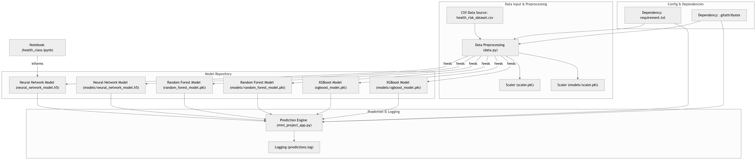

School of Computer Engineering, KIIT, BBSR 1

HEALTH RISK PREDICTOR

Chapter 2

Literature Review

2.1 Evolution of Health Risk Prediction System

Health informatics has evolved with the integration of Machine Learning (ML) and Artificial Intelligence (AI), shifting from manual analysis of medical data to automated, data-driven decision-making systems. Early approaches relied on statistical methods with limited capacity to capture non-linear patterns. In contrast, modern systems employ advanced ML models that analyze complex health data to provide predictive insights, aiding clinicians in early diagnosis and risk assessment.
Supervised learning algorithms have been widely adopted to classify individuals into various risk categories based on input features such as age, BMI, blood pressure, glucose levels, and lifestyle indicators. These models form the foundation of predictive systems for diseases like diabetes, cardiovascular disease, and hypertension.

2.2 Machine Learning Architecture in Health Informatics

The rise of ensemble learning and neural networks has significantly improved predictive accuracy in health risk assessment. Ensemble methods such as Random Forest and XGBoost capture complex, non-linear relationships and reduce overfitting through aggregation of multiple weak learners. Neural Networks, including deep learning architectures, have shown remarkable ability to model high-dimensional data and uncover subtle patterns among health indicators, particularly when supported by rigorous data preprocessing and hyperparameter tuning.
Transfer learning has also gained traction in scenarios with limited medical datasets, enabling the adaptation of pre-trained models to domain-specific tasks. These advancements collectively contribute to more robust and generalizable predictive health models.

School of Computer Engineering, KIIT, BBSR 2

HEALTH RISK PREDICTOR

Chapter 3

Problem Statement / Requirement Specifications

The rising cases of lifestyle-related illnesses demand early detection systems that can assist in preventive healthcare. Traditional health risk assessments are often manual, time-consuming, and error-prone. This project aims to develop a machine learning-based system that predicts individual health risks using clinical and lifestyle data, enabling early intervention and informed medical decisions.

3.1 Project Planning

The development of the Health Risk Prediction System adopts an iterative methodology, focusing on continuous refinement through data analysis and model evaluation. The project begins with problem identification, literature review, and dataset selection. This is followed by data preprocessing, model selection, training, and evaluation phases. Emphasis is placed on comparing the performance of multiple machine learning algorithms to select the most effective one. Final phases include system integration, user interface design, and deployment for practical usability testing and enhancements.

3.2 Project Analysis

The system must accurately predict an individual’s health risk based on various clinical and lifestyle parameters. It should support integration of multiple machine learning models such as Random Forest, Neural Networks, and XGBoost to offer comparative insights. The system is expected to be user-friendly, provide reliable risk scores, and ensure interpretability of predictions. Key non-functional requirements include high accuracy, data security, quick processing time, and adaptability to different datasets for broader usability in healthcare environments.

School of Computer Engineering, KIIT, BBSR 3

HEALTH RISK PREDICTOR

3.3 System Design

3.3.1 Design Constraints

Designing a health risk prediction system involves several challenges. Clinical data may contain missing values, inconsistencies, or biases that affect model performance. Additionally, ensuring that the model generalizes well across diverse demographics is crucial.

Balancing model complexity with interpretability and ensuring computational efficiency are also key considerations. The system must deliver accurate predictions without requiring excessive processing resources to remain accessible and scalable for real-world applications.

3.3.2 System Architecture

The system architecture is composed of three primary components: data input module, machine learning engine, and the result visualization layer. The data input module handles the ingestion and preprocessing of user-provided clinical and lifestyle data. The machine learning engine integrates and compares various algorithms for prediction and analysis. The result visualization layer provides risk scores and insights through a clear and interactive interface, enabling users and healthcare providers to interpret and act upon the predictions effectively.

School of Computer Engineering, KIIT, BBSR 4

HEALTH RISK PREDICTOR

Block Diagram

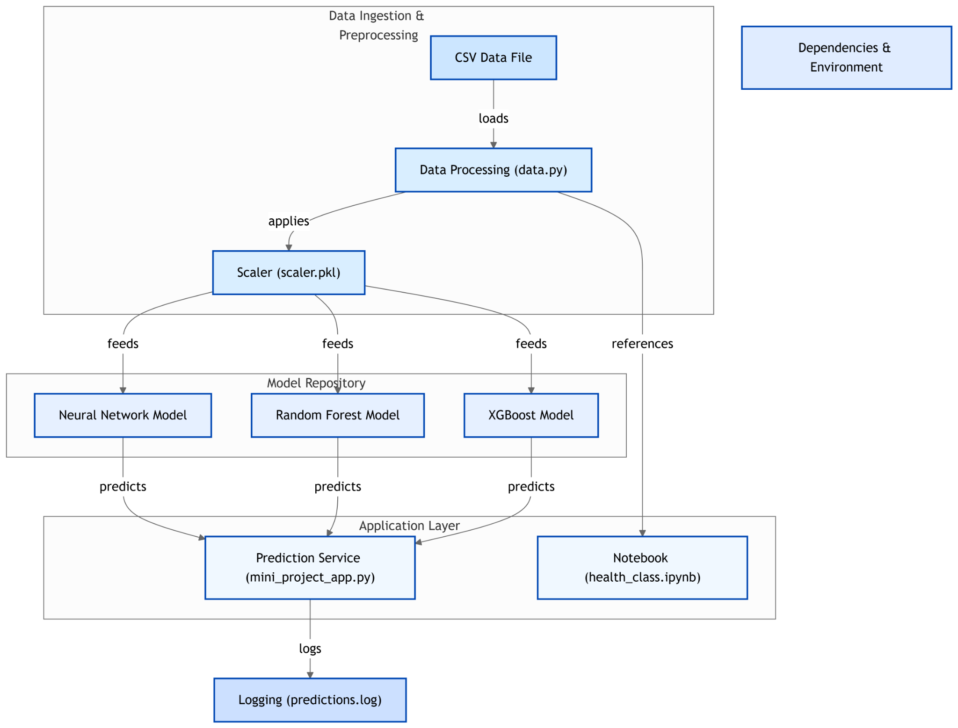

School of Computer Engineering, KIIT, BBSR 3
HEALTH RISK PREDICTOR

Chapter 4

Implementation

4.1 Methodology
The implementation of the Health Risk Prediction system follows a structured pipeline comprising data collection, preprocessing, model training, and deployment. Initially, a curated dataset is used, consisting of clinical and lifestyle-related features such as blood pressure, cholesterol levels, body mass index (BMI), physical activity, and dietary habits. Preprocessing steps including feature scaling and encoding are applied to enhance model compatibility and performance.
The system employs three machine learning models—Random Forest, Neural Networks, and XGBoost. Each model is trained and optimized using hyperparameter tuning techniques to maximize classification performance. FastAPI is used to develop the backend API, enabling real-time health risk predictions and seamless communication between the user interface and inference engine.

4.2 Testing
To ensure the robustness of the system, comprehensive testing is conducted at multiple stages. Unit testing is performed on core components such as data preprocessing, model inference, and API routes to validate their correctness. Integration testing ensures smooth interaction between various modules including data input, prediction logic, and API response handling. Additionally, functional testing simulates real-world usage scenarios to verify prediction accuracy and user interaction reliability.

4.3 Result Analysis
The performance of the models is evaluated using standard metrics such as accuracy, precision, recall, and the confusion matrix. Random Forest offers high accuracy and interpretability, making it suitable for risk prediction tasks. Neural Networks demonstrate consistent training convergence, while XGBoost excels in handling class imbalance. Visualizations such as feature importance graphs and performance plots are included to illustrate model behavior and classification effectiveness.

School of Computer Engineering, KIIT, BBSR 5

HEALTH RISK PREDICTOR

4.4 Quality Assurance
Maintaining quality throughout development is essential for the success of the Health Risk Prediction system. The codebase adheres to best practices, including modular design and comprehensive documentation. Pre-trained models are serialized using standard formats such as .pkl and .h5 for reproducibility. Regular unit and integration testing enhance system stability. Optimization techniques are implemented to balance prediction accuracy and inference latency, ensuring efficient real-time performance suitable for deployment in healthcare environments.

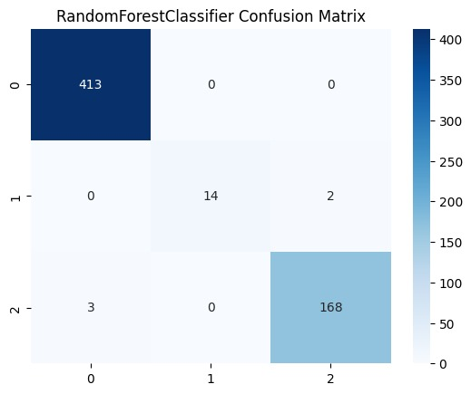

School of Computer Engineering, KIIT, BBSR 6

HEALTH RISK PREDICTOR

Chapter 5

Standards Adopted

5.1 Design Standards
The project follows standard software design principles with a focus on modularity, scalability, and maintainability. The architecture is structured into distinct layers including machine learning-based back-end, a Flutter-based front-end interface, and OpenCV-powered camera integration. This separation of concerns enables efficient development, debugging, and future scalability of the system.

5.2 Coding Standards
The backend development in Python adheres to PEP 8 coding standards, promoting code readability, consistency, and ease of maintenance. Proper naming conventions, organized imports, and consistent formatting are maintained throughout the implementation.

For the frontend, Dart language best practices are followed in the Flutter application, ensuring clarity, structured widget trees, and efficient state management. The project also maintains a clean directory structure, facilitating smooth navigation and collaboration.

In addition, the OpenCV integration follows efficient image processing practices, structured in a way that supports modular enhancements and optimization

School of Computer Engineering, KIIT, BBSR 7

HEALTH RISK PREDICTOR

5.3 Testing Standards
Testing practices include both automated and manual approaches. For the backend, model evaluation is done using appropriate metrics such as accuracy and F1-score, along with testing frameworks to validate input-output behavior. Manual testing is conducted for the Flutter frontend to ensure smooth navigation, responsiveness, and accuracy of results displayed to users.

End-to-end testing verifies integration between the ML models, frontend interface, and camera peripherals, ensuring that the overall application functions reliably in real-time use scenarios.

School of Computer Engineering, KIIT, BBSR 8

HEALTH RISK PREDICTOR

Chapter 6

Conclusion and Future Scope

6.1 Conclusion
The Health Risk Prediction system successfully showcases the integration of machine learning and mobile technologies to deliver real-time health assessments. By analyzing user-provided data such as age, BMI, blood pressure, and glucose levels, the system accurately classifies users into relevant health risk categories. The incorporation of Flutter for the frontend and OpenCV-based hand tracking adds a unique interactive dimension, making the application accessible and user-friendly. The project highlights the potential of AI in preventive healthcare and demonstrates an effective approach for early health risk detection.

6.2 Future Scope

There are several opportunities to enhance the system further. Future improvements may include:

- Expanding the Dataset: Incorporating more diverse and larger datasets to improve model generalization and accuracy.

- Personalization: Adding user profiles and tracking history for more personalized health insights and trends over time.

- Speech Integration: Enabling voice-based input/output for enhanced accessibility, especially for users with disabilities.

- Mobile App Deployment: Publishing the app on platforms like Google Play Store or App Store to reach a wider audience.

School of Computer Engineering, KIIT, BBSR 9

HEALTH RISK PREDICTOR

- Improved Gesture Recognition: Enhancing the hand tracking system using advanced deep learning models for more precise control.

- Cloud Integration: Allowing cloud-based storage and model inference for better performance and remote access to health reports.

- Multi-language Support: Incorporating multilingual UI options to cater to a broader demographic.

These enhancements would further strengthen the system’s usability, scalability, and real-world applicability in the field of digital health.

School of Computer Engineering, KIIT, BBSR 10

HEALTH RISK PREDICTOR

References

[1] Starner, T., et al. (1998). Real-time American sign language recognition using desk and wearable computer-based video. IEEE TPAMI, 20(12), 1371–1375.
[2] Vogler, C., & Metaxas, D. (1999). Parallel hidden Markov models for American sign language recognition. IEEE ICCV, 1, 116–122.
[3] Ong, S. C., & Ranganath, S. (2005). Automatic sign language analysis: A survey and the future beyond lexical meaning. IEEE TPAMI, 27(6), 873–891.
[4] Koller, O., et al. (2019). Weakly supervised learning with multi-stream CNN-LSTM-HMMs to discover sequential parallelism in sign language videos. IEEE TPAMI, 42(9), 2306–2320.
[5] Quesada, L., et al. (2017). Automatic recognition of the American sign language fingerspelling alphabet. JAIHC, 8(4), 625–635.
[6] Joze, H. R. V., & Koller, O. (2018). MS-ASL: A large-scale data set and benchmark for understanding American sign language. BMVC.
[7] Camgoz, N. C., et al. (2020). Sign language transformers: Joint end-to-end sign language recognition and translation. IEEE/CVF CVPR, 10023–10033.
[8] Albanie, S., et al. (2020). BSL-1K: Scaling up co-articulated sign language recognition using mouthing cues. ECCV, 35–53.
[9] Li, D., et al. (2020). Word-level deep sign language recognition from video: A new large-scale dataset and methods comparison. WACV, 1459–1469.
[10] Bragg, D., et al. (2019). Sign language recognition, generation, and translation: An interdisciplinary perspective. ACM SIGACCESS, 16–31.
[11] Rastgoo, R., et al. (2021). Sign language recognition: A deep survey. Expert Systems with Applications, 164, 113794.
[12] Sandler, W., & Lillo-Martin, D. (2006). Sign language and linguistic universals. Cambridge University Press.
[13] Sincan, O. M., & Keles, H. Y. (2020). AUTSL: A large-scale multi-modal Turkish sign language dataset and baseline methods. IEEE Access, 8, 181340–181355.

School of Computer Engineering, KIIT, BBSR 11

HEALTH RISK PREDICTOR

SAMPLE INDIVIDUAL CONTRIBUTION REPORT:

HEALTH RISK PREDICTOR

Harsh Ray
22052297
Abstract: The Health Risk Prediction project leverages machine learning algorithms to analyze structured health data for early identification of potential health threats. I contributed to the implementation and evaluation of the Random Forest model, focusing on its hyperparameter optimization and interpretability. The objective was to ensure high accuracy while maintaining model transparency for clinical usability.

Individual contribution and findings: I was primarily responsible for developing and fine-tuning the Random Forest model. My work included:
- Preprocessing the dataset using techniques like standard scaling and label encoding.
- Tuning hyperparameters such as number of estimators, max depth, and feature selection to achieve optimal performance.
- Evaluating the model using confusion matrices, accuracy, precision, and recall.
- Comparing Random Forest with XGBoost to validate reliability.
Technical Findings and Experience:
- The model achieved over 90% accuracy with stable performance across different test sets.
- Feature importance ranking provided valuable insights for clinical interpretation.
- Encountered challenges in balancing overfitting and generalization, which were mitigated through cross-validation and tuning.
- This project enhanced my understanding of ensemble learning and real-world application of predictive analytics in healthcare.

Individual contribution to project report preparation: Student should mention his/her role in preparing the group project report indicating which chapter and portions contributed.

Individual contribution for project presentation and demonstration: Student should mention his/her role in preparing presentations and part of the project demonstrated.

Full Signature of Supervisor: Full signature of the student:
……………………………. ……………………………..

School of Computer Engineering, KIIT, BBSR 12

HEALTH RISK PREDICTOR

INDIVIDUAL CONTRIBUTION REPORT:

HEALTH RISK PREDICTOR

Harsh Raj
22051681
Abstract: I worked on developing the Neural Network model using Keras and TensorFlow. This included preparing input pipelines and optimizing model architecture for healthcare classification tasks.

Individual contribution and findings: My responsibilities were centered around implementing and training the deep learning model:
- Designed and implemented a feedforward Neural Network for multi-class classification.
- Applied dropout and batch normalization to avoid overfitting.
- Tracked model training over epochs and tuned learning rate to ensure convergence.
- Visualized training and validation loss to monitor performance.
Technical Findings and Experience:
- Neural Network achieved consistent training accuracy and demonstrated non-linear pattern learning.
- Key insight was the need for normalization in medical datasets for convergence.
- Developed better intuition for tuning hidden layers and activation functions.

Individual contribution to project report preparation: Student should mention his/her role in preparing the group project report indicating which chapter and portions contributed.

Individual contribution for project presentation and demonstration: Student should mention his/her role in preparing presentations and part of the project demonstrated.

Full Signature of Supervisor: Full signature of the student:
……………………………. ……………………………..

School of Computer Engineering, KIIT, BBSR 13

HEALTH RISK PREDICTOR

INDIVIDUAL CONTRIBUTION REPORT:

HEALTH RISK PREDICTOR

Aman Kumar
22051663

Abstract:I contributed to the backend integration using FastAPI and ensured the trained models were connected to an interface for real-time prediction requests.

Individual contribution and findings: I managed the deployment and API integration for our machine learning models:
- Developed API endpoints to handle health risk prediction requests using FastAPI.
- Ensured seamless communication between frontend interface and backend logic.
- Handled error validation and API documentation.
Technical Findings and Experience:
- Improved skills in deploying machine learning solutions in production environments.
- Understood request/response handling and model serialization techniques.
Individual contribution to project report preparation: Student should mention his/her role in preparing the group project report indicating which chapter and portions contributed.

Individual contribution for project presentation and demonstration: Student should mention his/her role in preparing presentations and part of the project demonstrated.

Full Signature of Supervisor: Full signature of the student:
……………………………. …………………

School of Computer Engineering, KIIT, BBSR 14
HEALTH RISK PREDICTOR

INDIVIDUAL CONTRIBUTION REPORT:

HEALTH RISK PREDICTOR

Aakash Raj

2205695

Abstract: I handled dataset preprocessing, including missing value treatment, normalization, and feature encoding to prepare data for effective model training.

Individual contribution and findings: My work focused on preparing high-quality inputs for model training:
- Cleaned dataset and treated missing/null entries appropriately.
- Normalized numerical features and one-hot encoded categorical variables.
- Saved preprocessing pipeline using scikit-learn’s joblib for reuse.
Technical Findings and Experience:
- Understood the critical role of clean data in model performance.
- Practiced automation of data preparation and learned preprocessing strategies for health data.
Individual contribution to project report preparation: Student should mention his/her role in preparing the group project report indicating which chapter and portions contributed.

Individual contribution for project presentation and demonstration: Student should mention his/her role in preparing presentations and part of the project demonstrated.

Full Signature of Supervisor: Full signature of the student:
……………………………. ……………………………..

School of Computer Engineering, KIIT, BBSR 15

HEALTH RISK PREDICTOR

INDIVIDUAL CONTRIBUTION REPORT:

HEALTH RISK PREDICTOR

Gaurav Kumar
2205695

Abstract:I was responsible for the evaluation and comparison of multiple machine learning models to ensure we selected the best performing one for deployment.

Individual contribution and findings: I worked on model benchmarking and result analysis:
- Evaluated Random Forest, XGBoost, and Neural Network based on accuracy, precision, and recall.
- Plotted confusion matrices and ROC curves for result visualization.
- Conducted data distribution and correlation analysis.
Technical Findings and Experience:
- Understood model selection trade-offs and importance of explainability in healthcare.
- Gained hands-on experience with metrics-based validation and result documentation.
Individual contribution to project report preparation: Student should mention his/her role in preparing the group project report indicating which chapter and portions contributed.

Individual contribution for project presentation and demonstration: Student should mention his/her role in preparing presentations and part of the project demonstrated.

Full Signature of Supervisor: Full signature of the student:
……………………………. ……………………………..

School of Computer Engineering, KIIT, BBSR 16

HEALTH RISK PREDICTOR

INDIVIDUAL CONTRIBUTION REPORT:

HEALTH RISK PREDICTOR

Kanishka Mudgal
22053960

Abstract: I worked on documentation, user testing, and overall integration, ensuring all components of the project worked cohesively and were properly presented.

Individual contribution and findings: I contributed toward system integration, documentation, and user feedback:
- Managed user testing sessions and recorded usability feedback.
- Integrated ML model with backend and visualization components.
- Handled writing of technical content and consolidated final report sections.
Technical Findings and Experience:
- Developed attention to detail in documentation and technical writing.
- Learned to balance usability with technical accuracy through user feedback.
Individual contribution to project report preparation: Student should mention his/her role in preparing the group project report indicating which chapter and portions contributed.

Individual contribution for project presentation and demonstration: Student should mention his/her role in preparing presentations and part of the project demonstrated.

Full Signature of Supervisor: Full signature of the student:
……………………………. ……………………………..

School of Computer Engineering, KIIT, BBSR 17

TURNITIN PLAGIARISM REPORT
(This report is mandatory for all the projects and plagiarism
must be below 25%)

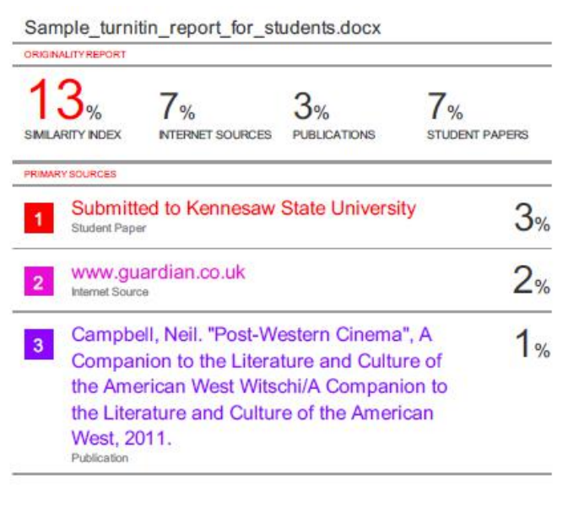

School of Computer Engineering, KIIT, BBSR 9

