Experiment no: 01

Aim: To explore and understand key Python libraries commonly used in machine learning, with practical examples demonstrating their usage.

Objectives
• Learn the purpose and role of important Python libraries in ML.
• Practice using each library on simple datasets or problems.
• Understand data manipulation, visualization, modeling, and evaluation with Python tools.

Tools Required
• Python 3.7 or above
• Jupyter Notebook or any Python IDE
• numpy, pandas, matplotlib, seaborn, scikit-learn, tensorflow (or keras), nltk, scipy, statsmodels
• Dataset: Student Placement Prediction Dataset 2026 from Kaggle. Download the CSV and keep it as student_placement.csv.
Kaggle dataset reference: https://www.kaggle.com/datasets/sehaj1104/student-placement-prediction-dataset-2026
Before the exercises, run this once:
import numpy as np
import pandas as pd
import matplotlib.pyplot as plt
import seaborn as sns
df = pd.read_csv('student_placement.csv')

Theory:

1. NumPy

Description:
NumPy is used for numerical calculations and working with arrays. It is useful for finding values such as mean, median and standard deviation.
Exercise: Calculate the mean CGPA and median salary of placed students.
placed = df[df['placement_status'] == 'Placed']
print('Mean CGPA:', np.mean(placed['cgpa']))
print('Median Salary:', np.median(placed['salary_package_lpa'].dropna()))

2. Pandas

Description:
Pandas is used to read, view, filter and manipulate tabular data. Its main data structure is the DataFrame.
Exercise: Preview the dataset and find female students with CGPA above 8.
print(df.head())
print(df[(df['gender'] == 'Female') & (df['cgpa'] > 8)]
[['student_id', 'gender', 'cgpa', 'branch']].head())

3. Matplotlib

Description:
Matplotlib is used to create basic graphs and visualize data.
Exercise: Plot the salary distribution of students with salary data.
plt.hist(df['salary_package_lpa'].dropna(), bins=10)
plt.xlabel('Salary (LPA)')
plt.ylabel('Number of Students')
plt.title('Salary Distribution')
plt.show()

4. Seaborn

Description:
Seaborn is built on Matplotlib and makes statistical graphs easier to create.
Exercise: Show placement count for each branch.
sns.countplot(x='branch', hue='placement_status', data=df)
plt.xticks(rotation=45)
plt.show()

5. scikit-learn

Description:
scikit-learn provides ready-to-use machine learning algorithms for tasks such as classification, regression and clustering.
Exercise: Build a simple logistic regression model to predict placement.
from sklearn.model_selection import train_test_split
from sklearn.linear_model import LogisticRegression
from sklearn.metrics import accuracy_score
d = df[['cgpa', 'coding_skill_score', 'internships_count', 'placement_status']].dropna()
X = d[['cgpa', 'coding_skill_score', 'internships_count']]
y = d['placement_status'].map({'Not Placed': 0, 'Placed': 1})
X_train, X_test, y_train, y_test = train_test_split(X, y, test_size=0.2, random_state=42)
model = LogisticRegression(max_iter=200).fit(X_train, y_train)
print('Accuracy:', accuracy_score(y_test, model.predict(X_test)))

6. TensorFlow / Keras

Description:
TensorFlow is used for machine learning and deep learning. Keras provides a simple way to build neural networks.
Exercise: Train a small neural network for placement prediction.
from tensorflow.keras import Sequential
from tensorflow.keras.layers import Dense
net = Sequential([Dense(8, activation='relu', input_shape=(3,)),
Dense(1, activation='sigmoid')])
net.compile(optimizer='adam', loss='binary_crossentropy', metrics=['accuracy'])
net.fit(X_train, y_train, epochs=10, verbose=0)
print(net.evaluate(X_test, y_test, verbose=0)[1])

7. NLTK

Description:
NLTK is used for working with human language data. One simple task is splitting a sentence into words, called tokenization.
Exercise: Tokenize a short student comment.
import nltk
from nltk.tokenize import word_tokenize
nltk.download('punkt', quiet=True)
text = 'The placement training was useful.'
print(word_tokenize(text))

8. SciPy

Description:
SciPy provides scientific and statistical functions. Here it can be used for a t-test.
Exercise: Compare the CGPA of placed and not placed students.
from scipy import stats
placed = df[df['placement_status'] == 'Placed']['cgpa'].dropna()
not_placed = df[df['placement_status'] == 'Not Placed']['cgpa'].dropna()
t, p = stats.ttest_ind(placed, not_placed)
print('t-statistic:', round(t, 3))
print('p-value:', round(p, 3))

9. Statsmodels

Description:
Statsmodels is useful when a statistical model and its detailed summary are required.
Exercise: Get a detailed logistic regression summary.
import statsmodels.api as sm
d = df[['cgpa', 'coding_skill_score', 'placement_status']].dropna()
X = sm.add_constant(d[['cgpa', 'coding_skill_score']])
y = d['placement_status'].map({'Not Placed': 0, 'Placed': 1})
print(sm.Logit(y, X).fit().summary())

Conclusion:
The experiment helped understand the basic use of important Python libraries in machine learning. NumPy and Pandas handle data, Matplotlib and Seaborn create visualizations, and libraries such as scikit-learn, TensorFlow, SciPy and Statsmodels support ML and statistical tasks. NLTK is useful when the data contains text.

CO Achieved: CO1 – Understand basics of Machine Learning
• Students gain foundational understanding of ML by exploring Python libraries (NumPy, Pandas, Matplotlib, Scikit-learn).
• They analyze how these libraries assist in data preprocessing, visualization, and model building.

POs Achieved
• PO1 (Engineering Knowledge): Apply computing fundamentals to study ML libraries.
• PO2 (Problem Analysis): Analyze the role of tools in solving ML problems.
• PO5 (Engineering Tool Usage): Explore and use modern libraries for ML tasks.
• PO11 (Life-Long Learning): Gain exposure to libraries that evolve over time, fostering adaptability.

PSO Achieved
• PSO1: Apply Python tools to create sustainable ML solutions.

Experiment No.02

Aim: Write a code to the FIND-S algorithm for finding the most specific hypothesis based on a given set of training data samples. Read the training data from a .CSV file

Theory:

Introduction :
The find-S algorithm is a basic concept learning algorithm in machine learning. The find-S algorithm finds the most specific hypothesis that fits all the positive examples. We have to note here that the algorithm considers only those positive training example. The find-S algorithm starts with the most specific hypothesis and generalizes this hypothesis each time it fails to classify an observed positive training data. Hence, the Find-S algorithm moves from the most specific hypothesis to the most general hypothesis.

Important Representation :
- ? indicates that any value is acceptable for the attribute.
- specify a single required value ( e.g., Cold ) for the attribute.
- Φ indicates that no value is acceptable.
- The most general hypothesis is represented by: {?, ?, ?, ?, ?, ?}
- The most specific hypothesis is represented by: {ϕ, ϕ, ϕ, ϕ, ϕ, ϕ}

Find-S Algorithm Machine Learning
1. Initilize h to the most specific hypothesis in H
2. For each positive training instance x
For each attribute contraint a_{i} in h
If the contraint a_{i} is satisfied by x
then do nothing
Else
replace a_{i} in h by the next more general constraint that is satisfied by x
3. Output the hypothesis h

Example:

Step – 1 of Find-S Algorithm
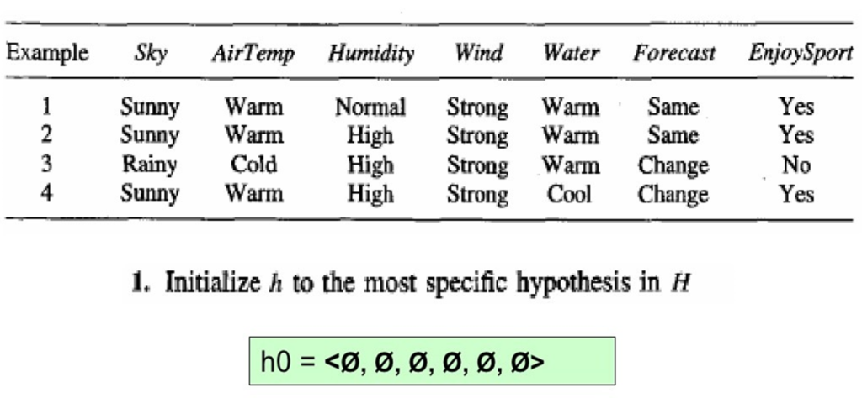

Step 2 of Find-S Algorithm First iteration
h0 = (ø, ø, ø, ø, ø, ø, ø)
X1 = <Sunny, Warm, Normal, Strong, Warm, Same>
h1 = <Sunny, Warm, Normal, Strong, Warm, Same>
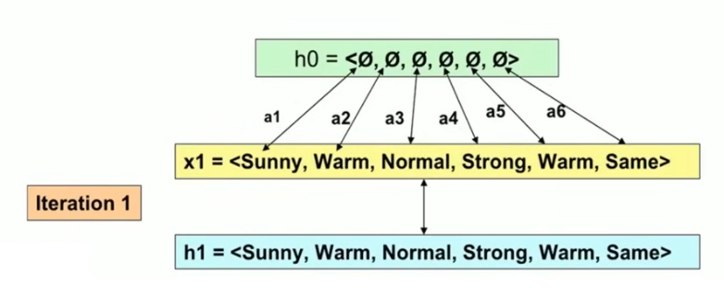

Step 2 of Find-S Algorithm Second iteration
h1 = <Sunny, Warm, Normal, Strong, Warm, Same>
X2 = <Sunny, Warm, High, Strong, Warm, Same>
h2 = <Sunny, Warm, ?, Strong, Warm, Same>
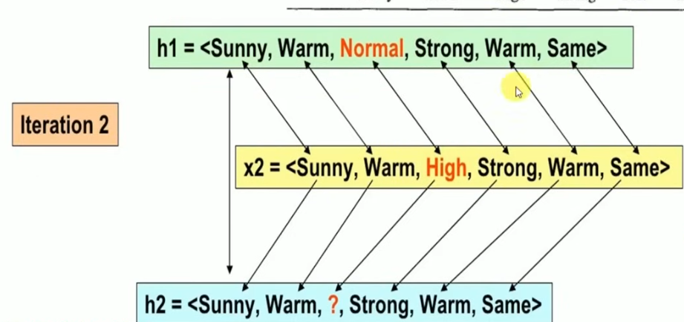

Step 2 of Find-S Algorithm Third iteration
h2 = <Sunny, Warm, ?, Strong, Warm, Same>
X3 = <Rainy, Cold, High, Strong, Warm, Change> – No
X3 is Negative example Hence ignored
h3 = <Sunny, Warm, ?, Strong, Warm, Same>
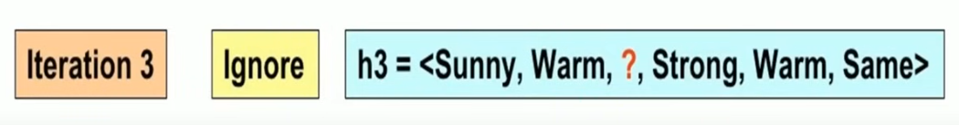

Step 2 of Find-S Algorithm Fourth iteration
h3 = <Sunny, Warm, ?, Strong, Warm, Same>
X4 = <Sunny, Warm, High, Strong, Cool, Change>
h4 = <Sunny, Warm, ?, Strong, ?, ?>
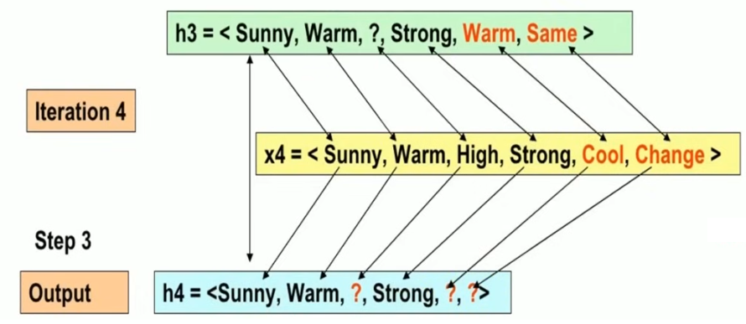

Step 3
The final maximally specific hypothesis is <Sunny, Warm, ?, Strong, ?, ?>
- After we have completed all the training examples we will have the final hypothesis when can use to classify the new examples.

Code:
To understand the implementation, let us try to implement it to a smaller data set with a bunch of examples to decide if a person wants to go for a walk.The concept of this particular problem will be on what days does a person likes to go on walk.
Time | Weather | Temperature | Company | Humidity | Wind | Goes
Morning | Sunny | Warm | Yes | Mild | Strong | Yes
Evening | Rainy | Cold | No | Mild | Normal | No
Morning | Sunny | Moderate | Yes | Normal | Normal | Yes
Evening | Sunny | Cold | Yes | High | Strong | Yes
Looking at the data set, we have six attributes and a final attribute that defines the positive or negative example. In this case, yes is a positive example, which means the person will go for a walk.So now, the general hypothesis is:
h₀ = {‘Morning’, ‘Sunny’, ‘Warm’, ‘Yes’, ‘Mild’, ‘Strong’}
This is our general hypothesis, and now we will consider each example one by one, but only the positive examples.
h₁= {‘Morning’, ‘Sunny’, ‘?’, ‘Yes’, ‘?’, ‘?’}
h₂ = {‘?’, ‘Sunny’, ‘?’, ‘Yes’, ‘?’, ‘?’}
We replaced all the different values in the general hypothesis to get a resultant hypothesis.
Code:
Dataset reference: Kaggle - Play Tennis Dataset (weather-based classifier)
https://www.kaggle.com/code/devraai/play-tennis-dataset-classification-analysis
import pandas as pd
df = pd.read_csv('play_tennis.csv')
attributes = df.columns[:-1]
target = df.columns[-1]
hypothesis = ['0'] * len(attributes)
for _, row in df.iterrows():
if str(row[target]).lower() == 'yes':
if hypothesis == ['0'] * len(attributes):
hypothesis = list(row[attributes])
else:
for i in range(len(attributes)):
if hypothesis[i] != row[attributes[i]]:
hypothesis[i] = '?'
print('Final Hypothesis:', hypothesis)
Save the Kaggle CSV as play_tennis.csv. FIND-S checks only positive rows and replaces different values with ?.
Output:
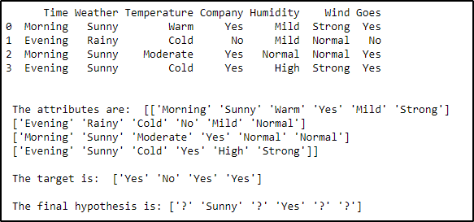

Practice problem:
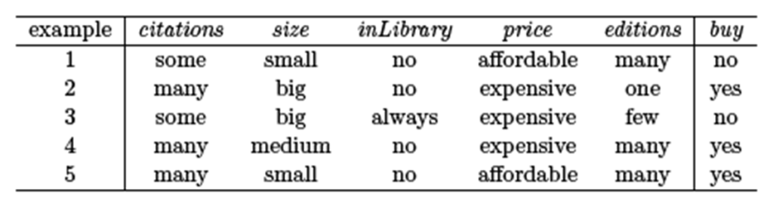

Conclusion
The FIND-S algorithm was successfully implemented to determine the most specific hypothesis consistent with the given set of training data. By reading input from a CSV file, the program iteratively generalized the hypothesis only for positive training samples while ignoring negative samples. This experiment demonstrates how concept learning algorithms work in the hypothesis space and provides a foundation for understanding more advanced algorithms like Candidate Elimination.

CO Achieved: CO1, CO2
- CO1: Understand concept learning and hypothesis space representation.
- CO2: Apply pre-processing techniques to read and process data from CSV before hypothesis generation.

POs Achieved
- PO1: Apply knowledge of algorithms to generate hypotheses.
- PO2: Analyze positive and negative examples to refine hypotheses.
- PO4 (Investigations): Interpret data to validate the hypothesis.
- PO5: Use programming tools to implement ML algorithms.

PSO Achieved
- PSO1: Implement basic AI/ML algorithms to solve introductory concept learning problems.

Experiment No.3

Lab Experiment: Data Handling with Python

1. Aim: To understand and perform data handling using Python libraries (NumPy and Pandas) for preprocessing datasets in Machine Learning.

2. Objectives
- To load and explore datasets using Pandas.
- To perform data cleaning (handling missing values, duplicates).
- To analyze and manipulate data using NumPy and Pandas functions.
- To apply basic descriptive statistics and visualization for data understanding.
- To prepare cleaned data for ML model training.

3. Pre-requisites
- Basic knowledge of Python programming (lists, functions, loops).
- Installed Python environment with NumPy, Pandas, and Matplotlib.
- Understanding of data types: numerical, categorical, text.

4. Theory
Data Handling in ML
- Data handling involves loading, cleaning, transforming, and analyzing data before feeding it into a machine learning model.
- Libraries used:
  - NumPy: Efficient handling of numerical arrays and matrices.
  - Pandas: Provides Series and DataFrame for tabular data handling.
  - Matplotlib / Seaborn: Visualization for exploratory data analysis.
Common Operations:
- Loading data: pd.read_csv(), pd.read_excel().
- Exploring data: .head(), .info(), .describe().
- Cleaning data: Handling null values, duplicates, and inconsistent formats.
- Transformation: Feature scaling, encoding categorical data.
- Aggregation: Grouping and summarizing data.
- Visualization: Understanding data distributions and relationships.

5. Software/Hardware Requirements
- Python 3.x
- Jupyter Notebook or Google Colab
- Libraries: numpy, pandas, matplotlib, seaborn

6. Procedure / Steps

Step 1: Import required libraries
import pandas as pd
import matplotlib.pyplot as plt
import seaborn as sns
Only the libraries needed for data handling and simple visualization are used.

Step 2: Load the dataset
df = pd.read_csv('train.csv')
print(df.head())
Download train.csv from the Kaggle Titanic dataset and keep it in the same folder as the notebook.

Dataset reference
Kaggle: Titanic - Machine Learning from Disaster
https://www.kaggle.com/competitions/titanic/data

Step 3: Check and clean the data
print(df.isnull().sum())
df['Age'] = df['Age'].fillna(df['Age'].median())
df = df.drop_duplicates()
Missing Age values are filled with the median, and duplicate rows are removed.

Step 4: Transform the data
df['Sex'] = df['Sex'].map({'male': 0, 'female': 1})
df['FamilySize'] = df['SibSp'] + df['Parch'] + 1
print(df[['Age', 'Sex', 'FamilySize']].head())
Categorical gender values are converted to numbers, and FamilySize is created as a new feature.

Step 5: Basic analysis and visualization
print(df['Age'].mean(), df['Age'].median())
sns.histplot(df['Age'], kde=True)
plt.title('Age Distribution')
plt.show()
sns.countplot(x='Sex', data=df)
plt.title('Gender Count')
plt.show()
The histogram gives a quick view of the age distribution.

Step 6: Save the cleaned data
df.to_csv('cleaned_titanic.csv', index=False)
The cleaned file can now be used for later ML experiments.

7. Output
- Display initial dataset.
- Show data cleaning steps and transformed dataset.
- Visualize distributions and relationships (e.g., age histogram, gender countplot).
- Generate a cleaned dataset ready for ML tasks.

8. Result
Successfully performed data handling using Python libraries: loaded, cleaned, transformed, and visualized dataset, preparing it for machine learning model development.

CO Achieved: CO2
- Apply data cleaning, transformation, and visualization techniques.
- Demonstrate pre-processing steps essential for training accurate models.

POs Achieved
- PO1: Apply foundational programming to handle datasets.
- PO2: Analyze data quality and handle missing or noisy data.
- PO3 (Design Solutions): Design efficient workflows for preparing data.
- PO4: Conduct experiments on datasets to validate results.
- PO5: Utilize libraries like Pandas/NumPy for modern data handling.

PSO Achieved
- PSO1: Enhance ML workflows through data handling skills.
- PSO2: Integrate data cleaning into scalable analytics pipelines.

Experiment No.4

Lab Experiment: Linear and Multiple Linear Regression

1. Aim: To implement Linear Regression and Multiple Linear Regression using Python and evaluate their performance on a given dataset.

2. Objectives
- To understand the concept of simple linear regression (one independent variable).
- To implement multiple linear regression (two or more independent variables).
- To train models, predict outcomes, and evaluate accuracy using metrics like MSE and R².
- To visualize regression lines and compare actual vs predicted values.

3. Pre-requisites
- Knowledge of Python, NumPy, Pandas.
- Understanding of regression algorithms.
- Libraries required: pandas, numpy, scikit-learn, matplotlib, seaborn.

4. Theory

Linear Regression
- Models relationship between a dependent variable y and one independent variable x.
- Equation:
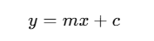
Where m = slope and c = intercept.

Multiple Linear Regression
- Models relationship between a dependent variable y and multiple independent variables x1,x2,x3,…x_1, x_2, x_3, \sx1​,x2​,x3​,….
- Equation: 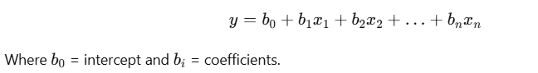

Evaluation Metrics
- Mean Squared Error (MSE): Measures average squared error between actual and predicted values.
- R² Score: Measures how well the regression line fits the data (closer to 1 = better fit).

5. Software/Hardware Requirements
- Python 3.x
- Jupyter Notebook / Google Colab
- Libraries: pandas, numpy, matplotlib, seaborn, sklearn

6. Procedure

Step 1: Import libraries
import pandas as pd
import matplotlib.pyplot as plt
from sklearn.model_selection import train_test_split
from sklearn.linear_model import LinearRegression
from sklearn.metrics import mean_squared_error, r2_score

Step 2: Load the dataset
data = pd.read_csv('train.csv')
data = data[['GrLivArea', 'OverallQual', 'GarageCars', 'SalePrice']].dropna()
print(data.head())
Download train.csv from the Kaggle House Prices dataset.

Dataset reference
Kaggle: House Prices - Advanced Regression Techniques
https://www.kaggle.com/competitions/house-prices-advanced-regression-techniques/data

Step 3: Simple Linear Regression
X = data[['GrLivArea']]
y = data['SalePrice']
X_train, X_test, y_train, y_test = train_test_split(
X, y, test_size=0.2, random_state=42)
model = LinearRegression()
model.fit(X_train, y_train)
y_pred = model.predict(X_test)
print('MSE:', mean_squared_error(y_test, y_pred))
print('R2:', r2_score(y_test, y_pred))
plt.scatter(X_test, y_test)
plt.plot(X_test, y_pred)
plt.xlabel('Living Area')
plt.ylabel('Sale Price')
plt.show()
One feature, GrLivArea, is used to predict SalePrice.

Step 4: Multiple Linear Regression
X = data[['GrLivArea', 'OverallQual', 'GarageCars']]
X_train, X_test, y_train, y_test = train_test_split(
X, y, test_size=0.2, random_state=42)
model = LinearRegression()
model.fit(X_train, y_train)
y_pred = model.predict(X_test)
print('MSE:', mean_squared_error(y_test, y_pred))
print('R2:', r2_score(y_test, y_pred))
Three features are now used together, so the R2 score can be compared with the simple model.

7. Output
- Coefficients and intercept for both linear and multiple regression.
- MSE and R² scores for performance evaluation.
- Scatter plot with regression line for simple linear regression.

8. Result
Successfully implemented linear and multiple linear regression, visualized regression line, and evaluated model performance using error metrics.

9. Conclusion
Linear regression is effective for modeling relationships between continuous variables. Multiple linear regression incorporates multiple features, improving prediction accuracy but may require feature selection to avoid multicollinearity. Both models are foundational in predictive analytics and form the basis for more complex regression techniques.

CO Achieved: CO2
- Apply statistical and ML-based techniques to identify significant features and reduce dimensionality.

POs Achieved
- PO1: Use mathematics/statistics for feature evaluation.
- PO2: Analyze feature importance and redundancy.
- PO4: Investigate feature selection methods to validate model performance.
- PO5: Use tools like Scikit-learn for feature extraction.

PSO Achieved
- PSO1: Apply feature engineering for better AI/ML solutions.
- PSO2: Use dimensionality reduction to enhance scalability of models.

Experiment No.5

Lab Experiment: Logistic Regression

1. Aim: To implement Logistic Regression for binary classification using Python and evaluate its performance.

2. Objectives
- To understand the concept of logistic regression for classification.
- To train a logistic regression model and predict binary outcomes.
- To evaluate model performance using confusion matrix and accuracy metrics.
- To visualize decision boundaries and probability predictions.

3. Pre-requisites
- Knowledge of Python, Pandas, and NumPy.
- Understanding of regression vs classification problems.
- Installed libraries: pandas, numpy, scikit-learn, matplotlib, seaborn.

4. Theory

Logistic Regression
- A supervised learning algorithm used for binary classification (0 or 1).
- Predicts probability using the sigmoid function:
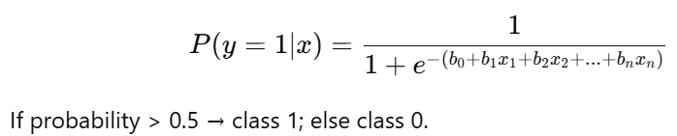

Evaluation Metrics
- Confusion Matrix: True Positive, False Positive, True Negative, False Negative.
- Accuracy, Precision, Recall, F1-score.

5. Software/Hardware Requirements
- Python 3.x
- Jupyter Notebook / Google Colab
- Libraries: pandas, numpy, scikit-learn, matplotlib, seaborn

6. Procedure

Step 1: Import libraries
import pandas as pd
import seaborn as sns
import matplotlib.pyplot as plt
from sklearn.model_selection import train_test_split
from sklearn.linear_model import LogisticRegression
from sklearn.metrics import confusion_matrix, accuracy_score

Step 2: Load the dataset
df = pd.read_csv('train.csv')
df = df[['Age', 'Fare', 'Sex', 'Survived']].dropna()
df['Sex'] = df['Sex'].map({'male': 0, 'female': 1})
print(df.head())
Use the train.csv file from the Kaggle Titanic dataset.

Dataset reference
Kaggle: Titanic - Machine Learning from Disaster
https://www.kaggle.com/competitions/titanic/data

Step 3: Train the Logistic Regression model
X = df[['Age', 'Fare', 'Sex']]
y = df['Survived']
X_train, X_test, y_train, y_test = train_test_split(
X, y, test_size=0.2, random_state=42)
model = LogisticRegression()
model.fit(X_train, y_train)
y_pred = model.predict(X_test)
print('Accuracy:', accuracy_score(y_test, y_pred))
The model predicts whether a passenger survived or not.

Step 4: Display the confusion matrix
cm = confusion_matrix(y_test, y_pred)
sns.heatmap(cm, annot=True, fmt='d')
plt.xlabel('Predicted')
plt.ylabel('Actual')
plt.show()
y_prob = model.predict_proba(X_test)[:, 1]
plt.hist(y_prob, bins=10)
plt.xlabel('Probability')
plt.ylabel('Count')
plt.title('Predicted Survival Probability')
plt.show()
The histogram shows the probability assigned to the survived class.
The confusion matrix shows correct and incorrect predictions for both classes.

7. Output
- Confusion matrix and classification report.
- Accuracy of logistic regression model.
- Probability histogram of predictions.

8. Result
Successfully implemented logistic regression for binary classification, evaluated performance, and visualized probability predictions.

9. Conclusion
Logistic regression is an effective classification algorithm for binary outcomes. It provides probability-based predictions and is interpretable, making it useful in applications like survival prediction, spam detection, and medical diagnosis.

CO Achieved: CO3
- Understand and apply regression for prediction tasks and evaluate outcomes.

POs Achieved
- PO1: Apply mathematics and programming to regression analysis.
- PO2: Analyze relationships between variables for model building.
- PO3: Design regression-based solutions for prediction tasks.
- PO4: Validate regression models using experimental data.
- PO5: Use computational libraries (Scikit-learn) to implement regression.

PSO Achieved
- PSO1: Apply regression in real-time AI/ML applications.
- PSO2: Use regression for scalable analytics in cloud/ICT solutions.

Experiment No.06

K-Nearest Neighbour (KNN) Algorithm

1. Aim: To implement and demonstrate the working of the K-Nearest Neighbour (KNN) algorithm for classification using Python.

2. Objectives
- To understand the concept of the KNN algorithm.
- To classify data points based on similarity (distance metric).
- To evaluate KNN performance using accuracy and confusion matrix.
- To visualize decision boundaries for different values of K.

3. Pre-requisites
- Knowledge of Python and basic machine learning workflow.
- Understanding of classification problems and distance metrics.
- Libraries required: pandas, numpy, matplotlib, seaborn, scikit-learn.

4. Theory

K-Nearest Neighbour (KNN)
- A lazy learning and instance-based algorithm.
- Classifies a data point based on the majority class of its K nearest neighbours.
- Steps:
  - Choose value of K (number of neighbours).
  - Calculate distance (e.g., Euclidean) between query point and all training points.
  - Select K nearest points and determine majority class.
  - Assign the class to the query point.

Distance Metric
Euclidean distance is commonly used:
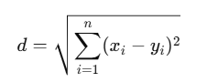

5. Software/Hardware Requirements
- Python 3.x
- Jupyter Notebook / Google Colab
- Libraries: numpy, pandas, matplotlib, seaborn, scikit-learn

6. Procedure

Step 1: Import libraries
import pandas as pd
from sklearn.model_selection import train_test_split
from sklearn.neighbors import KNeighborsClassifier
from sklearn.metrics import accuracy_score, confusion_matrix

Step 2: Load the dataset
df = pd.read_csv('Iris.csv')
X = df[['SepalLengthCm', 'SepalWidthCm', 'PetalLengthCm', 'PetalWidthCm']]
y = df['Species']
print(X.head())
Download Iris.csv from the Kaggle Iris Species dataset.

Dataset reference
Kaggle: Iris Species
https://www.kaggle.com/uciml/iris/data

Step 3: Split the dataset
X_train, X_test, y_train, y_test = train_test_split(
X, y, test_size=0.2, random_state=42)

Step 4: Train KNN and predict
knn = KNeighborsClassifier(n_neighbors=3)
knn.fit(X_train, y_train)
y_pred = knn.predict(X_test)
print('Accuracy:', accuracy_score(y_test, y_pred))
print('Confusion Matrix:\n', confusion_matrix(y_test, y_pred))
from sklearn.inspection import DecisionBoundaryDisplay
import matplotlib.pyplot as plt
X2 = X[['SepalLengthCm', 'SepalWidthCm']]
knn2 = KNeighborsClassifier(n_neighbors=3).fit(X2, y)
DecisionBoundaryDisplay.from_estimator(knn2, X2, alpha=0.25)
plt.scatter(X2.iloc[:, 0], X2.iloc[:, 1], c=pd.Categorical(y).codes)
plt.show()
The last part uses two features only so the KNN decision regions can be seen on a graph.
K=3 means the class is decided using the three nearest training points.

7. Output
- Confusion matrix and classification report.
- Accuracy score for KNN model.
- Decision boundary visualization (for 2D features).

8. Result
Successfully implemented K-Nearest Neighbour algorithm for classification on the Iris dataset and evaluated its accuracy.

9. Conclusion
KNN is a simple yet effective classification algorithm that works based on distance metrics. It performs well for small to medium datasets but is computationally expensive for large datasets. The choice of K value significantly impacts performance, requiring proper tuning.

CO Achieved: CO3, CO4
- Implement logistic regression for binary/multi-class classification.
- Assess classification outcomes and compare performance.

POs Achieved
- PO1: Apply mathematical foundations (sigmoid, logit) for classification.
- PO2: Analyze performance using confusion matrix and metrics.
- PO3: Design classification solutions for real-life problems.
- PO4: Experiment with datasets to validate classification performance.
- PO5: Use ML tools to implement and optimize logistic regression.

PSO Achieved
- PSO1: Build AI/ML solutions using classification models.
- PSO2: Integrate logistic regression into data-driven decision systems.

Experiment No.07

Lab Experiment: Feature Selection and Feature Extraction Techniques

1. Aim: To implement and understand feature selection and feature extraction techniques for dimensionality reduction and improving model performance in Machine Learning.

2. Objectives
- To identify the most relevant features using feature selection methods.
- To reduce dimensionality using feature extraction (PCA).
- To visualize data after feature extraction.
- To analyze impact of reduced features on model performance.

3. Pre-requisites
- Knowledge of Python, NumPy, Pandas.
- Basic concepts of Machine Learning (classification/regression).
- Installed libraries: pandas, numpy, sklearn, matplotlib, seaborn.

4. Theory
Feature Selection
- Involves choosing important features without changing them.
- Reduces overfitting, improves accuracy, and reduces training time.
- Methods:
  - Filter (e.g., Chi-Square test, correlation)
  - Wrapper (e.g., Recursive Feature Elimination - RFE)
  - Embedded (e.g., Lasso regularization)
Feature Extraction
- Creates new features by transforming existing features.
- Principal Component Analysis (PCA):
  - Converts correlated features into principal components.
  - Retains maximum variance with fewer dimensions.

5. Software/Hardware Requirements
- Python 3.x
- Jupyter Notebook / Google Colab
- Libraries: pandas, numpy, scikit-learn, matplotlib, seaborn

6. Procedure

Step 1: Import libraries
import pandas as pd
from sklearn.feature_selection import SelectKBest, chi2, RFE
from sklearn.linear_model import LogisticRegression
from sklearn.decomposition import PCA

Step 2: Load the dataset
df = pd.read_csv('Iris.csv')
X = df[['SepalLengthCm', 'SepalWidthCm', 'PetalLengthCm', 'PetalWidthCm']]
y = df['Species']
Use the same Kaggle Iris.csv file for this experiment.

Dataset reference
Kaggle: Iris Species
https://www.kaggle.com/uciml/iris/data

Step 3: Feature Selection using Chi-Square
selector = SelectKBest(chi2, k=2)
selector.fit(X, y)
print('Selected feature indices:', selector.get_support(indices=True))
Chi-Square keeps the two features with the strongest relation to the class labels.

Step 4: Feature Selection using RFE
rfe = RFE(LogisticRegression(max_iter=200), n_features_to_select=2)
rfe.fit(X, y)
print('Selected features:', rfe.support_)
RFE removes less useful features until two remain.

Step 5: Feature Extraction using PCA
import matplotlib.pyplot as plt
pca = PCA(n_components=2)
X_pca = pca.fit_transform(X)
print('Explained variance:', pca.explained_variance_ratio_)
plt.scatter(X_pca[:, 0], X_pca[:, 1], c=pd.Categorical(y).codes)
plt.xlabel('Principal Component 1')
plt.ylabel('Principal Component 2')
plt.title('PCA Feature Extraction')
plt.show()
PCA creates two new components while keeping as much information as possible.

7. Output
- Selected features using Chi-Square and RFE.
- 2D visualization using PCA.
- Variance ratio of principal components.

8. Result
Successfully implemented and analyzed feature selection and feature extraction techniques. Observed how reduced features still preserve important information for modeling.

9. Conclusion
Feature selection and extraction are essential steps in machine learning preprocessing. By selecting only the most relevant features (Chi-Square, RFE) or reducing dimensionality through PCA, we improve model efficiency, reduce overfitting, and maintain interpretability. PCA effectively visualizes high-dimensional data in lower dimensions while preserving maximum variance.

CO Achieved: CO4
- Apply KNN algorithm for classification and assess outcomes.

POs Achieved
- PO1: Use distance metrics and algorithms for problem-solving.
- PO2: Analyze impact of K-value on model performance.
- PO3: Design classification systems using KNN for real-world datasets.
- PO4: Validate model results experimentally.
- PO5: Utilize modern ML libraries for KNN implementation.

PSO Achieved
- PSO1: Apply KNN to AI/ML-based classification problems.
- PSO2: Integrate KNN into scalable real-time analytics pipelines.

Experiment No.08

Lab Experiment: Support Vector Machine (SVM) Algorithm

1. Aim: To implement and demonstrate the working of Support Vector Machine (SVM) algorithm for classification using Python.

2. Objectives
- To understand the concept and mathematical foundation of SVM.
- To classify data points using hyperplanes and support vectors.
- To evaluate model performance using confusion matrix and accuracy metrics.
- To visualize decision boundaries for SVM with linear and non-linear kernels.

3. Pre-requisites
- Knowledge of Python and supervised learning concepts.
- Basic understanding of linear separability and kernel functions.
- Libraries required: pandas, numpy, matplotlib, seaborn, scikit-learn.

4. Theory

Support Vector Machine
- A supervised learning algorithm used for classification and regression.
- Finds the optimal hyperplane that maximizes the margin between classes.
- The data points closest to the hyperplane are called support vectors.

Equation of Hyperplane
For linear SVM:
wTx+b=0w^T x + b = 0wTx+b=0
where www = weights, bbb = bias.

Kernel Trick
- Maps data to higher dimensions for non-linear classification.
- Common kernels: linear, polynomial, radial basis function (RBF).

5. Software/Hardware Requirements
- Python 3.x
- Jupyter Notebook / Google Colab
- Libraries: numpy, pandas, matplotlib, seaborn, scikit-learn

6. Procedure

Step 1: Import libraries
import pandas as pd
from sklearn.model_selection import train_test_split
from sklearn.svm import SVC
from sklearn.metrics import accuracy_score, confusion_matrix

Step 2: Load the dataset
df = pd.read_csv('Iris.csv')
X = df[['SepalLengthCm', 'SepalWidthCm', 'PetalLengthCm', 'PetalWidthCm']]
y = df['Species']
Use the Kaggle Iris Species dataset.

Dataset reference
Kaggle: Iris Species
https://www.kaggle.com/uciml/iris/data

Step 3: Split and train the SVM models
X_train, X_test, y_train, y_test = train_test_split(
X, y, test_size=0.2, random_state=42)
linear = SVC(kernel='linear')
rbf = SVC(kernel='rbf')
linear.fit(X_train, y_train)
rbf.fit(X_train, y_train)
pred_linear = linear.predict(X_test)
pred_rbf = rbf.predict(X_test)
print('Linear accuracy:', accuracy_score(y_test, pred_linear))
print('RBF accuracy:', accuracy_score(y_test, pred_rbf))
The two kernels are trained on the same data so their accuracy can be compared.

Step 4: Display a confusion matrix
print(confusion_matrix(y_test, pred_rbf))
from sklearn.inspection import DecisionBoundaryDisplay
import matplotlib.pyplot as plt
X2 = X[['SepalLengthCm', 'SepalWidthCm']]
svm2 = SVC(kernel='linear').fit(X2, y)
DecisionBoundaryDisplay.from_estimator(svm2, X2, alpha=0.25)
plt.scatter(X2.iloc[:, 0], X2.iloc[:, 1], c=pd.Categorical(y).codes)
plt.show()
Two features are used only for the graph so the linear decision boundary can be seen.
The matrix shows how the RBF SVM classified the test samples.

7. Output
- Confusion matrix and classification report for linear and RBF kernels.
- Accuracy comparison between kernels.
- Decision boundary visualization for 2D data.

8. Result
Successfully implemented SVM for classification using linear and RBF kernels, evaluated performance metrics, and visualized decision boundaries.

9. Conclusion
SVM is a powerful classification algorithm that maximizes the margin between classes. It works well for both linearly and non-linearly separable data using kernel tricks. The choice of kernel and hyperparameters (C, gamma) impacts the model’s accuracy.

CO Achieved: CO4
- Implement SVM with linear and non-linear kernels for classification tasks.

POs Achieved
- PO1: Apply kernel tricks and linear algebra for SVM design.
- PO2: Analyze decision boundaries and margin maximization.
- PO3: Design robust classification solutions using SVM.
- PO4: Conduct experiments to optimize kernel and parameters.
- PO5: Use ML tools (Scikit-learn) for SVM training and visualization.

PSO Achieved
- PSO1: Apply SVM to solve AI/ML classification problems.
- PSO2: Optimize SVM for scalable industrial solutions.
Experiment No.09

Lab Experiment: Decision Tree (CART) Algorithm

1. Aim: To implement and demonstrate the working of the Decision Tree (CART) algorithm for classification using Python.

2. Objectives
- To understand the concept of the Decision Tree algorithm (CART).
- To classify data using Gini Index or Entropy as splitting criteria.
- To evaluate the performance of the Decision Tree using confusion matrix and accuracy.
- To visualize the Decision Tree structure.

3. Pre-requisites
- Basic understanding of classification and tree-based algorithms.
- Python libraries: pandas, numpy, matplotlib, seaborn, scikit-learn, graphviz.

4. Theory

Decision Tree (CART)
- CART: Classification and Regression Trees.
- A tree-structured model where internal nodes represent conditions (features), branches represent outcomes, and leaf nodes represent class labels.

Splitting Criteria:

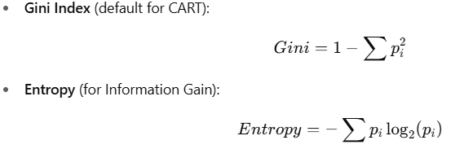

Advantages:
- Easy to interpret and visualize.
- Handles both numerical and categorical data.
- Non-linear decision boundaries.

5. Software/Hardware Requirements
- Python 3.x
- Jupyter Notebook / Google Colab
- Libraries: pandas, numpy, scikit-learn, matplotlib, seaborn

6. Procedure

Step 1: Import libraries
import pandas as pd
from sklearn.model_selection import train_test_split
from sklearn.tree import DecisionTreeClassifier, plot_tree
from sklearn.metrics import accuracy_score, confusion_matrix
import matplotlib.pyplot as plt

Step 2: Load the dataset
df = pd.read_csv('Iris.csv')
X = df[['SepalLengthCm', 'SepalWidthCm', 'PetalLengthCm', 'PetalWidthCm']]
y = df['Species']
Use the Kaggle Iris Species dataset.

Dataset reference
Kaggle: Iris Species
https://www.kaggle.com/uciml/iris/data

Step 3: Train the Decision Tree
X_train, X_test, y_train, y_test = train_test_split(
X, y, test_size=0.2, random_state=42)
tree = DecisionTreeClassifier(criterion='gini', max_depth=3, random_state=42)
tree.fit(X_train, y_train)
y_pred = tree.predict(X_test)
entropy_tree = DecisionTreeClassifier(criterion='entropy', max_depth=3, random_state=42)
entropy_tree.fit(X_train, y_train)
print('Gini accuracy:', accuracy_score(y_test, y_pred))
print('Entropy accuracy:', accuracy_score(y_test, entropy_tree.predict(X_test)))
print('Confusion Matrix:\n', confusion_matrix(y_test, y_pred))
The tree uses Gini Index to decide the best split at each node.

Step 4: Visualize the tree
plt.figure(figsize=(10, 6))
plot_tree(tree, feature_names=X.columns,
class_names=tree.classes_, filled=True)
plt.show()
The plot makes the decision rules easy to see.

7. Output
- Confusion matrix and classification report.
- Accuracy score for Gini and Entropy-based models.
- Decision Tree visualization (graph structure).

8. Result
Successfully implemented Decision Tree (CART) algorithm using Gini Index and Entropy, evaluated model performance, and visualized the tree structure.

9. Conclusion
Decision Tree (CART) is a simple yet powerful classification algorithm. It uses Gini or Entropy to split data and can handle non-linear relationships. Pruning and depth control are essential to prevent overfitting and improve generalization.
CO Achieved: CO4
- Build Decision Trees using Gini Index or Entropy for classification tasks.

POs Achieved
- PO1: Use algorithms and heuristics for classification problems.
- PO2: Analyze tree structure for interpretability and performance.
- PO3: Design solutions using tree-based models.
- PO4: Validate models with datasets using metrics.
- PO5: Apply tools for tree visualization and pruning.

PSO Achieved
- PSO1: Implement tree-based models for AI/ML solutions.
- PSO2: Use CART for scalable and interpretable analytics solutions.

Experiment No.10

Case Study on Deep Learning: Comprehensive Analysis and Implementation

Theory:

Building upon the previous practicals on Data Handling, Feature Selection, and Support Vector Machines, this case study demonstrates how Deep Learning revolutionizes complex pattern recognition and predictive modeling across diverse domains. Deep learning represents the pinnacle of machine learning sophistication, using multi-layered neural networks to automatically discover intricate patterns in data.

Understanding Deep Learning Fundamentals

What is Deep Learning?
Deep Learning is a subset of machine learning that uses artificial neural networks with multiple hidden layers (typically 3 or more) to model and understand complex patterns in data. Unlike traditional machine learning approaches that require manual feature engineering, deep learning algorithms automatically learn hierarchical representations of data through multiple levels of abstraction.

Key Characteristics
- Automatic Feature Learning: Eliminates the need for manual feature engineering
- Hierarchical Representation: Learns features at multiple levels of abstraction
- End-to-End Learning: Optimizes the entire pipeline from raw input to final output
- Scalability: Performance improves with increasing data and computational resources

Required Libraries and Setup
import pandas as pd
import matplotlib.pyplot as plt
from sklearn.model_selection import train_test_split
from sklearn.preprocessing import StandardScaler
from sklearn.metrics import classification_report, confusion_matrix
from tensorflow.keras import Sequential
from tensorflow.keras.layers import Dense
Only the libraries needed for this small deep learning experiment are imported.

Case Study 1: Healthcare - Medical Image Analysis for Cancer Detection

Problem Statement
Develop a deep learning system for automated detection of breast cancer from mammography images, improving diagnostic accuracy and reducing radiologist workload.

Dataset and Preprocessing
Dataset reference: Kaggle - Breast Cancer Wisconsin (Diagnostic) Data Set
https://www.kaggle.com/uciml/breast-cancer-wisconsin-data
df = pd.read_csv('data.csv')
X = df.drop(columns=['id', 'diagnosis', 'Unnamed: 32'])
y = (df['diagnosis'] == 'M').astype(int)
X_train, X_test, y_train, y_test = train_test_split(
X, y, test_size=0.2, random_state=42, stratify=y)
scaler = StandardScaler()
X_train = scaler.fit_transform(X_train)
X_test = scaler.transform(X_test)
For the lab, the tabular Kaggle breast cancer dataset is used. The features are measured from digitized breast-mass images, so no artificial image reshaping is needed.

Deep Learning Model Architecture
model = Sequential([
Dense(16, activation='relu', input_shape=(X_train.shape[1],)),
Dense(8, activation='relu'),
Dense(1, activation='sigmoid')
])
model.compile(optimizer='adam',
loss='binary_crossentropy',
metrics=['accuracy'])
history = model.fit(
X_train, y_train,
epochs=20, batch_size=16,
validation_split=0.2, verbose=0)
This small network has two hidden layers. ReLU is used in the hidden layers and sigmoid is used for binary output.

Model Evaluation and Results
test_loss, test_accuracy = model.evaluate(X_test, y_test, verbose=0)
y_pred = (model.predict(X_test, verbose=0) > 0.5).astype(int)
print('Test Accuracy:', round(test_accuracy, 3))
print('Test Loss:', round(test_loss, 3))
print(classification_report(y_test, y_pred))
cm = confusion_matrix(y_test, y_pred)
plt.imshow(cm)
plt.title('Confusion Matrix')
plt.xlabel('Predicted')
plt.ylabel('Actual')
plt.colorbar()
plt.show()
The test accuracy, loss and confusion matrix show how the trained network performs on unseen data.

Conclusion
This comprehensive case study on deep learning in healthcare has demonstrated the revolutionary potential of neural networks for medical applications, specifically focusing on automated cancer detection from medical imaging data. The implementation showcased how deep learning can augment and potentially transform traditional diagnostic approaches, offering unprecedented accuracy and efficiency in critical healthcare scenarios.

CO Achieved: CO6
- Illustrate deep learning principles and semi-supervised/reinforcement learning concepts using case studies.

POs Achieved
- PO1: Apply foundational knowledge for deep learning architectures.
- PO2: Analyze large datasets and feature learning in DL.
- PO4: Conduct investigations into deep learning models (CNN/RNN).
- PO6 (Engineer and World): Analyze societal and ethical impact of DL solutions.
- PO8 (Teamwork): Collaborate on case study analysis.
- PO11: Develop life-long learning through emerging DL frameworks.

PSO Achieved
- PSO1: Apply DL to AI/ML domains for innovative solutions.
- PSO2: Integrate DL with cloud/data analytics platforms.

