A*STAR IME PORTFOLIO PROTOTYPE

LithoTwin
  - Conditional neural surrogate for computational lithography and resist-contour prediction

HARSH SAAND
Technical report | 6 August 2026 | Locally measured on Apple M3 Pro CPU
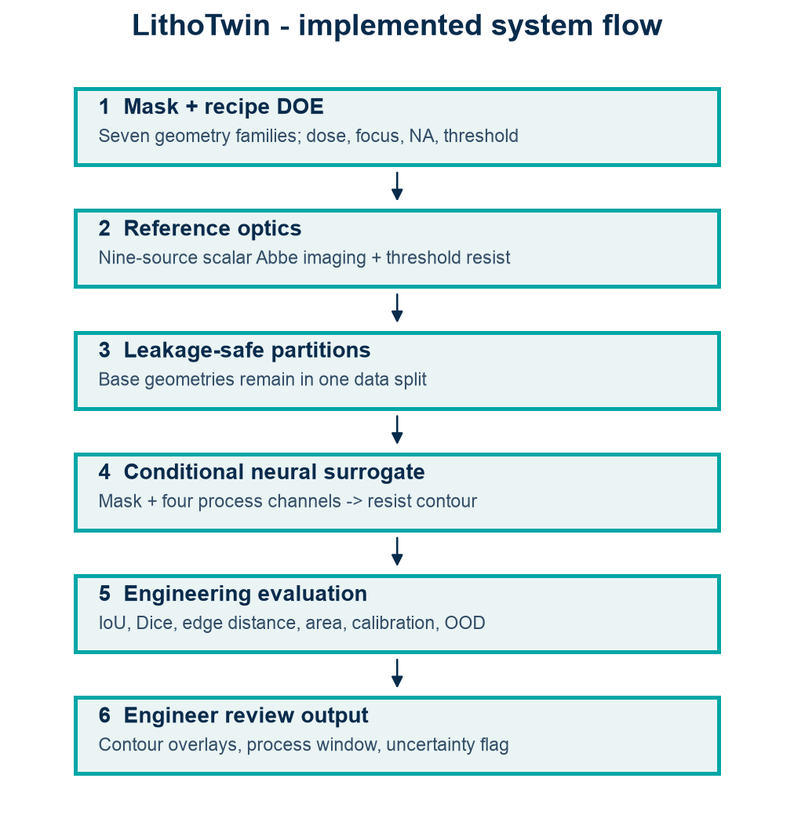
Implemented mask-to-contour workflow.
Evidence boundary All quantitative results measure fidelity to the declared nine-source scalar optics and threshold-resist simulator. This is not production lithography, OPC, resist chemistry, or fab validation.

Executive summary
LithoTwin implements a complete AI-for-process-modeling workflow: procedural semiconductor mask geometries, nine-source scalar Abbe imaging, dose/focus/NA/threshold variation, geometry-grouped partitioning, a Gaussian imaging baseline, a conditional U-Net contour surrogate, engineering metrics, uncertainty stress tests, and an interactive process-window workbench. On 252 held-out cases from unseen base geometries, the U-Net achieved mean IoU 0.902, Dice 0.928, and symmetric edge distance 1.66 pixels.
Measured contribution The neural model improved held-out IoU from 0.731 to 0.902 and Dice from 0.823 to 0.928. Separate process-range and unseen-contact-family OOD tests failed sharply, establishing a clear need to defer outside the validated domain.

Computational lithography problem
Lithography transfers a mask layout through an optical system and resist process into a printed contour. Small changes in dose, focus, numerical aperture, pitch, and threshold can change critical dimensions, merge neighbouring features, shorten line ends, or eliminate contacts. A conditional surrogate must therefore predict spatial contours while preserving process sensitivity and declaring where its training domain ends.
Figure 1. Implemented LithoTwin system flow.

Reduced-order lithography physics

Mask families
The deterministic generator creates 48 x 48 binary clips representing isolated lines, line ends, spaces, elbows, dense line arrays, two-line gaps, and circular contacts. Each base geometry receives multiple process conditions. Complete base IDs remain in a single partition, preventing near-identical recipe variants of one mask from leaking across train and test.

Nine-source scalar Abbe approximation
For each source position, the mask spectrum is filtered by a shifted circular pupil. A quadratic phase term represents defocus. Source intensities are averaged, multiplied by relative exposure dose, and thresholded into a binary developed-resist region. The model is more process-aware than ordinary image blur, while remaining lightweight and auditable.
Stage | Inputs | Output | Declared simplification
Mask rasterization | Family, width, pitch, location | Binary transmission mask | Procedural Manhattan clips
Optical imaging | Mask, NA, source positions, defocus, dose | Aerial intensity | Scalar model; nine source points
Resist development | Aerial image, threshold | Binary resist contour | No chemical diffusion or kinetics

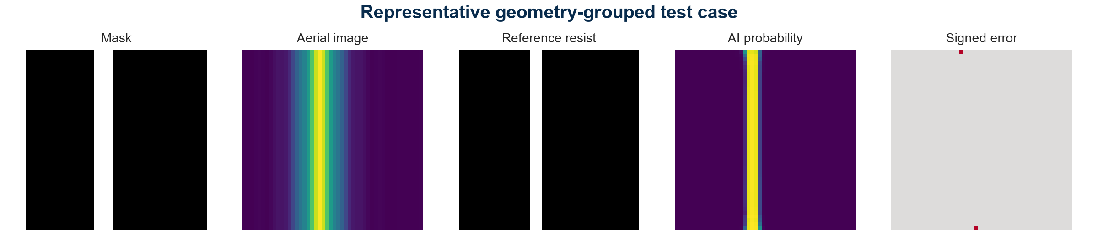
Figure 2. Representative geometry-grouped test case from mask to signed contour error.

Dataset and leakage-safe evaluation
The seed-42 dataset contains 3,360 simulated mask/process cases. The primary process domain uses relative dose 0.78-1.22, defocus -1.15 to 1.15, NA 0.58-0.72, and threshold 0.25-0.48. Every tenth base geometry is held out for test and the next for validation. One extreme condition per non-contact base forms the process OOD set. The entire contact family is excluded from training and reserved as geometry OOD.
Partition | Cases | Purpose
Train | 2,016 | Fit conditional contour model
Validation | 252 | Checkpoint selection
Held-out test | 252 | Unseen base geometries in primary process domain
Process OOD | 360 | Extreme dose and defocus
Geometry OOD | 480 | Entire unseen contact family

Metrics
Metric | Engineering meaning
IoU / Dice | Overlap of predicted and simulated developed resist
Symmetric edge distance | Average bidirectional contour displacement in pixels
Area error | Relative printed-area discrepancy; unstable for near-empty references
Brier score | Pixel-level probability error
Uncertainty-error correlation | Whether MC-dropout disagreement rises with contour error
Latency | Measured batched neural and reference-simulator CPU time

Area percentage error becomes extremely large when the reference has only a few printed pixels. It is retained for transparency but is not treated as the primary metric; IoU, Dice, and edge distance are more stable for this dataset.

AI methodology

Gaussian baseline
The baseline applies a defocus-dependent Gaussian blur, multiplies by dose, and thresholds the result. It provides a meaningful low-cost approximation that lacks the shifted-pupil interference structure of the reference simulator.

Conditional U-Net
The neural model receives five 48 x 48 channels: binary mask, relative dose, defocus, numerical aperture, and resist threshold. A compact encoder-decoder with skip connections predicts a continuous resist probability field. Training minimizes binary cross-entropy plus Dice loss with AdamW for 12 epochs; the lowest validation loss checkpoint is retained. Fixed seed 42 and CPU execution support reproducibility.
Component | Implementation | Purpose
Input | Mask + four broadcast process channels | Condition spatial prediction on recipe
Encoder | Two convolution blocks with max pooling | Capture local and multi-scale geometry
Bottleneck | 64-channel block with spatial dropout | Regularized latent representation
Decoder | Bilinear upsampling and skip connections | Recover contour localization
Output | One-channel logits | Resist probability at every pixel

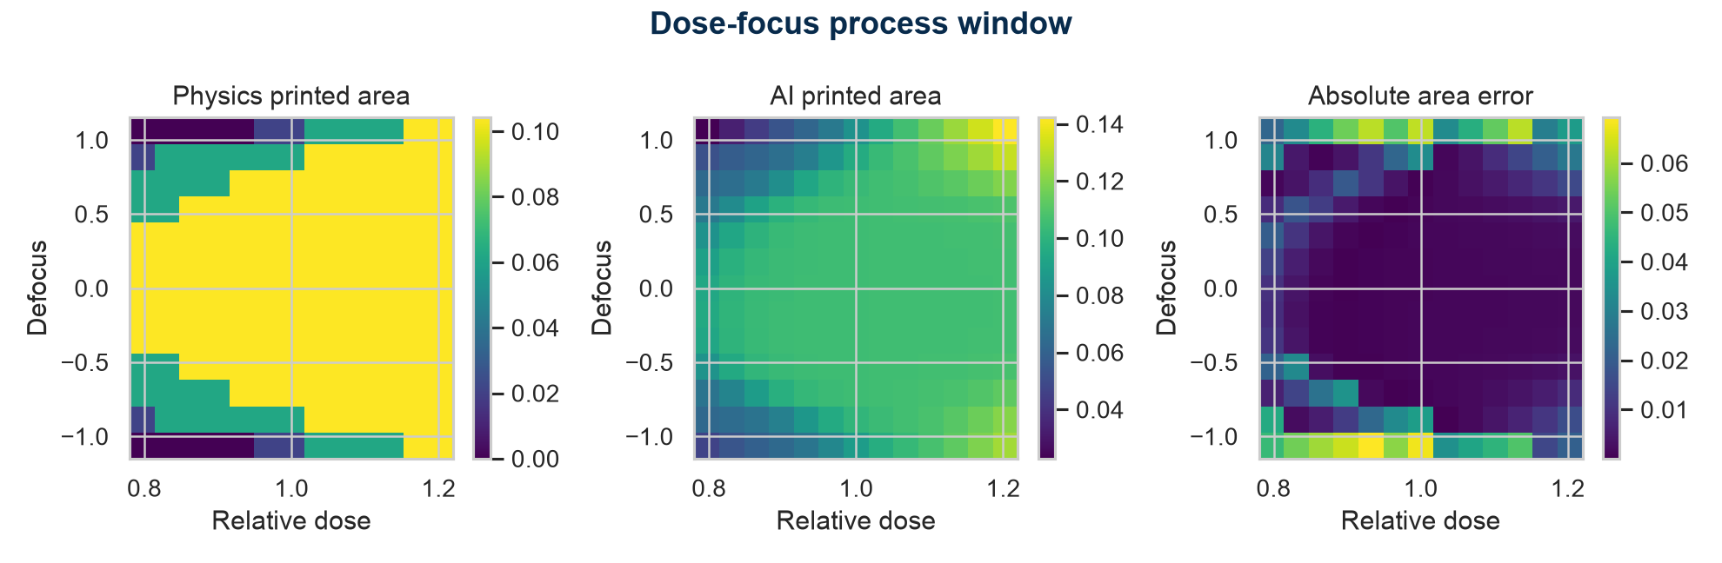
Figure 3. Physics and neural dose-focus process windows for a held-out geometry.

Locally measured results
Metric | Gaussian baseline | Conditional U-Net
Mean IoU | 0.731 | 0.902
Mean Dice | 0.823 | 0.928
Edge distance | 2.27 px | 1.66 px
Pixel Brier score | Not probabilistic | 0.0144
Uncertainty-error correlation | Not available | 0.272

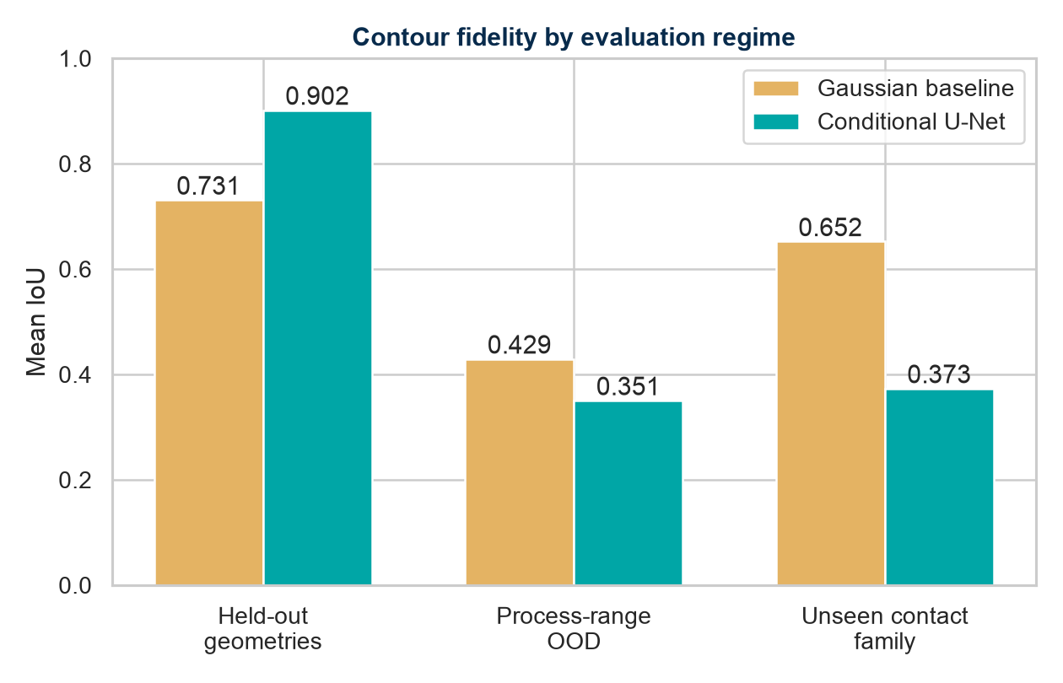
Figure 4. Mean contour IoU across interpolation and OOD regimes.
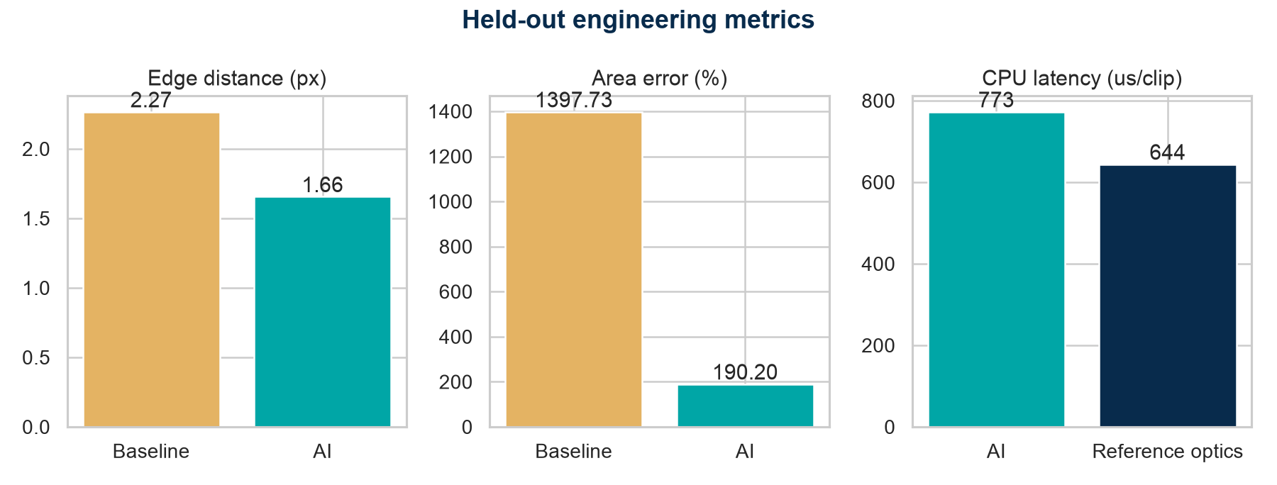
Figure 5. Held-out contour errors and measured CPU latency.
The U-Net substantially improves contour overlap in the validated regime. Batched neural inference measured 773 us per clip, while the already-lightweight reference simulator measured 644 us per clip. The neural model is therefore not faster in this implementation, and no acceleration claim is made. The value demonstrated is conditional contour learning, process-window fidelity, and explicit domain testing.

OOD and uncertainty findings
Evaluation regime | Cases | AI IoU | Baseline IoU | AI edge distance
Held-out primary domain | 252 | 0.902 | 0.731 | 1.66 px
Extreme process conditions | 360 | 0.351 | 0.429 | 18.85 px
Unseen contact family | 480 | 0.373 | 0.652 | 5.91 px

Process-range OOD IoU falls to 0.351; unseen-contact IoU falls to 0.373. The Gaussian baseline is stronger than the U-Net on unseen contacts, showing that generic optical smoothing can generalize better than learned morphology in this regime. MC-dropout uncertainty correlates with error at 0.545 for unseen contacts but only -0.270 for process OOD, so it is not a reliable universal detector.
Operational interpretation Inputs outside the dose/focus range or from an unseen geometry family must be routed to the reference simulator. The Streamlit interface displays this warning directly.

Engineer-facing interpretation
Contour overlays localize edge movement and missing or extra resist. Dose-focus maps show whether the learned response follows the reference process window. Signed error panels distinguish over-print from under-print. The held-out and OOD tables quantify applicability instead of relying on visually attractive examples alone.

Limitations and validity threats
Limitation | Impact on interpretation
Physics-generated evidence | Validates surrogate methodology, not fab accuracy
Scalar nine-source optics | Omits vector polarization, calibrated aberrations, flare, and dense source integration
Threshold resist | Omits diffusion, chemical amplification, stochastic effects, and development kinetics
Procedural 48 x 48 masks | Underrepresent real GDS complexity and long-range context
Pixel grid | Limits subpixel critical-dimension and contour accuracy
MC-dropout uncertainty | Does not reliably detect every process-range shift
CPU implementation | Reference simulator is faster than this neural model
Single seed/checkpoint | No multi-seed confidence interval is claimed

Conclusion
LithoTwin demonstrates a complete and candid AI-for-computational-lithography prototype. On geometry-grouped held-out data, the conditional U-Net reaches IoU 0.902 and Dice 0.928, materially outperforming the Gaussian baseline. Its process-window visualization and contour overlays are technically interpretable. The severe OOD degradation, incomplete uncertainty detection, and lack of CPU speedup are reported as findings rather than hidden.
The resulting portfolio evidence spans optical simulation, structured semiconductor geometry generation, leakage-safe spatial learning, contour metrics, probability calibration, OOD analysis, interactive engineering visualization, testing, and reproducible reporting. Commercial or fab use would require calibrated optics, realistic resist physics, real layout clips, multi-seed validation, and measured wafer data; none is claimed here.

References and model provenance
Reference | Use
J. W. Goodman, Introduction to Fourier Optics, 3rd ed. | Scalar Fourier imaging foundations
A. K. Wong, Resolution Enhancement Techniques in Optical Lithography | Lithography process-window and imaging context
C. A. Mack, Fundamental Principles of Optical Lithography | Optical and resist modeling context
Repository source files | Exact simulator equations, seed, data splits, checkpoint, and metrics

