A
Project Report On
Carrier Go
Developed At
L. J. Institute of Computer Application
As partial fulfillment
Of
M.C.A. (Sem-III)
Academic Year: 2024-2025



Under The Guidance Of
Prof. Dhaval shah

Developed By
Miss Surbhi Ramani (23004401110239 (C-29))
Mr. Harsh Hirani (23004401110090 (C-11))
Mr. Harsh Saliya (23004401110265 (C-32))

Submitted To
Lj university,Ahmedabad

LJ university
school of computer science
Dept. Master of computer application
Near Sarkhej Cross Roads,
Ahmedabad - 382210, Gujarat, India.
Website: www.ljku.edu.in

DIV: C ROLL NO: 11 ENROLLMENT NO: 23004401110090 This is to certify that Mr./Ms. Harsh HareshbhaiHirani studying in Master of Computer Applications (MCA), Semester III, has satisfactorily completed his/her Software Project Titled CARRIER GO (job portal)

Prof.Dhaval Shah
(Internal Guide)

Dr. Bhavin Shah,
HOD

LJ University
school of computer science
Dept. Master of computer application
Near Sarkhej Cross Roads,
Ahmedabad - 382210, Gujarat, India. Shah, HOD


DIV: C ROLL NO: 11 ENROLLMENT NO: 23004401110265 This is to certify that Mr./Ms. Harsh Sureshbhai Saliya studying in Master of Computer Applications (MCA), Semester III, has satisfactorily completed his/her Software Project Titled CARRIER GO(job portal)

Prof.Dhaval Shah
(Internal Guide)

Dr. Bhavin Shah,
HOD

LJ university
school of computer science
Dept. Master of computer application
Near Sarkhej Cross Roads,
Ahmedabad - 382210, Gujarat, India. Shah, HOD


DIV: C ROLL NO: 11 ENROLLMENT NO: 23004401110239 This is to certify that Mr./Ms. Surbhi Ashokbhai Ramani studying in Master of Computer Applications (MCA), Semester III, has satisfactorily completed his/her Software Project Titled CARRIER GO (job portal)

Prof.Dhaval Shah
(Internal Guide)

Dr. Bhavin Shah,
HOD

Acknowledgement

I would like to pay my praise and humblest thanks to God, the most merciful and beneficent of me, who bestowed me with the ability to complete this project.

I am highly indebted to Prof. Dhaval shah sir for their guidance and constant supervision as well as for providing necessary information regarding the project & also for their support in completing the project. I am extremely thankful to her for providing such a nice support and guidance, although she had a busy schedule managing the corporate affairs.

I would like to express my gratitude towards my parents & member of LJ Computer of Applications for their kind co-operation and encouragement which help me in completion of this project.

I am thankful to and fortunate enough to get constant encouragement, support and guidance from all Teaching staffs of MCA which helped us in successfully completing our project work.

Index:

Nos. | Topics | Page No.
1 | Existing System | 8
2 | Need for the New System | 9
3 | Objective of the New System | 10
4 | Problem Definition | 11
5 | Core Components | 12
6 | Project Profile | 14
7 | Assumptions and Constraints | 15
8 | Advantages and Limitations of the Proposed System | 24
9 | Requirement Determination | 29
10 | Requirement Specification | 32
11 | Targeted User | 36
12 | Use Case Diagram | 38
13 | Data dictionary | 41
14 | Coding standards | 57
15 | Screen shots | 67
16 | Agile Project charter | 75
17 | Agile Road map/schedule | 77
18 | Agile Project Plan | 79
19 | Agile User Story | 80
20 | Agile release plan | 81
21 | Agile sprint backlog | 83
22 | Agile Test plan | 84
23 | Earned value and burn chart | 86
24 | Proposed enhancement | 87
25 | Conclusion | 88
26 | Bibiliography | 89

- Online Job Portal System Overview

In today's digital age, an Online Job Portal System serves as a crucial bridge between job seekers and employers. This innovative platform operates under the principal objective of streamlining the hiring process while ensuring a secure and transparent experience for all users involved. By harnessing contemporary technology, the job portal aims to alleviate some of the most pressing issues in the recruitment landscape. The design of this portal focuses primarily on catering to the needs of fresher and new job seekers, thereby making it particularly beneficial for those entering the job market for the first time. This focus not only empowers fresh talent but also actively contributes to a more vibrant workforce.

1. Existing System
The job portal system consists of two main user roles: Job seekers and Employers. Job seekers can register or log in securely, upload and manage their resumes, apply for jobs, and track their application status. Additionally, they can use the ATS (Applicant Tracking System) to check their resume compatibility with job listings. Employers, on the other hand, can register and log in securely, post job listings, manage job postings by editing or deleting them, and review job applications to shortlist candidates.
The system provides a comprehensive job posting mechanism where employers can create job postings with details such as title, description, salary range, location, and requirements. These job postings are displayed on a dedicated page, allowing employers to review and edit them when necessary. Job seekers can browse and apply for jobs while employers can efficiently manage applications and filter candidates.
A significant feature of the system is the Resume Upload and ATS System. Job seekers can upload resumes in various formats, including PDF and DOCX. The ATS system then analyzes these resumes to assess their compatibility with job descriptions, providing feedback and suggestions to optimize resumes for specific job postings. Employers also benefit from a review system where they can manage applications, while job seekers can track the status of their applications in real time.
The user interface is designed for ease of use. The Job seekers Portal includes a dashboard that displays recommended jobs, saved jobs, and application statuses, along with a resume upload and ATS analysis feature. The Employers Portal includes a dashboard that provides an overview of active job postings and received applications, along with tools for job posting management and candidate review.

2.Need for the New System
Given the limitations of traditional job portals, a new online job portal system is essential to modernize job searching and recruitment. The growing need for a more efficient, reliable, and feature-rich platform necessitates the implementation of real-time job matching, enhanced employer tools, and seamless application management.

Key Needs:
- Seamless User Login: A secure and intuitive authentication system that allows both job seekers and employers to register and log in easily.

- Comprehensive Job Posting System: Employers should have a dedicated job posting page where they can efficiently create, manage, and review job listings.

- Job Posting Review Page: Employers can review posted jobs for accuracy and make necessary modifications, ensuring up-to-date job listings.

- Resume Upload and ATS System: Job seekers should be able to upload resumes in multiple formats. The ATS system will analyze resumes to assess their compatibility with job postings and provide suggestions for optimization.

- Efficient Job Application Management: Employers should have tools to track applications, filter candidates, and manage communication with job seekers.

By implementing these enhancements, the new system will significantly improve job search efficiency, provide better recruitment tools, and create a seamless experience for both job seekers and employers.

3.Objective of the New System
The primary goal of the Online Job Portal System is to create an advanced and efficient platform that simplifies the hiring process for both job seekers and employers. This objective is realized through several key features:

Main Objectives:
- Secure Job seeker and Employer Login: A streamlined authentication process that ensures secure access for users.

- Advanced Job Posting System: Employers can efficiently create, manage, and review job postings through a dedicated interface.

- Job Posting Review Feature: Employers can review, edit, and update job listings to maintain accurate and relevant job descriptions.

- Resume Upload and ATS Integration: Job seekers can upload their resumes, which are then analyzed by the ATS system to assess compatibility with job postings and provide optimization suggestions.

- Comprehensive Job Application Management: Employers can track applications, filter candidates, and manage recruitment efficiently.

- Support for Various Job Types: The platform accommodates full-time, part-time, freelance, and remote job opportunities, catering to a diverse range of users.

This system aims to establish a dynamic and efficient job marketplace that enhances the overall job search and recruitment experience. By integrating these advanced features, the platform will ensure reliability, security, and user satisfaction for both job seekers and employers.

4.Problem Definition

Challenges for Job Seekers:
- Information Overload: Difficulty in finding relevant job opportunities due to unstructured job listings.

- Scams and Fraudulent Listings: Risk of falling victim to fake job postings

- Lack of Personalized Job Recommendations: Current systems provide generic job lists without considering the candidate’s specific skill set.

- Slow Response Times: Delayed communication with employers leads to missed opportunities.

Challenges for Employers:
- High Volume of Unqualified Applications: Employers receive numerous irrelevant applications, making it difficult to find suitable candidates.

- Poor Applicant Tracking: Lack of a structured system to manage applications effectively.

- Limited Outreach: Inability to attract a diverse talent pool due to inefficient job posting mechanisms.

- Time-Consuming Hiring Process: Lengthy recruitment cycles due to ineffective candidate screening tools.
The proposed system will address these issues by integrating advanced technologies and optimizing workflow efficiency.

5.Core Components of the Online Job Portal
The online job portal is designed with essential components to facilitate the hiring process for both job seekers and employers, covering job postings, resume uploads, and applicant tracking.

1. User Authentication and Access Control
- Secure login and registration for job seekers and employers.

- Role-based access control to manage user permissions.

2. Employer Job Posting System
- Dedicated job posting page for employers to create, update, and manage job listings.

- Predefined job templates for quick job postings.

- Meta tags and keyword optimization for better job visibility.

3. Job Posting Review Page
- Employers can edit, review, and delete job postings.

- Automated verification to ensure accurate and complete job details.

- Employers can track job posting performance and engagement.

4. Jobseekers Resume Upload & ATS System
- Jobseekers can upload resumes in multiple formats (PDF, DOCX, etc.).

- ATS system scans resumes for compatibility with job postings.

- Resume analysis and optimization suggestions for better job matching.

5. Job Search and Application System
- Job seekers can search jobs using filters like location, salary, job type, and experience.

- Option to save job searches and receive notifications for new job openings.

- Easy one-click application submission with tracking features.

6. Applicant Tracking System (ATS) for Employers
- Employers can filter, sort, and shortlist applications based on job requirements.

- AI-driven candidate matching based on job descriptions and resume data.

- Real-time tracking of applicant status (applied, shortlisted, hired, etc.).

7. Reporting and Insights
- Employers can generate reports on job postings, applicant performance, and hiring trends.
- Job seekers receive feedback on resume effectiveness and application success rates.
By incorporating these core components, the new system ensures a streamlined, efficient, and transparent recruitment process that benefits both job seekers and employers.

6.Project Profile
The Online Job Portal System is a web-based solution designed using modern technologies for scalability and performance.

Technology Stack:
- Frontend: HTML, CSS, JavaScript, Bootstrap

- Backend: Django , python

- Database: SQLite
The project follows agile development methodologies, allowing for continuous iteration and improvements.

7.Assumptions and Constraints

1. Job Seekers and Employers Login

Assumptions:
- User-Related:
- Users are familiar with web applications and login processes.
- Multi-factor authentication (MFA) ensures secure and smooth login.
- Administrative:
- Admins monitor account creation to prevent fake profiles.
- Employer accounts will undergo verification for legitimacy.
- System-Related:
- Integration with social authentication options (Google, LinkedIn, etc.).
- Platform designed to handle high traffic during peak hiring seasons.

Constraints:

Technical:
- Support for multiple authentication mechanisms without delays.
- The system must scale for a large number of concurrent users.
- Legal & Policy:
- Compliance with data security regulations (e.g., GDPR, CCPA).

- Users must have the ability to request account deletion.

- Operational:
- Regular monitoring of login attempts for security breaches.
- Cross-platform compatibility (desktop, mobile, tablet).

2. Employers Job Posting

Assumptions:
- User-Related:
  - Employers need an intuitive system with templates for job postings.
  - Job seekers expect clear and detailed listings.
- Administrative:
  - Admins monitor job postings to prevent fraudulent listings.
  - AI-driven recommendations assist employers with job descriptions.
- System-Related:
  - Advanced filtering for job types, locations, and experience.
  - Employers will receive market-driven job posting suggestions.

Constraints:-
- Technical:
  - Support for bulk uploads while maintaining performance.
  - AI recommendations may impact processing speed.

- Legal & Policy:
  - Employers must adhere to equal employment opportunity (EEO) guidelines.
  - Job postings must be free of discriminatory language.

- Operational:
  - Allow employers to edit, delete, or archive postings.
  - Fraud detection to prevent scams and fake job offers.

3. Manage Job Posting Page for Employers

Assumptions:

- User-Related:
  - Employers need an intuitive dashboard for efficient job listing management.
  - Real-time synchronization is required for frequent updates.
- Administrative:
  - Admins provide support for job posting troubleshooting.
  - Automated expiration reminders for outdated listings.

- System-Related:
  - Analytics to track job listing performance (views, applicants).
  - Employers can modify or duplicate existing job postings.

Constraints:

- Technical:
  - Efficient handling of frequent edits and updates.
  - Scalability to maintain performance as listings grow.
- Legal & Policy:
  - Compliance with platform guidelines for fair job postings.
  - Job posting data must be securely stored and removable on request.
- Operational:
  - Bulk job posting management should be simple for employers.
  - Regular monitoring to detect expired or outdated listings.

4. Review Job Posting Page for Job Seekers

Assumptions:

- User-Related:
  - Job seekers use AI-driven recommendations and search filters for relevant jobs.
  - The page should be easy to navigate with clear details and application options.
- Administrative:
  - Admins verify the accuracy and quality of job postings.
  - Alerts notify job seekers of new relevant listings.

- System-Related:
  - Sorting and filtering options based on relevance, date, and location.
  - Job seekers can save jobs to revisit later.

Constraints:
- Technical:
  - Search algorithm must handle high query volumes efficiently.
  - Real-time updates for new job postings.
- Legal & Policy:
  - Job listings must comply with accuracy laws.
  - Job seeker personal data must be protected under privacy laws.
- Operational:
  - Minimal system downtime for constant job listing accessibility.
  - Employers cannot unfairly manipulate job posting rankings.

5. Job Seekers Resume Upload

Assumptions:
- User-Related:
  - Job seekers upload resumes in common formats (PDF, DOCX, etc.).
  - Easy resume updating and replacement functionality.

- Administrative:
  - Admins do not access personal resume data without consent.
  - Employers can only view resumes of applicants who apply to their jobs.
- System-Related:
  - Secure, encrypted file uploads for resumes.
  - AI tools provide resume optimization suggestions.

Constraints:
- Technical:
  - Efficient handling of large file uploads without performance issues.
  - Accurate resume parsing for skills and experience matching.
- Legal & Policy:
  - Resumes must be stored securely and be deletable on request.
  - Compliance with privacy regulations such as GDPR.
- Operational:
  - Notify job seekers of incompatible resume formats.
  - Employers should only have access to resumes of applicants with permission.

6. ATS System for Job Seekers and Employers to Check Resumes

Assumptions:
- User-Related:
  - Employers use ATS to filter and rank candidates.
  - Job seekers benefit from automated resume feedback to improve job matching.
- Administrative:
  - Admins may assist with troubleshooting ATS-related issues.
- System-Related:
  - ATS analyzes resumes based on job relevance, skills, and experience.
  - AI-driven resume ranking for improved efficiency.

Constraints:
- Technical:
  - ATS must handle large volumes of resumes without performance issues.
  - Integration with third-party ATS solutions may require extra development.

- Legal & Policy:
  - Compliance with privacy regulations regarding candidate data.
  - ATS filters should not be discriminatory.
- Operational:
  - Employers can customize ATS filters for job-specific needs.
  - Job seekers can opt out of automated resume scoring.

8.Advantages of the Proposed System

1 User Interface
- The system features a modern and intuitive user interface (UI) that ensures easy navigation.

- Responsive design ensures compatibility with various devices, including desktops, tablets, and mobile phones.

- A clean and well-structured layout improves user experience and reduces complexity.

2 Employer and Job Seeker Login & Registration
- Secure login and registration system with email verification for authenticity.

- Employers and job seekers have separate dashboards tailored to their needs.

- Quick sign-up process to facilitate immediate access to job-related features.

3 Employer Job Posting Page
- Employers can easily create and manage job postings with a user-friendly form.

- Options to include job descriptions, required qualifications, salary range, and location.

- Job postings can be edited or removed as per employer needs.

4 Job Posting Page Review
- A dedicated section for job seekers to review job postings before applying.
- Advanced filtering and sorting options to help users find relevant jobs.

- Users can save jobs for later reference or apply directly from the page.

5 Resume Management
- Job seekers can upload and update their resumes in various formats (PDF, DOCX, etc.).

- Employers can access and download resumes of applicants.

- Resume parsing feature to extract key details and improve job matching.

6 ATS System for Job Seekers and Employers
- Automated Tracking System (ATS) to streamline the recruitment process.

- Employers can filter and shortlist candidates based on predefined criteria.

- Job seekers receive real-time updates on their application status.
- AI-based resume screening to improve the hiring process and match candidates effectively.

- Limitations of the Proposed System:-

1. Information Overload for Job Seekers
- Volume of Job Postings: With the availability of thousands of job listings, job seekers may feel overwhelmed by the sheer number of opportunities presented to them.

- Ineffective Filtering: Without well-tuned filtering tools, users might miss out on job opportunities that align with their skills and preferences. Poorly implemented filters can lead to unfocused searches, reducing the quality of job matches

- Job Search Fatigue: The large volume of options can result in job search fatigue, where job seekers become frustrated by the continuous application process or fail to review all available positions thoroughly.

- Solution: Implementing advanced AI algorithms for personalized job recommendations, smart filtering, and automatic relevance ranking can help alleviate this issue by highlighting the most suitable jobs for the individual based on their preferences and past behavior.

2. Quality of Applications
- High Volume of Inappropriate Applications: One significant challenge of online job portals is the ease of application submission. The convenience of applying with a single click may lead to a flood of applications that do not meet job requirements.

- Mismatched Candidates: Since there are fewer barriers to applying, employers may receive a large number of resumes that do not fit the job criteria, creating additional workload for recruiters to sort through irrelevant applications.

- Solution: To mitigate this, the system could implement screening questions, skills assessments, or AI-powered resume analysis to pre-teen applicants and ensure they meet basic qualifications before applying. This would help narrow down the pool to candidates who are more likely to be a good fit for the role.

3. Potential for Fake or Misleading Job Listings
- False Job Postings: Despite implementing verification systems and moderation processes, there is still a risk that some fake or misleading job postings could slip through. This may occur when fraudulent employers or scammers create job listings that are either irrelevant or entirely fictional.

- Credibility Damage: If users frequently encounter fake job listings or deceptive companies, it can severely damage the credibility and trustworthiness of the platform, causing both job seekers and employers to leave.

- Solution: To combat this, the system should incorporate multi-layered verification processes for employers and job postings. This could include business verification (such as checking tax ID numbers or official registration), user reviews, and machine learning algorithms designed to detect suspicious or fraudulent activity. Regular audits and user reporting features should also be implemented to help identify and remove fake listings quickly.

4. Technical Challenges and System Reliability
- System Downtime: Given the technological dependence of the platform, there are concerns about the possibility of technical failures such as server downtime, glitches, or crashes that could disrupt the user experience.

- Load Handling: During peak hiring seasons or sudden traffic surges, the platform may struggle to handle high volumes of concurrent users. This could lead to slow load times, failed logins, and delayed responses.
- Bugs and Glitches: Bugs or errors in the platform's core features (e.g., job posting, application submission, and interview scheduling) could cause major disruptions and frustrate users, leading to a loss of engagement.

- Solution: To minimize these risks, the system must be built on a robust infrastructure capable of handling high traffic, such as cloud services with auto-scaling features. Regular system maintenance, thorough testing before launch, and bug tracking tools should be implemented to ensure the platform runs smoothly. Additionally, a dedicated support team should be available to address user issues promptly and resolve technical challenges as they arise.

5. Privacy and Security Concerns
- Data Protection Risks: Storing sensitive user information such as resumes, job applications, and personal details introduces significant risks regarding data breaches and identity theft.

- Misuse of Data: In some cases, data could be misused by unauthorized third parties, leading to a breach of user trust.

- Solution: Implementing end-to-end encryption, secure data storage, and GD PR-compliant data handling practices will help safeguard user privacy. Regular security audits and penetration testing should be performed to ensure the platform is secure against cyber threats. Additionally, users should be informed and given control over how their data is used and shared.

6. Integration and Compatibility Issues
- Third-Party Integration: The system may face challenges in integrating with third-party services such as job boards, background check providers, or video interview platforms. Compatibility issues may arise when integrating with existing systems or tools used by employers.

- Solution: To address this, the platform should be designed with open API structures that allow for easy integration with other services. Additionally, ensuring cross-platform compatibility and regular updates to maintain integration functionality will help keep the system adaptable and salable

9. Requirement Determination
Requirement determination is a critical phase in the development of the Online Job Portal System, focusing on understanding the needs and expectations of both job seekers and employers. This process involves engaging stakeholders, including users and associated parties, to gather and analyze requirements systematically.

Key Steps in Requirement Determination

1 Stakeholder Identification
Identifying key stakeholders ensures the system is designed to meet their needs. The primary stakeholders include:
- Job Seekers: Students, fresh graduates, experienced professionals, freelancers, and career changers.

- Employers: Startups, SMEs, large enterprises, recruitment agencies, government organizations, and contract hiring firms.

- System Administrators & Technical Teams: Responsible for maintaining and managing the platform.

2 User Interface (UI) Requirements
- The interface must be user-friendly, responsive, and accessible across all devices.

- Navigation should be intuitive, with clear menus and a structured layout.

- Dark mode and accessibility options should be included for enhanced usability.

3 Employer and Job Seeker Login & Registration
- Secure authentication using email and password, with optional multi-factor authentication (MFA).

- Quick sign-up process with the ability to auto-fill details using LinkedIn or Google.

- Separate dashboards for employers and job seekers for personalized experiences.

4 Employer Job Posting Page
- Employers should be able to post jobs easily with structured input fields for title, description, salary, and location.

- A preview option before publishing to review job details.

- Option to edit, delete, or republish job posts efficiently.

5 Job Posting Page Review
- Job seekers should have a clear, categorized, and filterable job listing.

- Bookmark/save jobs for later applications.

- Search functionality with filters like location, salary range, job type, and experience level.

6 Resume Management
- Job seekers should be able to upload and update resumes in different formats (PDF, DOCX).

- Employers should have the ability to view, download, and categorize resumes of applicants.

- AI-powered resume parsing for extracting key details and improving job matching.

7 ATS System for Job Seekers and Employers
- Automated resume screening to filter applicants based on experience, skills, and keywords.

- Applicant tracking system (ATS) for employers to manage applications and shortlisting.

- Job seekers receive real-time updates on their application status.

8 Prioritization of Requirements
The gathered requirements will be ranked based on importance and feasibility:
- Essential Features: Secure login, job posting, resume uploads, job search.

- High-Value Features: AI-powered ATS, resume parsing, profile recommendations.

- Future Enhancements: Advanced analytics, job market trends, and employer branding features.

9 Validation with Stakeholders
- Regular feedback sessions with employers and job seekers to ensure alignment with needs.

- Prototype testing to validate UI/UX efficiency before full implementation.

- Adjustments based on user feedback to enhance usability and performance.

10. Requirement Specification
Requirement specification involves documenting the identified requirements in a structured and detailed format, providing a clear and comprehensive guide for the system's development. This phase results in formal documentation that serves as a contract between stakeholders and developers.

10.1 Key Components of Requirement Specification

10.1.1 Functional Requirements

User Management System
- Registration and Login: Secure authentication for job seekers and employers with email verification.
- Profile Management:
  - Job seekers can create profiles, upload resumes, and update personal details.

  - Employers can manage company profiles, job postings, and applicant interactions.
- Dashboard for Employers and Job Seekers:
  - Employers can view posted jobs, applicant details, and hiring progress.

  - Job seekers can track applications, save jobs, and receive notifications.

Employer Job Posting and Management
- Employers can create, edit, delete, and republish job postings.

- Structured job entry fields including job title, description, location, salary, and qualifications.

- Job preview option before publishing.

- Automated email notifications to job seekers based on their preferences.

Job Posting Page Review
- Job seekers can browse and filter job postings based on location, experience, salary, and job type.

- Bookmark jobs for later review.

- Employers can track job engagement (views, applications, etc.).

Resume Management
- Job seekers can upload, update, and manage resumes in different formats (PDF, DOCX).

- Employers can view, download, and categorize resumes.

- AI-based resume parsing for efficient screening and keyword-based filtering.

Application Tracking System (ATS)
- Employers can track and filter applications, shortlist candidates, and schedule interviews.

- AI-powered resume screening based on job requirements.

- Real-time status updates for job seekers on application progress.

- Automated interview scheduling for shortlisted candidates.

10.1.2 Non-Functional Requirements

Performance
- The system should support at least 1,000 concurrent users without performance degradation.

- Job searches and profile updates should load in less than 2 seconds.

Security
- Encryption of sensitive data (passwords, resumes, employer data).

- Secure authentication with multi-factor authentication (MFA) option.

- Role-based access control to prevent unauthorized data access.

Usability
- User-friendly UI with a responsive design for desktop and mobile devices.

- Dark mode and accessibility options for improved user experience.

- Multi-language support to cater to a wider audience.

Scalability
- The system should support increasing numbers of users, job postings, and applications without requiring major modifications.

- Cloud-based storage and database optimization for high availability.

Assumptions and Constraints
- Assumptions:
  - Users have access to the internet and basic computer skills.

  - Employers will provide complete and accurate job details.

- Constraints:
  - Limited budget and development timeline.

  - Compliance with data protection laws (GDPR, IT Act, etc.).

Acceptance Criteria
- The system must be fully functional with no critical bugs.
- Automated and manual testing must ensure UI responsiveness, security, and system stability.
- Performance benchmarks (loading times, job search accuracy) must be met.

- User feedback should indicate at least 90% satisfaction with the platform's usability.

11.Targeted Base User

To maximize usability, the portal is targeted toward various user types, which include:

- Types of Employers:-

- Startups: Emerging companies that require assistance in building their teams while maximizing efficiency.

- Small and Medium Enterprises (SMEs): Organizations with moderate recruitment needs looking to streamline their hiring processes efficiently.

- Large Enterprises: Established companies frequently engaging in high-volume recruitment to fill a variety of positions.

- Recruitment Agencies: Third-party firms dedicated to sourcing candidates on behalf of employers, often managing significant numbers of listings at once.

- Government Organizations: Public sector institutions offering job opportunities to a diverse range of candidates and supporting community engagement through employment.

- Freelance/Contract Hiring Firms: Organizations seeking specialists for short-term projects that fit specific skill requirements.

- Remote-First Companies: Businesses that embrace a remote working culture, effectively recruiting talent from across geographic boundaries.

Types of Job Seekers:

- Students: Individuals searching for internships, work-study opportunities, or part-time jobs that align with their educational pursuits.

- Fresher: Recent graduates keen on landing their first full-time positions and embarking on professional careers.

- Experienced Professionals: Individuals with prior work experience who seek new career paths or advancements within their fields.

- Freelancers: Autonomous professionals looking for short-term projects that allow flexibility and independence in their work arrangements.

- Career Changers: Individuals aspiring to transition into new industries or job roles, seeking guidance and opportunities to facilitate their career shifts.

- Remote Job Seekers: Candidates interested in remote job opportunities that offer the potential for workspace flexibility in an increasingly digital world.

12.Use case Diagram:

- Job seeker Usecase Diagram:

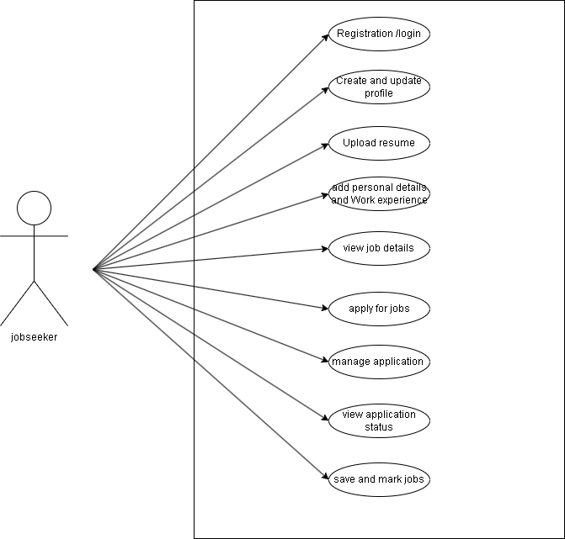

- Employeer Usecase Diagram

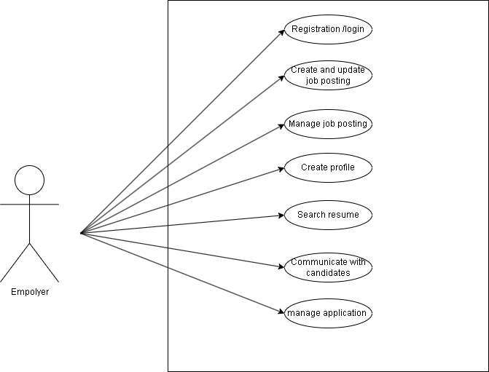

Admin Usecase Diagram:

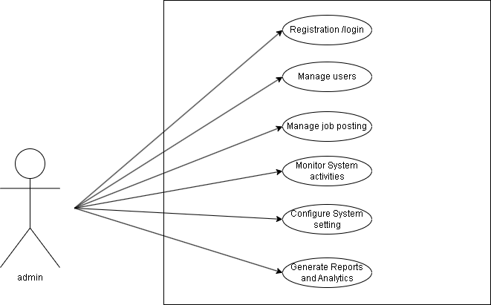

13.Data Dictonary:

User:

Column Name | Data Type | Constraint/Key | Description | Example
id | Integer | Primary Key | Unique identifier for the user | 1
username | String | Unique | User's login name | john_doe
email | Email | Unique | User's email address | john@example.com
password | String | - | Encrypted password | pbkdf2_sha256$...
is_staff | Boolean | - | Admin/staff privilege | False

🔹 Personal Info:

Column Name | Data Type | Constraint/Key | Description | Example
id | Integer | Primary Key | Auto-incremented ID | 1
user | ForeignKey (User) | Foreign Key | Link to the Django User model | 1
phone | String | Unique | User's contact number | +91-9876543210
address | Text | - | Full address of user | 123, Main Street...
dob | Date | - | Date of birth | 1999-12-31
gender | String | Choices | Gender (Male/Female/Other) | Male

🔹 Education Info

Column Name | Data Type | Constraint/Key | Description | Example
id | Integer | Primary Key | - | 1
user | ForeignKey (User) | Foreign Key | Linked user | 1
degree | String | - | Degree obtained | B.Tech
university | String | - | University name | GTU
year | Integer | - | Year of completion | 2021

🔹 JobInfo

Column Name | Data Type | Constraint/Key | Description | Example
id | Integer | Primary Key | - | 1
user | ForeignKey (User) | Foreign Key | Linked user | 1
company | String | - | Company name | TCS
role | String | - | Job title | Software Engineer
start_date | Date | - | Start date | 2022-01-01
end_date | Date | - | End date or null | 2023-12-31

🔹 Application:

Column Name | Data Type | Constraint/Key | Description | Example
id | Integer | Primary Key | - | 1
user | ForeignKey (User) | Foreign Key | Applicant | 1
job | ForeignKey (Job) | Foreign Key | Applied job | 4
applied_on | DateTime | - | Timestamp | 2025-04-11 14:30
status | String | Choices | Application status | Pending

🔹 Contact

Column Name | Data Type | Constraint/Key | Description | Example
id | Integer | Primary Key | - | 1
name | String | - | Sender’s name | Alice
email | Email | - | Sender's email | alice@mail.com
message | Text | - | Contact message | I have a question about...
sent_at | DateTime | - | Submission time | 2025-04-10 11:45

🔹 Job

Column Name | Data Type | Constraint/Key | Description | Example
id | Integer | Primary Key | - | 1
title | String | - | Job title | Backend Developer
company | String | - | Company name | TechCorp
location | String | - | Job location | Ahmedabad
posted_on | Date | - | Date posted | 2025-04-01
description | Text | - | Job description | We're hiring for...

🔹 Resume

Column Name | Data Type | Constraint/Key | Description | Example
id | Integer | Primary Key | - | 1
user | ForeignKey (User) | Foreign Key | Resume owner | 1
file | FileField | - | Resume file upload | resume_john.pdf
uploaded_on | DateTime | - | Upload time | 2025-04-10 15:00

🔹 DummyCreditCard

Column Name | Data Type | Constraint/Key | Description | Example
id | Integer | Primary Key | - | 1
user | ForeignKey (User) | Foreign Key | Linked user | 1
card_number | String | Unique | Dummy card number | 4111 1111 1111 1111
cvv | Integer | - | Dummy CVV | 123
expiry_date | String | - | Expiry date | 12/28

🔹 Plan

Column Name | Data Type | Constraint/Key | Description | Example
id | Integer | Primary Key | - | 1
name | String | Unique | Plan name | Premium
price | Decimal | - | Plan price | 499.00
duration_days | Integer | - | Duration in days | 30

🔹 Payment

Column Name | Data Type | Constraint/Key | Description | Example
id | Integer | Primary Key | - | 1
user | ForeignKey (User) | Foreign Key | Payer | 1
amount | Decimal | - | Payment amount | 499.00
payment_method | String | Choices | Payment method | Credit Card
timestamp | DateTime | - | Payment time | 2025-04-11 13:00
status | String | Choices | Payment status | Success

🔹 Blog Category

Column Name | Data Type | Constraint/Key | Description | Example
id | Integer | Primary Key | - | 1
name | String | Unique | Category name | Career Tips

🔹 Blog Post

Column Name | Data Type | Constraint/Key | Description | Example
id | Integer | Primary Key | - | 1
title | String | - | Blog title | How to crack interviews
content | Text | - | Blog content | In this post, we discuss...
category | ForeignKey (Category) | Foreign Key | Blog category | 1
posted_on | DateTime | - | Posting time | 2025-04-09 10:00

🔹 QuestionAnswer

Column Name | Data Type | Constraint/Key | Description | Example
id | Integer | Primary Key | - | 1
user | ForeignKey (User) | Foreign Key | Question asker | 1
question | Text | - | The question | What is Django?
answer | Text | Nullable | Admin’s answer | Django is a Python framework...
asked_on | DateTime | - | Question time | 2025-04-10 09:00

14.Coding Standards:

Below are the coding standards for the Online Job Portal System based on the provided content and industry best practices:

- Naming Conventions:

- Use descriptive, camel case names for variables and functions in JavaScript and Python (e.g., job-listing, application Status).

- For CSS classes and IDs, follow a consistent naming scheme such as kebab-case (e.g., job-listing, user-profile).

- Database table and field names must be lowercase and use underscores (e.g., job_postings, user_profiles).

File and Folder Organization:

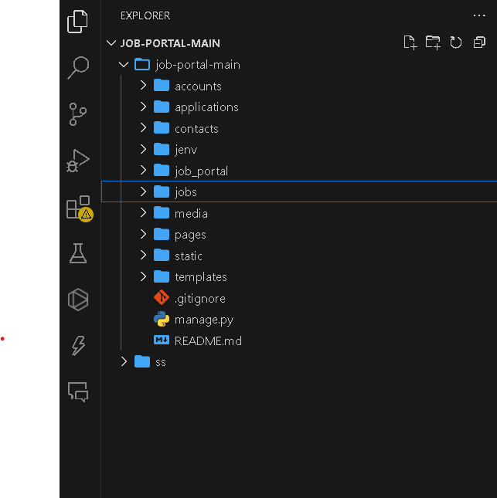

Organize code by modules: separate folders for Admin, Job Seeker, Employer, and common utilities.

- Keep front end (HTML, CSS, JavaScript) in a "public" or "static" folder, while back end code resides in a " src" or "app" folder.

- Use a clear directory structure for templates and components for consistency and ease of maintenance.

Code Formatting and Indentation:

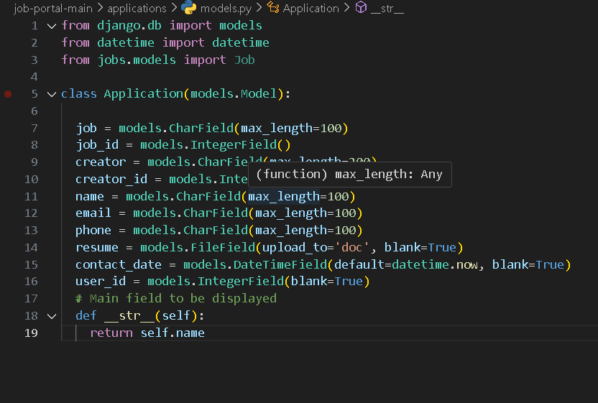

- Maintain uniform indentation (preferably 2 or 4 spaces) across all
code files.

- Use consistent spacing around operators and after commas for enhanced readability.

- In HTML, maintain proper nesting with closing tags on separate lines and avoid inline styling except when necessary.

- Commenting and Documentation:

- Include header comments in each file describing its purpose, author, and date of creation.

- Use inline comments sparingly to explain complex logic.

- Provide documentation for major functions and classes using standard
- formats (such as JSDoc or Python docstrings).
- Maintain separate documentation for API endpoints and module interactions, reflecting diagrams (such as use case diagrams and ER diagrams).

- Security and Data Handling:

- Enforce proper authentication and authorization standards when processing job applications and user data.

- Always sanitize inputs to prevent SQL injection and XSS attacks.
- Follow secure coding practices for handling file uploads (e.g., resumes) and personal data, ensuring compliance with GDPR or local regulations.

- Responsive and Cross-Platform Considerations:

- Ensure the HTML/CSS components are fully responsive using media queries or responsive frameworks (e.g., Bootstrap).

- Test modules on multiple devices and browsers to ensure consistent functionality and user experience.

- Version Control and Code Reviews:

- Use a Git-based version control system with clear branching strategies.
- Require code review before merging features to maintain quality and coding standards consistency.

- Document changes in commit messages in a concise, informative manner.

15.Screen shots of website:

About page:
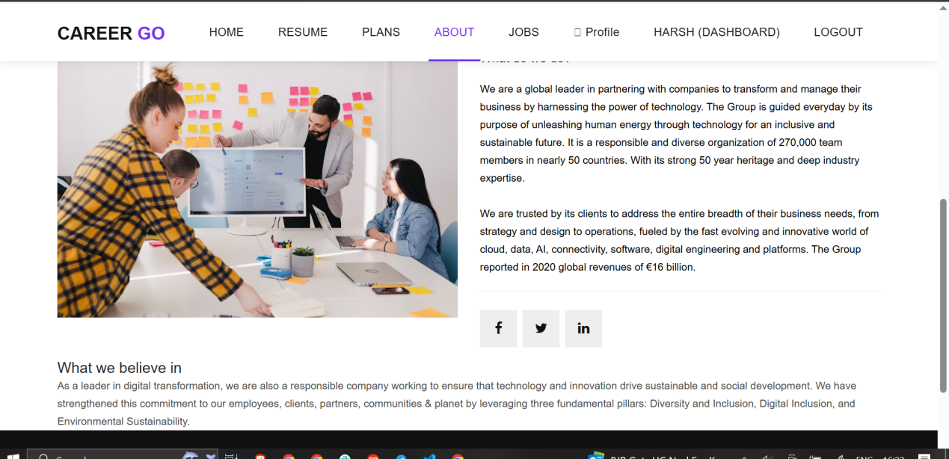

Admin panel dark model:
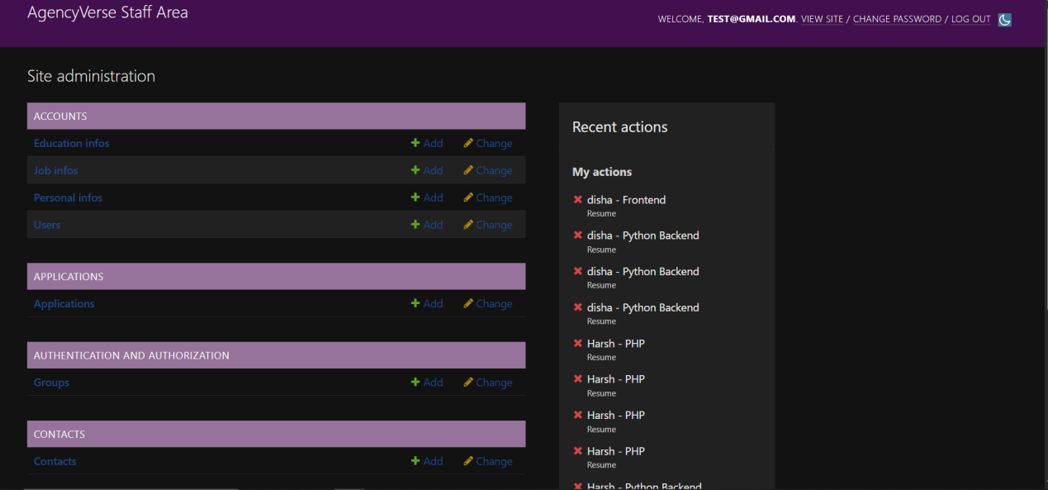

admin panel user info:
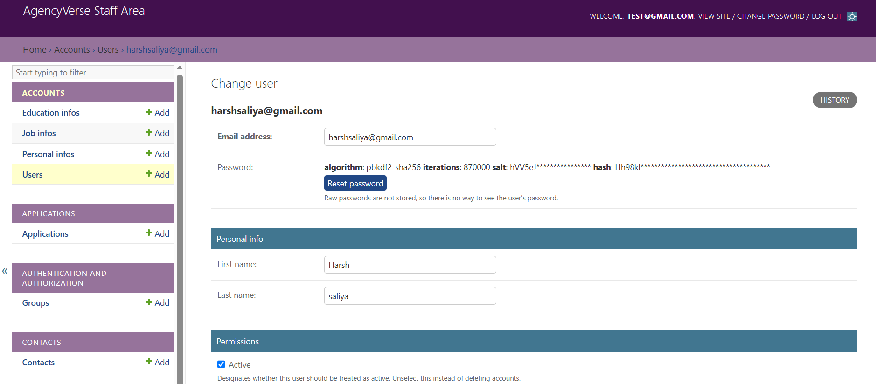

admin panel:
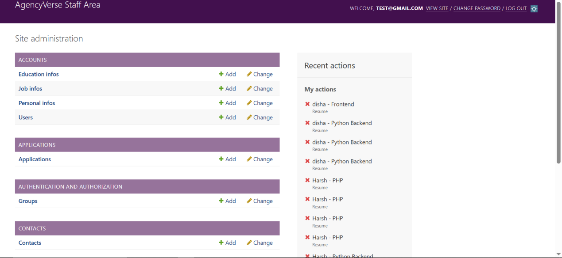

application filter:
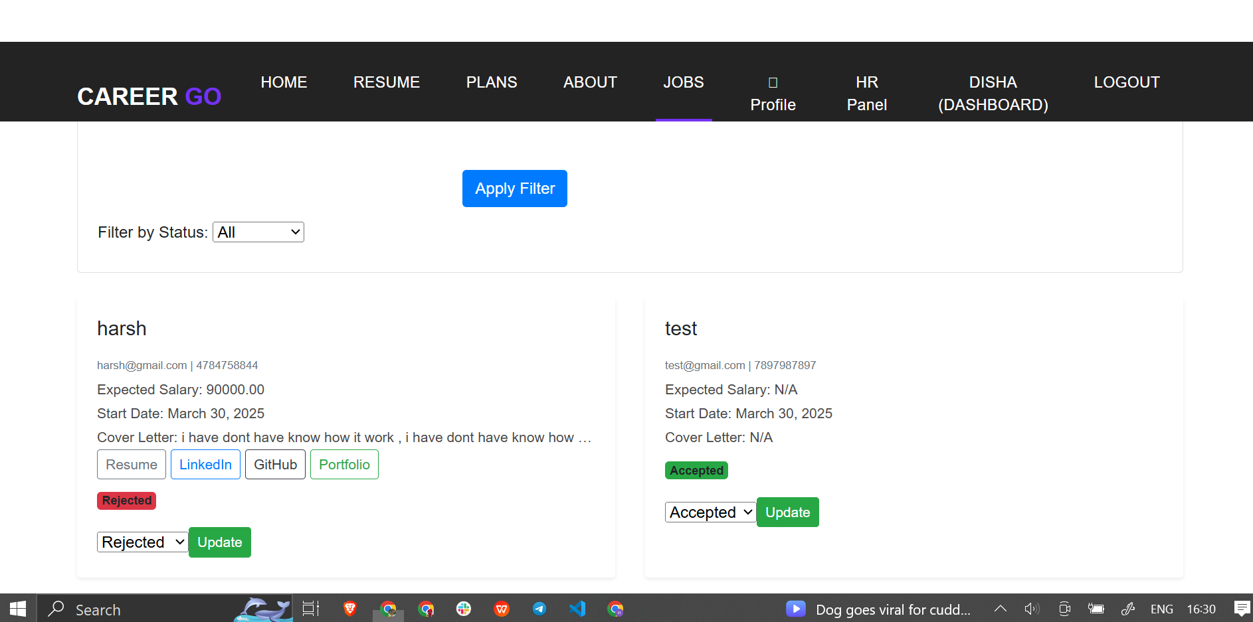

dashboard page:
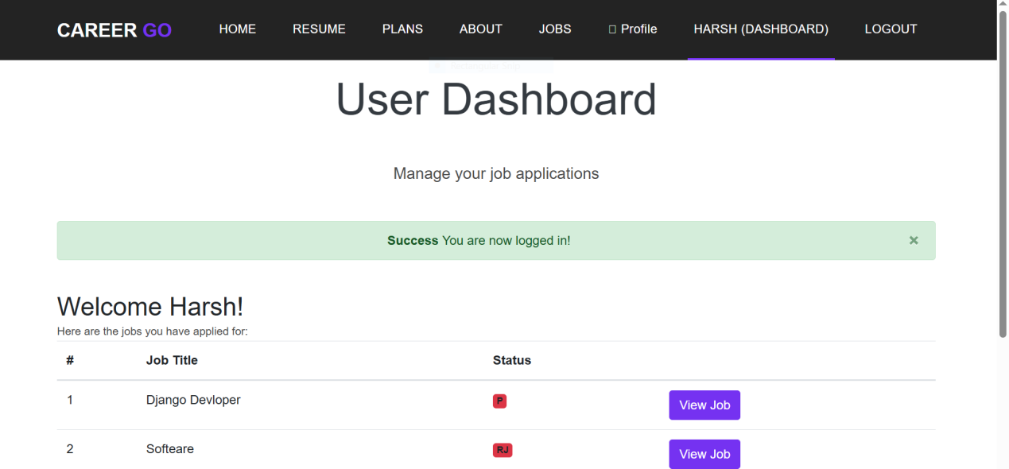

home:
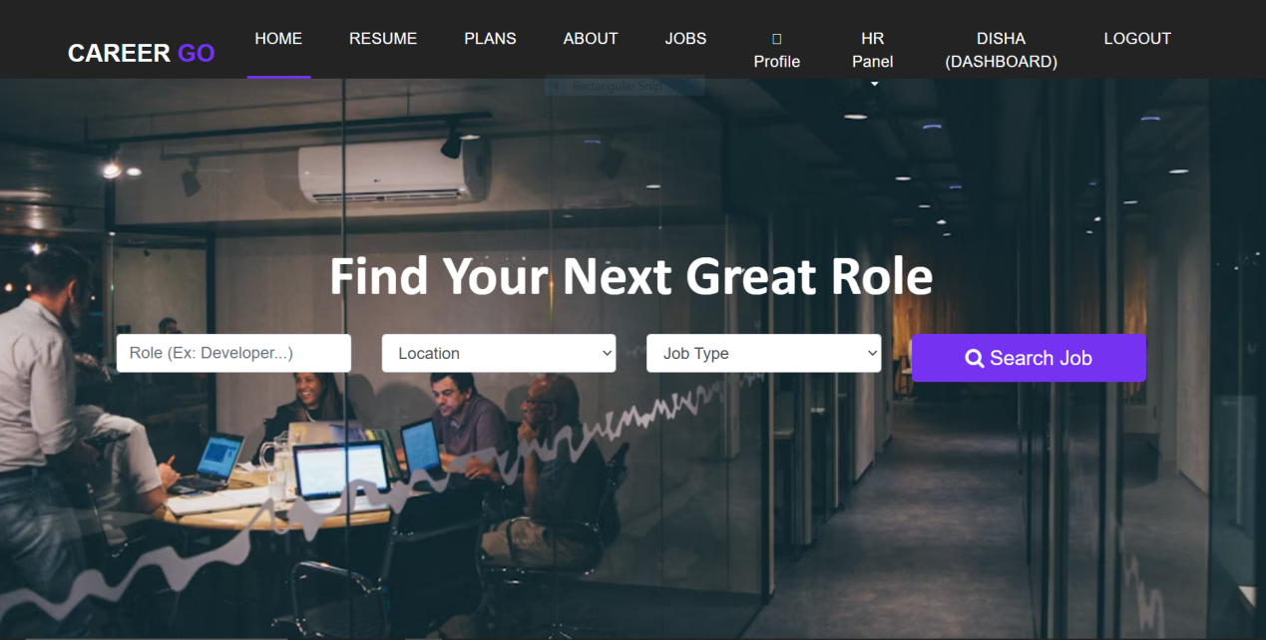

hr admin panel:
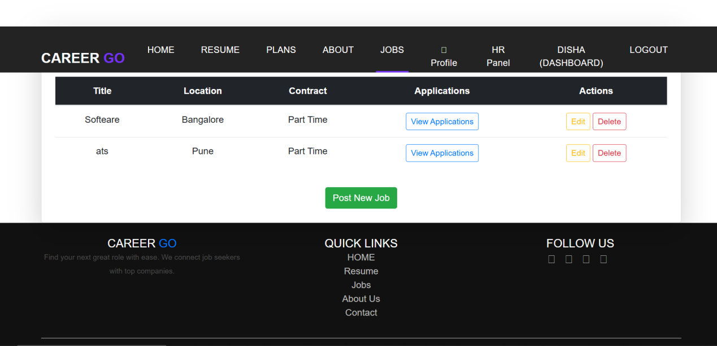

plans:
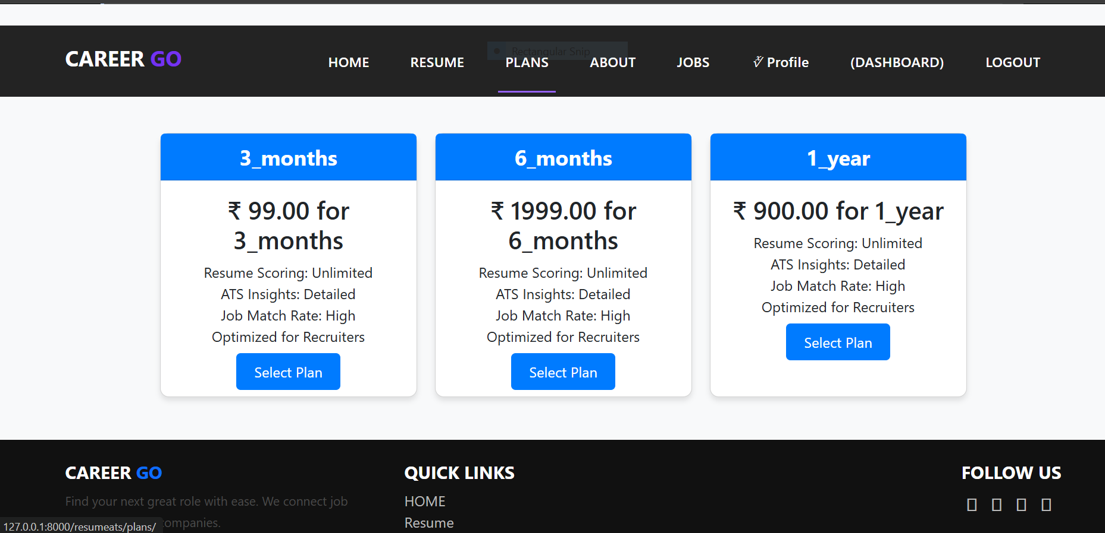

post job:
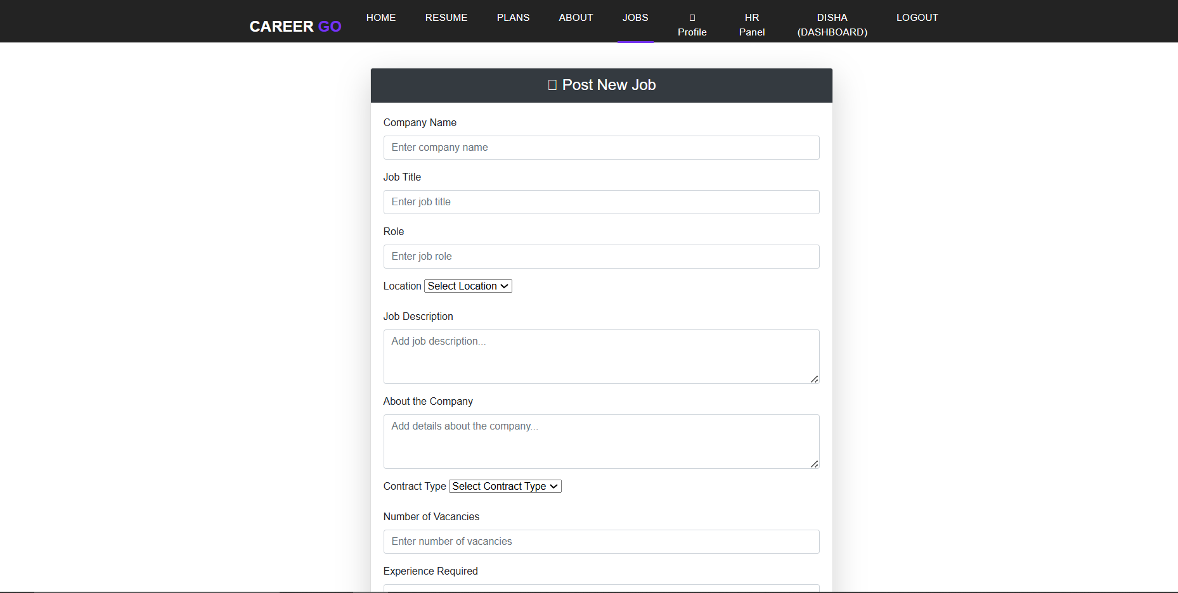

profile page:
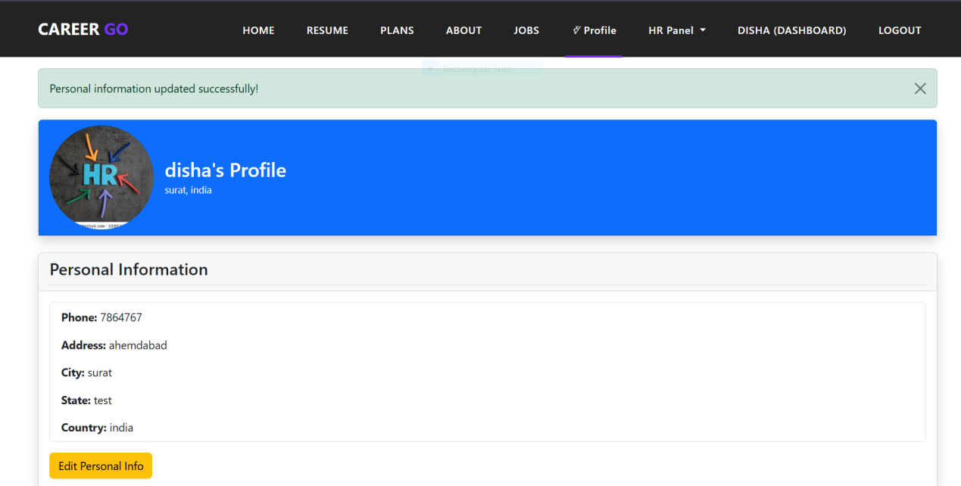

register page:
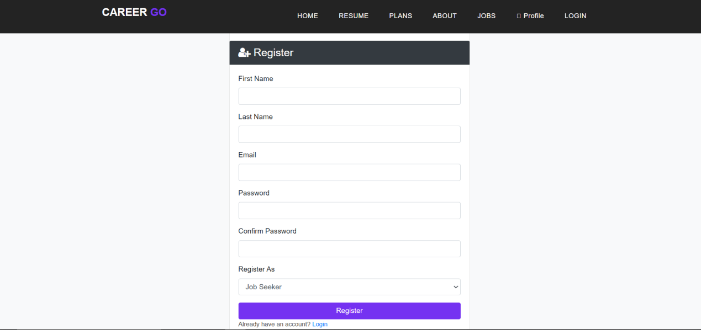

resume ats:
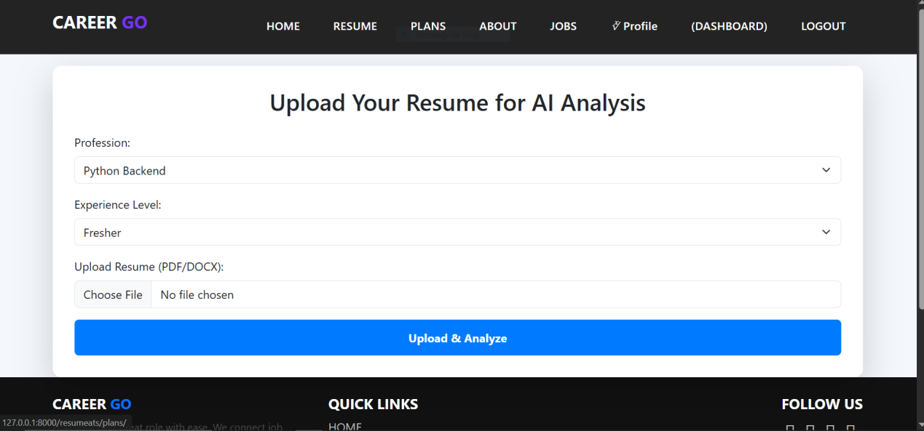

resume limits:
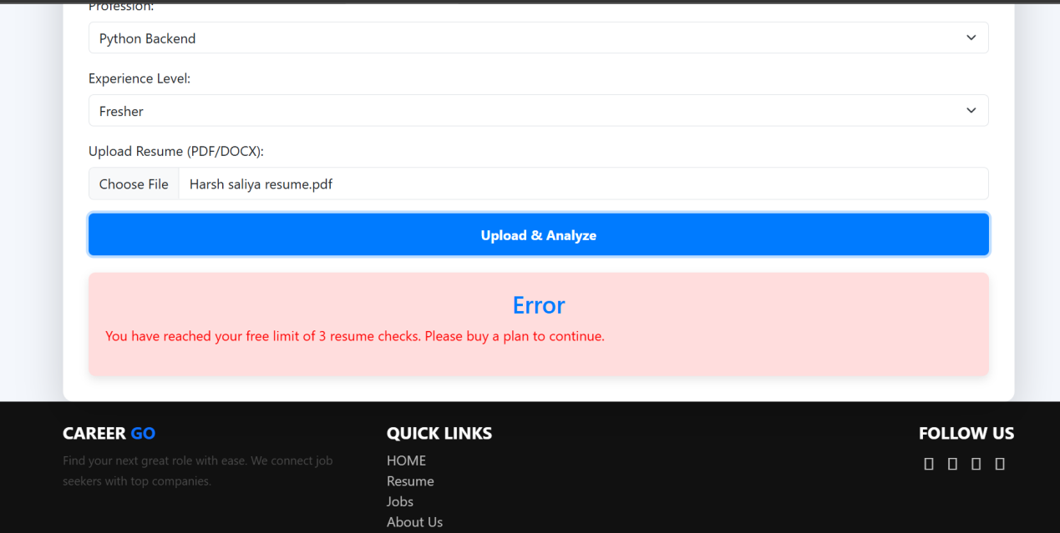

16.Agile project charter:

Project Name | carrier go(job portal)
Project Champion | HarshSaliya, Harsh Hirani, Surbhi Ramani
Project Sponsor | LJ INSTITUTE OF COMPUTER APPLICATIONS
Project Manager | Dhaval shah
Expected Start Date | 01-01-2025
Expected Completion Date | 10-04-2025
Project Goal | To develop an efficient, user-friendly online job portal that bridges job seekers with employers, enhancing recruitment efficiency and user satisfaction.
Project Vision | To create a cutting-edge platform that streamlines the entire hiring process with secure, transparent, and personalized features, thereby transforming recruitment practices.
Project Scope | Includes user management, job posting and management, job search and filtering, application tracking, resume management, notifications, admin dashboard, and security measures; excludes external HR integrations and advanced AI features in the initial phase.
Key Stakeholders | Primary: Job seekers and employers; Secondary: System administrators, technical support teams, and project sponsors.
Risk | Risks include scope creep, technical challenges, resource constraints, and potential security vulnerabilities that could impact system performance and data privacy.

,
17. Agile Project Plan:

Project name |  | Carrier GO | Agile Project Plan |  |  |  | Start date | End date | Overall progress
Project manager |  | Surbhi Ramani |  |  |  |  | 01/01/2025 | 15/04/2025 | In progress
Sprint | At Risk | Task Name | Responsible | Story Points | Start Date | End Date | Duration (Days) | Status | Comments
Sprint 1 | No | User Registration & Login | Harsh Saliya | 3 | 01-Jan-25 | 05-Jan-25 | 5 | Completed | Functionality tested and verified
Sprint 1 | No | Search & Filter Jobs | Surbhi Ramanai | 5 | 06-Jan-25 | 10-Jan-25 | 5 | Completed | UI completed, backend integration ongoing
Sprint 2 | No | User Reviews & Ratings | Harsh Saliya | 3 | 17-Jan-25 | 21-Jan-25 | 5 | Completed | Implemented using 5-star rating system
Sprint 2 | No | Admin Dashboard for Job Listings | Surbhi Ramanai | 5 | 22-Jan-25 | 27-Jan-25 | 6 | Completed | All metrics and charts working fine
Sprint 3 | No | Manage Jobs & Companies | Harsh Saliya | 5 | 03-Feb-25 | 09-Feb-25 | 7 | Completed | CRUD operations validated
Sprint 4 | No | Job Seeker Registration | Harsh Saliya | 3 | 21-Feb-25 | 25-Feb-25 | 5 | Completed | Seamless user onboarding implemented
Sprint 4 | Yes | Job Search Functionality | Harsh Hirani | 5 | 03-Mar-25 | 08-Mar-25 | 6 | Completed | Basic filters required
Sprint 5 | No | Employer Module: Job Posting | Harsh Saliya | 5 | 09-Mar-25 | 14-Mar-25 | 6 | Completed | API integration pending
Sprint 5 | Yes | Application Tracking System (ATS) | Surbhi Ramanai | 5 | 15-Mar-25 | 21-Mar-25 | 7 | Completed | Delayed due to dependency on employer module
Sprint 5 | Yes | Final Testing & Deployment | Harsh Hirani | 8 | 22-Mar-25 | 30-Mar-25 | 9 | Completed | Security & performance checks
- Agile Roadmap:
Duration | Sprint | Theme/Epic | Features
Week 1–2 | Sprint 1 | User Management Setup | - Set up version control, CI/CD  - User registration, login, and authentication
Week 2–3 | Sprint 1 | Dashboard UI | - Job Seeker and Employer dashboards  - Profile creation, updates
Week 3–4 | Sprint 2 | Job Posting & Searching | - Employer: Create/edit/delete jobs  - Job Seeker: Search/filter jobs
Week 4–5 | Sprint 2 | Job Applications | - Apply to jobs  - View application status
Week 5–6 | Sprint 3 | Admin & Company Management | - Admin dashboard  - Manage jobs, users, and companies
Week 6–8 | Sprint 3 | Basic Analytics & Reports | - Job post views, application count, and basic performance stats

Phase 1: Core Development & MVP (Minimum Viable Product)

Duration: 01-Jan-2025 to 08-Mar-2025

Phase 2:Feature Enhancement
Week | Sprint | Theme/Epic | Key Features / Activities
Week 08–10 | Sprint 4 | SEO & Language Settings | - Add SEO tags, FAQ page  - Multi-language toggle
Week 10–11 | Sprint 4 | Testing & Security | - Performance testing, bug fixes  - Secure endpoints and data encryption
Week 11–12 | Sprint 4 | Final QA & Deployment | - Stakeholder review  - Final deployment and documentation
Duration: 09-mar-2025 to -2025

19. Agile User Story Template:

User Story ID | PRIORITY | As a type of user | I want to <perform some task> | so that I can <achieve some goal>
1 | High | Job Seeker | Create a profile autometacaly | Apply for relevant job opportunities easily and increase my chances of getting hired.
2 | High | Job Seeker | Upload my resume | Have my details parsed automatically for better job matching.
3 | Medium | Job Seeker | Search for jobs using filters | Quickly find relevant job opportunities.
4 | High | Employer | Post job listings | Find the most suitable candidates efficiently.
5 | Medium | Employer | Review candidate applications | Shortlist qualified candidates based on job requirements.

20. Agile release Plan:
Risk | Sprint | Task Name | Description | Start Date | End Date | Duration | Story Points | Status | Release Date | Goal
Low | 1 | User Login & Registration | Users can register/login with email and password. | 01-Jan-2025 | 09-Jan-2025 | 9 | 5 | Completed | 15-Apr-2025 | Implement user registration/login functionality.
Medium | 1 | Job Search & Filtering | Candidates can search and filter job postings. | 10-Jan-2025 | 17-Jan-2025 | 8 | 8 | Completed | 15-Apr-2025 | Enable job searching and filtering.
High | 1 | Job Application | Job Seekers can apply to Job posting. | 18-Jan-2025 | 25-Jan-2025 | 8 | 2 | Completed | 15-Apr-2025 | Enable users to apply for jobs.
Medium | 2 | Admin Dashboard for Job Listings | Admin dashboard for job listings. | 26-Jan-2025 | 02-Feb-2025 | 8 | 5 | Completed | 15-Apr-2025 | Admin dashboard for job listings.
High | 2 | AI Job Recommendations | AI Job Recommendations. | 03-Feb-2025 | 10-Feb-2025 | 8 | 8 | Completed | 15-Apr-2025 | Implement AI logic for job recommendations.
Low | 3 | Manage Jobs & Companies | Manage Jobs and Companies. | 11-Feb-2025 | 20-Feb-2025 | 10 | 5 | Completed | 15-Apr-2025 | Manage Jobs and Companies.
Medium | 3 | SEO, FAQ, Language Settings | SEO, FAQ and Language Settings. | 21-Feb-2025 | 06-Mar-2025 | 14 | 8 | Completed | 15-Apr-2025 | SEO, FAQ and Language Settings.
High | 3 | Reporting & Analytics Features | Reporting & Analytics Features. | 07-Mar-2025 | 19-Mar-2025 | 13 | 2 | Completed | 15-Apr-2025 | Reporting & Analytics Features.
Low | 4 | Job Seeker Registration | Job Seeker Registration. | 08-Mar-2025 | 19-Mar-2025 | 12 | 5 | Completed | 15-Apr-2025 | Job Seeker Registration.
Medium | 4 | Resume Upload & Editing | Resume Upload & Editing. | 10-Mar-2025 | 21-Mar-2025 | 12 | 2 | Completed | 15-Apr-2025 | Resume Upload & Editing.
High | 4 | Job Search Functionality | Advanced Job Search Functionality. | 11-Mar-2025 | 22-Mar-2025 | 12 | 3 | Completed | 15-Apr-2025 | Job Search Functionality.

21. Agile sprint back log:
ID | User Story | Task | Priority | Story Points | Assigned To | Status | Original Estimate (Days) | Day 1 | Day 2 | Day 3 | Day 4 | Day 5 | Sprint Review | Acceptance Criteria
SB-001 | As a job seeker, I want to register on the platform. | Implement user registration with email verification. | High | 5 | harsh saliya | Completed | 3 | 5 | 3 | 1 | 0 | - | 0 | Users can register using a valid email, receive a verification email, and verify their account.
SB-002 | As a job seeker, I want to login to access my profile. | Develop login functionality with password encryption. | High | 3 | surbhi ramanai | Completed | 3 | 3 | 2 | 0 | - | - | 0 | Users can login with their verified email and password. Passwords are securely encrypted in the database.
SB-003 | As a user, I want to reset my password if I forget it. | Implement password reset functionality with email recovery. | Medium | 4 | harsh hirani | Completed | 3 | 4 | 2 | 2 | 1 | 0 | 0 | Users can request a password reset, receive an email with a reset link, and set a new password.

22. Agile test plan:

Test Case | Written By | Browser | Notes | Date | Description | Expected Result | Actual Result | Passed | Tested By | Comments
TC-001 | harsh saliya | Chrome | Basic Functionality | 27-02-2024 | Verify User Registration with valid credentials | User account created successfully, verification email sent | Account created, verification email received | Yes | harsh saliya | Registration flow works as expected
TC-002 | Surbhiramanai | Chrome | Basic Functionality | 01-03-2024 | Verify User Login with valid credentials | User successfully logs in and is redirected to the dashboard | User logged in, redirected to dashboard | Yes | Surbhi ramani | Login successful with valid credentials
TC-003 | harsh saliya | Firefox | Functional | 03-03-2024 | Verify Job Posting Creation by Employer | Job posted successfully, visible in job listings | Job posted, visible in job listings | Yes | harsh saliya | Employer can post jobs without issues
TC-004 | harsh hirani | Safari | Functional | 05-03-2024 | Verify Job Search by Keyword | List of jobs matching the keyword is displayed | Jobs matching keyword displayed | Yes | harsh hirani | Search functionality is working correctly
TC-005 | harsh saliya | Edge | Functional | 07-03-2024 | Verify Job Application by Job Seeker | Application submitted, confirmation message displayed | Application submitted, confirmation displayed | Yes | harsh saliya | Job seeker can apply to jobs successfully
TC-006 | Surbhiramani | Chrome | Admin Functionality | 09-03-2024 | Verify Admin User Login | Admin user logs in and accesses the admin dashboard | Admin user logged in, accessed admin dashboard | Yes | Surbhi ramani | Admin login is working as expected
TC-007 | harsh hirani | Chrome | Basic Functionality | 11-03-2024 | Verify Resume Upload and Parsing | Resume is uploaded successfully, and key details are parsed and displayed | Resume uploaded, key details parsed and displayed | Yes | harsh hirani | Resume parsing works correctly
TC-008 | harsh saliya | Chrome | Edge Case | 13-03-2024 | Test division by zero in calculator (if applicable) | Error message (e.g., "Cannot divide by zero.") | Error message displayed "Cannot divide by zero" | Yes | harsh saliya | Error handling works as expected
TC-09 | Surbhiramanai | Chrome | Clear Test | 15-03-2024 | Test clearing the input and result fields (if applicable) | Blank fields | Input field clear | Yes | Surbhi ramani | Works successfully
TC-010 | harsh saliya | Chrome | Resposiveness test | 17-03-2024 | Verify mobile UI responsiveness | UI should adjust to mobile screen | Responsive UI | Yes | harsh saliya | Mobile UI looks good

23. Agile based Project Earned-value and burn charts

Metric | Week 1 | Week 2 | Week 3 | Week 4 | Week 5 | Week 6 | Week 7 | Week 8 | Week 9 | Week 10 | Week 11 | Week 12 | Budget
Planned Value (PV in Rs.) | 5000 | 4000 | 6000 | 10000 | 3000 | 4000 | 7000 | 8000 | 9000 | 3000 | 4000 | 7000 | 70000
Actual Cost (AC in Rs.) | 4000 | 2000 | 7000 | 8000 | 2000 | 4500 | 8000 | 7000 | 8000 | 1000 | 3000 | 6000 | 60500
Project Completion (%) | 10 | 15 | 19 | 24 | 30 | 40 | 50 | 60 | 70 | 85 | 90 | 100 | -
Earned Value (EV in Rs.) | 7,000 | 10,500 | 13,300 | 16,800 | 21,000 | 28,000 | 35,000 | 42,000 | 49,000 | 59,500 | 63,000 | 70,000

Burn chart:
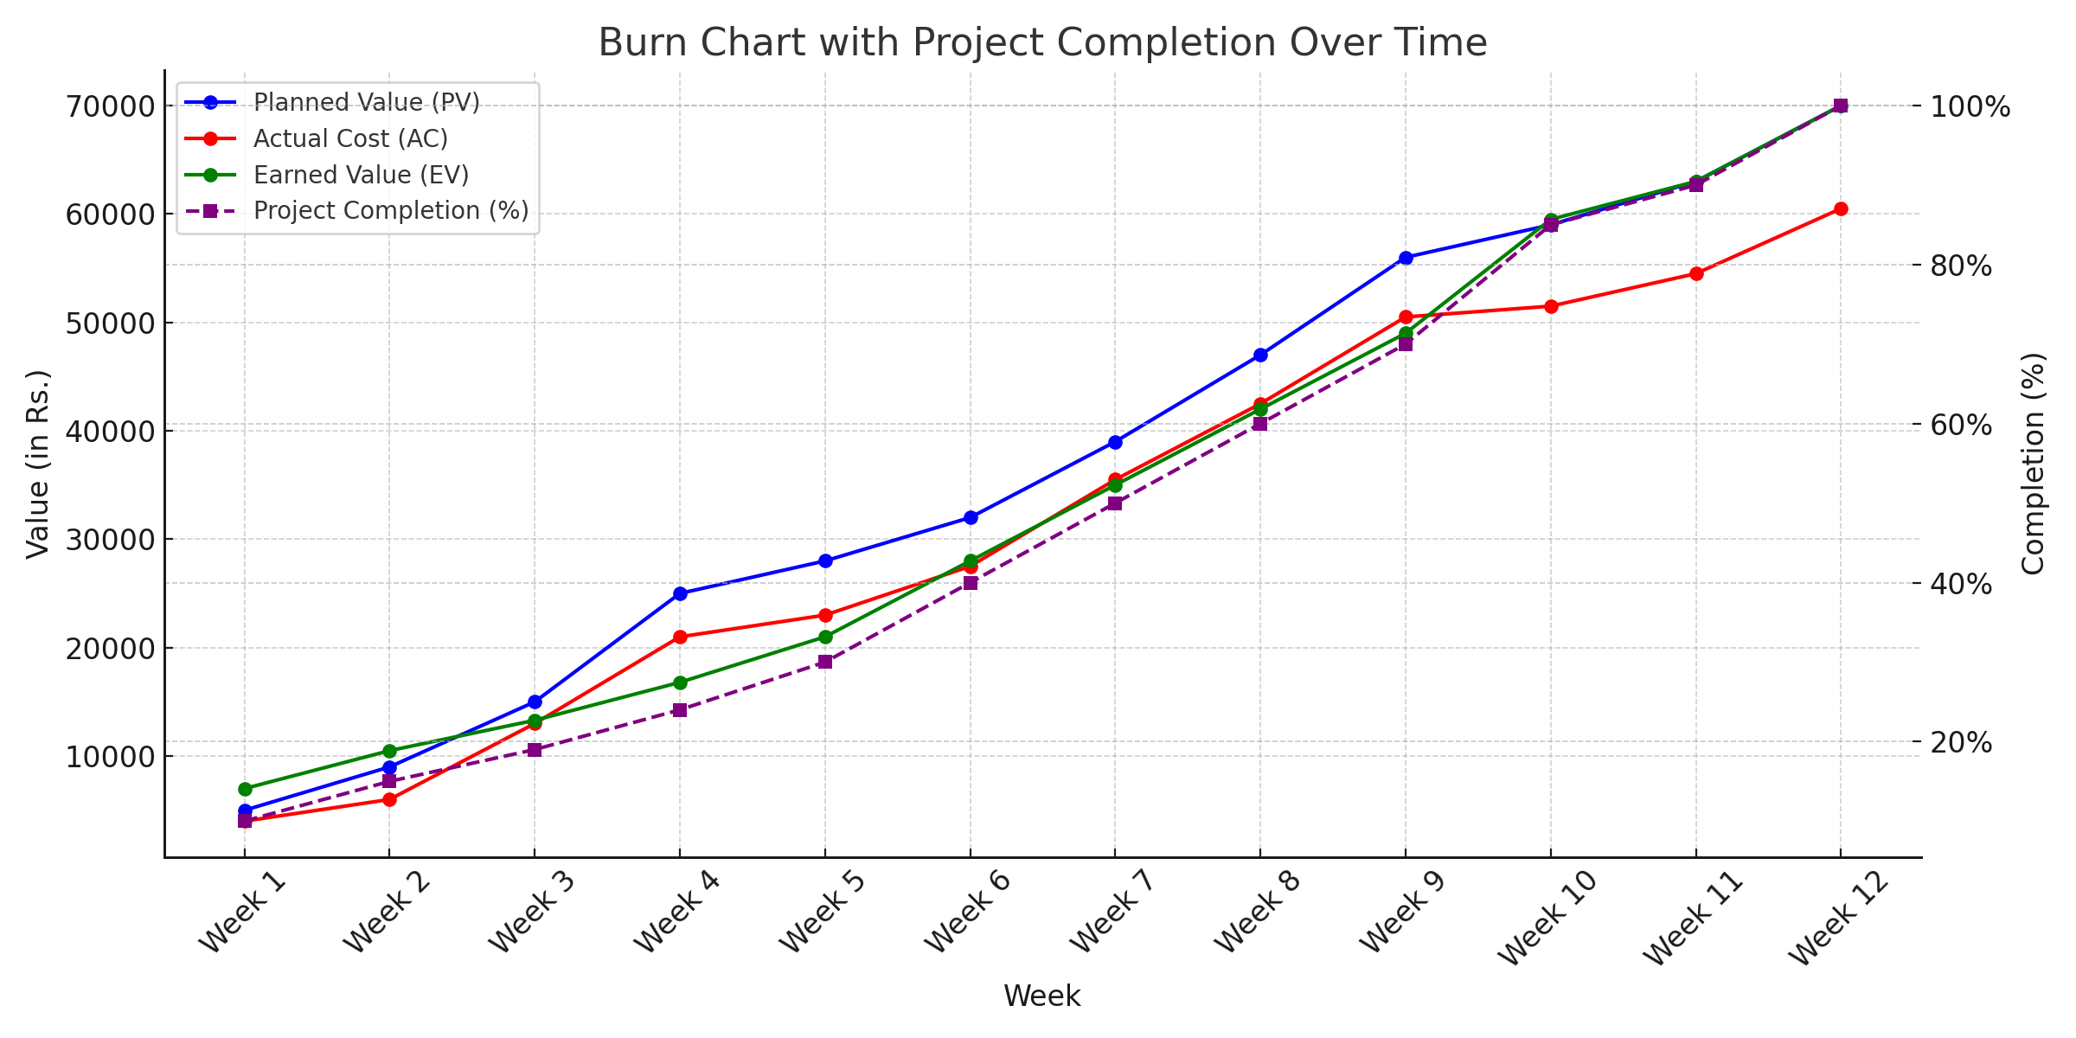

24. Proposed Enhancements
Based on the analysis of the current system, and keeping in mind user needs and market trends, the following enhancements are proposed for the Online Job Portal System:
- Mobile Application Development: Rather than just a website, create a mobile application for both Android and iOS platforms to enhance accessibility and user convenience.

- Advanced AI-Driven Job Matching: Implement more sophisticated AI algorithms to improve the accuracy and relevance of job recommendations for job seekers, considering factors like skills, experience, and preferences.

- Enhanced Security Measures: Incorporate multi-factor authentication, regular security audits, and secure data storage to ensure the protection of user data and prevent unauthorized access Integration of Video Interview Tools: Integrate video conferencing capabilities within the platform to facilitate remote interviews and improve communication between job seekers and employers.

- Internationalization: Offer the platform in multiple languages and support job postings from various countries to cater to a global audience .

25.Conclusion
The Online Job Portal System aims to connect job seekers and employers while simplifying the recruitment process in today's digital era. By addressing the limitations of traditional recruitment methods and existing online portals, the proposed system seeks to provide a more efficient, user-friendly, and secure platform. The success of this project relies on addressing the limitations of current systems, user empowerment, and continuous adaption. With ongoing improvements, it holds the potential to revolutionize the job search experience for both job seekers and employers, leading to more successful career placements and organizational growth

26.Bibliography

1. Django (Web Framework)
- Django Documentation – Django Software Foundation:https://docs.djangoproject.com/
- Django Tutorials – Real Python: https://realpython.com/tutorials/django/
- Django Best Practices – Simple is Better than Complex:https://simpleisbetterthancomplex.com/

2. Python Programming
- Official Python Documentation – Python Software Foundation:https://docs.python.org/3/
- Python Tutorials – W3Schools: https://www.w3schools.com/python/
- Python for Beginners – GeeksforGeeks: https://www.geeksforgeeks.org/python-programming-language/

3. Web Development (HTML, CSS, JavaScript)
- HTML & CSS Basics – MDN Web Docs:https://developer.mozilla.org/en-US/docs/Learn/HTML
- JavaScript Guide – MDN Web Docs:https://developer.mozilla.org/en-US/docs/Web/JavaScript/Guide
- Frontend Development Resources – FreeCodeCamp:https://www.freecodecamp.org/

4. SQLite (Database Management System)
- SQLite Official Documentation: https://www.sqlite.org/docs.html
- SQLite Tutorial – TutorialsPoint: https://www.tutorialspoint.com/sqlite/index.htm
- SQLite with Django – Django Documentation:https://docs.djangoproject.com/en/4.0/ref/databases/#sqlite-notes

5. Online Job Portal Development
- How to Build an Online Job Portal with Django – Real Python: https://realpython.com/django-job-board-tutorial/
- Job Portal Project with Django – GeeksforGeeks: https://www.geeksforgeeks.org/job-portal-project-using-django/
- Best Practices for Developing Job Portals – Smashing Magazine: https://www.smashingmagazine.com/category/web-development/

6. Full-Stack Development (Django, HTML, CSS, JS, SQLite)
- Full Stack Python – Guide to Django and Web Development:https://www.fullstackpython.com/
- Django + JavaScript Integration – Stack Overflow Discussions:https://stackoverflow.com/questions/tagged/django+javascript
- REST API Development with Django – Django REST Framework:https://www.django-rest-framework.org/

