CA-3: AGENTIC AI | DOMAIN-SPECIFIC PROOF OF CONCEPT
Claims Adjudication Agent
A multi-agent system that makes the first decision on a health-insurance claim, and knows when to ask a human
GROUP MEMBERS
Name | Roll number
Harsh Salunkhe | 24070126066
Dharna Sharma | 24070126053

Course: Flexi-Credit Course 26-27, SIT Pune
Technology: Python, LangGraph, Streamlit, local language model (llama3.2:3b through Ollama)
Code repository: github.com/HarshSalunkhe2005/claims-adjudication-agent (also submitted as a zip file)

1. Problem statement and domain justification
When a person is treated in hospital, the hospital sends the insurer (or the third-party administrator that works for it) a claim: an itemised bill, a discharge summary, and supporting documents. A claims officer must decide whether to pay, how much to pay, or whether something looks wrong. This is the claim adjudication step.
Problem statement. Manual first-pass adjudication of health-insurance claims is slow, inconsistent between officers, and lets inflated or irregular bills through. We propose a team of cooperating software agents that makes the first decision, explains it in plain words with the policy clause behind it, and sends only the doubtful or risky claims to a human.

Why this domain suits an agentic approach
- Rule-heavy. Waiting periods, pre-existing-condition rules, room-rent limits, procedure sub-limits, co-payments and exclusions all interact.
- Document-heavy. The facts sit in itemised bills and free-text discharge summaries that must be read and cross-checked.
- Errors are costly in both directions. A wrong payout loses money; a wrongful rejection harms a policyholder.
- Needs an audit trail. Every decision must cite the rule it rests on, which suits a pipeline that records each step.
- Needs a second opinion. A separate validating agent that can send work back is a natural fit for the Critic role in the assignment.

2. Existing business challenge and proposed solution

How it is done today
An officer reads the bill and discharge summary, looks up the relevant policy clauses, checks by eye whether the price is reasonable, and decides. We assume a first pass takes about 25 minutes per claim; this is an assumption, not a measured figure.

What goes wrong
- It is slow, so claims queue up and policyholders wait.
- Two officers can reach different decisions on the same claim.
- Inflated bills, tampered totals and mismatches between the claim form and the discharge summary are easy to miss.
- Deductions (for example a proportionate deduction when the room costs more than the plan allows) are error-prone to compute by hand.
- The reasoning behind a decision is often not recorded in a form that can be audited.

Our solution
Five agents orchestrated as a LangGraph state machine process each claim. All decisions and payout figures come from deterministic rules written in Python, so they are repeatable and auditable. A local language model (llama3.2:3b, run through Ollama on the same laptop) does the work that rules do badly: it reads free-text discharge summaries, including shorthand and abbreviations, explains the Planner's choice in one sentence, and writes the letter to the member. The model never decides anything, and its outputs are checked before they are used.
The five possible outcomes are: approved, approved in part (with each deduction explained), rejected (a policy rule applies), on hold (documents missing), and sent to a human officer.

3. Agent roles, responsibilities and orchestration workflow
Agent | Responsibility | Main tools
Planner | Assesses claim risk and chooses a quick or a thorough plan. Re-plans when the Critic objects. | Risk rules: amount of Rs 1,00,000 or more, non-network hospital, hospital on the audit watchlist, repeat claimant
Extractor | Reads the discharge summary: treatment performed, long-standing conditions, whether it followed an accident. | Fuzzy text parser plus the local language model, with verified quotes
Executor | Runs the planned checks one by one, stops early on a hard rule failure, then computes the payable amount. | 12 Python tools (documents, policy status, waiting periods, exclusions, duplicates, filing window, procedure match, bill integrity, high value, tariff check, fraud score, payout)
Critic | Independently re-verifies the work and can send the claim back to the Planner. | Five checks (see below)
Decision | Applies a fixed precedence, cites the policy clauses, and writes the letter to the member. | Precedence rules, clause library, language model for the letter

Orchestration workflow
- The claim arrives with its bill, claim form, documents and discharge summary.
- The Planner reads the risk indicators and builds a plan: a quick plan (core checks and the payout) or a thorough plan (adds the price check and the fraud score).
- The Extractor reads the discharge summary. The text parser handles clean wording; the language model reads shorthand and unusual phrasing. The model must quote the words it relies on, and quotes that do not appear in the summary are rejected.
- The Executor runs the plan. If a hard rule fails (for example a waiting period), it stops early and skips the remaining checks.
- The Critic re-checks: (a) the payout reconciles with the deductions, (b) it is within the claimed amount and the remaining sum insured, (c) every adverse finding cites a real policy clause, (d) the extracted facts agree with the claim form, (e) the fraud screening matched the claim's risk.
- If any Critic check fails, the claim goes back to the Planner, which adds checks or recomputes. This loop runs at most two rounds, after which the claim is escalated to a human.
- The Decision agent picks the outcome by a fixed precedence: reject, then query, then escalate, then partial, then approve. It cites the clauses and writes the letter.
Decision precedence. REJECT (a hard rule is broken: waiting period, pre-existing condition, exclusion, lapsed policy, duplicate) outranks QUERY (a mandatory document is missing or unreadable), which outranks ESCALATE (fraud score of 60 or more, tampered bill, treatment mismatch, high value over Rs 3,00,000, late filing), which outranks PARTIAL (deductions apply), which outranks APPROVE.
Deductions are applied in a fixed order: non-medical items, room-rent proportionate deduction, procedure sub-limit, 10% co-payment at non-network hospitals, and the remaining sum insured.

4. Architecture
The diagram shows the agents, the data flow between them, the tools the Executor uses, the data stores, the language-model layer, and the feedback loop from the Critic to the Planner. Solid arrows are the control flow; the dashed orange arrow is the re-plan loop; dotted arrows show what each part reads or assists.
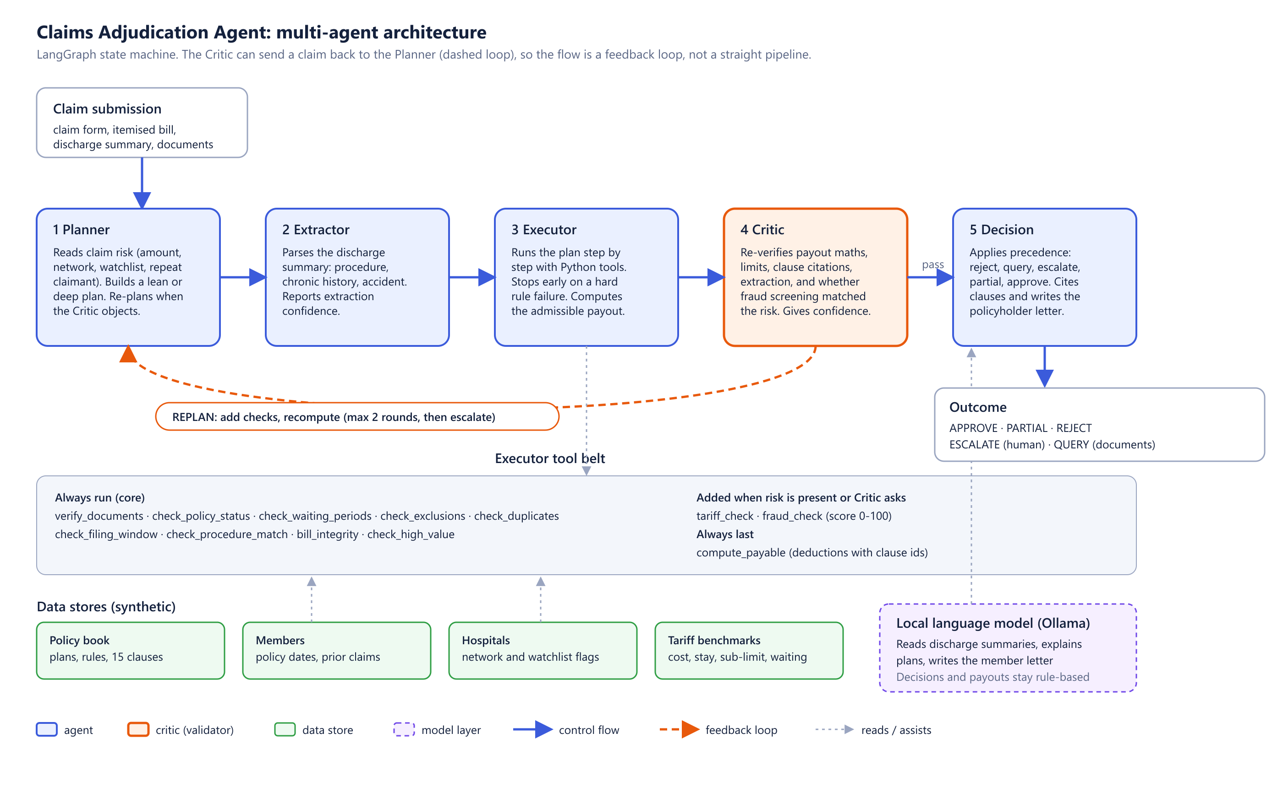
Figure 1. Multi-agent architecture of the Claims Adjudication Agent.

Components
- Orchestration: LangGraph state machine with a conditional edge from the Critic back to the Planner.
- Tools: twelve Python functions; each returns findings with a status (pass, info, query, flag, fail) and the policy clause it relies on.
- Data stores (synthetic): a policy book with three plans and fifteen clauses, members with policy dates and prior claims, ten hospitals with network and watchlist flags, and thirteen procedures with benchmark costs, typical stays, sub-limits and waiting periods.
- Language model: llama3.2:3b through a local Ollama server. Temperature is zero. For reading summaries it must answer from a closed list of our own procedure and condition names and quote the summary; quotes are verified. Letters are validated: exact figures, no titles guessed from a name, no placeholders, and no mention of fraud checks. A letter that fails twice is not shown.
- Interface: a Streamlit app that shows the pipeline running, a plain-English account of what each agent did, how the payout was worked out, and the evaluation results.

5. The proof of concept (Streamlit UI)
The app runs on the laptop with the model served by Ollama. The Claim desk tab offers nine demo cases and a searchable list of all 89 synthetic claims. Pressing Run claim animates the five agents, then shows the outcome with a plain-English story, a payout breakdown, the policy clauses with their text, and the letter. A switch simulates a calculation error so the audience can watch the Critic catch it and send the work back.
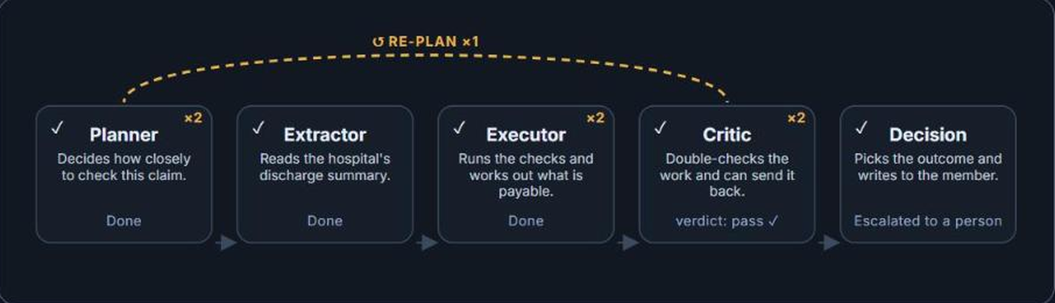
Figure 2. The agents running on claim CLM-26-0019. The dashed arrow is the Critic sending the claim back to the Planner.
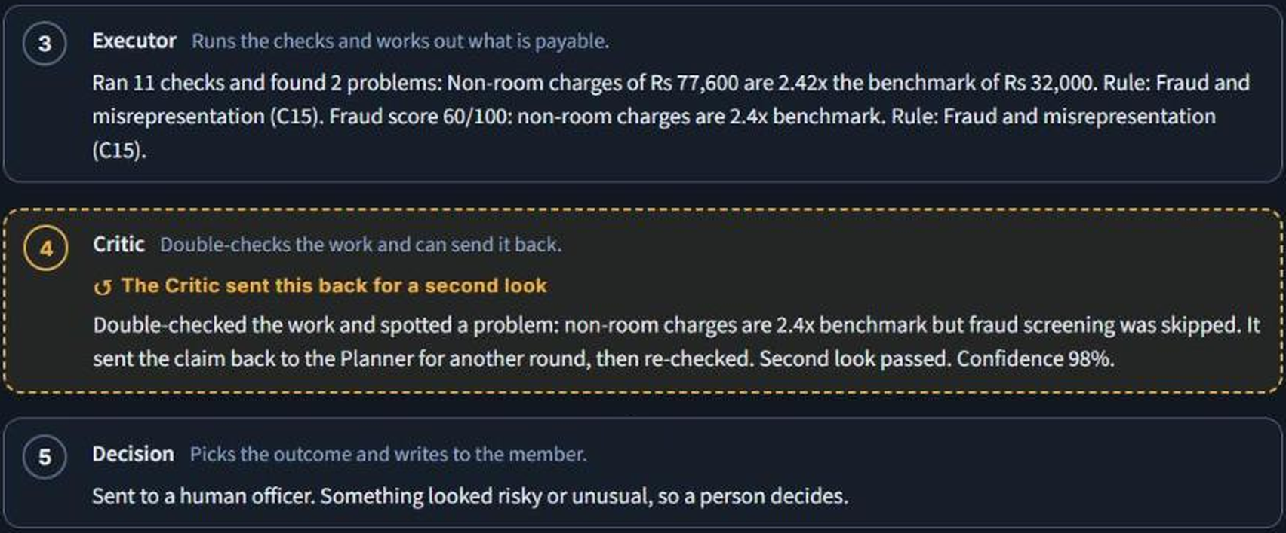
Figure 3. The plain-English account of the same claim, ending with the decision to send it to a human officer.

Worked example: claim CLM-26-0019 (cataract operation)
The Planner sees a small claim at a normal hospital and chooses a quick plan, which leaves out the price and fraud checks. The Executor finds that the non-room charges are Rs 77,600, which is 2.42 times the benchmark of Rs 32,000. The Critic notices that a bill this high should have had a fraud check that the quick plan skipped, and sends the claim back. On the second round the fraud check runs and scores 60 out of 100, so the claim is escalated to a human officer instead of being paid automatically.

Data
All data is synthetic: 89 labelled claims across 21 scenarios (clean approvals, room-rent and co-payment deductions, each kind of rejection, inflated bills, tampering, treatment mismatch, missing documents and so on), with 89 members, 10 hospitals, 13 procedures and 15 policy clauses. The correct outcome for each claim is stored beside it and is never passed into the pipeline.

6. Output validation and results

Validation built into the system
- The Critic re-verifies every calculation, limit and clause citation before a decision is released, and can send the work back.
- The language model's reading of a summary is accepted only if its quotes really appear in the text, and its labels are mapped onto our own fixed lists.
- The letter is checked against the real figures; if it fails twice, no letter is shown.
- Every decision, payout and deduction is computed by rules, not by the model.

Main test set
On the 89 labelled claims the system with the language model gave the correct outcome for 89 of 89 claims, with 0 risky claims wrongly paid and 0 payable claims wrongly held. 74.2% of claims were settled without a human (approved, part-paid or rejected); the rest went to a human or were put on hold for documents. The Critic sent 4 claims back for a second round.
Caution. The correct outcomes for this set come from the same design as the rules, so this result shows that the rules cover the scenarios; it does not prove accuracy on real claims. That is why we built the harder tests below.

Robustness test 1: hardening the rules
We generated 445 further claims from five new random seeds, damaged the discharge summaries and bills in realistic ways, and added 23 boundary cases whose answer is fixed by the policy text (for example 29 days versus 30 days of cover, or a claim of Rs 2,99,990 versus Rs 3,00,010). The first run exposed real weaknesses: typos and rewording hid treatment mismatches and pre-existing conditions, an unreadable summary was not put on hold, and an expensive private room diluted the price check. We fixed these (fuzzy matching, a hold for unreadable summaries, and a price check based on non-room charges). Two mistakes in our own test were also found and corrected.
Noise added to the claims | First run: accuracy | First run: risky claims wrongly paid | After fixes: accuracy | After fixes: wrongly paid
Clean held-out claims | 99.1% | 3 of 240 | 100% | 0 of 240
OCR-style typos | 94.2% | 25 of 240 | 100% | 0 of 240
Paraphrased wording | 92.4% | 33 of 240 | 100% | 0 of 240
Case and whitespace | 95.7% | 18 of 240 | 100% | 0 of 240
Bill amounts changed by up to 3% | 99.1% | 3 of 240 | 100% | 0 of 240
Summary unreadable | 0% | 205 of 205 | 100% | 0 of 205
Combined noise | 92.4% | 33 of 240 | 100% | 0 of 240

All 23 boundary cases passed after the fixes. The rows above are noise types we saw before fixing, so the improvement is partly tuned to them. We therefore added noise types written after the fixes.

Robustness test 2: the language model on unseen noise
Three noise families were written after the rules were tuned. With only the text parser reading the summary, shorthand still slipped through: a condition written as "k/c/o CAD" or "PMH: IHD", or a treatment written as "TKR" or "CAG", was not understood. We chose the model by testing two candidates that fit the laptop's 4 GB graphics card, using development claims separate from the claims used for the results below.
Model | Treatment read correctly | Histories found | False histories invented | Median time per summary
llama3.2:3b (chosen) | 258 of 258 | 15 of 15 | 0 of 252 | 3.4 s
qwen2.5:3b | 226 of 258 | 15 of 15 | 0 of 252 | 3.3 s

The results below use 89 claims from one held-out seed, so the same claims are read by both columns (48 of them should not be paid and 41 should be). The model's prompt was developed on other claims; the telegraphic-notes family was written after the prompt was fixed.
Noise family | Rules only: accuracy | Rules only: risky claims wrongly paid | With llama3.2:3b: accuracy | With llama3.2:3b: wrongly paid | Payable claims wrongly held
Clean wording | 100% | 0 of 48 | 100% | 0 of 48 | 0 of 41
Random character noise | 96.6% | 3 of 48 | 100% | 0 of 48 | 0 of 41
Clinical abbreviations (TKR, k/c/o DM-2) | 94.4% | 5 of 48 | 100% | 0 of 48 | 0 of 41
Telegraphic notes (PMH: IHD, Op: CAG) | 91% | 8 of 48 | 100% | 0 of 48 | 0 of 41

A language model can also invent a condition that is not in the summary, which would cause a payable claim to be rejected by mistake. We count this as "wrongly held" and it was 0 of 164 claim readings across the four conditions.

Speed
Reading one summary takes about 3.5 seconds on the laptop's GPU. A complete live claim, including the plan note and the letter, takes roughly 10 to 15 seconds. The first request after starting Ollama takes longer while the model loads.

7. Limitations
- All data is synthetic and the discharge summaries are generated from templates, so the results show behaviour on our scenarios, not on real claims.
- The correct outcomes in the main test set share their design with the rules, so that score measures coverage, not real-world accuracy.
- The model results use one held-out seed (89 claims), so the confidence interval is wide, and the prompt was tuned on separate development claims.
- A three-billion-parameter model on a laptop is slow and can still miss shorthand it has not seen; the quote check makes it fail safe (the rules then decide on the facts they can verify) but does not make it perfect.
- Fraud weights, price benchmarks and thresholds are set by hand, not learned from real outcomes.
- The figure of 25 minutes of manual work per claim is an assumption.
- The system needs a running local Ollama server. A cloud-hosted demo is not possible without a hosted model.

8. Future scope
- Test a larger or fine-tuned model on real, anonymised discharge summaries.
- Add optical character recognition so scanned bills and summaries can be read.
- Add a strict mode that holds any claim whose history cannot be verified, trading more manual reviews for fewer missed pre-existing conditions.
- Learn the fraud weights and price benchmarks from real outcomes, with officer feedback on escalated claims.
- Connect the tools to real policy and hospital systems through standard interfaces such as MCP.
- Measure the real time saved per claim in a pilot instead of assuming it.

9. Conclusion
The project shows an agentic workflow that plans, executes, validates and decides, rather than a chatbot. The Critic's ability to send work back made a real difference on claims where a quick plan missed a risk, and a local language model reads the shorthand that rules alone cannot. Testing against damaged and held-out claims, and reporting where the system still fails, gives a more honest picture than a single clean score.

Appendix A. Demo claims
Claim | Story | Outcome
CLM-26-0003 | Everything checks out | Approved in full
CLM-26-0001 | Room rent above the plan cap, proportionate deduction (clause C6) | Approved in part
CLM-26-0004 | Illness within the first 30 days of the policy (clause C2) | Rejected
CLM-26-0007 | Pre-existing condition with only 10 months of cover (clause C3) | Rejected
CLM-26-0019 | Quick plan misses an inflated bill; the Critic sends it back | Sent to a human
CLM-26-0008 | Itemised bill does not add up to the amount claimed | Sent to a human
CLM-26-0006 | Claim form says one procedure, discharge summary says another | Sent to a human
CLM-26-0002 | Mandatory documents missing | On hold
CLM-26-0003 with the error switch | Executor overpays by 15% on purpose; the Critic catches it and the work is redone | Approved in full

Appendix B. Repository contents and how to run
Path | What it holds
app.py, ui/ | Streamlit app and its styling
claimsagent/graph.py | LangGraph orchestration of the five agents
claimsagent/tools.py | The twelve Executor tools and the discharge-summary parser
claimsagent/llm.py | Local language-model layer (Ollama), grounded reading, letter validation
claimsagent/explain.py | Plain-English account of a finished run
claimsagent/data_gen.py | Synthetic data generator (seeded)
claimsagent/evaluate.py, robustness.py, llm_bench.py | Main evaluation, robustness suite, model comparison
data/ | Synthetic data and the saved result files used in this report
docs/ | Presentation, this report, architecture diagram, screenshots

To run: install Ollama, run "ollama pull llama3.2:3b", then "pip install -r requirements.txt" and "streamlit run app.py". The app shows a clear message if Ollama is not running.

