A PROJECT REPORT
On
Student Performance Analysis System
An AI-Assisted System for Answer-Sheet Analysis and Learning Feedback
Submitted by
Harsh S. Salvi - 03
Arshad Shaikh - 27
In partial fulfillment for the award of the degree of
BACHELOR OF SCIENCE
In
COMPUTER SCIENCE
Under the guidance of
Project Guide: __________________________________
Department of Computer Science
SEM V
2026 - 2027

DEPARTMENT OF COMPUTER SCIENCE
College / Institution: __________________________________
CERTIFICATE
This is to certify that Harsh S. Salvi and Arshad Shaikh of T.Y. B.Sc. Computer Science have satisfactorily completed the project entitled “Student Performance Analysis System” in partial fulfilment of the requirements for the award of the Bachelor of Science degree in Computer Science.
Academic Year: 2026 - 2027
Date of Submission: ____________________________
Project Guide Project Coordinator
Department of Computer Science
College Seal Signature of Examiner

DECLARATION
We hereby declare that this project report entitled Student Performance Analysis System has been prepared by us as documentation of our academic project. The report describes the system objectives, design, implementation, analysis workflow, evaluation limitations, and future scope to the best of our knowledge. Any results discussed in the report are identified according to the type of evidence available, and experimental model outputs are not represented as verified academic grades.
Harsh S. Salvi – 03 | Arshad Shaikh – 27
Signature | Signature

ACKNOWLEDGEMENT
We would like to express our sincere gratitude to our project guide and the faculty members of the Department of Computer Science for their guidance, suggestions, and encouragement throughout the development of the Student Performance Analysis System.
We are thankful to our college and department for providing the academic environment and resources required to plan, implement, and document this project. The concepts learned during our studies helped us bring together web development, database management, image text extraction, and AI-assisted analysis in one application.
Finally, we thank our families and friends for their patience, motivation, and support throughout the project. Their encouragement helped us continue working through implementation challenges and complete this report.

CONTENTS
LIST OF FIGURES v
LIST OF TABLES vi
ABSTRACT vii
LIST OF ABBREVIATIONS viii
1 INTRODUCTION 1
1.1 Project Context 2
1.2 Purpose of the Black Book 2
1.3 Document Organization 2
1.4 System at a Glance 2
1.5 Key Terminology 3
2 PROBLEM, OBJECTIVES AND SCOPE 4
2.1 Problem Statement 5
2.2 Objectives 5
2.3 Scope 5
2.4 Actors 6
2.5 Constraints 6
3 REQUIREMENTS AND FEASIBILITY 7
3.1 Functional Requirements 8
3.2 Non-Functional Requirements 9
3.3 Technical Feasibility 10
3.4 Deployment Feasibility Observation 10
3.5 Operational Feasibility 10
4 SYSTEM ANALYSIS AND USER WORKFLOWS 11
4.1 Application Navigation 12
4.2 Registration Workflow 12
4.3 Login Workflow 13
4.4 Protected Route Workflow 13
4.5 Analysis Workflow 13
4.6 History and Profile Workflows 13
4.7 State Model for an Analysis 14
5 SYSTEM ARCHITECTURE AND DESIGN 15
5.1 Architectural Style 16
5.2 Component View 16
5.3 Frontend Layer 16
5.4 Backend Layer 16
5.5 Background Processing Boundary 16
5.6 Deployment View 17
6 AUTHENTICATION AND USER MANAGEMENT 18
6.1 Registration Data Model 19
6.2 Password Hashing 19
6.3 JWT Access Token 19
6.4 Ownership Checks 20
6.5 Profile Management 20
6.6 Authentication Limitations and Observations 20
7 AI ANALYSIS PIPELINE 21
7.1 Pipeline Overview 22
7.2 OCR Layer 22
7.3 Prompt Engineering 22
7.4 LLM Invocation 23
7.5 PDF Processing Capability 23
7.6 Persistence of the Result 23
8 CUSTOM METRICS AND STUDENT DEVELOPMENT 24
8.1 Purpose and Integration 25
8.2 Rule-Based Subject-Knowledge Score 25
8.3 Student Development Classifier 26
8.4 Synthetic Dataset and Training Procedure 26
8.5 Evaluation Artifact and Interpretation 27
8.6 Runtime Integration and Dependency Notes 27
8.7 Limitations and Safe Use 27
9 DATA MANAGEMENT AND STORAGE 29
9.1 Database Initialization 30
9.2 Conceptual Document Relationship Model 30
9.3 User Document 30
9.4 Analysis Document 30
9.5 File Storage 30
9.6 Data Access Patterns 31
9.7 Persistence Configuration Observation 31
9.8 Data Integrity Considerations 31
10 FRONT-END IMPLEMENTATION 32
10.1 Technology Stack 33
10.2 Application Shell 33
10.3 Home Page 33
10.4 Dashboard 33
10.5 History 34
10.6 Profile 34
10.7 User Feedback 34
10.8 Responsive Behavior 34
10.9 UI Design Observations 34
11 BACK-END IMPLEMENTATION AND API 35
11.1 Cross-Origin and Local Development Configuration 36
11.2 Backend Module Organization 36
11.3 API Surface 36
11.4 Registration Endpoint 37
11.5 Login Endpoint 37
11.6 Dashboard Endpoint 37
11.7 Analysis, History and Profile Endpoints 37
12 TESTING AND VERIFICATION 38
12.1 Testing Evidence Available in the Project 39
12.2 Verification Strategy 39
12.3 Unit-Level Verification Opportunities 41
12.4 Integration Verification 41
12.5 UI Verification 41
12.6 Requirements-to-Evidence Traceability 41
12.7 Testing Limitations 43
13 DEPLOYMENT, CONFIGURATION AND DEVELOPMENT OBSERVATIONS 44
13.1 Backend Container 45
13.2 Compose Configuration 45
13.3 Configuration Variables 45
13.4 Reproducibility Checklist 45
13.5 Implementation and Deployment Observations 45
14 KNOWN ISSUES AND DOCUMENTATION LIMITATIONS 47
14.1 Known-Issue Register 48
14.2 Interpretation of Severity 50
14.3 Data Privacy and External Processing 50
14.4 AI Reliability and Evaluation Boundaries 50
14.5 Priority for Future Work 50
15 CONCLUSION AND FUTURE SCOPE 51
15.1 Implemented System Summary 52
15.2 Architectural Summary 52
15.3 Observed Strengths of the Current Design 52
15.4 Current Limitations 52
15.5 Future Scope 52
15.6 Conclusion 52
REFERENCES 54
GLOSSARY 55
API REFERENCE AND RESPONSE SHAPES 56
PROJECT STRUCTURE AND IMPLEMENTATION TRACEABILITY 57

LIST OF FIGURES
Figure 1.1: High-level view of the implemented Student Performance Analysis System 2
Figure 2.1: Project actor and service context 6
Figure 4.1: Implemented front-end route structure 12
Figure 4.2: Registration workflow derived from the current API and form implementation 12
Figure 4.3: Front-end protected-route decision 13
Figure 4.4: Client-side status polling flow 13
Figure 4.5: Analysis record state transition implemented by the backend 14
Figure 5.1: Component-level architecture of the current application 16
Figure 5.2: Asynchronous analysis interaction used by the dashboard 17
Figure 5.3: Deployment model implied by the current code and runtime configuration 17
Figure 6.1: Authentication token lifecycle 19
Figure 7.1: End-to-end AI analysis pipeline with post-LLM metric enrichment 22
Figure 8.1: Training and inference artifact flow for the experimental development classifier 27
Figure 9.1: Conceptual data relationship between users and analysis documents 30
Figure 10.1: Dashboard client-side processing flow 34

LIST OF TABLES
Table 1.1: Core terminology used throughout the black book 3
Table 2.1: Scope of the current implementation 5
Table 3.1: Functional requirements and implementation evidence 8
Table 3.2: Non-functional properties visible in the implementation 9
Table 6.1: Registration inputs supported by the backend schema 19
Table 7.1: Prompt constraints used by the analysis pipeline 22
Table 8.1: Components of the rule-based subject-knowledge heuristic 25
Table 8.2: Architecture of the student development MLP 26
Table 8.3: What the classifier evaluation does and does not establish 27
Table 9.1: Primary data access patterns implemented by the backend 31
Table 10.1: Front-end technology stack 33
Table 11.1: Backend module responsibilities 36
Table 11.2: Implemented HTTP endpoints 36
Table 12.1: Implementation-based verification scenarios 39
Table 12.2: Requirements-to-evidence traceability matrix 41
Table 13.1: Implementation and deployment observations 45
Table 14.1: Known issues and limitations in the application 48

ABSTRACT
The Student Performance Analysis System is an academic web application intended to help students review handwritten or printed test-paper content through an AI-assisted feedback workflow. The application combines a React and TypeScript front end with a FastAPI backend, MongoDB persistence, local file storage, PaddleOCR-based text extraction, and a language-model request through the Groq client. Authenticated students can submit an image with a subject name, view the resulting analysis, revisit past analyses, delete history records, and manage profile information.
The processing pipeline extracts text from the submitted image, constructs a subject-focused prompt, and requests an advisory response. The analysis workflow also appends two experimental assessments: a rule-based subject-knowledge score derived from text features and subject vocabulary, and a PyTorch classifier that assigns one of four development categories. The outputs are presented as advisory information rather than official grades. The classifier evaluation file reports perfect scores on a held-out synthetic dataset; this does not establish accuracy on real student work, because the examples and labels are generated from related templates and score ranges.
This black book documents the architecture, functional workflows, authentication, database documents, front-end and back-end modules, AI/OCR processing, custom metrics, available verification evidence, deployment configuration, known limitations, and future scope. It distinguishes behavior visible in the implementation from proposed improvements. The project is an end-to-end academic prototype; additional testing, independent evaluation, dependency reproducibility, and security hardening are needed before stronger claims about production readiness or educational validity can be made.
Keywords: student performance analysis, OCR, PaddleOCR, FastAPI, MongoDB, Groq, rule-based scoring, PyTorch, synthetic data.

LIST OF ABBREVIATIONS
API | Application Programming Interface
AI | Artificial Intelligence
CSS | Cascading Style Sheets
CSV | Comma-Separated Values
HTTP | Hypertext Transfer Protocol
JWT | JSON Web Token
LLM | Large Language Model
MLP | Multi-Layer Perceptron
MongoDB | Document-oriented database used by the application
OCR | Optical Character Recognition
PDF | Portable Document Format
REST | Representational State Transfer
UI | User Interface
URL | Uniform Resource Locator
UUID | Universally Unique Identifier
Vite | Front-end development and build tool
SPA | Single-Page Application
TSX | TypeScript JSX source file

CHAPTER 1

INTRODUCTION
This chapter establishes the project context, purpose, terminology, and the relationship between the student-facing application and its AI-assisted analysis pipeline. It introduces the problem addressed by the system without assuming functionality beyond the current implementation.

1.1 Project Context
The project is a web-based Student Performance Analysis System designed to help a student submit an image of a handwritten or printed test paper and receive a subject-focused analysis. The project combines a React and TypeScript front end with a FastAPI and Python back end. The back end stores user and analysis information in MongoDB, persists uploaded files in a local uploads directory, performs OCR with PaddleOCR, and sends extracted text to a language model through the Groq client. The front end presents registration, login, dashboard, history, profile, and about pages.
The project addresses a recurring educational workflow: a student completes written work, but detailed feedback is often delayed, generic, or difficult to organize across multiple attempts. The application converts uploaded written work into machine-readable text and generates a structured advisory response. The system also includes two experimental metrics: a rule-based subject-knowledge heuristic and a small PyTorch classifier that estimates a development category. The combined report is still not a conventional marksheet: neither custom component verifies factual correctness, and the classifier has only been evaluated on generated synthetic examples.

1.2 Purpose of the Black Book
The black book documents the implemented system, emphasizing its components, data flow, user workflows, API routes, processing pipeline, UI routes, database collections, deployment files, and implementation boundaries. Planned or implied functionality is not silently treated as implemented.

1.3 Document Organization
The report proceeds from requirements and scope to analysis, architecture, authentication, the OCR/LLM pipeline, the new subject-knowledge and student-development metrics, data management, front-end and back-end implementation, testing, deployment observations, known issues, and future scope. Appendices summarize the API surface, project structure, and implementation traceability.

1.4 System at a Glance
The current implementation can be understood as a client-server workflow with a browser-based client, a FastAPI application, MongoDB persistence, local file storage, an OCR engine, a remote language-model service, and two backend metric modules. A submitted analysis is inserted into the database with a processing status. FastAPI background processing runs OCR, asks the Groq model for an advisor response, attempts to append a rule-based subject score and a PyTorch development classification, then updates the analysis document with the combined Markdown result and a final status. The browser polls the analysis endpoint until the result is complete.
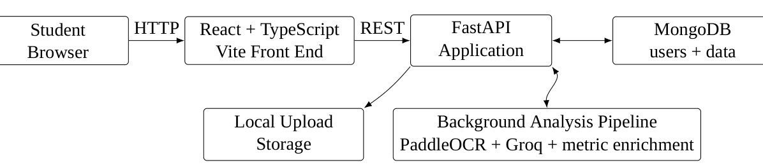
Figure 1.1: High-level view of the implemented Student Performance Analysis System
Figure 1.1 summarizes the main runtime relationships documented in the system design. The browser communicates with FastAPI through HTTP endpoints. FastAPI writes and reads MongoDB documents, stores uploaded files, and starts the analysis work through FastAPI background tasks. After OCR and the Groq advisor request, the backend attempts to append the rule-based knowledge score and experimental development classifier output to the same result string.

1.5 Key Terminology
Core terminology used throughout the black book
OCR | Optical Character Recognition used to convert text in uploaded images into machine-readable text.
Analysis | The stored record representing one uploaded paper and its generated advisory output.
Subject | The subject string supplied by the student and inserted into the AI analysis prompt.
Background task | FastAPI background processing used after an analysis record is created.
Access token | JWT bearer token stored by the browser and sent in the Authorization header.
Protected route | A React route that checks for an access token before rendering its page.
Heuristic score | A rule-based numeric estimate derived from text features, not a verified exam mark.
Development classifier | A small trained model that predicts one of four text-derived development categories.
Synthetic dataset | Generated training/evaluation examples that are not observations of real students.
CHAPTER 2

PROBLEM, OBJECTIVES AND SCOPE
This chapter explains the problem the project addresses, the objectives that can be verified from the implementation, the users and boundaries of the current system, and the distinction between implemented behavior and future scope.

2.1 Problem Statement
Students produce handwritten or printed answer sheets, but a useful performance review often requires a human reviewer to read the material, interpret content, identify conceptual gaps, and communicate precise next steps. The project targets a narrower and automatable portion of that process: extracting written content from an uploaded paper and generating subject-specific conceptual feedback from that content.
The project explicitly positions the application as an AI-powered learning platform. The home page describes an upload, AI analysis, and performance-report flow. The current backend implementation supports this workflow through image upload, OCR, a subject-specific prompt, LLM generation, and persistence of the analysis result.

2.2 Objectives
The verified objectives of the implemented system are:
- Provide a web interface for students to register and authenticate.
- Allow an authenticated student to upload a test-paper image together with a subject name.
- Store the submitted analysis request in MongoDB with an explicit processing status.
- Perform OCR on the uploaded image using PaddleOCR in CPU mode.
- Construct a subject-focused prompt from the extracted text.
- Request a structured advisory response from the configured Groq language-model client.
- Update the original analysis record with the generated response and a completed or failed status.
- Let the browser poll the analysis endpoint while processing is underway.
- Provide history, deletion, profile viewing, and profile update functionality.

2.3 Scope
Scope of the current implementation
In scope | Student registration, login, protected pages, image upload, subject input, OCR, AI feedback generation, analysis status polling, history retrieval, history deletion, profile retrieval, profile update, local upload storage, MongoDB persistence.
Out of scope in the current HTTP workflow | PDF uploads through the dashboard, reference-answer grading, validated official marks, persistent job queues, teacher/admin roles, batch uploads, and a separate MongoDB service in the provided Docker Compose file.
Standalone capability | The project’s main.py contains a file-processing path for both images and PDFs, but the web endpoint in index.py validates the uploaded content as an image.

2.4 Actors
The implemented front end has one principal human actor: the student. The student can access public pages such as Home and About, register and login, then access protected Dashboard, History, and Profile pages. External software components act as supporting actors or services: MongoDB, PaddleOCR, and the Groq LLM service.
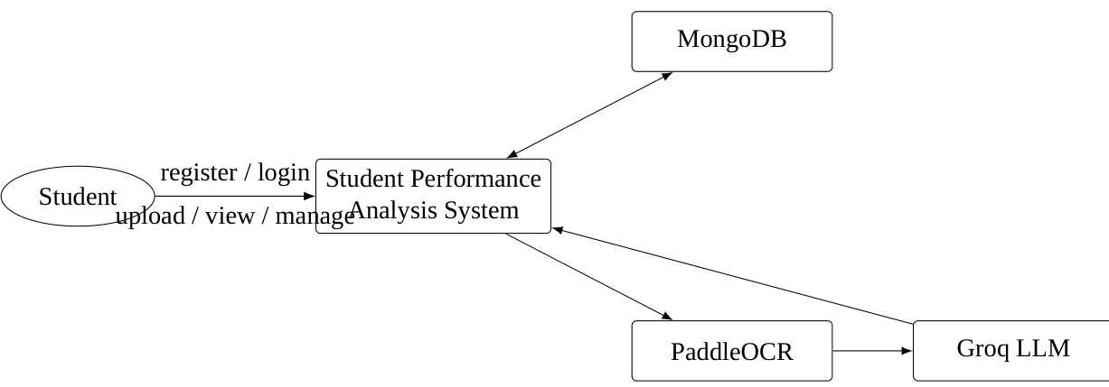
Figure 2.1: Project actor and service context
The context diagram in Figure 2.1 shows the student as the primary actor while database and AI services support system behavior. No separate teacher, reviewer, or administrator role is represented because no such role is implemented in the current implementation.

2.5 Constraints
The implementation contains several constraints that should be understood as design boundaries rather than hidden behavior. Authentication is based on JWTs stored in browser local storage. CORS is configured for the local Vite development origin http://localhost:5173. The backend reads MONGO_URL from environment variables, while the supplied Compose file provisions MySQL rather than MongoDB. The AI processing is therefore dependent on an externally configured MongoDB instance and Groq credentials in the runtime environment.
CHAPTER 3

REQUIREMENTS AND FEASIBILITY
This chapter translates the implemented project functionality into functional and non-functional requirements and examines technical, operational, and deployment feasibility without assuming requirements that are not represented in the code.

3.1 Functional Requirements
Functional requirements and implementation evidence
ID | Requirement | Verified implementation
ID | Requirement | Verified implementation
FR-01 | Registration | User data and a required profile image are received through /register.
FR-02 | Duplicate check | Registration checks whether the submitted email already exists.
FR-03 | Password confirmation | Registration compares create and confirm password values before insertion.
FR-04 | Password hashing | Argon2 is used through Passlib before storing the password.
FR-05 | Login | /login accepts an OAuth2 password form and verifies the stored password.
FR-06 | Token generation | A JWT access token contains the MongoDB user id as the subject and an expiration.
FR-07 | Protected navigation | React routes for dashboard, profile, and history are wrapped in ProtectedRoute.
FR-08 | Paper upload | /dashboard accepts an image and subject for an authenticated user.
FR-09 | Analysis status | An analysis document starts with status processing.
FR-10 | Background processing | FastAPI BackgroundTasks invokes the OCR + LLM pipeline.
FR-11 | Analysis retrieval | returns processing, completed, or failed state plus analysis text.
FR-12 | History | /history returns the current user’s analysis documents sorted newest first.
FR-13 | Delete history | deletes an analysis owned by the current user.
FR-14 | Profile | /profile returns profile fields for the authenticated user.
FR-15 | Profile update | /profile_update updates text fields and can replace the profile image.
FR-16 | Subject-knowledge metric | The pipeline attempts a rule-based score using text length, vocabulary variation, subject terms, explanation markers, and sentence structure.
FR-17 | Development category | The pipeline attempts a four-class PyTorch prediction after the advisor response; output is experimental and may be omitted if the model or dependencies fail to load.

3.2 Non-Functional Requirements
Non-functional properties visible in the implementation
Security | Passwords are hashed with Argon2; protected API routes validate a JWT bearer token.
Maintainability | Front end and back end are separated into distinct directories, and the backend is organized into schema, utility, processing, and model modules.
Usability | The React UI provides validation messages, loading states, completion states, error alerts, and history/profile screens.
Responsiveness | The front end uses Tailwind utility classes and responsive layout variants such as sm, md, and lg.
Interoperability | The browser communicates with FastAPI over HTTP and uses JSON responses plus multipart form data for uploads.
Persistence | User and analysis metadata are stored in MongoDB, while uploaded image files are stored on the backend filesystem.
Performance behavior | Long-running analysis is moved to a FastAPI background task so the initial dashboard request can return a processing id.

3.3 Technical Feasibility
The project is technically feasible because each major step is represented by a concrete technology and code path. React and Vite provide the client runtime; FastAPI exposes the HTTP API; MongoDB provides document storage; PaddleOCR provides text extraction; and Groq provides the LLM request. The current Dockerfile uses Python 3.12 and installs the backend dependencies inside a Linux container.

3.4 Deployment Feasibility Observation
The project contains a Docker Compose file that provisions a MySQL container and a backend container. However, the backend code in the application imports pymongo, creates a MongoClient, and uses MongoDB collections for application data. No MySQL driver or SQLAlchemy model layer is present in the current backend dependencies. This creates a deployment configuration mismatch that should be documented explicitly.

3.5 Operational Feasibility
The student workflow is straightforward: register, log in, select a subject, upload an image, wait for analysis, and review the report. The dashboard stores the active analysis id locally so status polling can resume after a page lifecycle interruption.
CHAPTER 4

SYSTEM ANALYSIS AND USER WORKFLOWS
This chapter analyzes the implemented system as a set of user-facing workflows, validation paths, state transitions, and data interactions. The diagrams focus on how the current code behaves rather than on a generalized ideal architecture.

4.1 Application Navigation
The React application maps user navigation to page components through React Router. Public routes include Home, Register, Login, and About. Protected routes wrap Dashboard, Profile, and History. Navbar visibility is suppressed on Login and Register; on other pages, Navbar is rendered globally. The navbar itself checks the token by calling the profile endpoint and switches between guest and authenticated navigation.
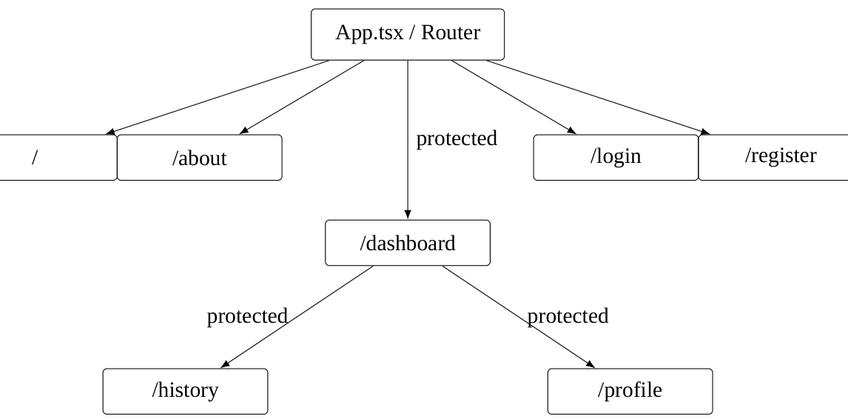
Figure 4.1: Implemented front-end route structure

4.2 Registration Workflow
Registration collects a profile image, username, age, class, description, email, and two password fields. The front end creates a multipart form containing a JSON-encoded user object and the selected image. FastAPI parses the JSON into RegisterSchema, checks duplicate email and password confirmation, writes the image, hashes the password with Argon2, and inserts a user document into the users collection.
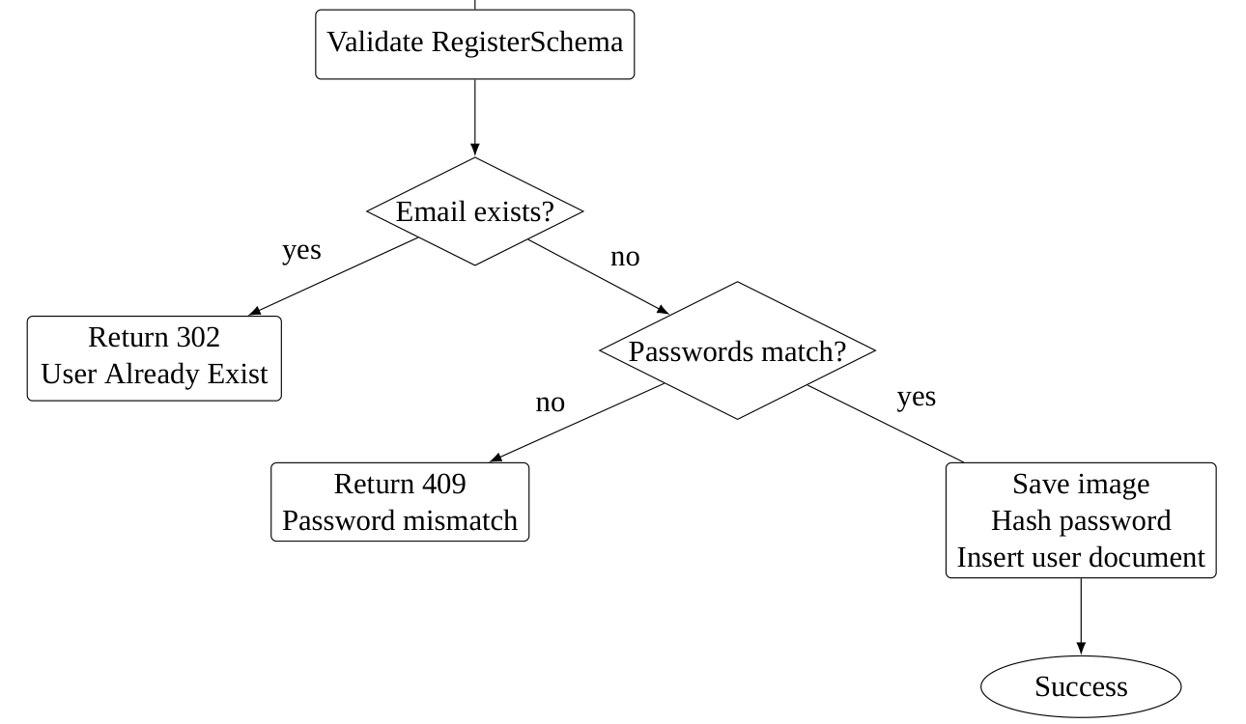
Figure 4.2: Registration workflow derived from the current API and form implementation

4.3 Login Workflow
Login uses an OAuth2 password form rather than JSON. The browser sends username and password as URL-encoded form data. The FastAPI handler finds the user by username, verifies the password against the Argon2 hash, and returns a bearer token. The front end places the token in local storage and navigates to the dashboard.

4.4 Protected Route Workflow
The React ProtectedRoute component performs a local token-presence check. It is a navigation guard rather than the final security boundary. The backend separately validates the bearer token on protected endpoints through the JWT dependency. The front end also contains an autoLogout utility that removes the token and navigates to login when a protected request returns a 401 response.
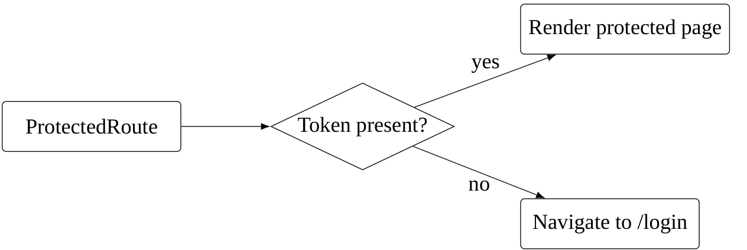
Figure 4.3: Front-end protected-route decision

4.5 Analysis Workflow
The main student workflow begins when the dashboard validates that an image is selected and a subject is non-empty. The request is then sent to /dashboard. The backend stores the upload path, an empty analysis, creation time, user id, subject, and processing status. It immediately schedules process_analysis. The front end stores the analysis id and polls every six seconds while the status remains processing. On completion, the dashboard stops polling, shows a brief completion animation, and renders the feedback; a failed response stops polling and displays an error.
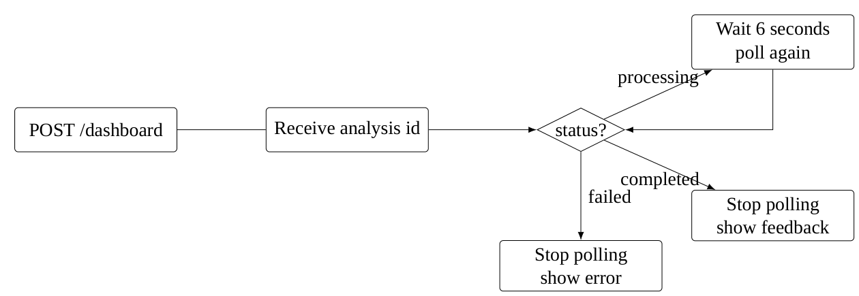
Figure 4.4: Client-side status polling flow

4.6 History and Profile Workflows
History retrieves records belonging to the current user, displays the uploaded image and a text preview, and opens a modal containing the full AI response. A separate delete action invokes the delete-history endpoint. Profile loads profile data and history length, displays the student’s details, and opens a profile-update modal. The update endpoint can modify text fields and optionally replace the image.

4.7 State Model for an Analysis
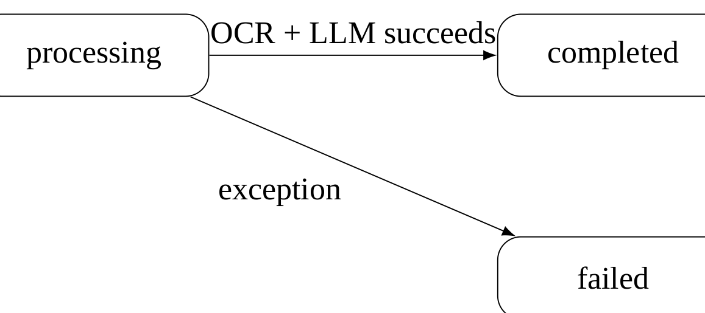
Figure 4.5: Analysis record state transition implemented by the backend
Figure 4.4 reflects the exact statuses used in the code. There is no separate queued state in the database. The user-visible lifecycle begins with processing and ends with completed or failed.
CHAPTER 5

SYSTEM ARCHITECTURE AND DESIGN
This chapter presents the implemented software architecture, major components, communication boundaries, deployment relationships, and the rationale implied by the current separation between the user interface, API layer, data layer, file storage, OCR, and AI service.

5.1 Architectural Style
The system is best described as a client-server application with a modular backend rather than as a microservice system. The browser application is a separately built React client. FastAPI serves as a single application server exposing the domain endpoints and invoking processing helpers. MongoDB is the persistence layer, while local storage holds uploaded image files. The analysis pipeline is invoked as a background task but remains inside the backend process.

5.2 Component View
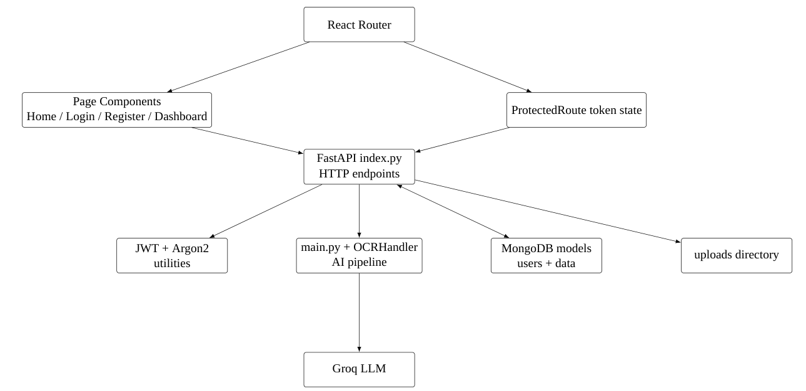
Figure 5.1: Component-level architecture of the current application

5.3 Frontend Layer
The front end is organized as a Vite application using React and TypeScript. Page components are located under src/pages. Shared behavior such as protected routing and automatic logout is under src/lib. The application uses Axios for HTTP communication, React Router for navigation, React Markdown for rendering AI feedback, and Sonner for toast notifications. Tailwind CSS supplies the utility-first visual layer.

5.4 Backend Layer
The backend’s principal API module is index.py. It configures CORS, mounts static uploads, defines registration, login, dashboard, analysis retrieval, history, history deletion, profile, and profile-update routes, and imports the automated pipeline. Supporting modules contain schema definitions, database initialization, token creation and validation, password hashing, OCR handling, and prompt text.

5.5 Background Processing Boundary
The backend creates the analysis record synchronously, then delegates the expensive processing to a FastAPI background task. This design keeps the first dashboard response short and gives the browser an analysis id immediately. The browser then performs status reads rather than holding the original HTTP request open for the entire OCR and LLM operation.
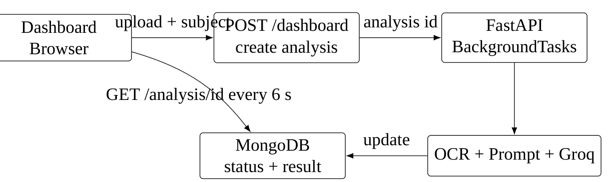
Figure 5.2: Asynchronous analysis interaction used by the dashboard

5.6 Deployment View
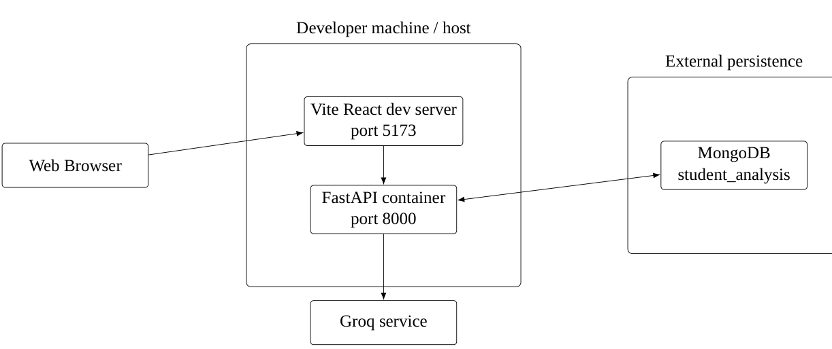
Figure 5.3: Deployment model implied by the current code and runtime configuration
The deployment diagram intentionally separates the configured application database from the MySQL service declared in Docker Compose. The backend reads MONGO_URL and constructs a MongoClient, so MongoDB is an external dependency from the application’s perspective.
CHAPTER 6

AUTHENTICATION AND USER MANAGEMENT
This chapter documents registration, login, JWT handling, route protection, password hashing, profile access, and user-specific ownership checks in the application.

6.1 Registration Data Model
The registration schema defines username, age, student class, description, email, create password, and confirm password. Registration also requires an uploaded image. The backend validates the JSON representation through Pydantic and then builds a MongoDB document with the hashed password.
Registration inputs supported by the backend schema
Field | Type | Use
username | string | Login identity and display name.
age | integer | Student profile data.
studentClass | string | Academic class / standard.
description | string | Short student profile description.
email | EmailStr | Registration duplicate check and contact field.
create_password | string | Password input before hashing.
confirm_password | string | Confirmation value checked against create_password.
image | file | Profile image stored under the uploads directory.

6.2 Password Hashing
The utility module configures Passlib with the Argon2 scheme. Registration calls hashpassword; login calls verifyPassword. The plaintext password is therefore not inserted directly into the stored user document.

6.3 JWT Access Token
The token utility reads SECRET_KEY, ALGORITHM, and ACCESS_TOKEN_EXPIRE_MINUTES from the environment. A token is created with the MongoDB user id stored as the sub claim and an exp claim. Protected endpoints depend on FastAPI’s OAuth2 bearer scheme and decode the token before accepting the request.
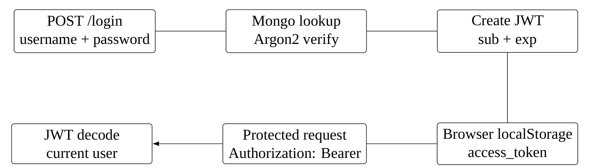
Figure 6.1: Authentication token lifecycle

6.4 Ownership Checks
Analysis retrieval and deletion include both the analysis identifier and the authenticated user id in their MongoDB query. History similarly filters documents by the current user id. These conditions ensure that the relevant API queries are scoped to the authenticated owner according to the current implementation.

6.5 Profile Management
The profile endpoint maps the MongoDB user document into ProfileSchema. The update route accepts a JSON user payload plus an optional image file. It filters out null values, writes a new image when present, updates the MongoDB document, and returns the updated profile subset.

6.6 Authentication Limitations and Observations
The browser stores the access token in local storage. The project does not implement refresh tokens or a server-side session store. The front-end token presence check is local, while the backend remains the authoritative validation layer for protected API requests.
The backend’s credential settings depend on environment variables. The .env.example file contains placeholder values rather than real secrets, which is appropriate for a configuration template. The actual runtime requires valid values in the deployment environment.
CHAPTER 7

AI ANALYSIS PIPELINE
This chapter documents the project’s central processing pipeline: uploaded image validation, OCR, subject-specific prompt construction, Groq LLM inference, result persistence, and browser polling. It also distinguishes the web workflow from the standalone PDF-capable helper included with the application.

7.1 Pipeline Overview
The AI analysis pipeline begins after the dashboard has saved the uploaded image and inserted an analysis record. The backend invokes run_automated_pipeline(image_path, subject). The pipeline initializes an OCRHandler, extracts text, validates that usable text was detected, formats the prompt with the subject and OCR output, and requests a response from the Groq client using the openai/gpt-oss-120b model name present in the code. Two post-processing steps may then append a subject-knowledge heuristic report and a development-classifier report before the combined text is persisted.
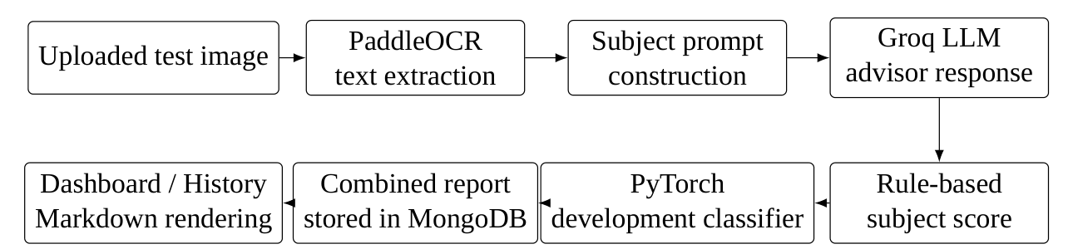
Figure 7.1: End-to-end AI analysis pipeline with post-LLM metric enrichment

7.2 OCR Layer
The OCR handler explicitly disables several oneDNN-related flags before importing PaddleOCR and initializes the OCR engine with text-line orientation support, English language, CPU execution, and disabled MKLDNN. The extraction method supports multiple result wrapper shapes and collects recognized text into a newline-separated string.
This implementation is defensive with respect to PaddleOCR result representations. It checks direct recognition attributes, dictionary responses, document-level structures, and generic nested response data. If no meaningful text is found, the pipeline returns a descriptive failure result rather than sending empty content to the language model.

7.3 Prompt Engineering
The prompt in prompts.py is deliberately restrictive. It instructs the model to remain inside the specified subject, avoid generic advice, identify exact sub-topics and relationships, and ground conclusions in the extracted notes. The requested output format contains four sections: Conceptual Performance Summary, Targeted Learning Roadmap, Concept Check, and Advisor Note.
Prompt constraints used by the analysis pipeline
Prompt rule | Purpose
Stay within subject | Reduces irrelevant analysis outside the student’s selected subject.
No generic advice | Encourages recommendations tied to the extracted content.
Name exact sub-topic | Makes the feedback actionable.
Concrete next action | Converts identified gaps into a learning activity.
Do not invent topics | Restricts unsupported assumptions.
Exact output format | Produces stable sections for front-end Markdown rendering.

7.4 LLM Invocation
The Groq client is constructed inside the pipeline. The request specifies a system message describing a strict academic-advisor role and a user message containing the formatted prompt. Temperature is set to 0.7, maximum output length to 1500 tokens, top-p to 1.0, and streaming is disabled. The initial returned message is then used as the base string to which the two custom metric sections are appended on a best-effort basis; the final combined Markdown becomes the stored analysis string.

7.5 PDF Processing Capability
The standalone main.py contains a helper that converts a PDF into images with pdf2image, then processes each page through the same OCR, Groq, and best-effort metric-enrichment path. However, the HTTP dashboard endpoint currently rejects non-image uploads through an image content-type check. Therefore PDF processing exists as a standalone helper path, not as a currently exposed dashboard capability.
Implementation evidence. The standalone helper imports pdf2image when a PDF is passed. The backend does not list pdf2image; the source code itself also points to Poppler as an additional system requirement. This should be treated as a deployment consideration for the standalone PDF path.

7.6 Persistence of the Result
On successful completion, the background task updates the original analysis document by matching both the analysis id and user id, then sets analysis and status=completed. On an exception, the implementation attempts to update the document to status=failed. If that secondary update also fails, the error is printed to the server log.
CHAPTER 8

CUSTOM METRICS AND STUDENT DEVELOPMENT
This chapter documents the two custom analysis components: a transparent rule-based subject-knowledge heuristic and an experimental PyTorch classifier that estimates a development category. It distinguishes their implemented calculations from validated academic grading and summarizes the synthetic data and dependency limitations that affect interpretation.

8.1 Purpose and Integration
The original OCR and Groq stages produce a natural-language advisor response. The newer implementation adds two distinct signals to that response. The first computes a numeric heuristic from the OCR text and subject. The second uses a small trained multilayer perceptron (MLP) to classify the answer into one of four text-derived development levels. Both outputs are appended to the existing Markdown string rather than stored as separate database fields or exposed through independent API endpoints.
These components should be interpreted as experimental learning aids. The rule-based score measures observable text characteristics and selected subject vocabulary; it does not compare the answer with an authoritative solution. The neural classifier was trained on generated examples whose labels are related to template patterns and score ranges. Neither metric has been externally validated against real student answers.

8.2 Rule-Based Subject-Knowledge Score
The class SubjectKnowledgeModel is implemented in . It receives OCR text and a subject name, optionally matches numbered question boundaries, and scores each detected answer. If recognizable question numbering is missing, the entire OCR text is treated as one answer so the program does not invent question boundaries. The model contains subject-term dictionaries for computer science, mathematics, physics, chemistry, and biology. Other subjects can still receive text-structure points, but the integration does not supply a custom term list for unrecognized subjects.
Components of the rule-based subject-knowledge heuristic
Scoring component | Maximum | Calculation represented in code
Answer depth | 30 points | Word count rises linearly up to the 80-word cap.
Vocabulary variety | 15 points | Ratio of unique words to total words.
Subject terminology | 25 points | Up to five distinct matching subject terms.
Explanation markers | 15 points | Up to three detected explanation words or phrases.
Structure | 15 points | Up to four sentence-like units split by punctuation.
The five components sum to a nominal maximum of 100 points. Very short answers are capped further in the code: fewer than five words cannot score above 10, and answers under 15 words cannot score above 35. The model averages the resulting answer scores to obtain the overall knowledge score. Topic ratings are created from vocabulary matches and inherit the answer score; they are not separate factual assessments of each concept.
The output formatter in converts the result to Markdown containing the subject, overall score, a verbal rating, topic ratings, recommendations, an assessment summary, and explicit limitations. It labels the method as a rule-based heuristic rather than official grading.

8.3 Student Development Classifier
The student_development package adds a small PyTorch MLP. During prediction, the code loads the saved weights from models/development_model.pt and normalizing statistics and labels from models/model_metadata.json. The classifier consumes ten numeric features extracted from the answer and advisor report. These include answer word count, unique-word ratio, sentence count, explanation-marker count, subject-term count, average word length, the subject score, counts of selected positive and improvement-oriented terms in the advisor report, and advisor-report word count.
Architecture of the student development MLP
Network element | Implementation evidence
Input | 10 numeric text/report features.
Hidden layer 1 | Fully connected layer with 32 units and ReLU activation.
Regularization | Dropout probability of 0.10 after the first hidden layer.
Hidden layer 2 | Fully connected layer with 16 units and ReLU activation.
Output | Four logits mapped by softmax to the labels in model metadata.
Inference | Checkpoint is loaded on CPU; inference runs without gradient calculation.
The predicted categories are Needs Improvement, Developing, Proficient, and Advanced. The report also includes class scores, the subject score used, an extracted word count, simple strengths and improvement suggestions, and a warning about limitations. The class scores are the model’s softmax outputs; the code explicitly cautions that they are not calibrated probabilities of actual student ability.

8.4 Synthetic Dataset and Training Procedure
The generate_dataset.py module builds a synthetic starter dataset with 1,000 generated examples: 250 records per label. Example subject areas include thermodynamics, computer science, biology, mathematics, and physics. Each example combines a templated answer, subject, a score drawn from a label-associated range, a short advisor report, and a generated development label. The generator uses random seed 42 for repeatability.
The training script computes the ten numeric features and standardizes them using training-set means and standard deviations. The training procedure uses stratified splitting to form approximately 70 percent training data, 15 percent validation data, and 15 percent test data. The MLP is optimized with Adam at learning rate 0.003 and cross-entropy loss. Training can stop early after 20 consecutive validation checks without sufficient loss improvement, with an upper bound of 300 epochs. The best validation-loss checkpoint is evaluated on the held-out synthetic test partition.
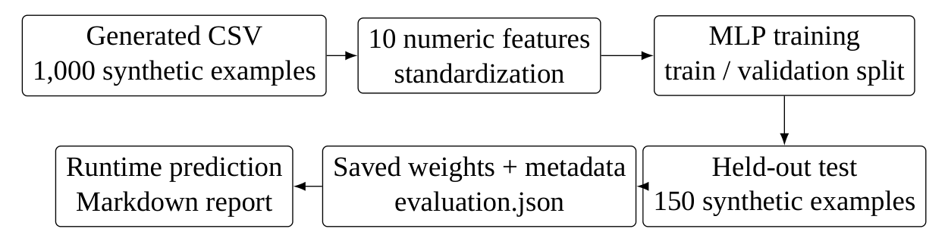
Figure 8.1: Training and inference artifact flow for the experimental development classifier

8.5 Evaluation Artifact and Interpretation
The evaluation.json file reports a test accuracy of 1.00 and precision, recall, and F1-score of 1.00 for each of the four classes on a held-out partition containing 150 synthetic examples. The confusion matrix stored in that file is diagonal. This is best described as the evaluation file’s result on generated synthetic examples only. Since the generator creates labels from templates and scores that are intentionally correlated with those labels, this evaluation does not demonstrate generalization to real student work and must not be described as a 100 percent real-world accuracy result.
What the classifier evaluation does and does not establish
Evaluation field | Recorded value
Dataset type | Synthetic
Held-out support | 150 generated examples
Test accuracy | 1.00
Precision / recall / F1 per class | 1.00 / 1.00 / 1.00 for each class in the evaluation file
Confusion matrix | Diagonal; no errors recorded in this synthetic split
Real-student validation | Not provided

8.6 Runtime Integration and Dependency Notes
In main.py, the subject-knowledge report is generated after the Groq response and appended to the response string. The development report is then attempted inside a separate exception handler. This design means a metric failure is logged and can be skipped without necessarily discarding the base Groq advisor response. The dashboard and history views use React Markdown to render the resulting combined string. The API contract remains the existing /dashboard and /analysis/{analysis_id} workflow; no separate scoring endpoint was added.
The development predictor imports PyTorch and NumPy, and its feature-extraction module imports scikit-learn utilities. The package README instructs developers to install torch, numpy, and scikit-learn, but the checked-in does not explicitly declare these three packages. A clean Docker or virtual-environment installation may therefore skip development classification when the import fails. This should be resolved in dependency management before treating the component as consistently available.

8.7 Limitations and Safe Use
The two metric additions are not equivalent to answer marking. The subject score does not check a reference answer or establish whether statements are correct. Its result changes with OCR quality, text length, punctuation, and recognized vocabulary. The classifier learns patterns present in synthetic templates and uses lightweight text/report features rather than a domain-specific semantic representation. It may therefore reward surface characteristics unrelated to the correctness of an answer. The report’s own warnings are appropriate: neither output should be used as an official grade, admission decision, ranking, or other high-stakes judgment.
Further validation requires reviewed and consented real examples with reliable human labels, clear separation between training and evaluation sources, per-subject analysis, error analysis, and calibration checks. If a production learning tool is pursued, the interface should make the experimental status clear and allow students to challenge or disregard an unsupported prediction.
CHAPTER 9

DATA MANAGEMENT AND STORAGE
This chapter describes the MongoDB collections, document fields, ownership relationships, uploaded-file storage, analysis lifecycle, and the mismatch between the application data layer and the MySQL service declared in Docker Compose.

9.1 Database Initialization
The database module loads the MONGO_URL environment variable, creates a MongoClient, and selects the database named student_analysis. The models module exposes two collections: users and data.

9.2 Conceptual Document Relationship Model
Although MongoDB is document-oriented rather than relational, the implemented documents can be described through a conceptual entity relationship model. A user may own multiple analysis documents, represented by the userId field in the analysis collection.
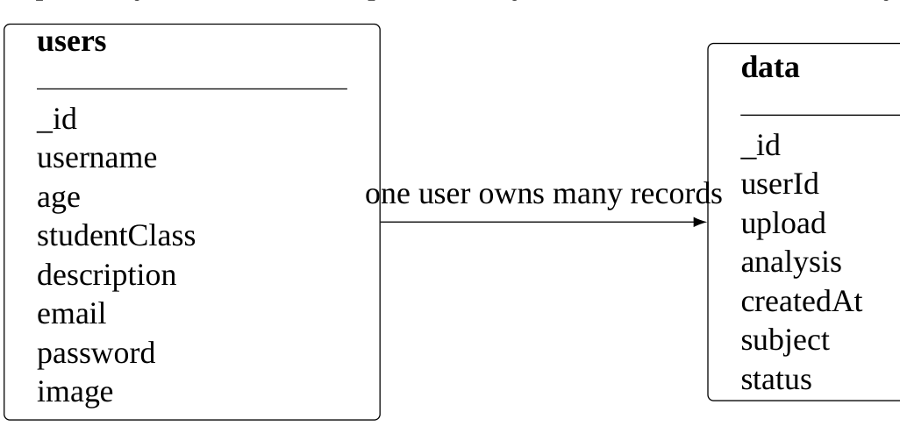
Figure 9.1: Conceptual data relationship between users and analysis documents

9.3 User Document
A stored user document includes the profile image path, username, age, class, description, email, and a hashed password. The code checks duplicate email during registration but logs in by username. This means the email participates in uniqueness validation while the username serves as the authentication lookup key.

9.4 Analysis Document
The analysis document contains the uploaded file path, generated analysis text, creation timestamp, current user id, subject, and status. The initial document is inserted before AI processing begins. On completion, the analysis field stores one combined Markdown string containing the Groq advisor response and any successfully appended subject-knowledge and student-development reports; these outputs are not stored as separate database fields. The persistent identifier enables the front end to poll the same record until the asynchronous task updates it.

9.5 File Storage
Uploaded images are stored beneath the backend’s uploads directory and served through FastAPI’s StaticFiles mount at /uploads. The Compose configuration also maps the upload directory to a host path so uploaded content can persist across container replacement according to the local mount configuration.

9.6 Data Access Patterns
Primary data access patterns implemented by the backend
Operation | Collection | Query basis
Register | users | email duplicate check then insert.
Login | users | username lookup.
Profile | users | authenticated user id.
Profile update | users | authenticated user id.
Create analysis | data | insert with user id.
Get analysis | data | analysis id + user id.
History | data | user id, sort by _id descending.
Delete history | data | analysis id + user id.

9.7 Persistence Configuration Observation
The project contains a docker-compose.yml that creates a MySQL container named mysql-container, sets the database to fastapi_db, and mounts the data directory into the MySQL data directory. The FastAPI application, however, does not import a MySQL client and instead connects to MongoDB through MONGO_URL. Therefore the Compose file should not be represented as the application’s active database architecture without qualification.

9.8 Data Integrity Considerations
The code enforces user ownership at the query level for analysis retrieval and deletion. It also converts MongoDB ObjectIds to strings when returning data to the client. The history front end models its id as a number in TypeScript while the backend sends strings; this is a type-level mismatch visible in the implementation and worth resolving in a future cleanup.
CHAPTER 10

FRONT-END IMPLEMENTATION
This chapter documents the React user interface, routing, form handling, dashboard state management, history rendering, profile management, and user feedback mechanisms as implemented in the Vite front end.

10.1 Technology Stack
Front-end technology stack
Technology | Role | Implementation evidence
React 19 | UI framework | Declared in package.json.
TypeScript | Static typing | Page and component files use TSX/TS.
Vite | Development/build tool | Scripts include vite, vite build, and vite preview.
React Router | Page navigation | Routes are defined in App.tsx.
Axios | HTTP client | Used by authentication, dashboard, history, profile, and navbar.
React Markdown | Feedback rendering | Dashboard and history render stored analysis as Markdown.
Tailwind CSS | UI styling | Front end imports Tailwind and uses utility classes extensively.
Sonner | Notifications | Login, register, dashboard, profile, and history use toast feedback.
Lucide React | Icons | Dashboard and UI alerts use icon components.

10.2 Application Shell
App.tsx controls route registration, global navbar visibility, and the Sonner toaster. The top-level background is a light interface surface. Navbar is hidden on the login and register routes, while the authenticated and public content pages share the common shell.

10.3 Home Page
The home page explains the product as an AI-powered learning platform. It visually presents a three-step concept: upload a test paper, perform AI analysis, and use a performance report for improvement. The project language also describes handwritten or printed answer sheets and emphasizes conceptual feedback.

10.4 Dashboard
The dashboard is the central interaction point. The left side collects a subject and an image. The right side displays the generated report or a loading, completed, or error state. The component uses React state for image, subject, loading, feedback, completion state, and errors. A ref stores the polling interval and another ref is used to scroll the feedback area after completion. The returned Markdown can contain the Groq advisor response, the Answer Knowledge Scoring section, and an experimental Student Overall Development section; the browser treats them as one report string.
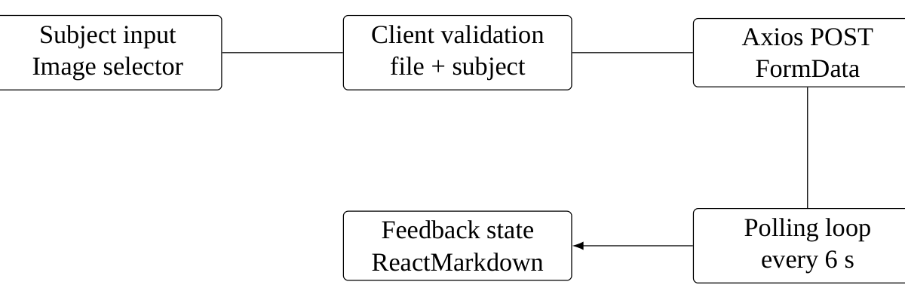
Figure 10.1: Dashboard client-side processing flow

10.5 History
History fetches the authenticated user’s analysis records. Each record shows an uploaded image, a text preview, timestamp, and delete control. Clicking the card opens a modal with the test image and the complete Markdown analysis. The history page also includes an empty state and a loading skeleton.

10.6 Profile
The profile page fetches both profile information and history to compute the total number of analyses. The page supports profile image preview, profile update via a modal, and display of username, email, age, class, description, and analysis count.

10.7 User Feedback
The front end uses toasts for successful registration, successful login, session expiration, validation warnings, analysis completion, and error conditions. Loading states use spinners or skeleton content. The new metrics do not add separate visual widgets or API calls: their Markdown sections are displayed in the same result area and history modal as the advisor response. This gives the UI explicit status communication around operations that may take several seconds.

10.8 Responsive Behavior
The code uses responsive Tailwind variants including sm, md, and lg. Dashboard content transitions from a single-column view to a two-column layout on larger screens. Registration and profile forms use responsive grids for age/class and password fields.

10.9 UI Design Observations
The current implementation uses a modern gradient-oriented interface with indigo and violet accents. Because the black book itself must be strictly black-and-white, these application colors are described textually in this documentation but are not reproduced as colored pixels in the report.
CHAPTER 11

BACK-END IMPLEMENTATION AND API
This chapter explains the FastAPI implementation module by module, describes the HTTP interface used by the front end, and traces how request validation, authentication, persistence, and background AI processing fit together.

11.1 Cross-Origin and Local Development Configuration
The backend configures CORS for the single origin http://localhost:5173. The front end directly calls http://127.0.0.1:8000. This confirms a local development-oriented configuration rather than a production reverse-proxy arrangement.

11.2 Backend Module Organization
Backend module responsibilities
index.py | FastAPI application, CORS, uploads, all current HTTP routes, and background-task orchestration.
main.py | OCR + prompt + Groq pipeline, best-effort metric enrichment, and standalone image/PDF file-processing helpers.
ocr_handler.py | PaddleOCR initialization and robust extraction of recognized text.
prompts.py | Subject-focused academic-advisor prompt template.
 | Rule-based rubric for answer text, terminology, explanation markers, and structure.
 | Converts rule-based scoring output to Markdown.
 | Synthetic data generator, feature extraction, PyTorch classifier, prediction formatter, metadata, and evaluation artifact.
database.py | MongoDB client and database selection.
models.py | Names for users and analysis collections.
schema.py | Pydantic validation models for registration and profile operations.
 | JWT creation, OAuth2 bearer dependency, and current-user extraction.
 | Argon2 hashing and verification.

11.3 API Surface
Implemented HTTP endpoints
Method | Path | Purpose
Method | Path | Purpose
POST | /register | Register a student with profile data and image.
POST | /login | Authenticate username/password and return bearer token.
POST | /dashboard | Create a new analysis request for an uploaded image and subject.
GET |  | Retrieve the current analysis state and output.
GET | /history | Return current user’s previous analysis documents.
DELETE |  | Delete one owned analysis document.
GET | /profile | Return current user profile.
PUT | /profile_update | Update profile fields and optional profile image.

11.4 Registration Endpoint
The route receives the user object as form data and the profile image as an uploaded file. It parses the object with Pydantic, checks for duplicate email, checks matching passwords, writes the image, hashes the password, and inserts the document. The endpoint returns a short success message after insertion.

11.5 Login Endpoint
The login route uses FastAPI’s OAuth2PasswordRequestForm. A missing username produces a 404 response in the current code. An incorrect password produces a 401 response. A successful request returns the access token and its type.

11.6 Dashboard Endpoint
The dashboard route is the main protected creation endpoint. It validates that the upload content type starts with image/, trims the subject, writes the file to the uploads directory, creates the processing document, schedules the background task, and returns the generated analysis id.

11.7 Analysis, History and Profile Endpoints
The analysis retrieval route converts the provided id to a MongoDB ObjectId, looks up the matching record owned by the current user, and returns the id, status, and analysis text. This focused response matches the dashboard polling design.
History is sorted by the MongoDB document id in descending order, which acts as a recency proxy. Each document’s MongoDB ObjectId and user id are converted to strings before serialization. Deletion uses a combined query on analysis id and user id.
The profile endpoint maps database fields into a Pydantic response model. The update route uses optional image and partial text fields, writes the image when present, then returns the updated visible profile properties.
CHAPTER 12

TESTING AND VERIFICATION
This chapter documents the evidence available for verification, the test scenarios implied by the implemented behavior, and the boundaries of what can truthfully be reported about execution results. The project does not contain a conventional automated test suite, so unverified outcomes are not presented as passed results.

12.1 Testing Evidence Available in the Project
The project does not include a dedicated pytest or unittest test suite. The OCR module contains a direct execution block that runs OCR against a local image filename for isolated testing. The main pipeline module also contains a direct execution path that selects a sample image or PDF and requests a subject name interactively. The student-development package includes a training-time evaluation artifact in student_development/evaluation.json; this is evidence of a synthetic-data experiment, not a conventional application test suite or real-student validation.
Implementation evidence. The project includes sample upload files and direct-execution test blocks, but it does not include a formal automated test directory or test configuration. Consequently, this chapter separates implementation-verifiable test design from unverified execution outcomes.

12.2 Verification Strategy
The system can be verified at five levels: form and route validation, authentication, data ownership, asynchronous analysis, and user interface state handling. Each level has clear observable conditions in the implementation.
Implementation-based verification scenarios
ID | Scenario | Expected behavior from implementation | Evidence status
ID | Scenario | Expected behavior from implementation | Evidence status
T01 | Register valid user | User document inserted; password hashed; success message returned. | Code path verified
T02 | Register duplicate email | 302 response with duplicate-user message. | Code path verified
T03 | Register mismatched passwords | 409 response. | Code path verified
T04 | Login unknown username | 404 response. | Code path verified
T05 | Login incorrect password | 401 response. | Code path verified
T06 | Access protected route without token | React redirects to login. | Code path verified
T07 | Protected API without valid token | JWT dependency raises 401. | Code path verified
T08 | Dashboard without image | Front end warns and does not submit. | Code path verified
T09 | Dashboard without subject | Front end warns; backend also rejects empty subject. | Code path verified
T10 | Dashboard with image + subject | Analysis record created with processing status. | Code path verified
T11 | OCR success | Extracted text inserted into prompt flow. | Code path verified
T12 | OCR no text | Pipeline returns a descriptive analysis failure text. | Code path verified
T13 | LLM success | Analysis field updated and status becomes completed. | Code path verified
T14 | Pipeline exception | Analysis status is attempted to be set to failed. | Code path verified
T15 | Poll completed analysis | Front end stops polling and displays feedback. | Code path verified
T16 | History load | Current user’s records returned newest first. | Code path verified
T17 | Delete history | Owned analysis is deleted. | Code path verified
T18 | Profile load | User fields and analysis count displayed. | Code path verified
T19 | Profile update with image | Image path and text changes saved. | Code path verified
T20 | PDF through dashboard | Current endpoint rejects non-image content type. | Code path verified
T21 | Rule-based score on very short text | Score is capped when text has fewer than 5 or 15 words. | Code-derived scenario; no automated test shown.
T22 | Unknown subject name | No preset subject vocabulary is matched; generic text features still contribute. | Code-derived scenario; no automated test shown.
T23 | Missing development model/dependencies | Predictor raises during loading; nested handler logs the error and skips classifier output. | Code path verified; clean-install test not shown.
T24 | Classifier metric artifact | The evaluation JSON reports 1.00 scores on 150 synthetic examples only. | Evaluation artifact reviewed; not an application acceptance test.

12.3 Unit-Level Verification Opportunities
The modular structure creates natural targets for future automated tests: schema validation functions, password hashing and verification, JWT creation and decoding, OCR extraction, prompt formatting, and individual API handlers. The lack of a dedicated test suite means these opportunities are documented rather than claimed as already automated.

12.4 Integration Verification
Integration verification should connect the browser, FastAPI, MongoDB, OCR engine, and Groq client. The analysis path is especially important because its observable output depends on external services. A robust integration environment would supply valid environment variables, a reachable MongoDB instance, OCR model dependencies, and valid Groq credentials.

12.5 UI Verification
The front end contains explicit visual states that can be inspected manually: loading skeletons, success toasts, error alerts, empty history state, profile loading, completion animation, and Markdown rendering. These UI states are not separate server features; they are client behaviors layered over the API responses.

12.6 Requirements-to-Evidence Traceability
To strengthen the academic audit trail, the following matrix links user needs to implemented behavior and the available implementation and verification evidence. The final column deliberately distinguishes source inspection from an executed test result.
Requirements-to-evidence traceability matrix
Requirement | User-facing need | Implementation evidence | Verification status
Requirement | User-facing need | Implementation evidence | Verification status
BR-01 | Create an account and sign in. | Registration/login routes, password hashing, JWT utilities and user collection. | Implementation documented; no automated test result recorded.
BR-02 | Submit a paper for analysis. | Dashboard image/subject validation and analysis creation endpoint. | Implementation documented; full browser/API execution not verified here.
BR-03 | Receive readable text-based feedback. | PaddleOCR extraction, subject prompt, Groq request and Markdown result. | Integration depends on OCR runtime and external Groq service; no controlled acceptance result recorded.
BR-04 | Review earlier analyses. | History endpoint and history page use stored analysis records. | Implementation documented; no automated regression test recorded.
BR-05 | Manage profile details. | Profile read/update endpoints and profile page. | Implementation documented; no automated regression test recorded.
BR-06 | See a subject-knowledge estimate. | Rule-based scoring module appended to the analysis report. | Logic reviewed; not validated against reference answers or human scores.
BR-07 | See a development category. | PyTorch predictor and four labels in model metadata. | Synthetic evaluation artifact exists; real-student validation absent.
BR-08 | Keep user analyses separated. | Retrieval/deletion queries include the authenticated user identifier. | Implementation documented; authorization penetration tests have not been demonstrated.
The matrix is a traceability aid, not a claim that every requirement passed an end-to-end test. A future test record should capture a test identifier, environment, input, expected result, actual result, pass/fail status, date, and screenshot or log reference. Where that evidence is absent, the status remains unverified rather than being inferred from the existence of a code path.

12.7 Testing Limitations
The evaluation file reports 1.00 accuracy, precision, recall, and F1 on 150 held-out synthetic records. Because its labels are generated alongside the text templates, these results do not establish real-world student-classification accuracy. No independent human-labelled evaluation set, formal pytest/unittest suite, or end-to-end acceptance report is included with the project.
CHAPTER 13

DEPLOYMENT, CONFIGURATION AND DEVELOPMENT OBSERVATIONS
This chapter explains how the project is configured for local development and containerized backend execution, then records implementation observations that affect reproducibility, portability, and future refinement.

13.1 Backend Container
The backend Dockerfile is based on Python 3.12 slim. It installs build tools, OpenGL-related libraries, Tesseract, and Python requirements. The working directory is changed to /app/src before Uvicorn starts index:app on port 8000.

13.2 Compose Configuration
The supplied Compose file defines two services named db and backend. The database service uses mysql:latest, creates database fastapi_db, exposes port 3306, and mounts the host data directory as the MySQL data directory. The backend service builds from ./back-end, exposes port 8000, loads .env, and mounts uploads and data directories.

13.3 Configuration Variables
The .env.example configuration template declares , , , , and . These values must be provided at runtime. No real secrets are represented in the report.

13.4 Reproducibility Checklist
A fresh environment requires Node and package installation for the front end, a Python 3.12-compatible runtime for the backend container, a MongoDB connection string, valid JWT settings, a Groq API key, and OCR runtime dependencies. To enable the experimental development classifier, the setup guide additionally instructs installing PyTorch, NumPy, and scikit-learn, which are not all explicitly pinned in . The front end expects the API at 127.0.0.1:8000 during development. The backend container is configured to serve on 0.0.0.0:8000.

13.5 Implementation and Deployment Observations
Implementation and deployment observations
Area | Evidence | Implication
Area | Evidence | Implication
Database service | Compose declares MySQL; backend code uses MongoDB. | Deployment definition should be reconciled before relying on Compose as a complete environment.
PDF support | main.py supports PDF pages; dashboard accepts image uploads only. | PDF support is currently exposed as a standalone helper rather than a web feature.
PDF dependency | Source imports pdf2image; requirements do not list it. | Standalone PDF execution needs dependency management outside the current requirements list.
LLM package | Source imports groq; requirements directly list langchain-groq. | Dependency declaration should be reviewed for reproducibility.
Metric packages | Development inference imports torch, numpy, and a feature helper that imports scikit-learn; the package README requests them, but does not explicitly list them. | A clean install may skip the development classifier when imports fail.
Synthetic classifier data | Training rows and evaluation file are included in . | The 1.00 test accuracy only describes the generated held-out split, not real-world validity.
File naming | Uploaded filename is used to build local paths. | A future hardening pass can introduce sanitized, collision-resistant names.
Token storage | Browser token stored in local storage. | Token persistence is simple but depends on browser storage security.
API host | Front end uses 127.0.0.1:8000; CORS allows localhost:5173. | Current configuration is oriented toward local development.
CHAPTER 14

KNOWN ISSUES AND DOCUMENTATION LIMITATIONS
This chapter consolidates the most relevant limitations observed in the implementation so readers can distinguish implemented functionality from unresolved risks. Severity indicates potential impact, not proof that an exploit or failure has occurred in every deployment. Recommendations are presented as future work and are not described as completed changes.

14.1 Known-Issue Register
Known issues and limitations in the application
ID | Area | Priority | Current observation | Reported status / next step
ID | Area | Priority | Current observation | Reported status / next step
KI-01 | Deployment | Critical | Compose defines MySQL while backend source connects to MongoDB. | Reconcile deployment configuration before relying on it.
KI-02 | Upload handling | High | Original upload filename contributes to local path construction. | Security hardening recommended; use generated names and strict validation.
KI-03 | File privacy | High | Uploads are mounted for static serving under the uploads path. | Review access controls and avoid public exposure of private student documents.
KI-04 | Authentication | High | Front end persists bearer token in local storage. | Prototype behavior; consider safer cookie/session design and additional mitigations.
KI-05 | Automated tests | High | No dedicated pytest or unittest suite is included with the project. | Add unit, integration, authorization and upload tests; do not claim unexecuted cases as passed.
KI-06 | AI quality | High | OCR and generated advice have no independent labelled quality evaluation. | Build reviewed datasets and report OCR and feedback-quality metrics.
KI-07 | Classifier validity | High | Development model evaluation uses synthetic generated examples. | Real-student validity is unknown; do not use as an official grade or high-stakes decision.
KI-08 | Dependencies | Medium / High | Metric inference dependencies are not all explicitly declared in requirements. | Pin and declare dependencies; test a clean environment.
KI-09 | PDF workflow | High | A standalone PDF helper exists but dashboard validation accepts images only. | Describe PDF as a helper capability, not an end-to-end user feature.
KI-10 | API typing | Medium | MongoDB identifiers are strings in responses while a front-end history type models ID numerically. | Align the TypeScript model with serialized identifiers.
KI-11 | Reliability | Medium / High | Analysis uses in-process background tasks and client polling. | Add timeouts/retries and a durable worker if operational scale requires it.
KI-12 | Output format | Medium | Advisor and metric content is stored together as Markdown/free text. | Consider validated structured fields for future integration and analysis.

14.2 Interpretation of Severity
The register groups confirmed configuration mismatches and documented absences with engineering risks that should be tested in the deployment environment. For example, a public static upload mount is a privacy concern, but a complete security conclusion requires checking the actual deployment boundary. Likewise, the absence of a project test suite means test execution is not evidenced; it does not prove that developers have never manually tested the application. This distinction is important for an accurate academic report.

14.3 Data Privacy and External Processing
The system stores user profile data, analysis metadata, uploaded answer-sheet images and generated feedback. The pipeline sends OCR-derived student text to an external Groq-hosted language model. Answer sheets may contain identifying or educationally sensitive information, so any real deployment should disclose external processing, limit access, define retention and deletion rules, avoid logging unnecessary content, and obtain appropriate consent. The application does not provide a complete retention or consent workflow; this report therefore records it as a limitation rather than implying compliance has been established.

14.4 AI Reliability and Evaluation Boundaries
OCR mistakes can propagate into the prompt and affect generated feedback. Language-model responses may include unsupported statements, and instructions in a prompt alone do not guarantee correctness. The rule-based subject score relies on text surface features and term dictionaries; the development classifier is evaluated on synthetic examples. Future evaluation should use reviewed examples, human reference labels, per-subject error analysis, OCR character/word error rates, feedback relevance and unsupported-claim measures, and calibration checks. Until then, outputs should be presented as advisory and experimental, not as verified marks.

14.5 Priority for Future Work
A sensible sequence is to resolve the deployment mismatch and upload/privacy risks first, improve dependency reproducibility and authentication safeguards next, then establish repeatable automated tests. Only after a reliable test baseline exists should the project claim measured performance or educational validity. Advanced features such as question-level analysis, progress analytics and persistent job queues should follow this foundation rather than substitute for it.
CHAPTER 15

CONCLUSION AND FUTURE SCOPE
This chapter consolidates the verified capabilities of the Student Performance Analysis System, records the main implementation conclusions, and identifies future work that follows naturally from the current architecture without presenting proposed capabilities as already implemented.

15.1 Implemented System Summary
The application delivers a student-facing flow for account creation, authentication, test-image submission, asynchronous OCR and AI analysis, history management, profile management, a rule-based subject-knowledge estimate, and an experimental four-category development prediction. The implementation combines a React/Vite front end with FastAPI, MongoDB, local file storage, PaddleOCR, Groq, and a small PyTorch classifier. The combined report is subject-aware but is not an official marksheet or verified factual grading result.

15.2 Architectural Summary
The architecture is a client-server application with a single FastAPI backend. The AI pipeline remains inside the backend execution environment and is launched as a FastAPI background task. MongoDB holds user and analysis metadata while uploaded images remain on the backend filesystem. The browser does not call OCR or the LLM directly; those operations stay behind the backend API boundary.

15.3 Observed Strengths of the Current Design
The implementation separates concerns into schemas, authentication utilities, OCR handling, prompt text, a rule-based subject-knowledge module, and a student-development package containing data generation, training, inference, metadata, and evaluation artifacts. The analysis status field and polling strategy provide a way to model a slow AI operation without blocking the original upload request. The metric reports remain appended to one free-text analysis field.

15.4 Current Limitations
The application does not include a formal automated application test suite, a persistent worker queue, or a teacher/admin role model. The subject score is a surface-feature heuristic; the classifier is trained on synthetic examples and has no real-student validation. The classifier dependencies are not fully represented in the requirements file. The dashboard accepts only images even though the standalone helper can process PDFs, and the Compose database definition does not match the MongoDB implementation. The project remains local-development oriented through fixed origins and local upload storage.

15.5 Future Scope
Future development should first validate both metric components using reviewed, consented and human-labelled student work, assess performance separately by subject, investigate errors, calibrate model scores, and clarify how experimental outputs are presented. Other opportunities include declaring and pinning the classifier dependencies, adding formal automated tests, introducing a persistent job queue, exposing validated PDF uploads through the web workflow, using structured fields for separate metric outputs, reconciling MongoDB deployment configuration, and adding longitudinal learning analytics. These are future possibilities; only the implemented workflows described in this report are treated as implemented.

15.6 Conclusion
The Student Performance Analysis System demonstrates an end-to-end pipeline in which the browser submits written work, the backend extracts text through OCR, a subject-focused language model generates advice, custom logic estimates observable answer characteristics, and an experimental classifier adds a development category. The combined output is persisted and displayed through the existing dashboard and history workflow. The system is best characterized as an end-to-end academic prototype rather than a production-ready educational assessment service. The technical implementation is broader, but the report keeps a clear distinction between implemented calculations and validated educational outcomes. Security hardening, reproducible deployment, automated testing, privacy documentation, and independent AI/OCR evaluation remain necessary before making stronger claims about reliability or real-world learning impact.

REFERENCES
[1] FastAPI Contributors. “FastAPI documentation,” accessed September 22, 2026. Available: https://fastapi.tiangolo.com/.
[2] Meta Open Source. “React documentation,” accessed September 22, 2026. Available: https://react.dev/.
[3] Vite Contributors. “Vite documentation,” accessed September 22, 2026. Available: https://vite.dev/.
[4] MongoDB Inc. “MongoDB documentation,” accessed September 22, 2026. Available: https://www.mongodb.com/docs/.
[5] MongoDB Inc. “PyMongo documentation,” accessed September 22, 2026. Available: https://pymongo.readthedocs.io/.
[6] Pydantic Contributors. “Pydantic documentation,” accessed September 22, 2026. Available: https://docs.pydantic.dev/.
[7] PaddlePaddle Authors. “PaddleOCR documentation,” accessed September 22, 2026. Available: https://www.paddleocr.ai/.
[8] Groq. “Groq documentation,” accessed September 22, 2026. Available: https://console.groq.com/docs/.
[9] Python Software Foundation. “Python documentation,” accessed September 22, 2026. Available: https://docs.python.org/3/.
[10] Docker Inc. “Docker documentation,” accessed September 22, 2026. Available: https://docs.docker.com/.
[11] React Router Contributors. “React Router documentation,” accessed September 22, 2026. Available: https://reactrouter.com/.
[12] Passlib Contributors. “Passlib documentation,” accessed September 22, 2026. Available: https://passlib.readthedocs.io/.
[13] PyTorch Authors. “PyTorch documentation,” accessed October 12, 2026. Available: https://pytorch.org/docs/stable/.
[14] NumPy Developers. “NumPy documentation,” accessed October 12, 2026. Available: https://numpy.org/doc/stable/.
[15] scikit-learn Developers. “scikit-learn documentation,” accessed October 12, 2026. Available: https://scikit-learn.org/stable/.

GLOSSARY
Password-hashing algorithm used by Passlib in the backend.
HTTP client used by the React front end.
FastAPI facility used to execute analysis processing after the dashboard response is initiated.
Cross-Origin Resource Sharing policy used to allow the configured browser origin to call the API.
Python web framework providing the HTTP API.
JSON Web Token used as the bearer access token for protected API calls.
Large Language Model used to generate the subject-focused advisory response.
Document database used by the backend for users and analysis records.
Multilayer perceptron, a feed-forward neural network used here for experimental classification.
Python library used to represent and normalize numeric feature vectors.
Tensor library and neural-network framework used to train and run the development classifier.
Python machine-learning toolkit used for data splitting and evaluation metrics in the training script.
Generated examples with template-derived labels; not a sample of real student work.
Optical Character Recognition used to extract text from uploaded test images.
OCR framework used by the application’s OCRHandler.
Front-end route that checks for a locally stored access token before rendering.
Front-end library used to display the model’s Markdown-formatted analysis.
ASGI server used to run the FastAPI application.

API REFERENCE AND RESPONSE SHAPES
Chapter overview. This appendix provides a compact reference for the implemented HTTP API and the response fields that can be verified directly from the backend implementation. It is intended as supporting academic documentation rather than a replacement for the source code.

Authentication Endpoints
Authentication API reference
Endpoint | Input | Response / behavior
Endpoint | Input | Response / behavior
POST /register | multipart form: JSON user + image | Success message or validation-related HTTP error.
POST /login | URL-encoded username + password | access_token and token_type.
GET /profile | Bearer token | Profile fields including username, email, class, age, description and image path.
PUT /profile_update | multipart JSON user + optional image | Updated profile subset.

Analysis Endpoints
Analysis and history API reference
Endpoint | Input | Response / behavior
Endpoint | Input | Response / behavior
POST /dashboard | image + subject + bearer token | Creates analysis record, returns id and processing status.
GET /analysis/analysis_id | analysis id + bearer token | Returns id, status and analysis text.
GET /history | bearer token | Returns current user’s analysis records.
 | analysis id + bearer token | Deletes owned record and returns success message.

Observed Status Values
processing: The record has been created and background analysis is in progress. completed: The OCR/LLM pipeline returned a result and the record was updated. failed: The pipeline raised an exception and the backend attempted to mark the record as failed.

PROJECT STRUCTURE AND IMPLEMENTATION TRACEABILITY
Chapter overview. This appendix maps the major project files to their responsibilities and shows how the implementation is organized.

Top-Level Structure
Student-Performance-App/
|-- .env.example
|-- .gitignore
|-- docker-compose.yml
|-- back-end/
| |-- Dockerfile
| |-- requirements.txt
| |-- src/
| |-- index.py
| |-- main.py
| |-- ocr_handler.py
| |-- prompts.py
| |-- subject_knowledge_model.py
| |-- subject_knowledge_report.py
| |-- student_development/
| | |-- generate_dataset.py
| | |-- train_model.py
| | |-- predict_development.py
| | |-- student_answers.csv (synthetic)
| | |-- evaluation.json
| | `-- models/
| | |-- development_model.pt
| | `-- model_metadata.json
| |-- database.py
| |-- models.py
| |-- schema.py
| `-- utils/
| |-- create_token.py
| `-- hass_password.py
|-- front-end/
| |-- package.json
| |-- src/
| |-- App.tsx
| |-- main.tsx
| |-- pages/
| |-- lib/
| |-- components/
| `-- assets/
`-- data/

Implementation Traceability
The file names below are relative to the corresponding application folder: back-end/src for Python modules and front-end/src for browser code.
Project-file-to-report traceability
Project file | Covered in this black book
index.py | API surface, authentication, profile, history, uploads, and background task orchestration.
main.py | OCR, Groq advisor, metric enrichment, and standalone image/PDF helper.
ocr_handler.py | OCR engine configuration and recognized-text extraction.
prompts.py | Subject-specific prompt constraints and output structure.
subject_knowledge_model.py | Rule-based rubric for answer text, terminology, explanations, and structure.
subject_knowledge_report.py | Converts subject-knowledge scoring output to Markdown.
student_development/ | Synthetic-data generation, MLP training/inference, model metadata, and evaluation artifact.
database.py + models.py | MongoDB database selection and collection declarations.
schema.py | Registration and profile data validation schemas.
utils/create_token.py | JWT creation, bearer-token validation, and current-user extraction.
utils/hass_password.py | Argon2 password hashing and verification.
App.tsx | Front-end route map and global UI shell.
pages/dashboard.tsx | Upload, polling, loading, completion, and report rendering.
pages/history.tsx | History retrieval, modal report view, and deletion.
pages/profile.tsx | Profile display, analysis count, and update modal.
pages/login.tsx + pages/register.tsx | Login and account-creation interface.

