Report

**Task**: To create a model which will take two coordinates and a video as input and return json file with person id and time at which the line (formed by coordinates) is crossed. An image folder to be created where all the captured frames when line is crossed will be saved.

**Chronology:**

1. Detecting Humans.
2. Tracking them.
3. Giving unique id to each human.
4. Forming a line with given coordinates.
5. Storing the person id and time of event if he/she crosses the line in a json file.
6. Extracting the image of event and storing in images folder.

**Detecting Humans**

The algorithm used for human detection is yolo v3. As we all know that current best object detection algorithms are YOLO and SSD. SSD training takes a lot of time and our local machines are not fast enough. On the other hand, yolo models can be trained on local machines with pretty good accuracy. Also, yolo training workflow is simple.

**Tracking Humans**

The algorithm used for tracking them is DEEP SORT. Deep sort is much better than other algorithms like sort (personal opinion). As it uses more features and thus give better accuracy, I chose this algorithm for tracking. Another reason to choose yolo and deep sort is that I have better understanding of these than other algorithms and thus have a good hand on it.

**Giving unique id**

According to the needs of project, we need to store id of person, therefore unique id has been given by deep sort algorithm.

Forming line with coordinates

I have used cv2.line function to draw a line on video.

**Storing id and time of whoever crosses the line.**

The main logic behind checking if person crosses the line or not is that if anyone crosses the line then there will be a common point of intersection between given line and one (or more) bounding line which is drawn around a person for tracking.

In the given image, bounding box of one person (middle yellow) is intersecting with given line, which means that he has crossed the line.

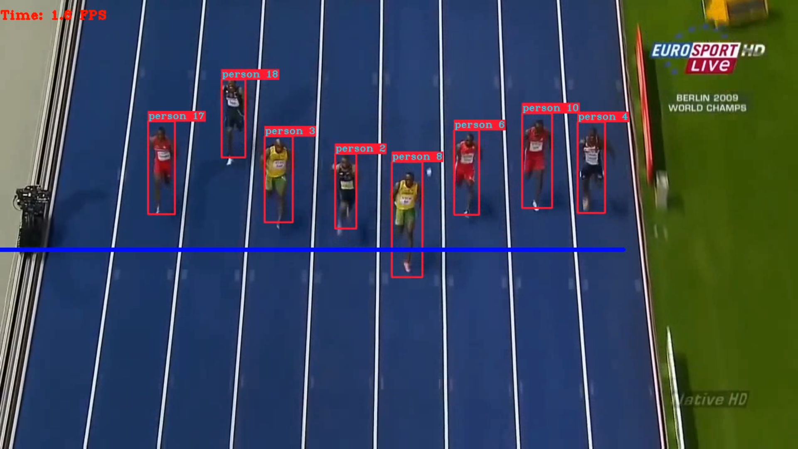

Other way could have been used that if someone’s coordinates are more than given line then line is crossed but it would require more cases and if someone is already behind the line then he will be captured.

**Storing id and time**

If above condition is satisfied then we store the id of person and time (calculated by cv2 library) in json file. The main thing to be kept in mind is that if an id already exists in file, we need not to store it again and again.

**Extracting image**

In addition to above work, if line crossing event happens, the image of person is extracted using coordinates of bounding box.

Submitted by - Harsh Sharma