Q-1) Query to find the total number of orders placed by each user.

Q-2) Query to find the average age of individual users who have placed at least 2 orders.

Q-3) Find the total number of orders placed by each user for each city, ordered by the user ID and city.

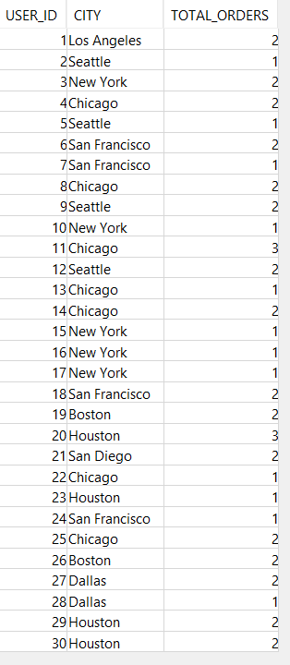

Q-4) Query to find the total number of ratings and the average rating received by each delivery person.

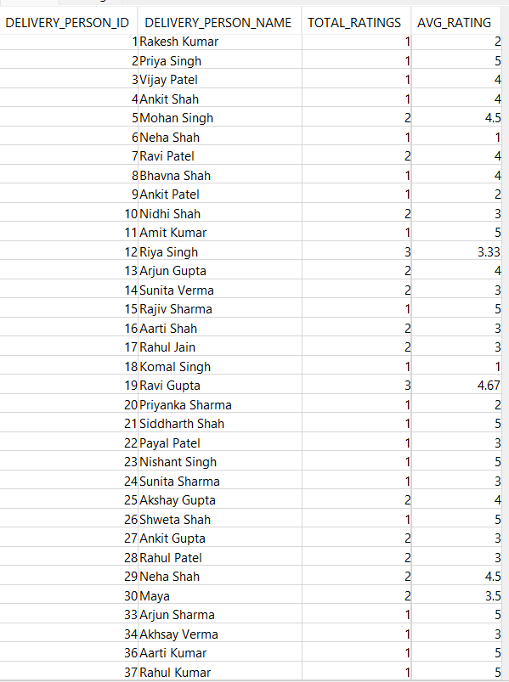

Q-5) Find the total number of orders made in each city.

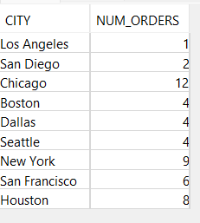

Q-6) Show the total number of orders placed by each user type and in each zip code in the system:

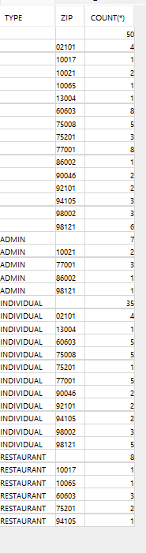

Q-7) Total number of orders made by each combination of city and user type, including subtotals and grand totals

Q-8) Find all the delivery persons who have delivered food to every food receiver in a specific ZIP code

Q-9) Retrieve the user name and the count of orders made by each user

Q-10) Retrieve all the orders, DATE OF ORDERS from a specific city Dallas.

Q-11) Retrieve the NAME, AGE, ADDRESS, and PHONE of Users and orders the results by NAME and AGE in ascending order. Skips the first 10 rows of the result set and fetches the next 5 rows only

