**VISVESVARAYA TECHNOLOGICAL UNIVERSITY**

**“Jnana Sangama”, Belgaum -590014, Karnataka.**



**PROJECT WORK-1 REPORT**

**on**

**“Music Artist HHH’s Page”**

***Submitted by***

**Harsh Shankar Rao(1BM18CS032)**

**Harshavardhana K(1BM18CS035)**

**Harshit Hiremath(1BM18CS036)**

***Under the Guidance of***

|  |  |
| --- | --- |
| **Mrs. Namratha M**  **Assistant Professor, BMSCE** |  |

***in partial fulfillment for the award of the degree of***

**BACHELOR OF ENGINEERING**

***in***

**COMPUTER SCIENCE AND ENGINEERING**



**B.M.S. COLLEGE OF ENGINEERING**

**(Autonomous Institution under VTU)**

**BENGALURU-560019**

**DEC 2019**

**B. M. S. College of Engineering,**

**Bull Temple Road, Bangalore 560019**

(Affiliated To Visvesvaraya Technological University, Belgaum)

**Department of Computer Science and Engineering**



**CERTIFICATE**

This is to certify that the project work entitled “**Music Artist HHH’s Page**” carried out by **HARSH SHANKAR RAO (1BM18CS032), HARSHAVARDHANA K (1BM18CS035), and HARSHIT HIREMATH (1BM18CS036**) who are bonafide students of **B. M. S. College of Engineering.** It is in partial fulfillment for the award of **Bachelor of Engineering in Computer Science and Engineering** of the Visveswaraiah Technological University, Belgaum during the year 2019. The project report has been approved as it satisfies the academic requirements in respect of **Project Work-1 (19CS3PWPW1)** work prescribed for the said degree.

Signature of the Guide                 Signature of the HOD

Mrs. Namratha M Dr. Umadevi V

Assistant Professor Prof & Head of Dept of CSE

BMSCE, Bengaluru BMSCE, Bengaluru

External Viva

Name of the Examiner                                                                                       Signature with date

1._____________________________ ________________________

2. _____________________________ _________________________

**B.M.S. College of EngineerinG**

**DEPARTMENT OF COMPUTER SCIENCE AND ENGINEERING**



***DECALARATION***

We Harsh Shankar Rao (1BM18CS032), Harshavardhana K (1BM15CS035), and Harshit Hiremath (1BM18CS036), students of 3rd Semester, B.E, Department of Computer Science and Engineering, BMS College of Engineering, Bangalore, hereby declare that, this Web Programmingwork entitled "**Music Artist HHH’s Page**" has been carried out by us under the guidance of Prof. Namratha G, Assistant Professor, Department of CSE, BMS College of Engineering, Bangalore during the academic semester Aug-Dec 2019.

We also declare that to the best of our knowledge and belief, the development reported here is not from part of any other report by any other students.

**Signature**

Harsh Shankar Rao (1BM18CS032) :

Harshavardhana K (1BM15CS035) :

Harshit Hiremath (1BM18CS036) :

**TABLE OF CONTENTS**

|  |  |  |
| --- | --- | --- |
| **CHAPTER NO.** | **TITLE** | **PAGE NO.** |
| 1 | **Introduction** | 5 |
| 1.1 | Overview | 5 |
| 1.2 | Motivation | 5 |
| 2 | **Software Requirement Specification** | 6 |
| 2.1 | Hardware Requirements | 6 |
| 2.2 | Software Requirements | 6 |
| 2.3 | Development | 6 |
| 3 | **User Interface Design** | 7 |
| 3.1 | Home Page | 7 |
| 3.2 | Login page and Form Validations | 8 |
| 3.3 | Sign Up Page and Form Validations used | 13 |
| 3.4 | Under Development Page | 25 |
| 3.5 | Team Page | 27 |
| 4 | **Conclusion** | 29 |

1. **INTRODUCTION**
   1. **Overview**

Every artist has his/her own unique style and approach to their brand image. And every other artist has his/her unique set of fans and followers who are always willing to know what the artist is upto and what is his/her latest work.

Our project, “Music Artist HHH’s Page”, is focused on solving this want of knowing your favorite artist’s updates.

The look, feel, appeal, and the UI/UX of the first page that loads up on the user’s display is very important to create a positive image of the artist in the follower’s mind. Keeping this in mind, we have developed a beautiful looking website that does all the jobs mentioned above, and also helps the artist to have a medium in which it is very easy to convey some message, share new music, and also create a simple and easy to find portal for selling the artist’s event’s ticket and his/her merchandise.

* 1. **Motivation**

Our major motivations came when we observed the following flaws in the brands of modern artists:

1. Lack of modern medium to share new work with fans and followers, in a legal approach.
2. Lack of having a database of true fans and followers, whose constant interest in artist’s work would motivate the artist to do more.
3. Lack of having artist’s own website, in which the artist can sell his/her event’s tickets and merchandise, where no third-party is involved.
4. **Software Requirement Specifications**
   1. Hardware Requirements:

* A PC with the following or greater specifications:
  + Intel Core i3 (4th gen or higher)
  + 2 GB RAM
  + 100 GB Hard Drive
* A stable internet connection (1Mbps or higher).
  1. Software Requirements:
* Operating system : Windows XP(SP2/SP3), Vista, 7, 8/8.1, 10, Ubuntu 14+
* Browser versions : Chrome 53, Edge 11, Firefox 54, Safari 8
  1. Development
* Technologies used : HTML, CSS, JavaScript, PHP, MySQL
* Frameworks used : Three JS, Particle JS
* IDE Used for coding : Vim / Brackets / Atom / VS Code

1. **User Interface Design**
   1. **Homepage**

The homepage is the first page the user usually arrives at. Hence this page has to be made attractive, be sensibly relaxing, and entertaining.

Since the website is mainly for the middle ages we have made it a

Theme-based website which is in dark mode featuring two primary colors (Black and Yellow) which is intended to save more power(as the black color doesn’t need the pixels on the display to be lit up) and to make it look attractive.

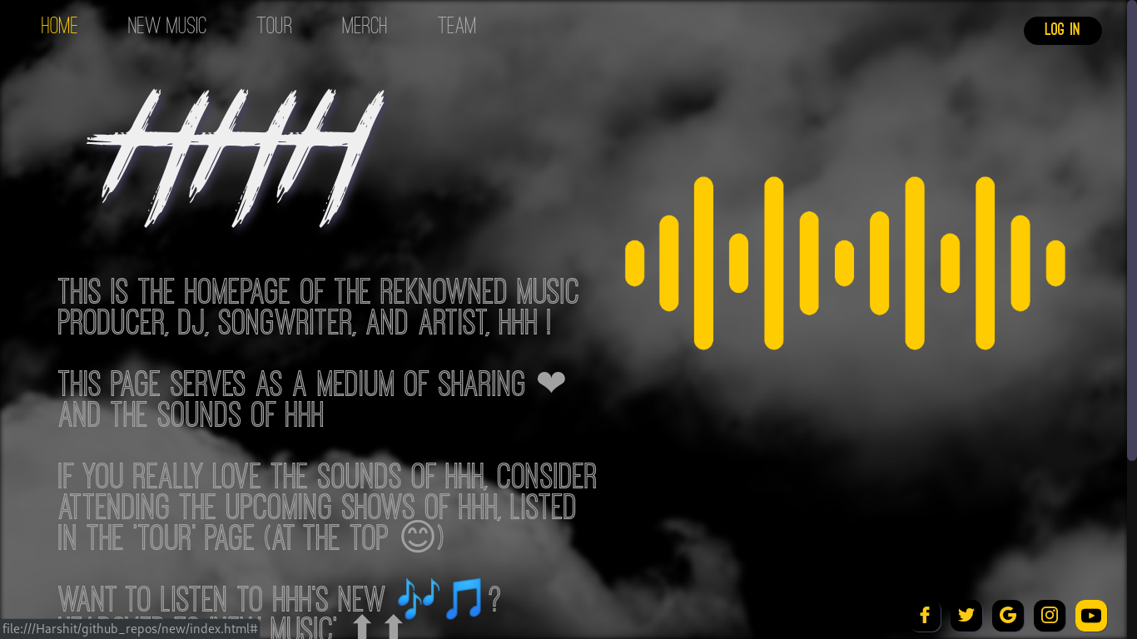

As the intention of the moment is to make the look and feel of the first page be good, have an efficient code to be practically feasible and efficient enough to be used in real-life where the traffic is unpredictable, and can go haywire any moment, the following steps were taken get the above shown picture as the output.

The first thing that is noticed is the moving cloud background.

The approach to this was as follows:

1. Create a background container which contained the main super ultra-wide cloud image.
2. Animate it to move the cloud image continuously in a loop, (an infinite loop).
3. Add blur to the container a little.
4. Add the header links.
   1. **Login Page and Form Validations**

3.2.1 Initial look

This page allows the fans using the website to login with the help of username and password. Logging in gives them privileges to extra features like creating a playlist of their interests and buying merchandise of their favorite artists. The website will also update the logged in users about the artists they follow and if there are any tours in their city they will be notified.

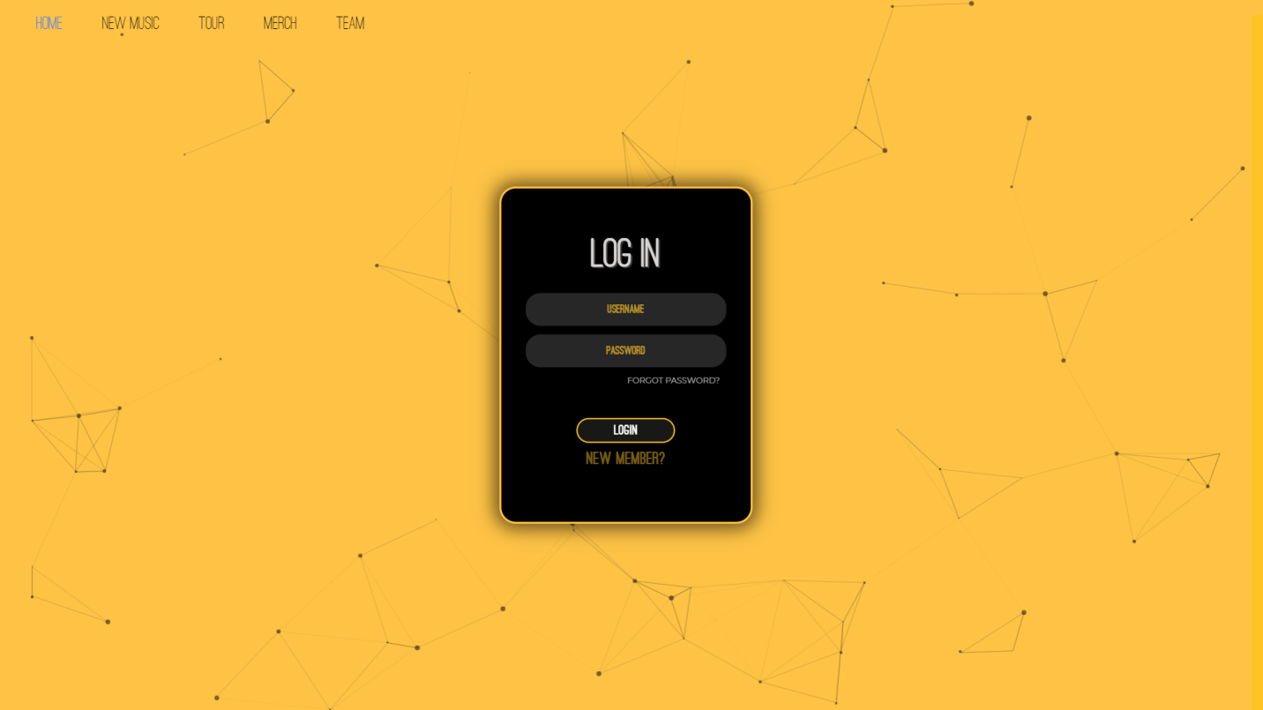Login Page

To make the user feel the website is legitimate, and to create a connection with the webpage, we have added a breathing glow effect to the login form box which glows with a high intensity after every 1.5 seconds. This will make the user feel more active and will hence make the best use of the website. Particle JS has been added to the background, which makes it look dynamic, and not very static hence hooking the users to the site.

 The following image shows the page when the form glow is at the 100% opacity.

3.2.2 Form Validations

a. Invalid username input

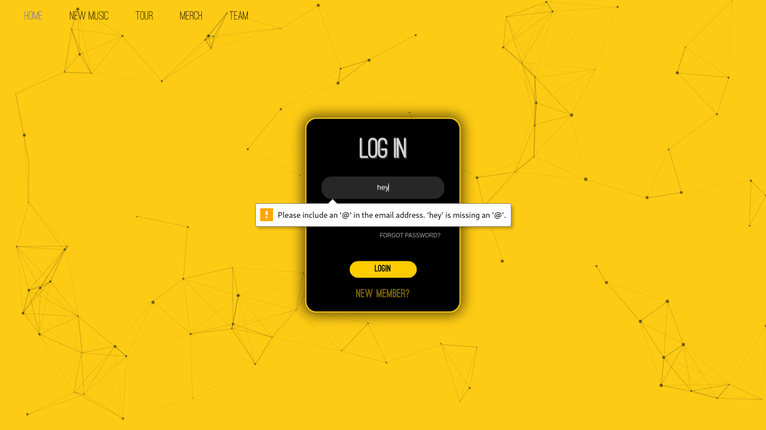Invalid email input

When the user inputs an invalid email address, an error prompt like the one shown in the image is popped up. This form validation is a great solution not only to get valid inputs, but also to save the php server from php injection, which is a very common and easy way of hacking a basic login page.

b. Small password input

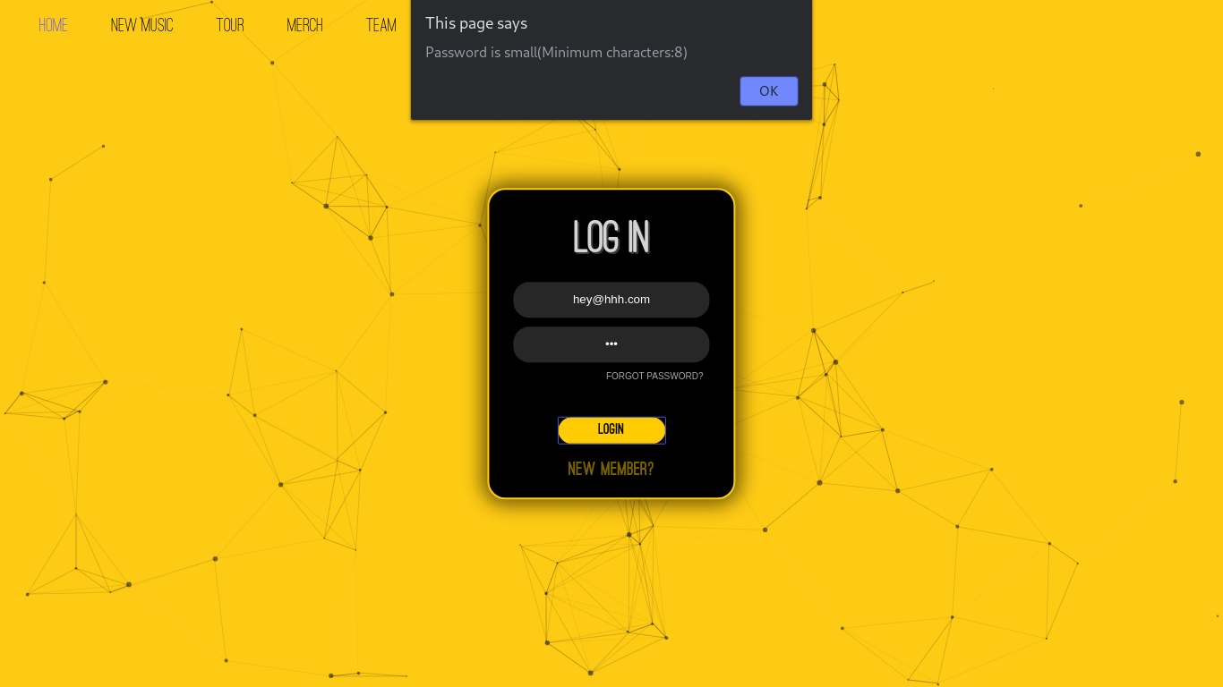Error message when small password is entered

Usually, due to typos, or due to purposeful wills, users might input small passwords in the password field. Any password smaller than 8 characters is invalid in our website, as during user sign up, we only allow passwords with 8 or more characters.

When the user enters valid username and password, the login page will take the user back to the home page, but now the “Log In” button would be changed to “Log Out” due to obvious reasons.

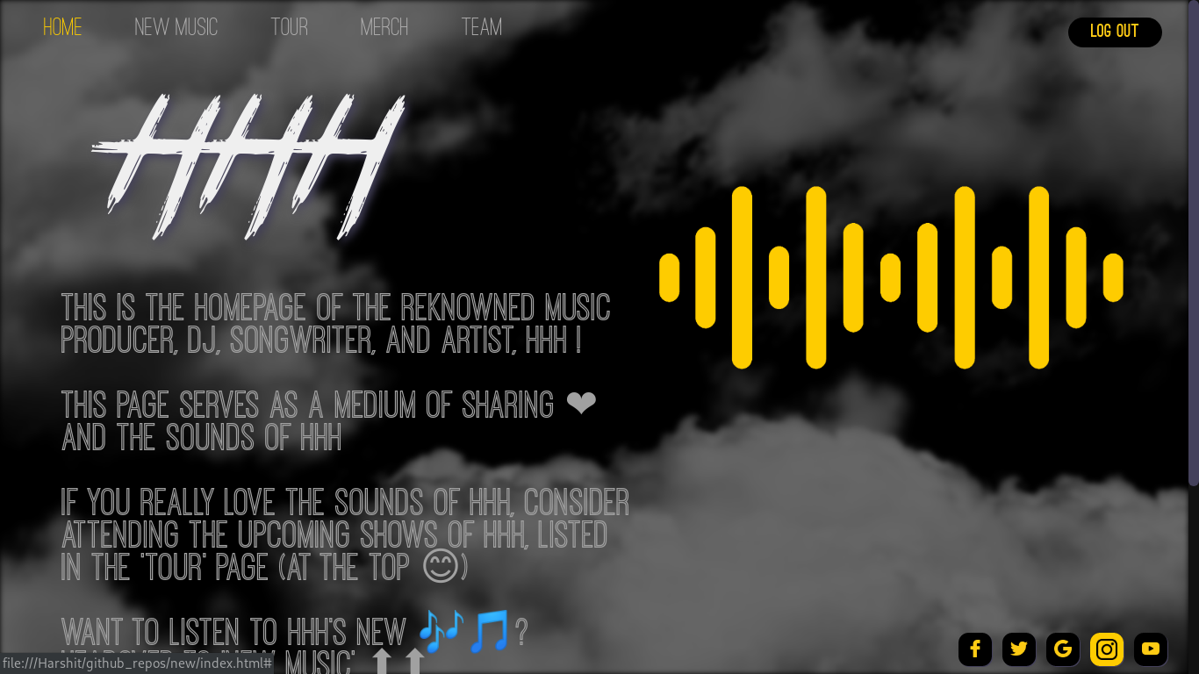Homepage when user is logged in

As you can see in the above image, after successfully logging in, the website takes the user to the Homepage; But now, the “Log In” button is changed to “Log Out” button.

* 1. **Sign Up Page and Form Validation used**

3.3.1 Initial look

This page allows the fans to register for the website and create his/her own profile using which they can enjoy the privileges on our website. The user can create his/her own profile just by entering their username, e-mail id, phone numbers and by entering a suitable password for secure access to the website. Again, we have implemented Particle JS in the background, which makes the page look alive; this also helps to convey to the user implicitly that, this page belongs to the same family which had “Log In” page; the family which comprises of pages that allow users to have a unique account in the page.

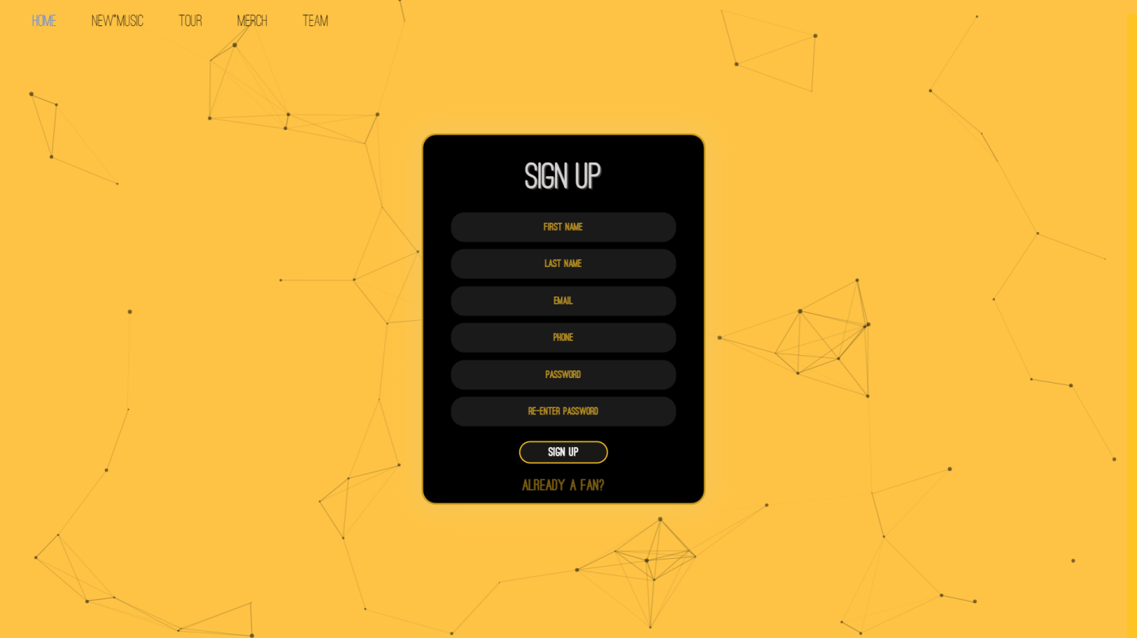

The above image shows the sign-up page which again has a glowing box like the one in Log in page. The box contains many forms, which have to be filled correctly, and valid data should be input in order to register.

3.3.2 Form Validations

The input values are locally validated using JavaScript. The following are the form validations used:

1. No First name or Last name input:

When the first name or last name are not filled, the browser notifies the user. This can help us save faux inputs to the server by casual people.

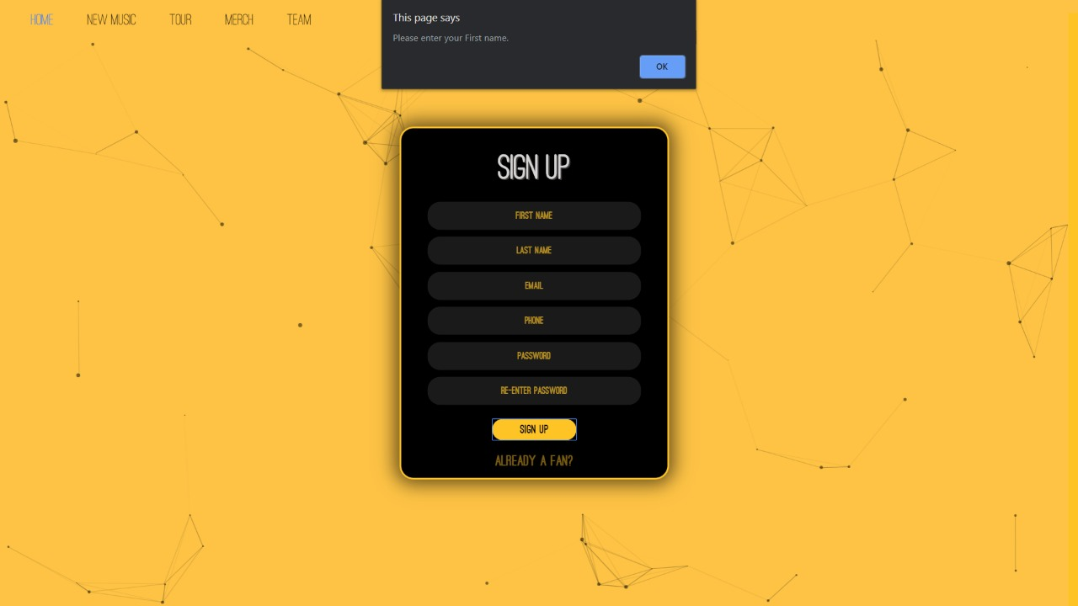

In the picture shown above, we can see that the error message “Please Enter you first name” appears. After ‘OK’ is pressed, the cursor moves to the First name box.

The same applies to the last name also.

1. No email is typed:

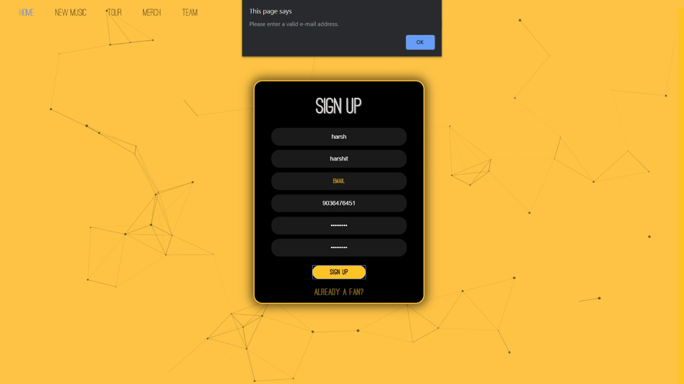

As you can see in the above diagram the “Please enter a valid Email address” error message pop-up.

After “OK” is pressed, the email form is highlighted, and the user is prompted to enter the email again.

1. Invalid email is input

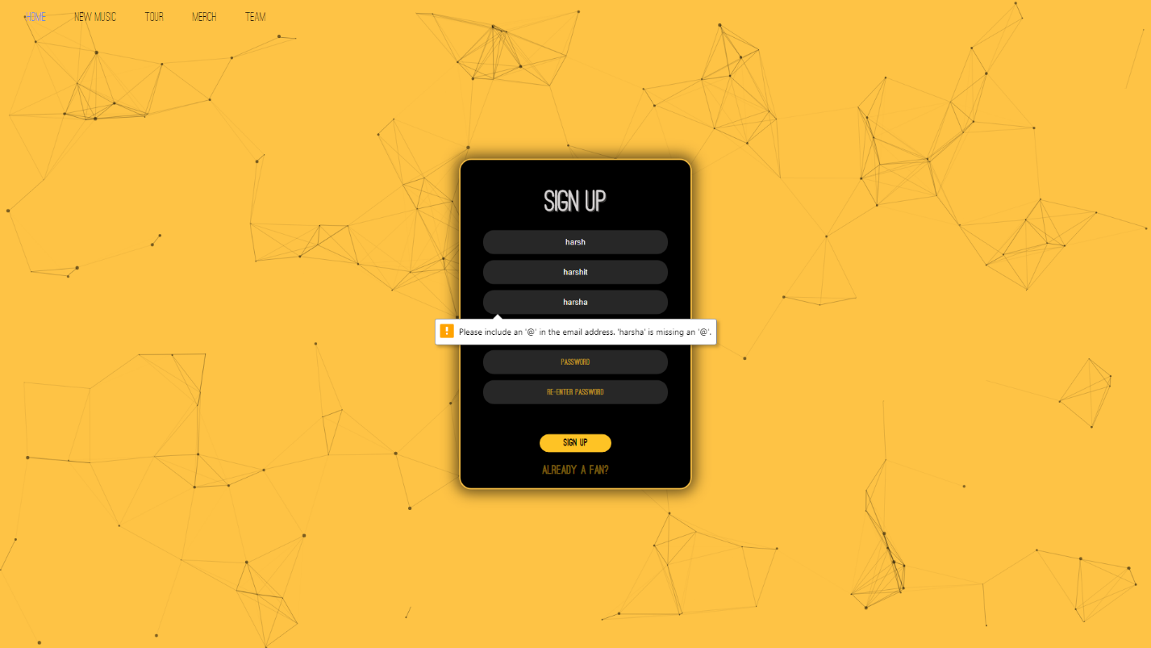Invalid email input in signup page

Sometimes, the user might input random text in email form, this might lead to bad data in the server, this has to be avoided. This has been solved using form validation. So, when the user inputs an invalid email id, the above shown error prompt is prompted.

1. No phone number is input

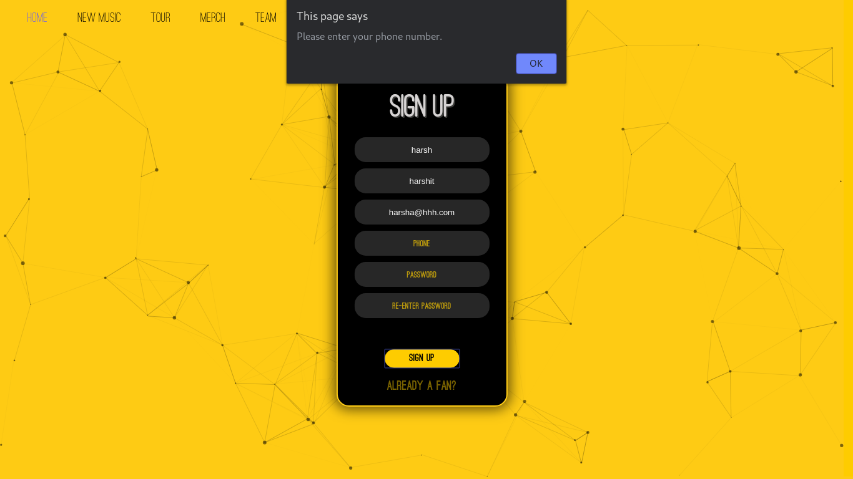Error prompt when no phone number is input

When no phone number is input, the above shown error message pops up.

1. Invalid characters in phone number form

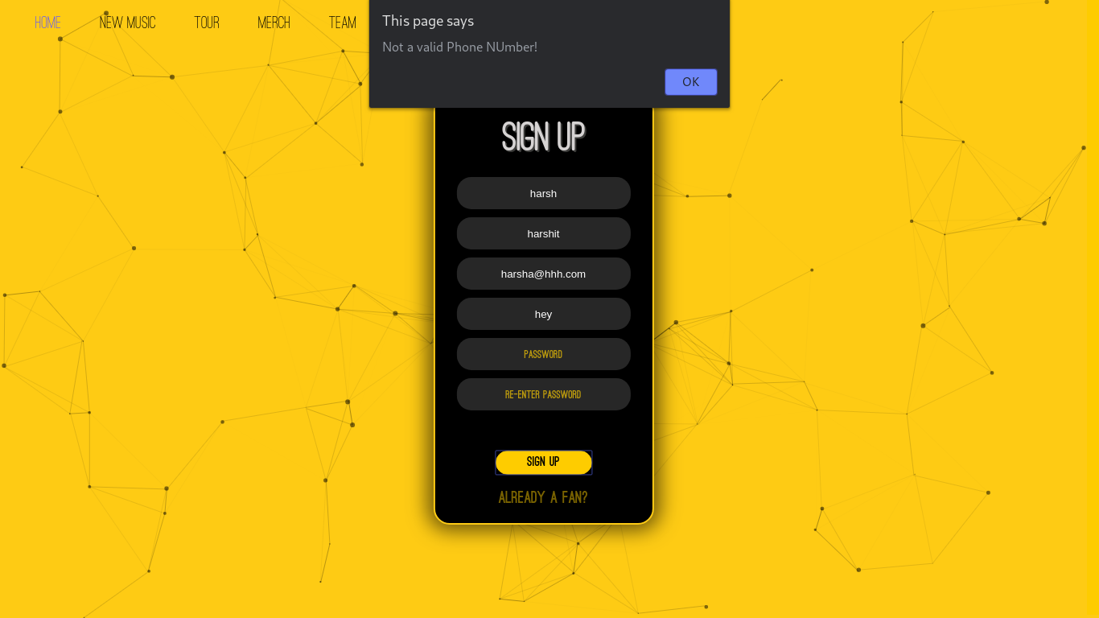Characters other than numbers input

Often, the new users might input wrong number in the phone number form. To avoid faux input, and to avoid invalid data in the database, form validation has been added.

When characters other than numbers are input, the above shown error prompt is popped up, and on clicking “Ok”, the cursor is focused back to the phone number form.

1. Phone number with wrong length is input

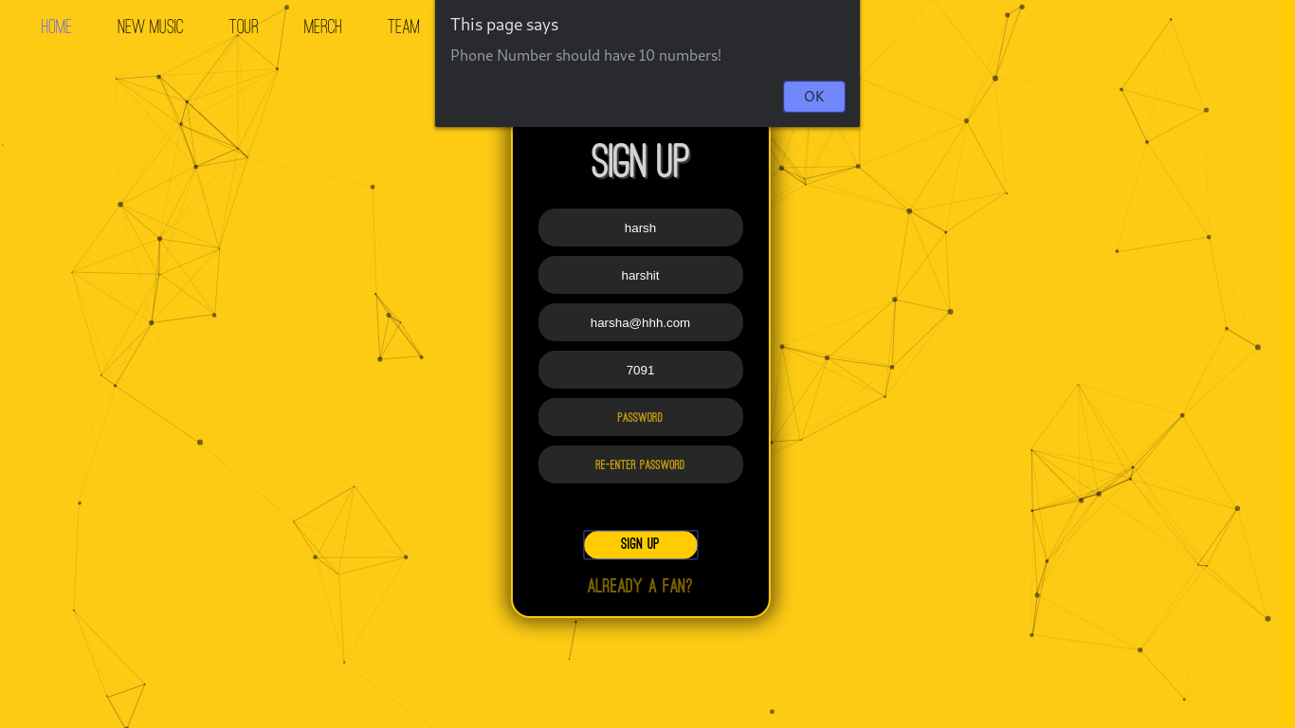Phone number is smaller than 10 numbers

Often, the new user might miss a number during input or give wrong phone number input. This should be avoided, as this creates bad data in the database.

This is avoided using form validation. When the user inputs small phone numbers, the above shown prompt, “Phone Number should have 10 numbers” is prompted.

A similar prompt is prompted when the phone number is larger than 10 numbers.

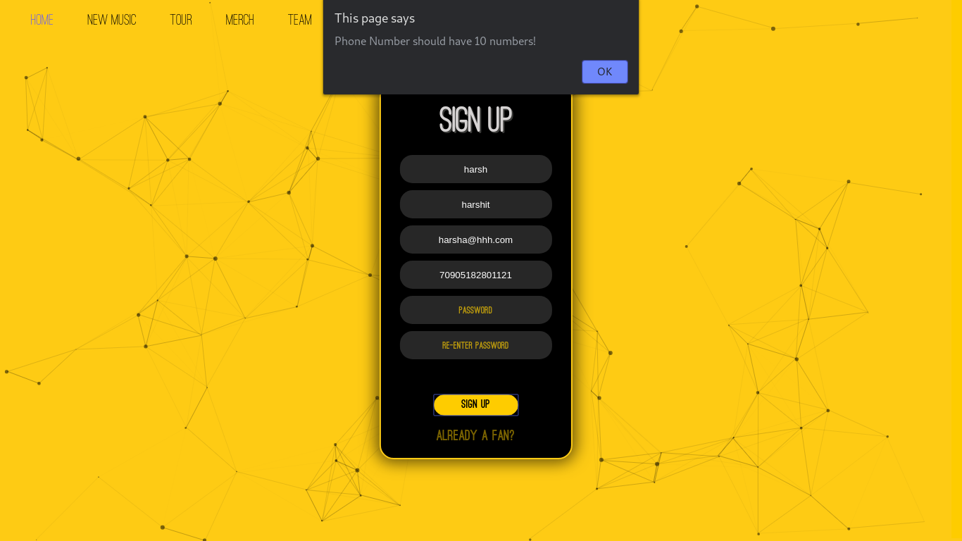Phone number is greater than 10 numbers

Often, the user might input an extra number. This is solved using the same form validation.

1. No password is input in the password form:

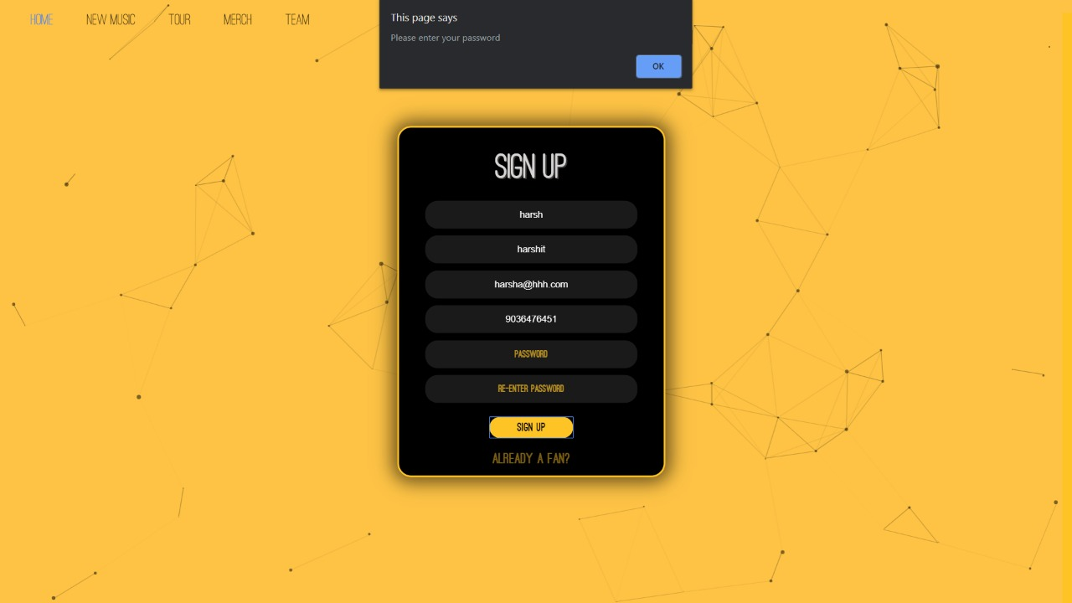

When no password is input, the error message “Please enter your password” appears. This means the user has left the password field blank.

After “OK” is pressed, the password form is highlighted.

1. Small Password input:

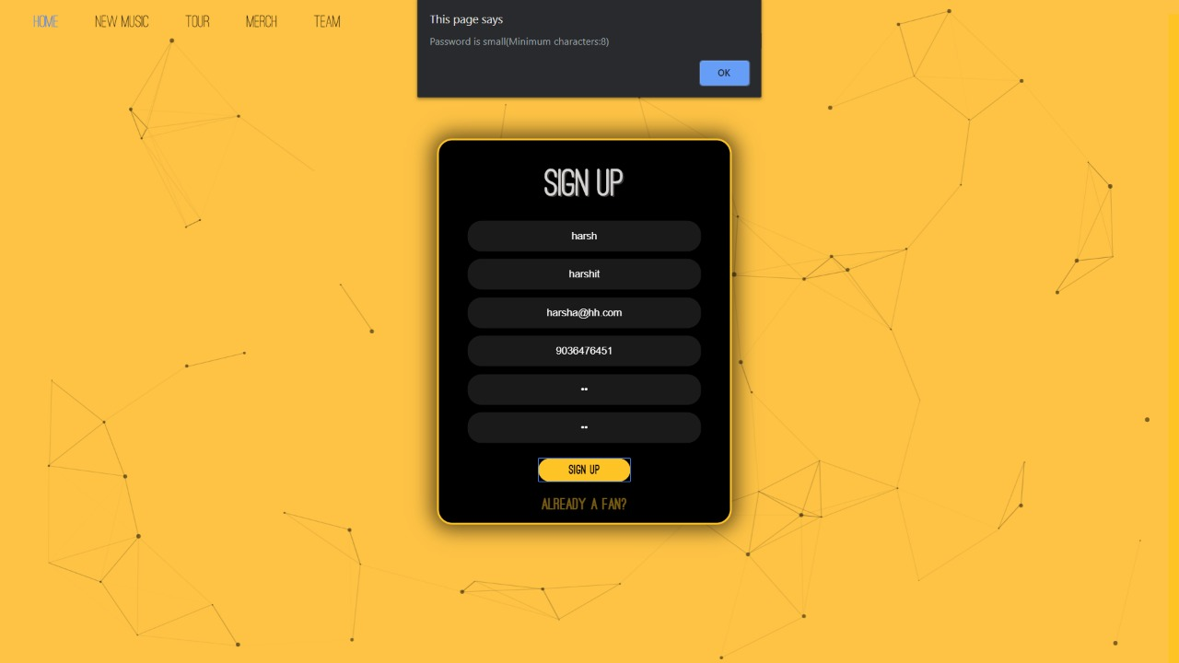

When the user registers with small passwords, it becomes really easy to crack the password. To solve this dangerous problem and to help the user, this form validation is added.

When the user enters passwords of size less than 8, an error message “Password is small (Minimum characters:8)” is shown.

When the user clicks on “OK”, the passwords form is highlighted.

1. Passwords do not match:

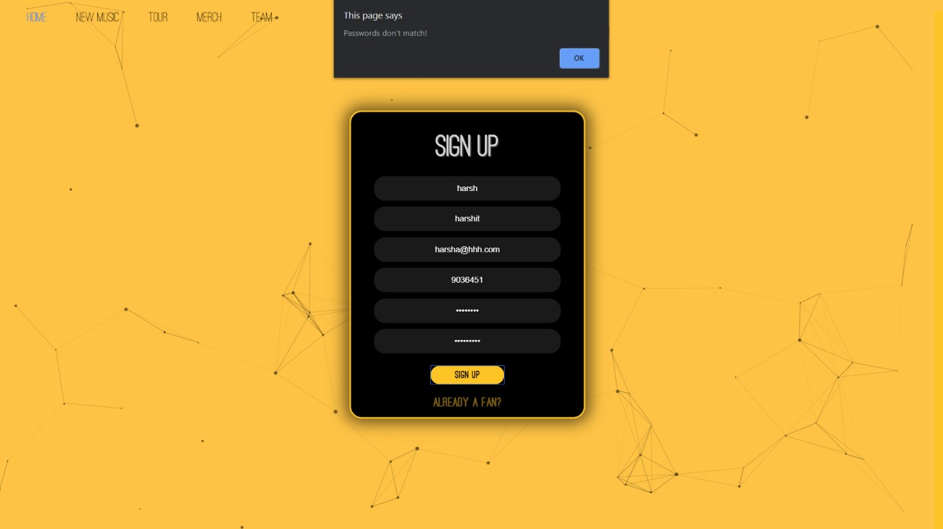

Typos are really common in modern lifestyle, and when the user registers with the password that has type in it, the user can virtually never log in with the correct password as he/she can’t simulate the same typo again. Hence, it typos should be removed.

This is achieved by having 2 password forms. When the passwords are longer than 8 characters, the password is accepted; else, not.

As you can see in the above image, an error message “Passwords don’t match” appears, and the password form is highlighted when “OK” is pressed.

When all the forms are correctly input and all the forms are validated, the webpage takes the input & pushes it to the server.

After successfully logging in, the webpage takes the user back to the homepage, but now the “Log In” button is changed to “Log Out”.

The signed in user page of the home page looks like the following:



* 1. **Under Development Page**

This page is a beautiful animation of a lion who is willing to get pampered. This is a user-interactive page in which the lion reacts to the cursor movements. It turns it’s head in the direction of the cursor and also gives a reaction when the cursor is held. This page is developed using Three JS in which every frame of the webpage is defined. The page is a substitute for all the webpages which are being developed and yet to be uploaded. (All the pages that need good amount of backend support in our project, have been replaced with this page.)

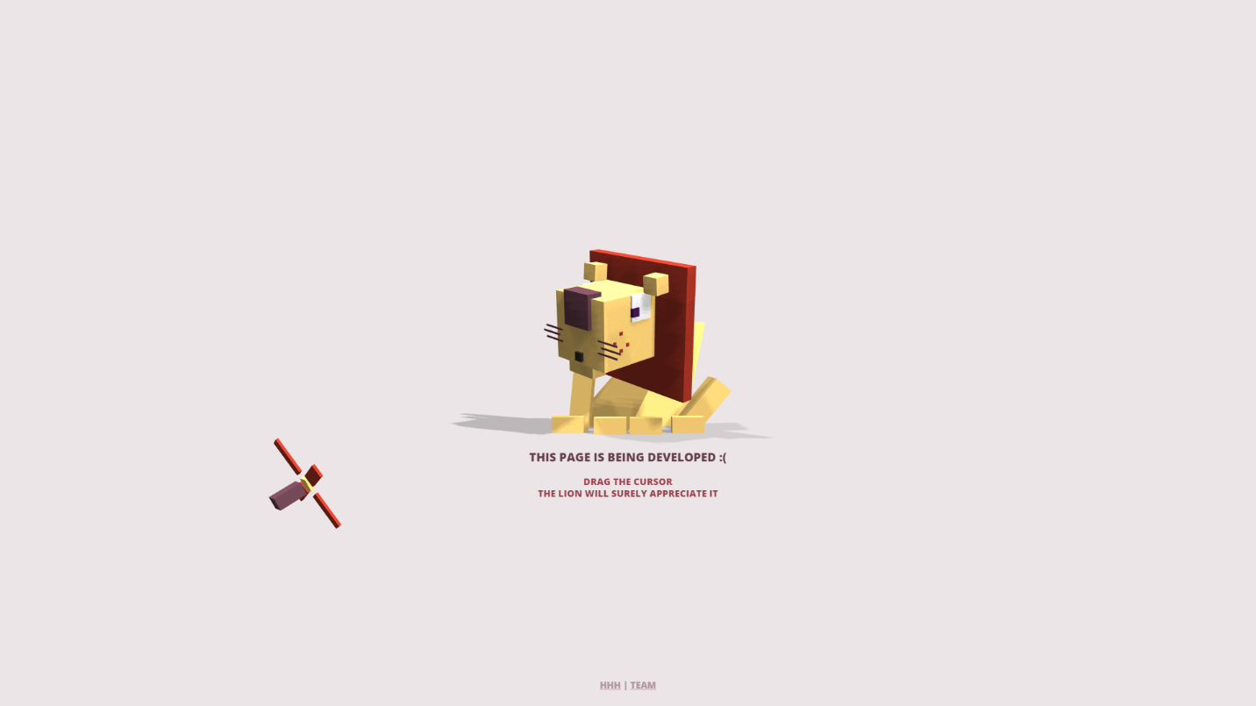The lion’s reaction when the cursor is moved.

When the left-mouse is not pressed and the cursor moves, the lion turns it’s head towards the fan in anticipation as the fan isn’t turned on yet.

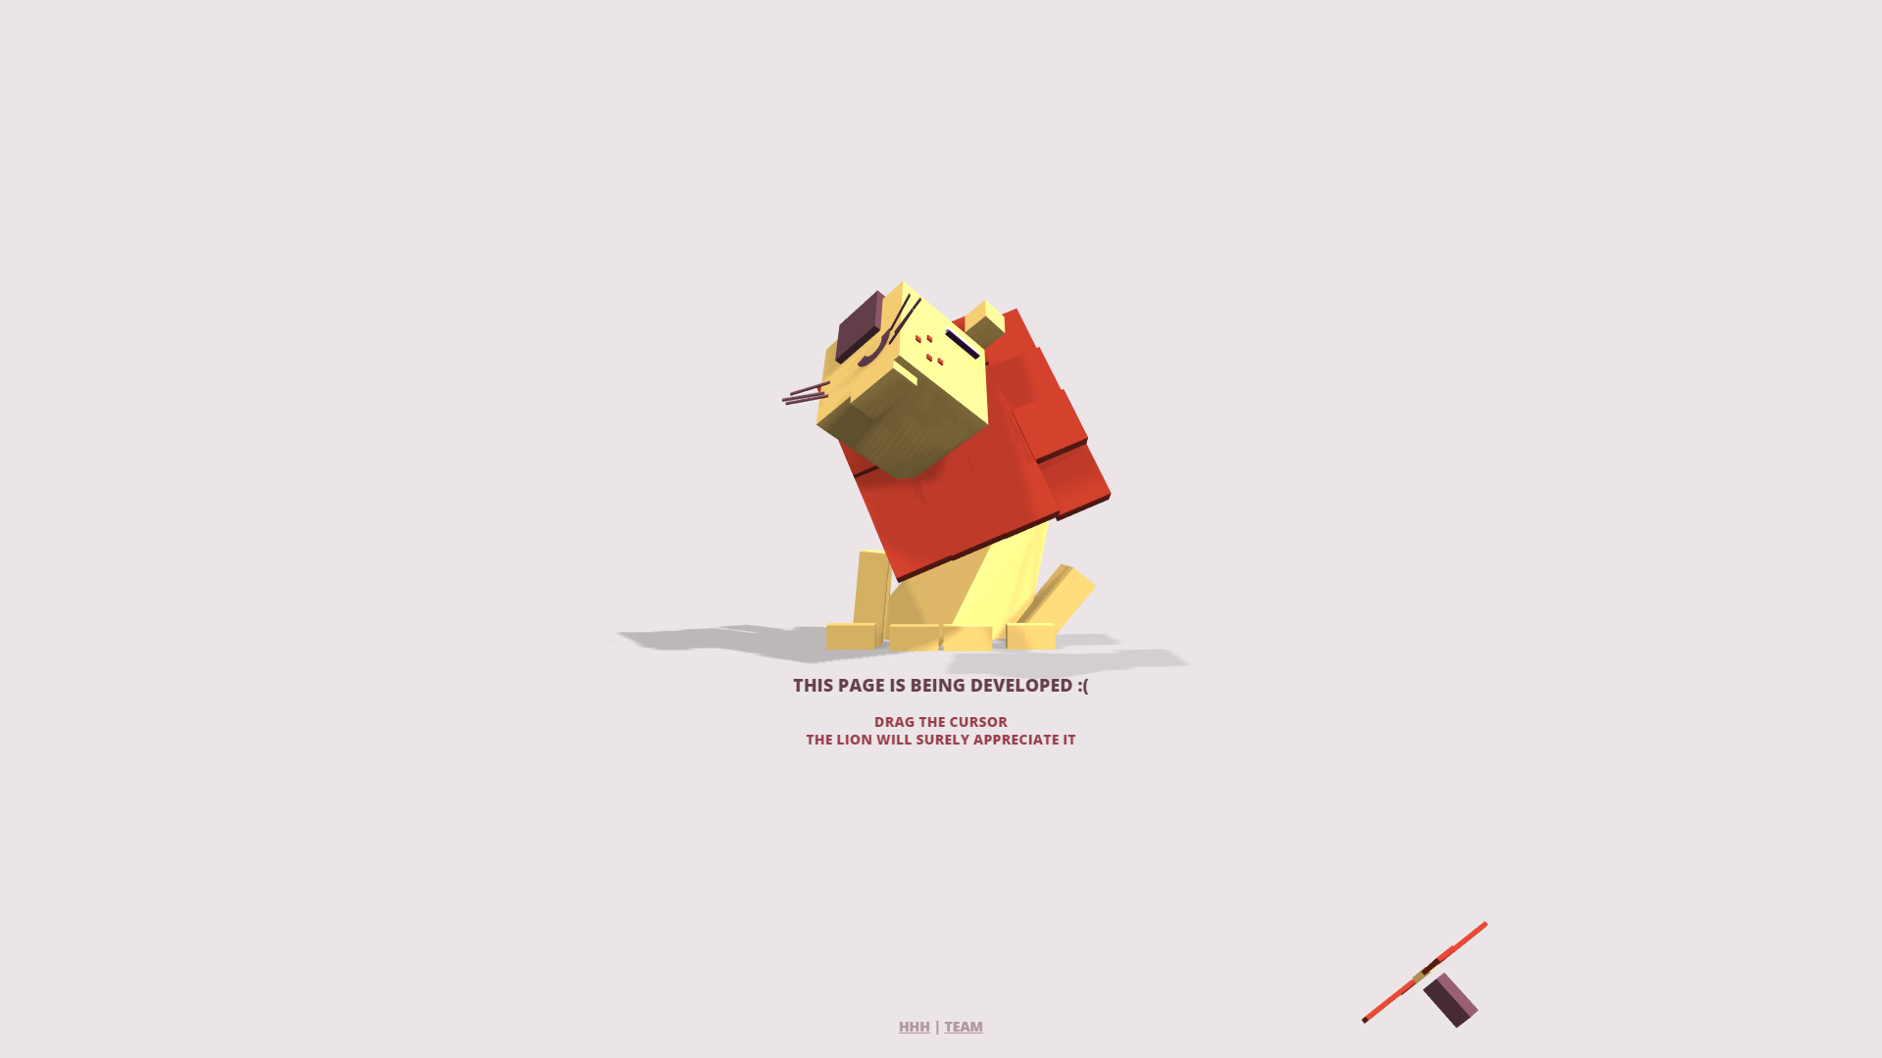

The lion when the mouse is held at a place. Now when the left-mouse button is pressed, the fan is turned on, and the lion reacts to it.

* 1. **Team page:**

Team page is used to show the details about the developers of the page.

It looks like the following image when logged in.

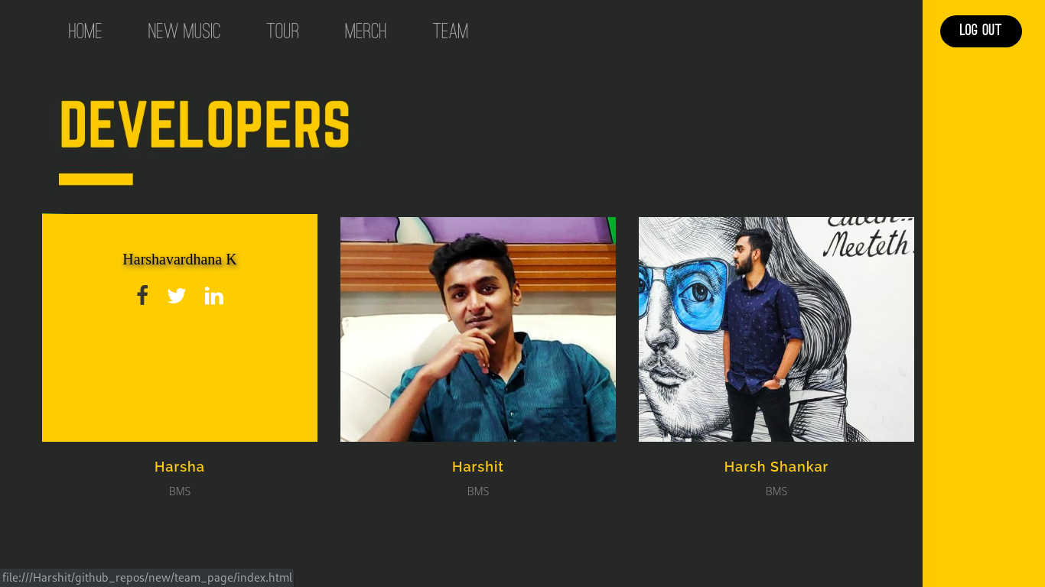

As you can see in the above image, the developer information appears over the image. This added to the theme of the project, makes it look attractive.

When logged out, it looks like the following:

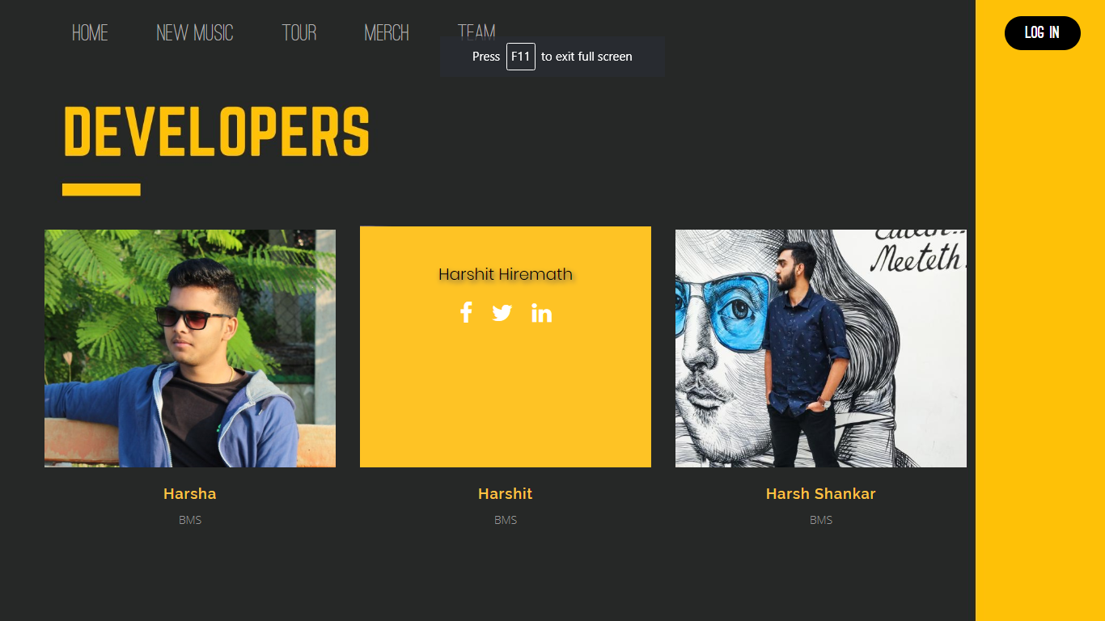

1. **Conclusion**

This concludes the project carried out by us,

Harsh Shankar Rao (1BM18CS032),

Harshavardhana K (1BM18CS035), and

Harshit Hiremath (1BM18CS036).

This website can be used in a very specific use-case. The webpage can help the users, and the creators equally, it’s a win-win situation. This Front-End Project can be used by Music artists, DJ, producers, content creators, YouTubers, and many more, as a tool to increase their fan following, and to keep their followers up-to-date with their latest works and content, and also to sell their curated merchandise.

Doing this project-cum-course was very fun, and was one where the learning edge was pretty steep. We learnt a lot in the field of web designing -- we learnt the basics and also some advanced topics of HTML5, CSS3, JavaScript, and PHP. We also learnt how real-world websites are built, and how they are protected using form validations.

As we used GitHub exclusively to store the project, and to work from different locations (our homes), we learnt a lot about it, and are very confident that we will not encounter basic problems like merge conflicts.

This project-cum-course also helped us improve our team-working skills, and our presentation skills, which is very essential in corporate life.

Hence, this report includes and concludes the Project work carried out by us.

Thank You.