SYMBIOSIS INSTITUTE OF TECHNOLOGY, PUNE
CA-3: Domain-Specific Agentic AI Proof of Concept
Model Drift Watchdog
An Agentic AI System for Monitoring Machine Learning Models in Production

Team Details
S. No. | Name | PRN
1 | Harsh Sharma | 24070126067
2 | Divyansh Agarwal | 24070126056

GitHub Repository
https://github.com/HarshSharma-28/model-drift-watchdog

Project Details
Project Title | Model Drift Watchdog
Domain | MLOps (Machine Learning Operations) - credit risk model at a digital lending company
Problem | Deployed ML models silently degrade when real-world data changes (data drift). In lending, this leads to bad loan decisions that are discovered only months later.
Solution | A team of AI agents that plans checks, profiles data quality, detects drift, decides on an action (No action / Alert / Retrain / Fix pipeline), validates the decision with a Critic, and asks a human before deploying a retrained model.
Tech Stack | Python, Streamlit, LangGraph, scikit-learn, SciPy, pandas, Plotly, Ollama (optional) with mock fallback

Agents
- Planner Agent - builds the task plan and re-plans when data is bad
- Data Profiler (Research) - checks schema, missing values and sample size
- Drift Detector (Executor) - runs KS, Chi-square and PSI tests
- Decision Agent (Business Automation) - applies the decision policy
- Critic Agent - validates evidence, retries (max 2) or escalates
- Reporter / Action Agent - writes the report and compares old vs new model
- Human Approver - final sign-off before deployment

Presentation Snapshots
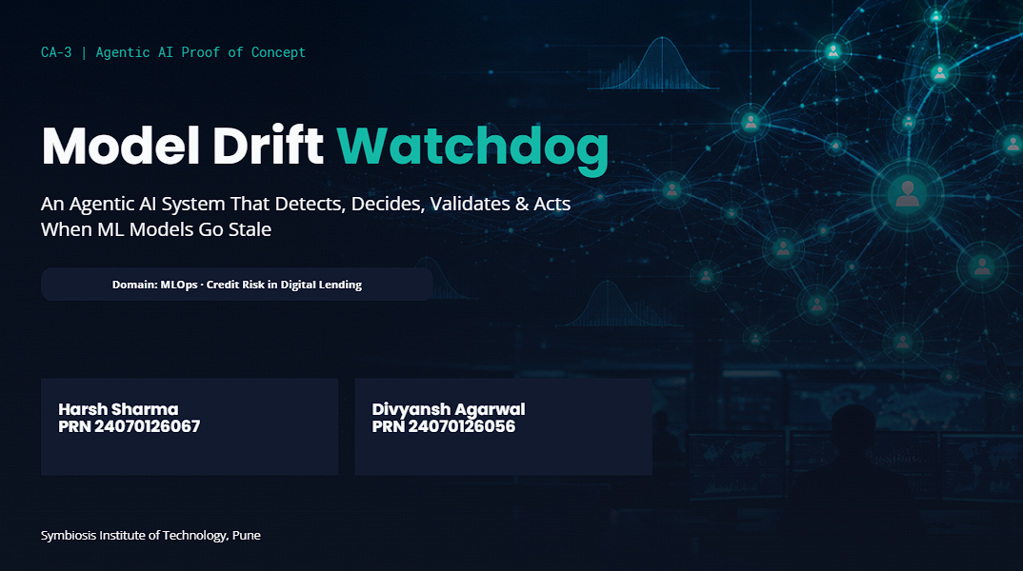
Slide 1 - Title
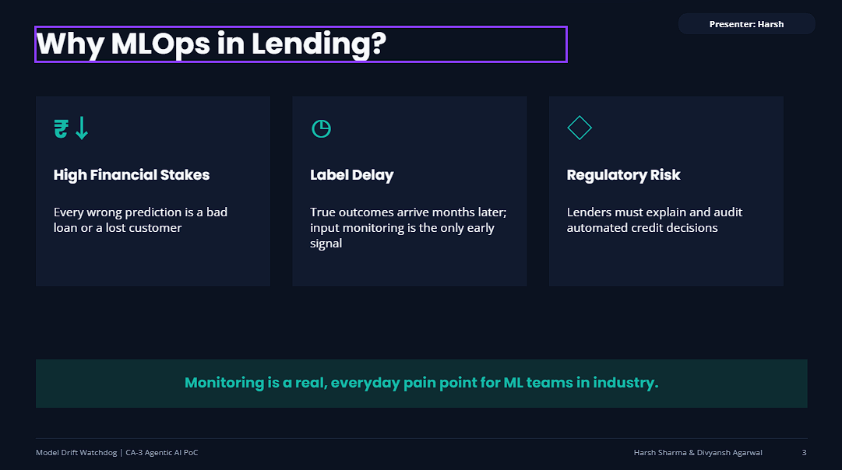
Slide 3 - Why MLOps in Lending?
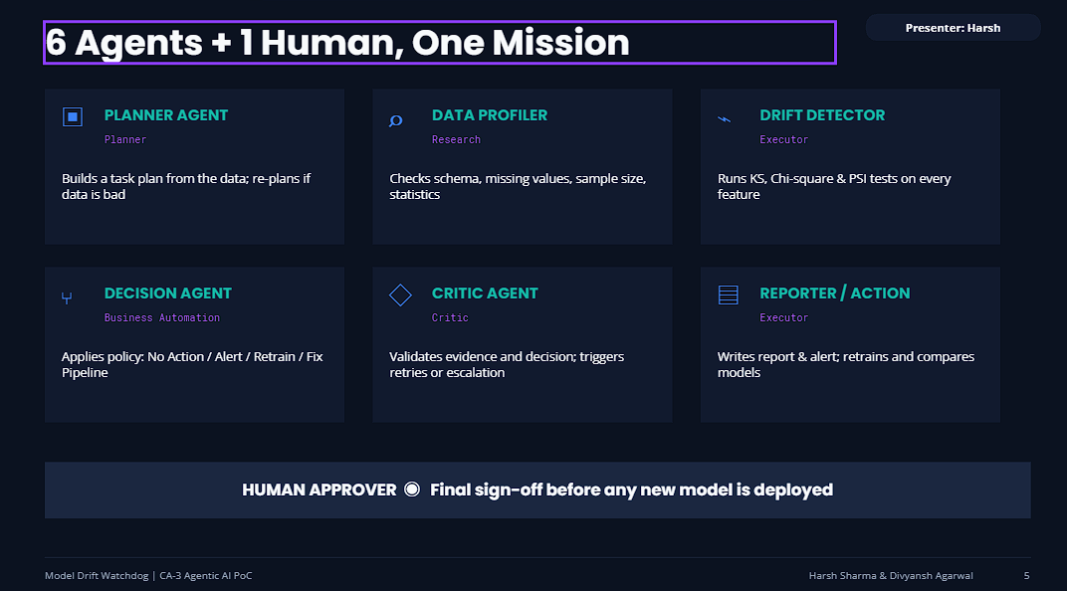
Slide 5 - Agent Roles (6 Agents + 1 Human)
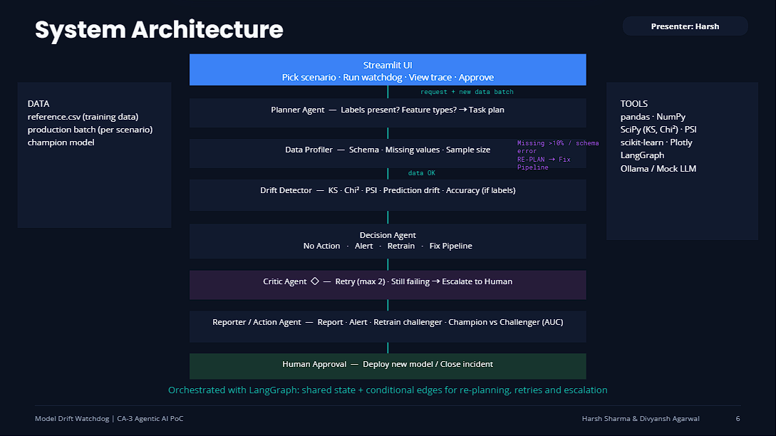
Slide 6 - System Architecture

