**Assignment-Ansible**

**Host1 – httpd install & start ,Deploy index of 22Q1**

**Jenkins Master – Ansible Server**

**Git-hub**

**Clone 22Q1**

**Git-Repo**

**Host2 – httpd install & start ,Deploy index of 22Q2**

**Clone 22Q2**

**22Q1 index.html**

**httpd.yaml 🡪 for ansible push**

**22Q2 index.html**

**Index.html**

**Step 1: Launch 3 EC2 instances 1 with Jenkins-master & ansible-server configuration and**

**Other 2 as ansible hosts**

**On all 3 Instances**

1. **useradd ansible**
2. **echo “ansible” | passwd ansible –stdin**
3. **vi /etc/ssh/sshd_config 🡪**

**uncomment PermitRootLogin yes**

**PasswordAuthentication yes**

**comment PasswordAuthentication no**

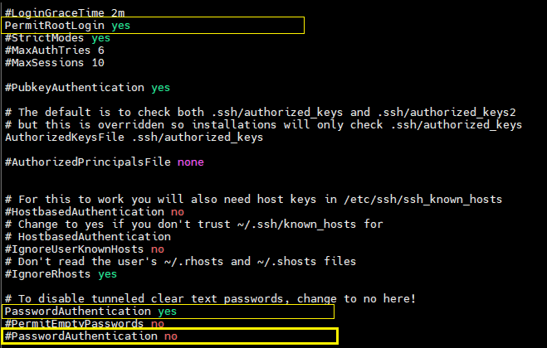

1. **Save & exit**
2. **service sshd restart**

**On ansible server**

1. **amazon-linux-extras install ansible2 –y**
2. **vi /etc/ansible/ansible.cfg**

**uncomment** 🡪 **#inventory & # sudo user**

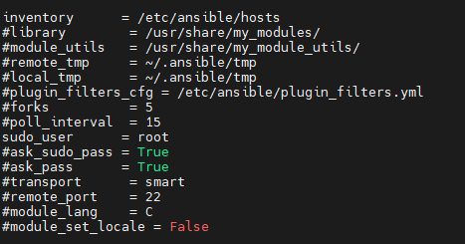

1. **Save & exit**
2. **visudo 🡪 add entry bellow 🡪 root ALL=(ALL) ALL**

**ansible ALL=(ALL) NOPASSWD: ALL**



1. **vi /etc/ansible/hosts & add**

**[apache]**

**172.31.11.176 🡪 1st host IP**

**172.31.11.4 🡪 2nd host IP**

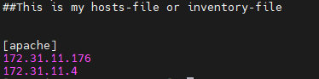

1. **configure Jenkins from ansible user**
2. **run “ssh-keygen” and press enter till it exit from ansible user**
3. **Run ssh-copy-id ansible@IP1 & ssh-copy-id ansible@IP2 from ansible users and enter password “ansible” for 1 time verification**

**Step 2: cd /home/ansible/** 🡪 **vi httpd.yaml**

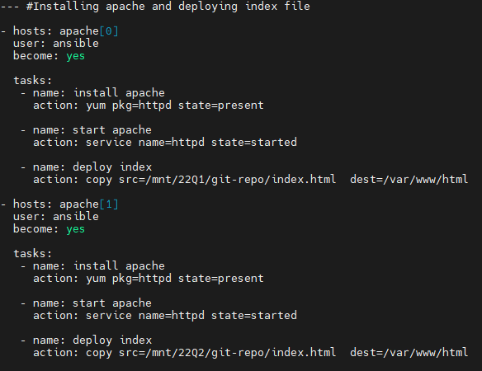

**Step 3: Create Jenkins pipeline 🡪 Ansible-assignment**

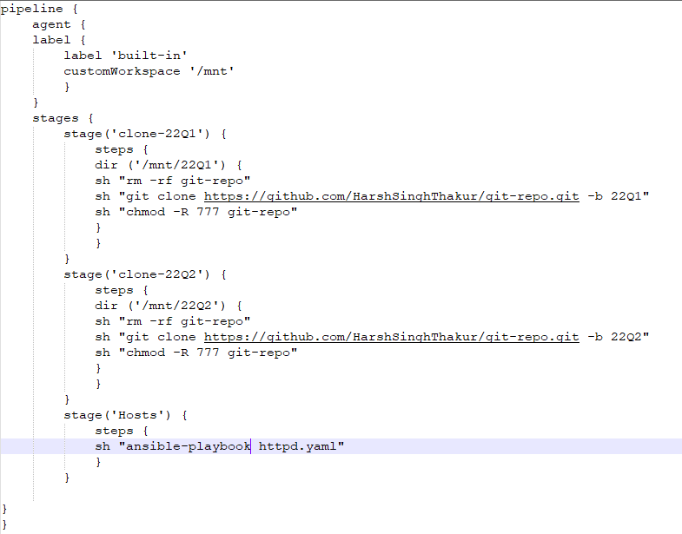

**Result :**

