Backend Development Roadmap for CampusFit 360
A step-by-step guide to building a scalable, secure, and efficient backend for the CampusFit 360 platform.

1️⃣ Technology Stack Selection
Language: Python (FastAPI) or JavaScript (Node.js with Express.js)
Database: MongoDB (NoSQL for flexibility)
Authentication: JWT (JSON Web Token)
Hosting: AWS, Firebase, or DigitalOcean
IoT Integration: MQTT Protocol for real-time gym occupancy tracking
AI Components: TensorFlow/PyTorch for personalized fitness plans

2️⃣ Project Setup & Backend Architecture
- Initialize the backend with FastAPI (Python) or Express.js (Node.js).
- Structure project directories:
- backend/
- ├── src/
- │ ├── routes/ # API routes
- │ ├── controllers/ # Business logic
- │ ├── models/ # Database models
- │ ├── services/ # Third-party integrations (AI, IoT)
- │ ├── utils/ # Helper functions
- │ ├── middlewares/ # Auth and security
- ├── config/ # Database and environment settings
- ├── tests/ # Unit tests
- ├── app.py (FastAPI entry point) or server.js (Express entry point)
- └── package.json / requirements.txt

3️⃣ User Authentication & Role Management
Implementation:
✅ Use JWT for authentication (access & refresh tokens).
✅ Role-based access control (RBAC) – Student, Trainer, Admin.
✅ Secure password hashing with bcrypt.
Endpoints:
- POST /auth/register – Register a user (Student/Trainer)
- POST /auth/login – Authenticate and generate JWT tokens
- GET /auth/profile – Fetch user profile
- POST /auth/logout – Invalidate JWT token

4️⃣ Database Schema & Integration (MongoDB)
Schemas (Mongoose for Node.js or Pydantic for FastAPI)
- User Model: Stores student/trainer details.
- Workout Plan: Tracks routines, progress.
- Gym Booking: Manages time slots.
- Nutrition Plan: AI-generated meal plans.
- Activity Log: Stores steps, calories, sleep data.
Implementation Steps:
✅ Set up MongoDB Atlas (cloud) or local MongoDB.
✅ Implement database connection in config/db.js (Node) or database.py (FastAPI).
✅ Use ODM (Mongoose or Pydantic) for schema validation.

5️⃣ Workout & Nutrition Plan (AI Integration)
Implementation:
✅ Use TensorFlow/PyTorch for AI-driven workout & nutrition plans.
✅ AI generates personalized plans based on user goals, past activities, and fitness level.
✅ Provide a REST API endpoint for fetching/updating plans.
Endpoints:
- GET /workout/plan – Get AI-generated plan
- PUT /workout/update – Modify plan
- GET /nutrition/plan – AI-based meal recommendations

6️⃣ Gym Booking System
Implementation:
✅ Real-time slot booking for gym equipment.
✅ IoT-based occupancy tracking using MQTT/WebSockets.
✅ Prevent overbooking by checking slot availability before confirming.
Endpoints:
- GET /gym/availability – Fetch available slots
- POST /gym/book – Book a gym slot
- DELETE /gym/cancel – Cancel booking

7️⃣ Community Engagement (Social Features)
Implementation:
✅ Leaderboards, challenges, and forums for motivation.
✅ Implement real-time chat using Socket.io (Node.js) or FastAPI WebSockets.
Endpoints:
- POST /community/post – Create a community post
- GET /community/feed – Fetch latest posts
- POST /community/challenge/join – Join a fitness challenge

8️⃣ Wearable Device Integration & IoT
Implementation:
✅ Sync data from smartwatches & fitness bands using Google Fit API / Apple HealthKit.
✅ MQTT/WebSockets for real-time data updates (heart rate, steps, calories).
Endpoints:
- POST /wearable/sync – Upload data from wearables
- GET /activity/logs – Fetch health metrics

9️⃣ Progress Analytics & Insights
Implementation:
✅ Generate progress reports using Matplotlib (Python) or Chart.js (Node.js frontend).
✅ Provide weekly/monthly fitness insights.
Endpoints:
- GET /analytics/progress – Fetch fitness progress
- GET /analytics/summary – Generate fitness report

🔟 Deployment & Scaling
Steps:
✅ Dockerize the backend for containerized deployment.
✅ Deploy to AWS Lambda (serverless) or EC2/DigitalOcean.
✅ Use NGINX as a reverse proxy.
✅ Implement Redis for caching frequent queries.

Final Deliverables
✅ REST API documentation (Swagger / Postman).
✅ Fully tested backend with unit & integration tests.
✅ Secure authentication & data encryption.
✅ Optimized database queries for high performance.
✅ Cloud-hosted backend with monitoring (AWS CloudWatch).

Workflow Alignment with DFD
1. User interacts with the CampusFit 360 System for:
- Login Authentication.
- Workout Planning.
- Gym Booking.
- Community Engagement.
- Nutritional Tracking.
- Wearable Integration.
- Progress Analytics.

2. CampusFit 360 System processes data and interacts with the Fitness Database to:
- Store and retrieve user profiles.
- Manage workout plans, gym bookings, and activity logs.
- Track nutritional data and wearable device metrics.

3. Trainer Connect allows trainers to:
- Provide feedback on workout plans.
- Book sessions with students

Schema For Campusfit:-

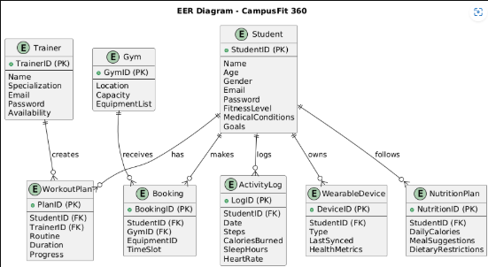

Visual Representation of Workflow:-
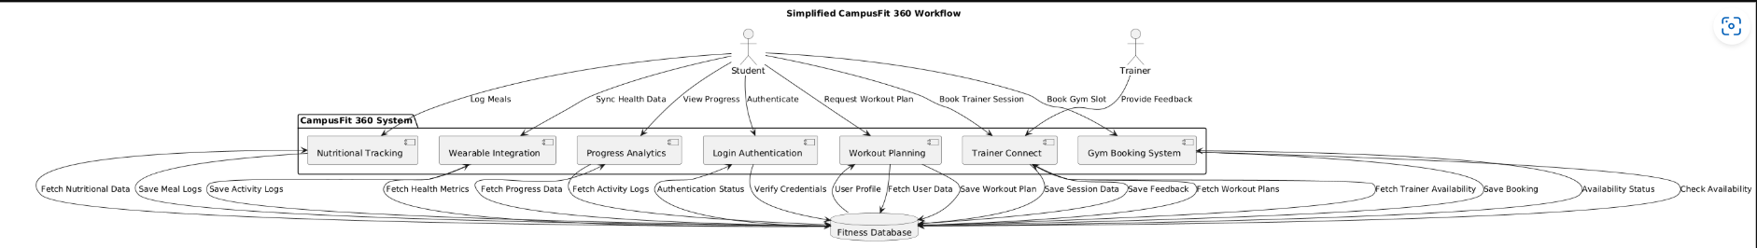
Use case Diagram:-
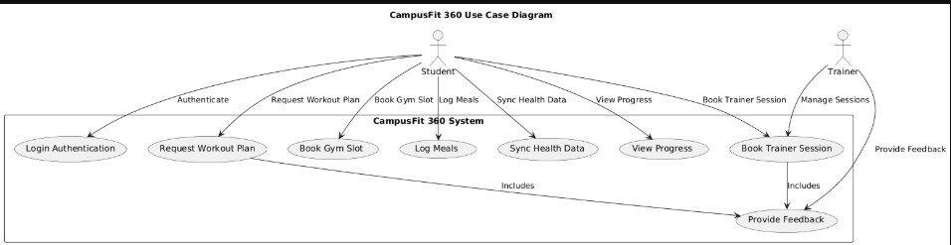

Data Flow Diagram :-
