INTERNSHIP PROJECT REPORT
On
Implementation of FTP Server using C on Linux

Submitted by:
Sayli Polakhare
Internship Organization:
Sunbeam Institute of Information Technology, Pune
Guide / Mentor:
Mr. Sohail Inamdar
Duration:
August 2025 – September 2025
Date:
05 September 2025
Submitted in partial fulfillment of Internship Program

ABSTRACT

File Transfer Protocol (FTP) is a standard network protocol that enables the reliable transfer of files between client and server systems over a TCP/IP network. It is widely used for tasks such as uploading, downloading, and managing files across remote systems, making it a fundamental concept in computer networks. This project, “Implementation of FTP Server using C on Linux”, is undertaken to gain practical knowledge of socket programming, client–server communication, and system-level programming in Linux. The implementation consists of several key modules: the server setup for listening and accepting client connections, client handling for managing multiple users, authentication with predefined credentials to ensure secure access, and the execution of core FTP commands including file upload, file download, directory listing, and file size retrieval. Each module has been carefully developed using C programming constructs and Linux system calls to handle data transfer, connection management, and error handling effectively. The main outcome of this project is a functional FTP server that allows authenticated clients to interact with the server and perform file operations efficiently. This work not only demonstrates the application of networking concepts in real-world scenarios but also provides a strong foundation for enhancing the server with advanced features like encryption, passive/active transfer modes, and robust error recovery.

INTRODUCTION

File Transfer Protocol (FTP) is a standard network protocol used to transfer files between client and server systems over a TCP/IP network. It provides a reliable mechanism for uploading, downloading, and managing files across remote systems, making it one of the oldest and most widely used protocols in computer networking. FTP plays a vital role in real-world applications such as website hosting, data sharing, software updates, and secure file management, where efficient and structured file transfer is essential.
This project, “Implementation of FTP Server using C on Linux”, is aimed at developing a simplified yet functional FTP server to understand the core concepts of socket programming, client–server communication, and Linux system-level programming. The objectives of the project include building a server that can accept and manage multiple client connections, implementing user authentication through predefined credentials to ensure controlled access, and supporting essential FTP commands such as file upload, file download, directory listing, and file size retrieval. The implementation focuses on using C programming constructs and Linux system calls to handle networking, file operations, and error management efficiently. The outcome is a working FTP server that demonstrates practical application of networking concepts and provides a strong foundation for future improvements such as encryption and advanced transfer features.

LITERATURE REVIEW

File Transfer Protocol (FTP) is one of the earliest protocols developed for file sharing, formally standardized in RFC 959 (1985). It was designed to enable reliable and structured file transfers between client and server systems over TCP/IP networks. Over time, FTP became a widely adopted protocol due to its simplicity and efficiency, though it also introduced challenges related to authentication security and data encryption. Compared to HTTP, which is primarily used for delivering web content, FTP focuses specifically on file storage, retrieval, and management. In contrast, SFTP (SSH File Transfer Protocol) provides secure file transfer by encrypting both commands and data, addressing FTP’s limitations in confidentiality and integrity.
In practice, FTP servers are widely deployed using established tools such as vsftpd (Very Secure FTP Daemon) and proftpd, which provide production-ready, secure, and feature-rich implementations. However, this project takes a different approach by developing a custom FTP server using C on Linux. This hands-on implementation emphasizes learning the underlying mechanisms of socket programming, authentication, and file operations, rather than relying on prebuilt software. By re-creating essential FTP functionalities, the project bridges theoretical knowledge with practical system-level programming, offering insights into the internal working of networking protocols.

SYSTEM REQUIREMENTS

Hardware Requirements:
- Processor (CPU): Minimum Intel i3 / AMD equivalent (dual-core, 2.0 GHz or higher).
- RAM: At least 4 GB RAM (8 GB recommended for smoother multitasking and running analysis tools like Wireshark).
- Storage: Minimum 20 GB free disk space (for Linux OS, source code, and file transfer testing).
- Network Interface: Ethernet/Wi-Fi adapter to test client–server communication over TCP/IP.
- System Type: Standard PC or laptop capable of running Linux distributions.

Software Requirements:
- Operating System: Ubuntu 22.04 LTS (or any Linux distribution supporting GCC and socket programming).
- Compiler: GCC (GNU Compiler Collection) for compiling C programs.
- Libraries: Standard C libraries (glibc) and sockets library (sys/socket.h, netinet/in.h, arpa/inet.h, etc.) for networking.
- Development Tools:
  - VS Code / Vim / Nano (any text editor or IDE for writing code).
  - Make utility (for compiling larger projects with Makefiles).
- Testing and Debugging Tools:
  - Wireshark (for network packet capture and analysis of FTP communication).
  - Telnet/Netcat (to test basic server connections).
  - FTP Client software (e.g., FileZilla or Linux ftp command) to verify server functionality.

SYSTEM DESIGN

Architecture
- The system follows a Client–Server architecture.
- Client Side: Initiates connection requests, sends authentication details, and performs commands like upload, download, and list.
- Server Side: Listens on a specific port (default: 21 in real FTP, but custom port in project), authenticates clients, and executes requested file operations.
- Communication: All exchanges happen over TCP sockets ensuring reliable data transfer.

Architecture Diagram:
+-----------+ TCP/IP Network +------------------+
| Client | <-------------------------> | FTP Server |
| (FTP CLI) | | (C on Linux) |
+-----------+ +------------------+
| File System |
+-------------+

Flowchart of Request–Response Cycle
- Client requests connection
- Server accepts connection
- Client sends username/password
- Server authenticates user
  - If valid → proceed
  - If invalid → connection closed
- Client sends FTP command (e.g., LIST, GET, PUT)
- Server processes command
- Server sends response (success/failure + data)
- Repeat until client exits
- Connection terminated.

State Diagram for Connection Handling
- Idle State: Server waiting for client connections.
- Connected State: TCP connection established.
- Authentication State: User credentials verified.
- Command Execution State: File transfer or directory operation performed.
- Termination State: Client disconnects or server closes session.

File Transfer Modes Supported

- Active Mode (default in project): Server opens a data connection back to the client for file transfer.
- Passive Mode (future extension): Client initiates both control and data connections (useful behind firewalls).
- Transfer Formats:
  - Binary Mode: Transfers files as raw byte streams (used for images, executables, archives).
  - Text Mode (ASCII): Transfers files line by line with newline conversions (used for plain text).

IMPLEMENTATION

SOCKET CREATION STEPS:
1. Create server socket.
serv_fd = socket(AF_INET, SOCK_STREAM, 0);
2. Assign socket address (IP addr + port no).
ret = bind(serv_fd, &serv_addr, sizeof(serv_addr));
3. Listen to the server socket.
listen(serv_fd, 5);
4. Create Client Socket.
cli_fd = socket(AF_INET, SOCK_STREAM, 0);
5. Connect to the server.
ret = connect(cli_fd, &serv_addr, sizeof(serv_addr));
6. Accept client connection (blocked until client connects).
cli_fd = accept(serv_fd, &cli_addr, sizeof(cli_addr));
7. Send data to server.
write(cli_fd, buf, size);
8. Read data from client.
read(cli_fd, buf, size);
9. Send data to client.
write(cli_fd, buf, size);

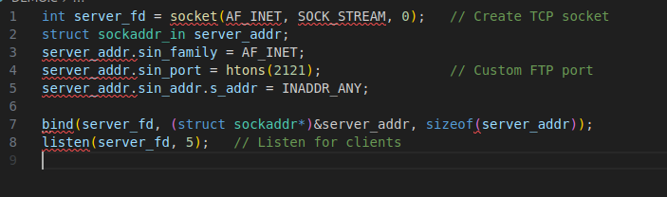

10. Read data from server.
read(cli_fd, buf, size);
11. Close client socket.
close(cli_fd);
12. Close client socket.
close(cli_fd);
13. Shutdown the server socket.
shutdown(serv_fd, SHUT_RDWR);

Socket Binding and Listening:

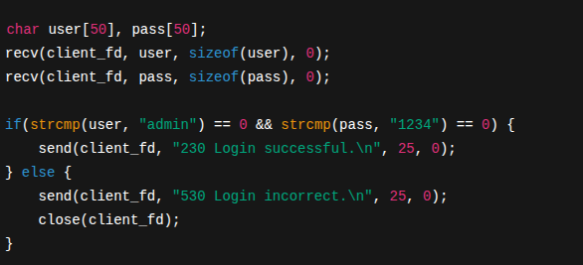
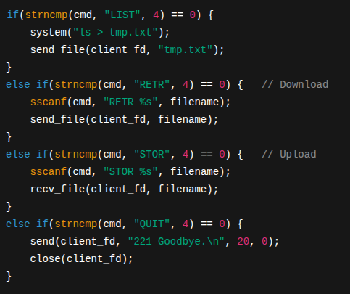

User Authentication (Login System)

Handling FTP Commands:

,hn
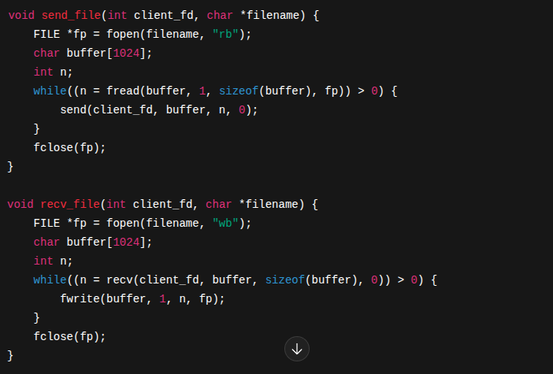

File Transfer (Upload/Download)

lj
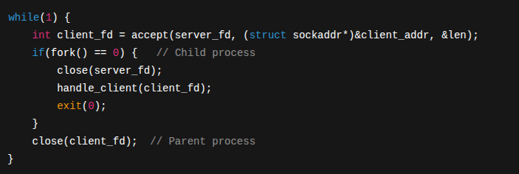

Multi-Client Handling

TESTING

Test Cases Performed

- Login with Valid/Invalid Credentials
- Valid Login: When correct username and password were entered, the server granted access and displayed the “230 Login successful” message.
- Invalid Login: Incorrect credentials resulted in the “530 Login incorrect” message, and the connection was terminated.
- File Upload (STOR) & Download (RETR)
- Successfully uploaded text and binary files from the client to the server.
- Successfully downloaded files stored on the server to the client system.
- Verified integrity of files after transfer (no data corruption).
- LIST Directory Contents
- Executed the LIST command to display all files in the server directory.
- Output was correctly received by the client, confirming directory listing functionality.
- Multiple Clients Connected Simultaneously
- Using fork()/threads, multiple clients were able to connect and perform operations independently.
- File transfers were executed in parallel without interfering with each other’s sessions.

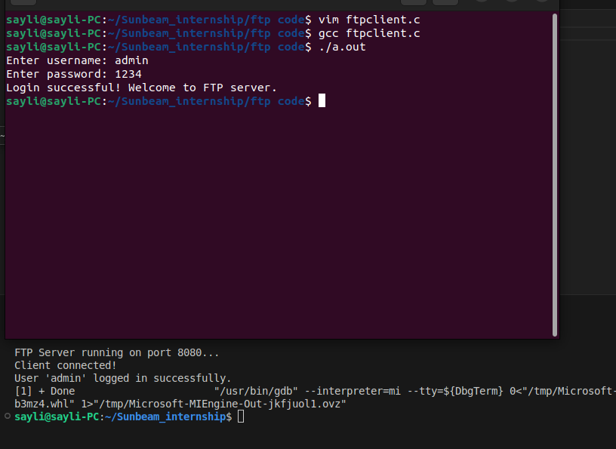

RESULTS

Connection Established:

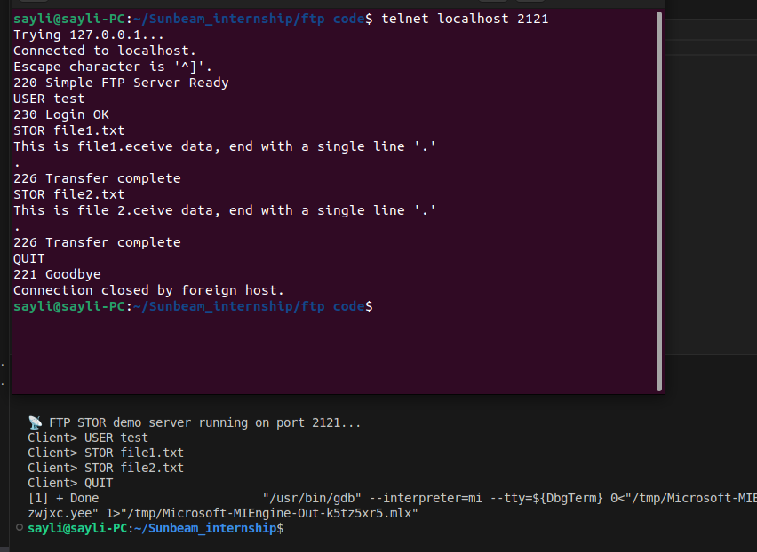

Client Uploading & Downloading Files

Upload (STOR):

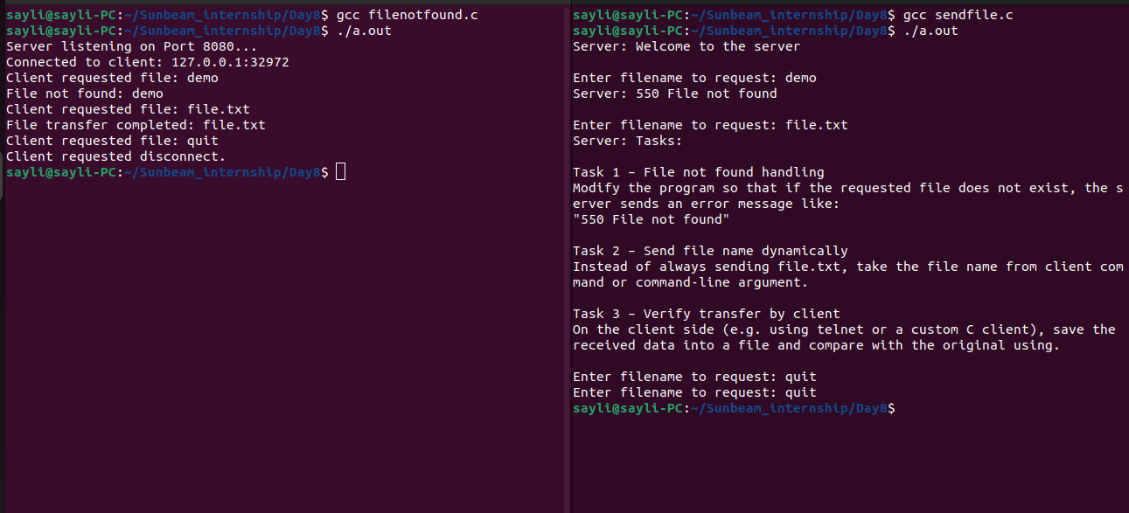

Download (RETR):

FUTURE SCOPE

In the near future, FTP is expected to evolve with significant enhancements. SSH Communications Security Corp., a global leader in enterprise security and secure communications solutions, has announced that file transfer technologies will increasingly emphasize security through protocols such as SFTP (Secure File Transfer Protocol). SFTP ensures stronger confidentiality, integrity, and authentication, making it suitable for both interactive and automated file transfers across multi-platform systems.
Beyond security, traditional FTP is also anticipated to gain upgraded features. One such improvement is transparent FTP-to-SFTP conversion, which allows organizations to migrate to SFTP without modifying existing scripted file transfers. This means users will not need to uninstall or reinstall software; instead, existing FTP scripts will be automatically upgraded to SFTP, simplifying the transition. Another key enhancement is automatic guaranteed delivery with configurable alerts. This ensures that critical file transfers are reliably completed, and in cases where files fail to transfer, the system will generate an alert to notify users of incomplete deliveries.
These future enhancements highlight the move toward a more secure, reliable, and user-friendly FTP ecosystem, ensuring smooth operations in enterprise and multi-platform environments.

/

CONCLUSION

The rapid advancement of information technology has made global resource sharing possible with just a computer and an internet connection. Today, downloading from remote servers and uploading files to websites is simple, thanks to the File Transfer Protocol (FTP).
Initially, file transfer over the internet relied on email attachments, which imposed strict limitations on file size and type. FTP overcame these issues by enabling the transfer of virtually any file type without size restrictions, making it a more flexible and reliable solution. However, FTP also raises concerns regarding security and access control. While some FTP servers allow open public access, others restrict usage and require user authentication to ensure controlled data sharing.
Looking to the future, FTP is being enhanced with more secure technologies such as Enhanced File Transfer (EFT) and Secure File Transfer Protocol (SFTP). These improvements focus on confidentiality, integrity, and authentication, ensuring safer file transfers across diverse platforms.
In summary, FTP has played a critical role in efficient data transmission, overcoming early limitations, and continues to evolve toward more secure and reliable communication in modern networking.

REFERENCES

- J. Postel, J. Reynolds, RFC 959 – File Transfer Protocol (FTP) Specification, IETF, 1985.
- W. Richard Stevens, UNIX Network Programming, Volume 1: The Sockets Networking API, Prentice Hall, 3rd Edition, 2003.
- Linux Manual Pages – man 2 socket, man 2 bind, man 2 listen, man 2 accept, man 2 connect.
- Online resources and tutorials on C socket programming and FTP server implementation (e.g., GNU/Linux Documentation, GeeksforGeeks, and Beej’s Guide to Network Programming).

