Jess Brisbois, Aaron Ramirez, Abbey Gonzales, Harsh Wadhwani.

GITHUB LINK:

<https://github.com/HarshWadhwani/HorseyGame.git>

Goal of the project

The goal of this project is to create a video game for anyone to play. The game will be about a horse who is going on an adventure. The adventure is about a horse named Smitty Horstholomew the 3rd, who will run for presidency. The two parties will be the Carnivoricans and the Herbivorats and Smitty will be representing the Herbivorats. A horse mafia called Marefia will act as the enemies that Smitty needs to fight. The player will control Smitty and will have to play through levels and rooms in each level to complete the game.

Potential Users  
There are many potential users for this game, the largest demographic being 18 to 25 years old college students. This game has elements of games this age group played while growing up due to it being an action adventure RPG with dialog on modern society. The group will find enjoyment in the varying levels and be able to stop and play the game whenever due to it being on PC and being compatible with most operating systems. Teenagers will also be interested in this game, as many enjoy playing video games on their computers, this game would be a good time killer for them and would teach them some puzzle solving techniques in later levels. The game will be able to run on their personal or school computers since it does not need a graphic intensive computer. Another large group of users would be equestrian enthusiasts that love any and everything related to horses, they would deeply enjoy this game since they will watch the daring horse protagonist on his road to presidency. This game is also family friendly fun for the entire family to enjoy, it’s a game that can teach children to strive for their goals, learn how to problem solve and to think logically. Parents will be able to easily download and use the game since they all should be using an operating system that supports java.

Contribution: Harsh worked on the goal of project and GitHub. Abbey worked on potential users. Jess and Aaron worked on the use cases. And we all contributed to coding the project.

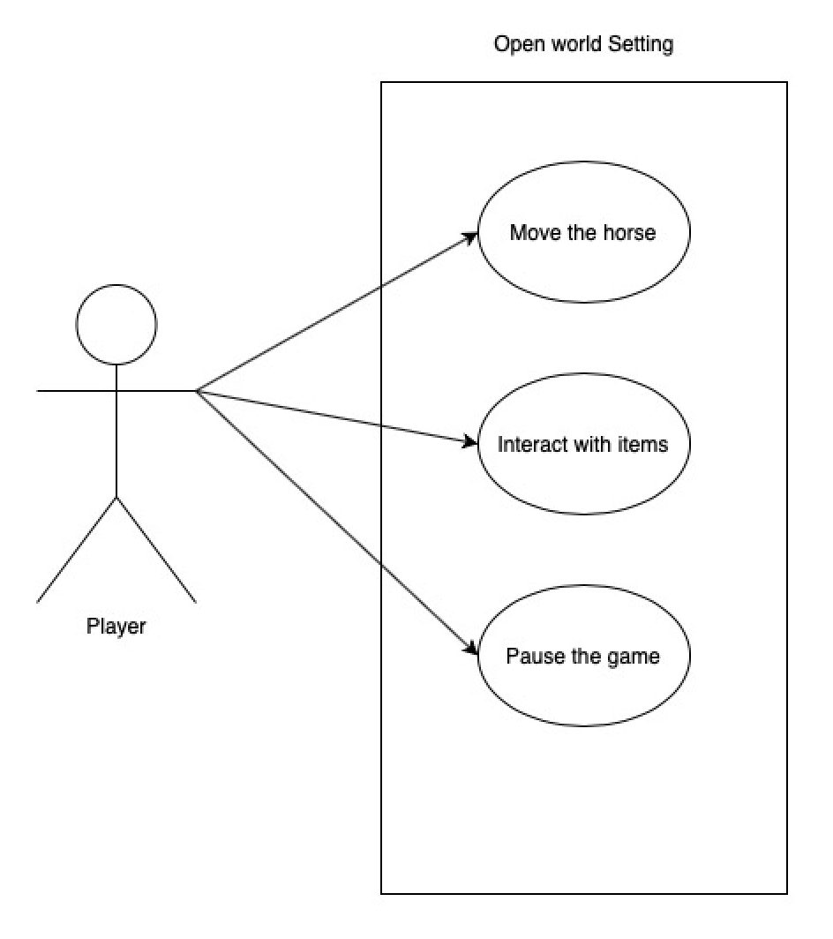

This user case shows how the user will be able to interact with the world. The user will be able to move the horse around the map using the W,A,S,D keys. The horse will be able to interact with specific items and NPCs within the game. The user will be able to pause the game.

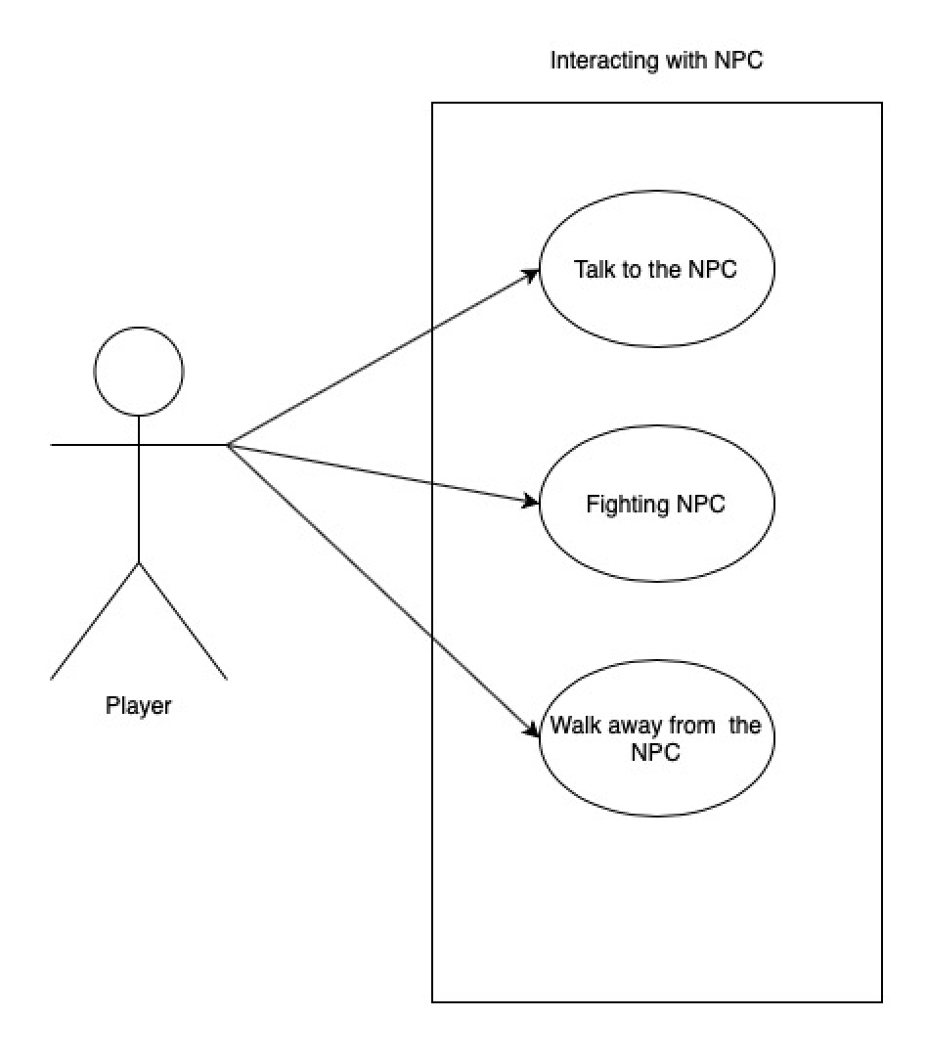

This user case shows how the user will be interacting with NPCs within the game. The user will be able to talk to the user, creating a dialogue. The user will also be able to fight the NPCS. Finally, the user will be able to end both the conversation and the fight with the NPC.

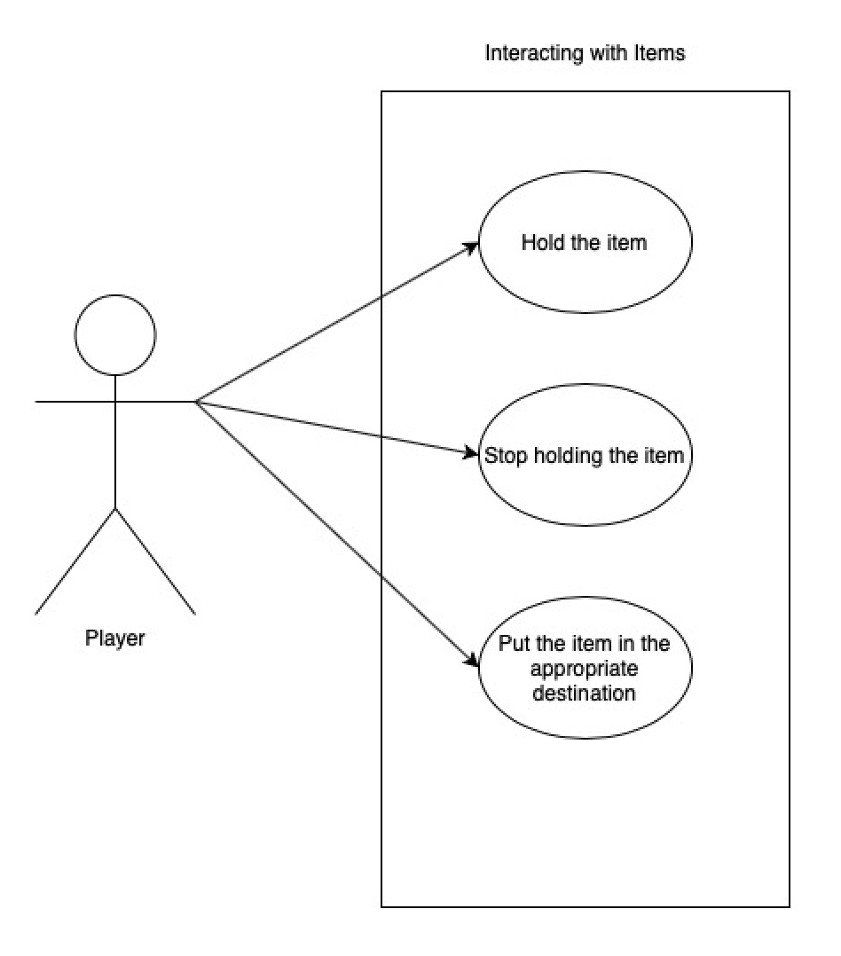

Our character would be able to solve puzzles and get different items to help solve these puzzles. Our hero will be able to pick up and hold the item. They will be able to carry the item to the destination needed or drop it before if they insist. Not only this they will be able to put the item in the appropriate destination. Overall this mechanic will allow puzzles in our game and test the player wits.

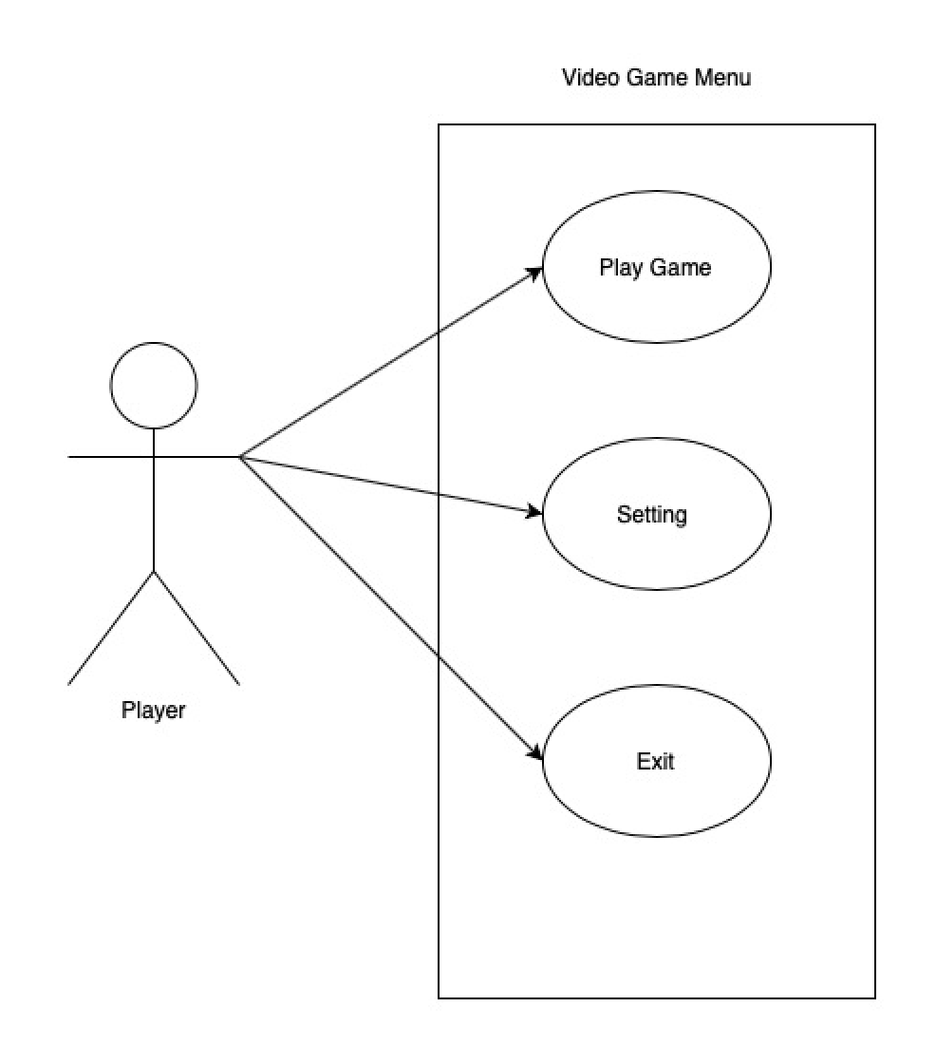

This functionality shows how the player will interact with the video game menu. The user will be able to play the game, which will put the horse at the beginning of the game. The user will be able to alter some settings of the game. Finally, the player can quit the game which will kill the program.