WIREFRAME

Flight Fare Prediction

Harsha MS

|  |  |  |  |
| --- | --- | --- | --- |
| Date | Version | Description | Author |
| 31/10/2022 | 1.0 | Wireframe | Harsha MS |
|  |  |  |  |

**HOMEPAGE**

We have a single page UI which will facilitate prediction for Flight Fare Prediction.

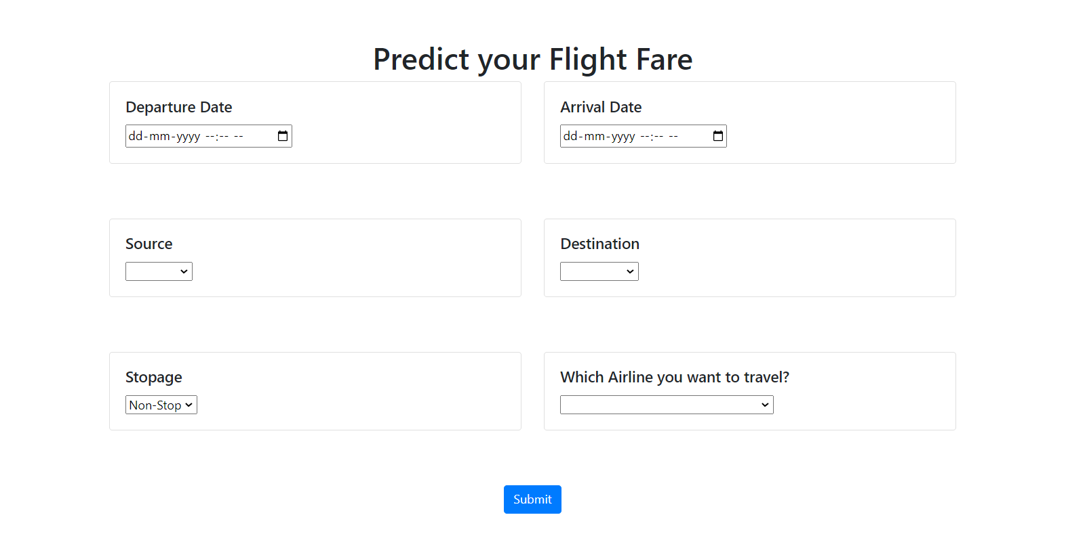

**USER INPUT**

On the Home page, the user has to provide all the information asked for the prediction. The user can select from the drop-down lists attached to each of the input fields. Once all the asked information is provided, the user clicks on submit button to get the output.

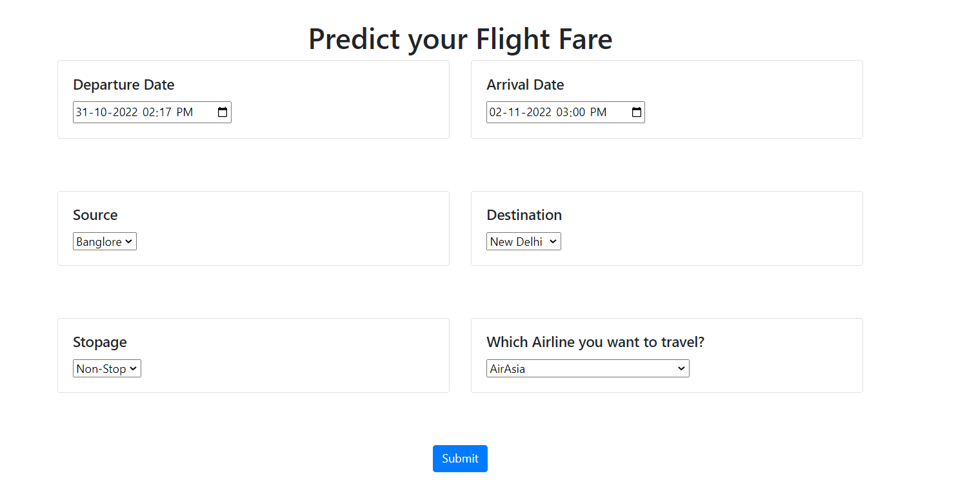

**RESULTS**

On the Home page, the user provides all the asked information and then clicks on submit button. The predicted fare of the selected flight is displayed to the user.

