**Cucumber:**

**Sample example to work with cucumber:**

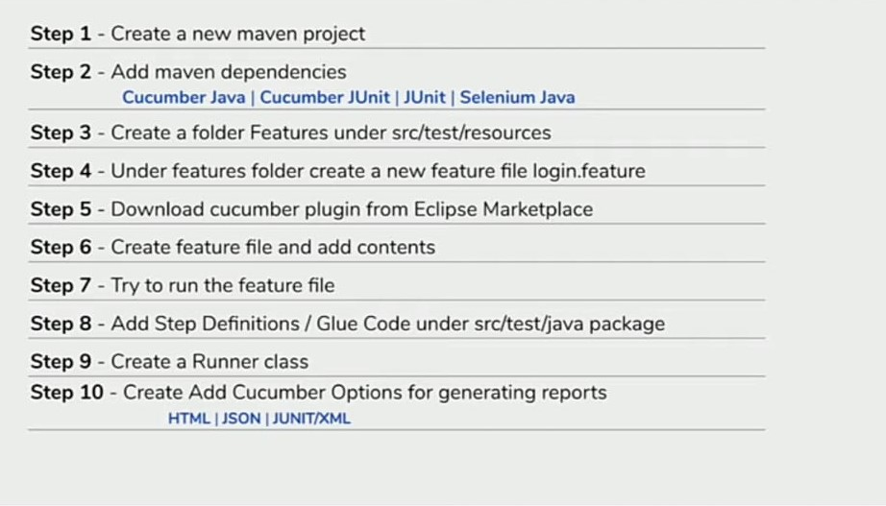

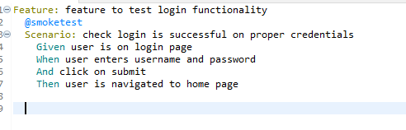

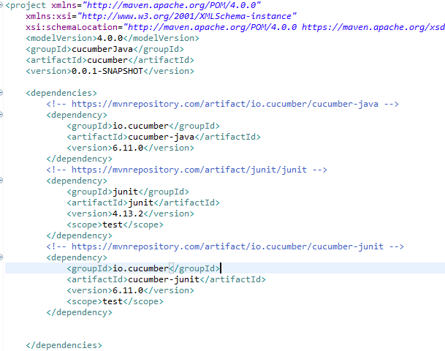

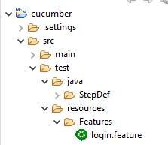

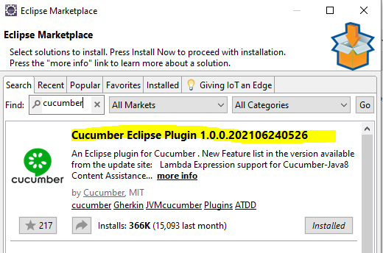

* Create the file in the Features folder with the extension .feature
* Then you can start writing the feature and scenario inside that feature file.

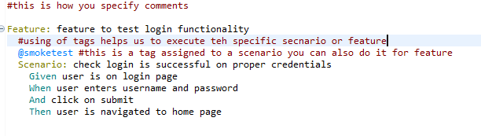

* Run this feature file as shown below

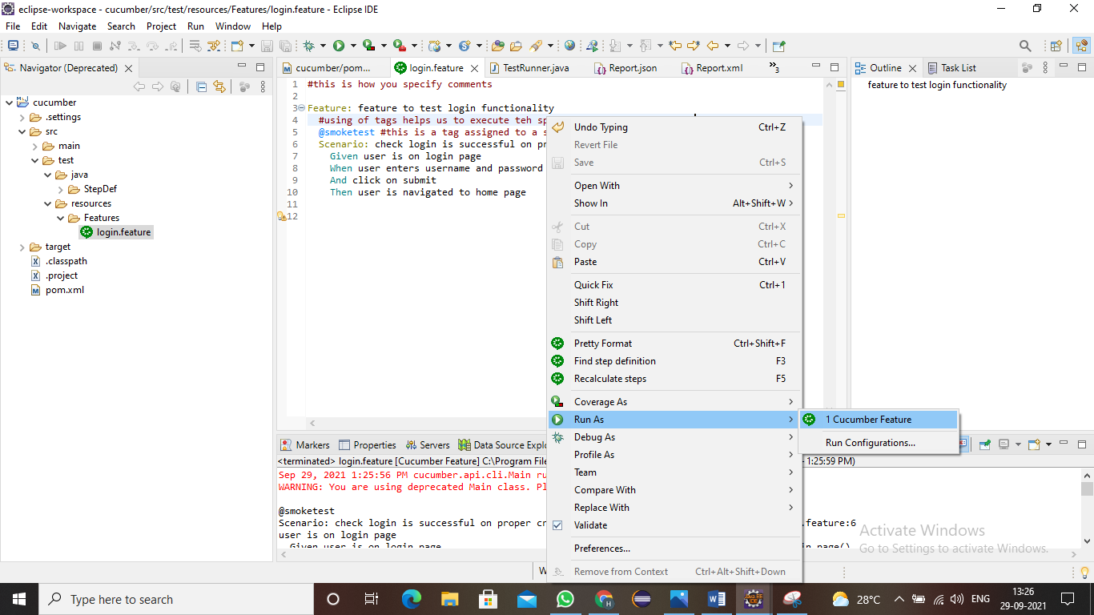

* You will get the step definitions as output which is also called as the Glue code.
* Then follow STEP-8 and you have create it as like image shown below.

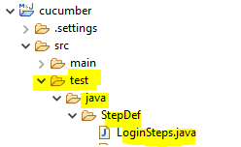

* After this copy that glue code from the console to that Loginsteps.java file

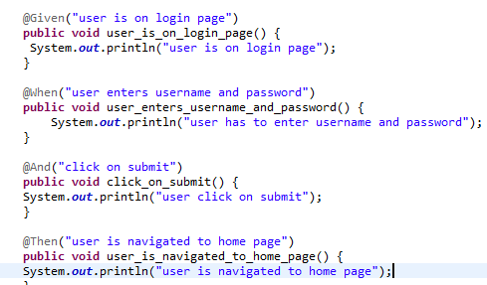

* You will get some errors, which is because you need to import some packages.

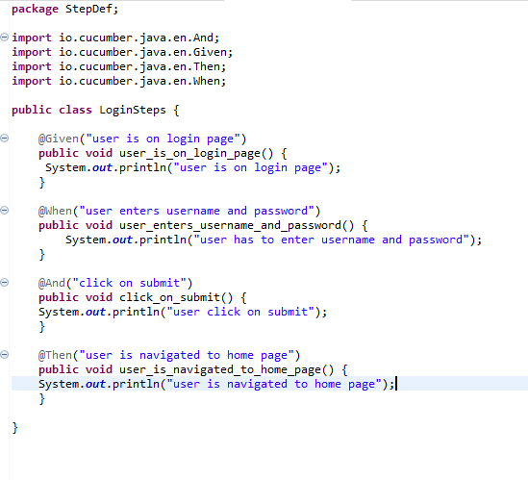

* Then you need to create a runner class. This is useful when you are dealing with multiple feature files.

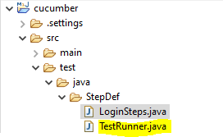

* You have write something inside it as shown below.

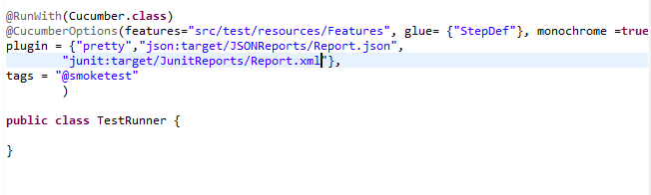

* You will again find some errors as you need to import some packages.
* Then when you run you will see the output somewhat like below image.

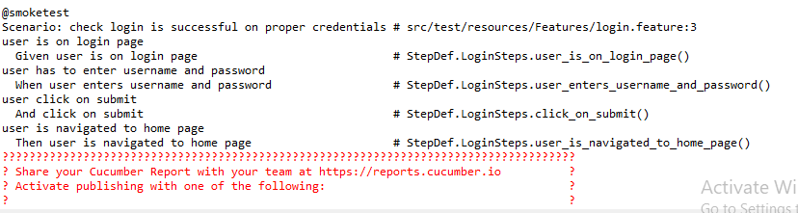

* Then we can also generate the reports of different formats like .xml for junit report, .html for html report, and .json for json report.

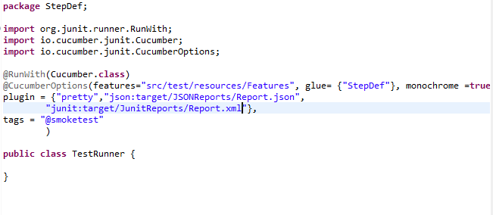

* This is what we can see in the TestRunner file and when we run it we get the reports in the path that we specify.

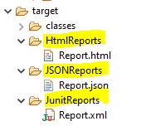

* We can open and view the reports.
* And these reports are very necessary that if we are working with say CICD tools like Jenkins we can make these reports available to the developers and so that it becomes easy for them to understand things.

**Sample Example to work with cucumber combo selenium:**