**Step-1: INSTALL JDK 11**

* Make sure you have the jdk 11 installed first in your system. [ better use jdk 11 which is compatible to Jenkins. Else it may through version error/exception].
* If not follow the below sequence:

1. Go to the link given <https://www.oracle.com/java/technologies/javase-jdk11-downloads.html>

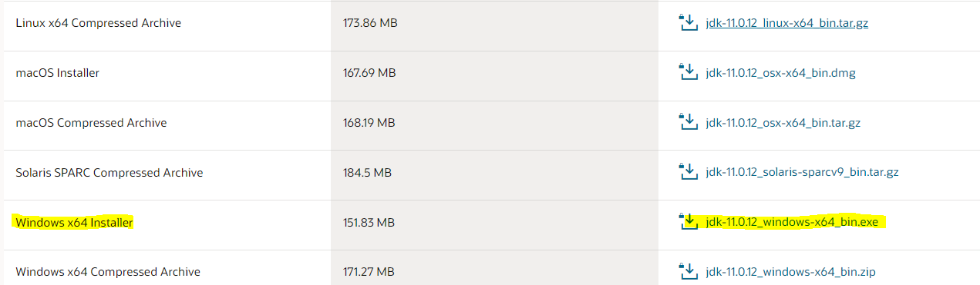

* Click on the link that is highlighted on website.
* Then automatically download begins.
* Once it is downloaded, install it on your system.

*[NOTE: If you are not getting to download unless you login for oracle account, please do create the oracle account by mentioning your details (note: give as student and your college name for organization respectively). Then when account is created, try to download now, it will get downloaded]*

* To check whether it downloaded successfully or not.
* Go to command prompt in your system. And type java –version
* You need to see the version displayed on the prompt:

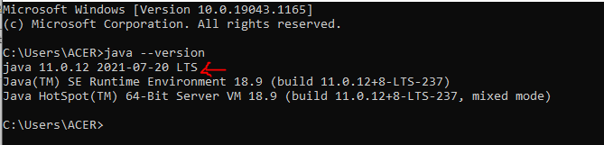

**Step-2: INSTALL JENKINS**

* Go to browser and just type Jenkins.
* You will be taken to the official website of Jenkins.
* Or click on the link below:

<https://www.jenkins.io/>

* There in the website click on download button.
* You will be taken to the different site.

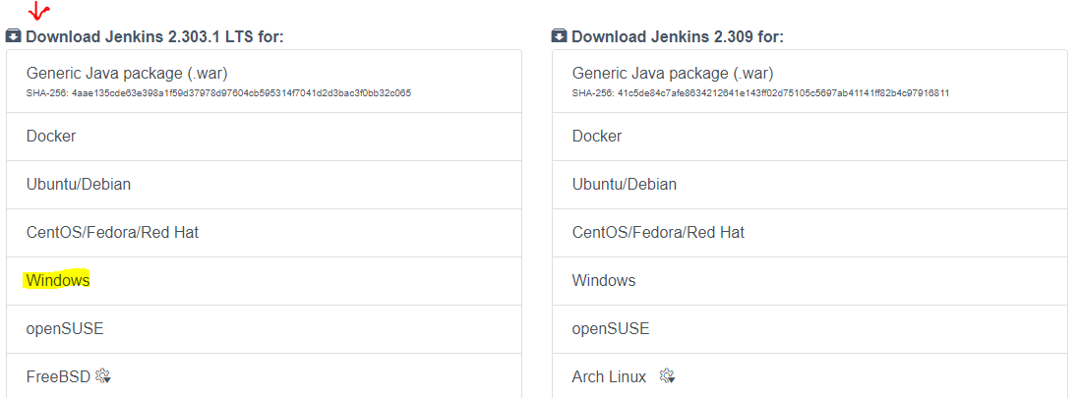

* When you click on windows you need to get the Jenkins downloaded.
* And then you have to install it on your system. Just keep giving next and next to all leaving all as default. [NOTE: you will be asked to enter the account and password in the middle of installation this will be for local or domain, but you choose an option for local System and click next]
* Once the Jenkins get installed on your system.
* Go to command prompt and change the location to place where Jenkins is installed on your system

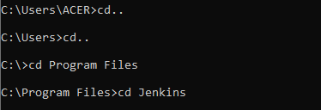

* Once the directory is set, type the following command:

**java –jar jenkins.war**

* After which go to browser and type “**localhost:8080**”.
* This is the port number allocated for Jenkins **8080.**
* When that command has run you can see that there is some initial Administrator password displayed.

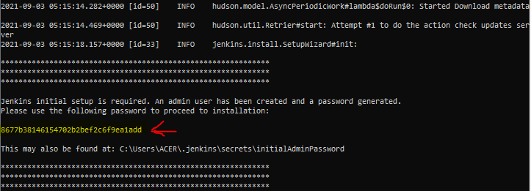

* If you don’t get the password in prompt, go to the folder named “.jenkins” in your user folder and go to “secret” folder.
* Then look for the file named initialAdminpassword file.
* You will get the password in that file.
* Now when you see the browser you will get the login page for the Jenkins where it will ask for the initial administrator password.
* Enter that password there and click continue.

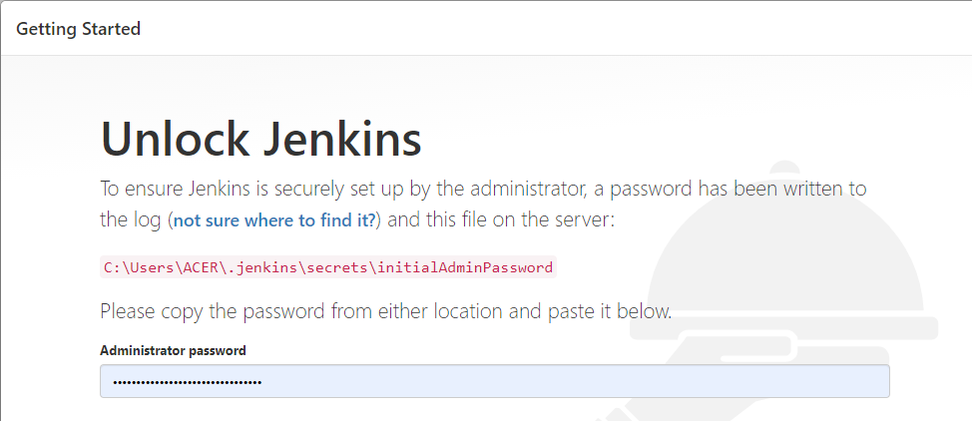

* Once you click on continue you will move to the next page i.e.

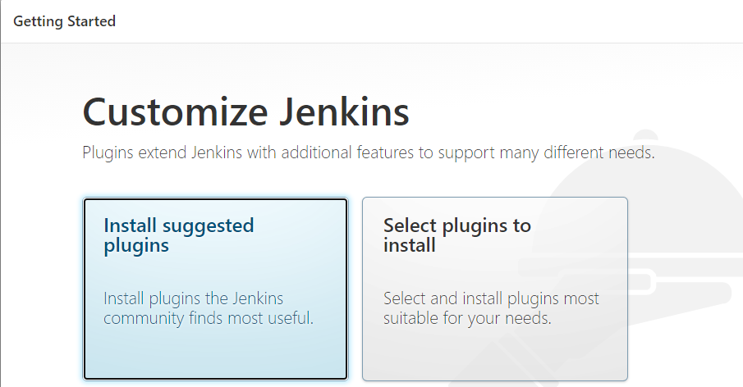

* You can choose any option, if you need any extra plugin to be added then click on select plugins to install. Else you can just click on install suggested plugin.
* I will choose for the “install suggested plugin”
* Then you will see that the suggested plugins will get installed.

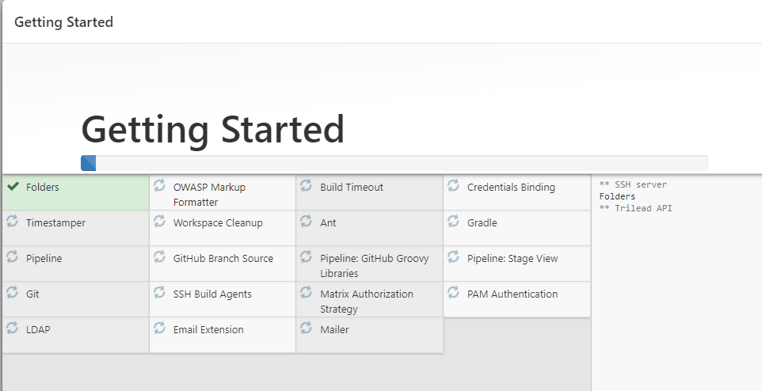

* Once all the plugins are installed you will be asked to create the user.
* You can create the new user if you need else click on **continue as admin** below.
* Then you will see **start Jenkins** button click on the webpage.
* It will take you to the below mentioned page:

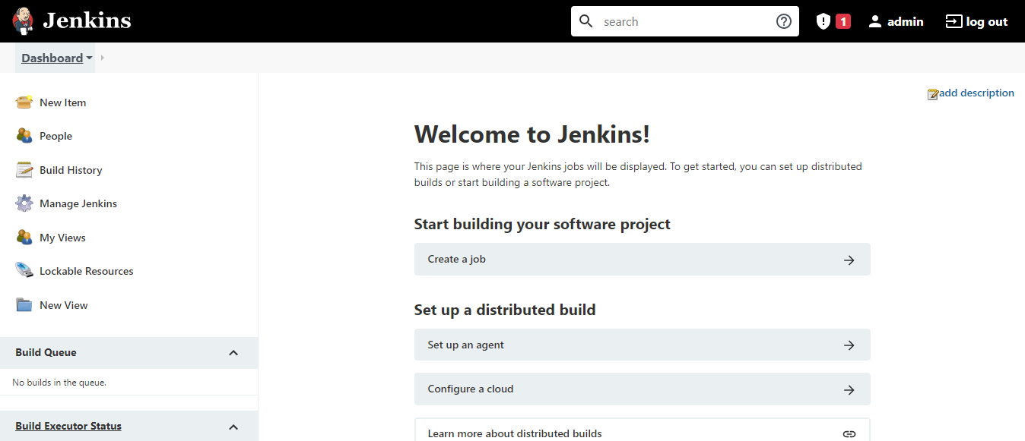

* Now your Jenkins is ready to use.